UNITED STATES

SECURITIES AND EXCHANGE COMMISSION

Washington, D.C. 20549

Form 10-K

- ANNUAL REPORT PURSUANT TO SECTION 13 OR 15(d) OF THE SECURITIES EXCHANGE ACT OF 1934 For the Fiscal Year Ended December 31, 2023

or

- TRANSITION REPORT PURSUANT TO SECTION 13 OR 15(d) OF THE SECURITIES EXCHANGE ACT OF 1934

 |  |  | For the Transition Period from |  | to
 |  |  | Commission File Number: 001-34949
 |  |  | Arbutus Biopharma Corporation
 |  |  | (Exact Name of Registrant as Specified in Its Charter)
 | British Columbia, Canada |  |  |  | 98-0597776
 | (State or Other Jurisdiction of |  |  |  | (I.R.S. Employer
 | Incorporation or Organization) |  | 701 Veterans Circle |  | Identification No.)
 |  |  | Warminster
 |  |  | PA
 |  |  | 18974
 |  |  | (Address of Principal Executive Offices)
 |  |  | 267-469-0914
 |  |  | (Registrant’s Telephone Number, Including Area Code)
Securities registered pursuant to Section 12(b) of the Act:
 | Title of Each Class |  | Trading Symbol(s) |  | Name of Each Exchange on Which Registered
 | Common shares, without par value |  | ABUS |  | The Nasdaq Stock Market LLC
 | Securities registered pursuant to Section 12(g) of the Act: None.

Indicate by check mark if the registrant is a well-known seasoned issuer, as defined in Rule 405 of the Securities Act. Yes o No x Indicate by check mark if the registrant is not required to file reports pursuant to Section 13 or Section 15(d) of the Act. Yes o No x

Indicate by check mark whether the registrant (1) has filed all reports required to be filed by Section 13 or 15(d) of the Securities Exchange Act of 1934 during the preceding 12 months (or for such shorter period that the registrant was required to file such reports), and (2) has been subject to such filing requirements for the past 90 days. Yes x No o

Indicate by check mark whether the registrant has submitted electronically every Interactive Data File required to be submitted pursuant to Rule 405 of Regulation S-T during the preceding 12 months (or for such shorter period that the registrant was required to submit such files). Yes x No o

Indicate by check mark whether the registrant is a large accelerated filer, an accelerated filer, a non-accelerated filer, a smaller reporting company, or an emerging growth company. See the definitions of “large accelerated filer,” “accelerated filer,” “smaller reporting company,” and “emerging growth company” in Rule 12b-2 of the Exchange Act.

Large accelerated filer | Accelerated filer | Non-accelerated filer | Smaller reporting company | Emerging growth company
☐ | ☐ | ☒ | ☒ | ☐

If an emerging growth company, indicate by check mark if the registrant has elected not to use the extended transition period for complying with any new or revised financial accounting standards provided pursuant to Section 13(a) of the Exchange Act. o

Indicate by check mark whether the registrant has filed a report on and attestation to its management’s assessment of the effectiveness of its internal control over financial reporting under Section 404(b) of the Sarbanes-Oxley Act (15 U.S.C. 7262(b)) by the registered public accounting firm that prepared or issued its audit report. ☐

If securities are registered pursuant to Section 12(b) of the Act, indicate by check mark whether the financial statements of the registrant included in the filing reflect the correction of an error to previously issued financial statements. ☐

Indicate by check mark whether any of those error corrections are restatements that required a recovery analysis of incentive-based compensation received by any of the registrant’s executive officers during the relevant recovery period pursuant to § 240.10D-1(b). ☐

Indicate by check mark whether the registrant is a shell company (as defined in Rule 12b-2 of the Act). Yes ☐ No x

As of June 30, 2023, the last business day of the registrant’s most recently completed second fiscal quarter, the approximate aggregate market value of voting and non-voting common equity held by non-affiliates of the registrant was $288,128,811 (based on the closing price of $2.30 per share as reported on the Nasdaq Global Select Market as of that date).

As of March 1, 2024, the registrant had 179,492,199 common shares, without par value, outstanding.

DOCUMENTS INCORPORATED BY REFERENCE

Portions of the registrant’s definitive proxy statement for its 2024 Annual Meeting of Shareholders, which the registrant intends to file pursuant to Regulation 14A with the Securities and Exchange Commission no later than 120 days after the registrant’s fiscal year ended December 31, 2023, are incorporated by reference into Part III of this Form 10-K.

2

 |  |  |  |  |  |  |  |  |  |  |  |  |  |  |  |  |  |  |  |  |  | ARBUTUS BIOPHARMA CORPORATION
 |  |  |  |  |  |  |  |  |  |  |  |  |  |  |  |  |  |  |  |  |  |  | TABLE OF CONTENTS
 |  |  |  |  |  |  |  |  |  |  |  |  |  |  |  |  |  |  |  |  |  |  |  |  |  |  |  |  |  | Page
Cautionary Note Regarding Forward-looking Statements |  |  |  |  |  |  |  |  |  |  |  |  |  |  |  |  |  |  |  |  |  |  |  |  |  |  |  |  |  | 4
Risk Factors Summary |  |  |  |  |  |  |  |  |  |  |  |  |  |  |  |  |  |  |  |  |  |  |  |  |  |  |  |  |  | 6
PART I |  |  |  |  |  |  |  |  |  |  |  |  |  |  |  |  |  |  |  |  |  |  |  |  |  |  |  |  |  | 8
 | Item |  |  |  | 1. |  |  |  | Business |  |  |  |  |  |  |  |  |  |  |  |  |  |  |  |  |  |  |  |  | 8
 | Item |  |  |  | 1A. |  |  |  | Risk Factors |  |  |  |  |  |  |  |  |  |  |  |  |  |  |  |  |  |  |  |  | 34
 | Item |  |  |  | 1B. |  |  |  | Unresolved Staff Comments |  |  |  |  |  |  |  |  |  |  |  |  |  |  |  |  |  |  |  |  | 56
 | Item |  |  |  | 1C. |  |  |  | Cybersecurity |  |  |  |  |  |  |  |  |  |  |  |  |  |  |  |  |  |  |  |  | 56
 | Item |  |  |  | 2. |  |  |  | Properties |  |  |  |  |  |  |  |  |  |  |  |  |  |  |  |  |  |  |  |  | 57
 | Item |  |  |  | 3. |  |  |  | Legal Proceedings |  |  |  |  |  |  |  |  |  |  |  |  |  |  |  |  |  |  |  |  | 57
 | Item |  |  |  | 4. |  |  |  | Mine Safety Disclosures |  |  |  |  |  |  |  |  |  |  |  |  |  |  |  |  |  |  |  |  | 60
PART II |  |  |  |  |  |  |  |  |  |  |  |  |  |  |  |  |  |  |  |  |  |  |  |  |  |  |  |  |  | 61
 | Item |  |  |  | 5. |  |  |  | Market for Registrant’s Common Equity, Related Stockholder Matters and Issuer Purchases of Equity Securities |  |  |  |  |  |  |  |  |  |  |  |  |  |  |  |  |  |  |  |  | 61
 | Item |  |  |  | 6. |  |  |  | Reserved |  |  |  |  |  |  |  |  |  |  |  |  |  |  |  |  |  |  |  |  | 61
 | Item |  |  |  | 7. |  |  |  | Management’s Discussion and Analysis of Financial Condition and Results of Operations |  |  |  |  |  |  |  |  |  |  |  |  |  |  |  |  |  |  |  |  | 62
 | Item |  |  |  | 7. |  |  |  | Quantitative and Qualitative Disclosures about Market Risk |  |  |  |  |  |  |  |  |  |  |  |  |  |  |  |  |  |  |  |  | 72
 | Item |  |  |  | 8. |  |  |  | Financial Statements and Supplementary Data |  |  |  |  |  |  |  |  |  |  |  |  |  |  |  |  |  |  |  |  | 73
 | Item |  |  |  | 9. |  |  |  | Changes in and Disagreements with Accountants on Accounting and Financial Disclosure |  |  |  |  |  |  |  |  |  |  |  |  |  |  |  |  |  |  |  |  | 102
 | Item |  |  |  | 9A. |  |  |  | Controls and Procedures |  |  |  |  |  |  |  |  |  |  |  |  |  |  |  |  |  |  |  |  | 102
 | Item |  |  |  | 9B. |  |  |  | Other Information |  |  |  |  |  |  |  |  |  |  |  |  |  |  |  |  |  |  |  |  | 103
 | Item |  |  |  | 9C. |  |  |  | Disclosure Regarding Foreign Jurisdictions that Prevent Inspections |  |  |  |  |  |  |  |  |  |  |  |  |  |  |  |  |  |  |  |  | 103
PART III |  |  |  |  |  |  |  |  |  |  |  |  |  |  |  |  |  |  |  |  |  |  |  |  |  |  |  |  |  |  | 104
 | Item |  |  |  | 10. |  |  |  | Directors, Executive Officers and Corporate Governance |  |  |  |  |  |  |  |  |  |  |  |  |  |  |  |  |  |  |  |  | 104
 | Item |  |  |  | 11. |  |  |  | Executive Compensation |  |  |  |  |  |  |  |  |  |  |  |  |  |  |  |  |  |  |  |  | 104
 | Item |  |  |  | 12. |  |  |  | Security Ownership of Certain Beneficial Owners and Management and Related Stockholder Matters |  |  |  |  |  |  |  |  |  |  |  |  |  |  |  |  |  |  |  |  | 104
 | Item |  |  |  | 13. |  |  |  | Certain Relationships and Related Transactions, and Director Independence |  |  |  |  |  |  |  |  |  |  |  |  |  |  |  |  |  |  |  |  | 104
 | Item |  |  |  | 14. |  |  |  | Principal Accountant Fees and Services |  |  |  |  |  |  |  |  |  |  |  |  |  |  |  |  |  |  |  |  | 104
PART IV |  |  |  |  |  |  |  |  |  |  |  |  |  |  |  |  |  |  |  |  |  |  |  |  |  |  |  |  |  | 105
 | Item |  |  |  | 15. |  |  |  | Exhibits and Financial Statement Schedules |  |  |  |  |  |  |  |  |  |  |  |  |  |  |  |  |  |  |  |  |  | 105
 | Item |  |  |  | 16. |  |  |  | Form 10-K Summary |  |  |  |  |  |  |  |  |  |  |  |  |  |  |  |  |  |  |  |  | 108

3

Cautionary Note Regarding Forward-looking Statements

This Annual Report on Form 10-K (Form 10-K) contains “forward-looking statements” or “forward-looking information” within the meaning of applicable United States and Canadian securities laws (we collectively refer to these items as “forward-looking statements”). Forward-looking statements are generally identifiable by use of the words “believes,” “may,” “plans,” “will,” “anticipates,” “intends,” “budgets,” “could,” “estimates,” “expects,” “forecasts,” “projects” and similar expressions that are not based on historical fact or that are predictions of or indicate future events and trends, and the negative of such expressions. Forward-looking statements in this Form 10-K, including the documents incorporated by reference, include statements about, among other things:

- our strategy, future operations, preclinical research, preclinical studies, clinical trials, prospects and the plans of management;

- the potential for our product candidates to achieve their desired or anticipated outcomes;

- the expected cost, timing and results of our clinical development plans and clinical trials, including our clinical collaborations with third parties;

- the discovery, development and commercialization of a curative combination regimen for chronic hepatitis B infection, a disease of the liver caused by the hepatitis B virus;

- the potential of our product candidates to improve upon the standard of care and contribute to a functional curative combination treatment regimen;

- obtaining necessary regulatory approvals;

- obtaining adequate financing through a combination of financing activities and operations;

- the expected returns and benefits from strategic alliances, licensing agreements, and research collaborations with third parties, and the timing thereof;

- our expectations regarding our technology licensed to third parties, and the timing thereof;

- our anticipated revenue and expense fluctuation and guidance;

- our expectations regarding the timing of announcing data from our ongoing clinical trials;

- our expectations regarding current patent disputes and litigation;
- our expectation of a net cash burn between $63.0 million and $67.0 million in 2024, excluding any proceeds from our Open Market Sale AgreementSM with Jefferies dated December 20, 2018, as amended, and
- our belief that we have sufficient cash resources to fund our operations into the first quarter of 2026,

as well as other statements relating to our future operations, financial performance or financial condition, prospects or other future events. Forward-looking statements appear primarily in the sections of this Form 10-K entitled “Item 1-Business,” “Item 1A-Risk Factors,” “Item 7-Quantitative and Qualitative Disclosures About Market Risk,” and “Item 8-Financial Statements and Supplementary Data.”

Forward-looking statements are based upon current expectations and assumptions and are subject to a number of known and unknown risks, uncertainties and other factors that could cause actual results to differ materially and adversely from those expressed or implied by such statements. Factors that could cause or contribute to such differences include, but are not limited to, those discussed in this Form 10-K and in particular the risks and uncertainties discussed under “Item 1A-Risk Factors” of this Form 10-K. As a result, you should not place undue reliance on forward-looking statements.

Additionally, the forward-looking statements contained in this Form 10-K represent our views only as of the date of this Form 10-K (or any earlier date indicated in such statement). While we may update certain forward-looking statements from time to time, we specifically disclaim any obligation to do so, even if new information becomes available in the future. However, you are advised to consult any further disclosures we make on related subjects in the periodic and current reports that we file with the Securities and Exchange Commission.

The foregoing cautionary statements are intended to qualify all forward-looking statements wherever they may appear in this Form 10-K, including any documents incorporated by reference therein.

For all forward-looking statements, we claim protection of the safe harbor contained in the Private Securities Litigation Reform Act of 1995.

This Form 10-K also contains estimates, projections and other information concerning our industry, our business, the markets for certain diseases, including data regarding the estimated size of those markets, and the incidence and prevalence of certain

4

medical conditions. Information that is based on estimates, forecasts, projections, market research or similar methodologies is inherently subject to uncertainties and actual events or circumstances may differ materially from events and circumstances reflected in this information. Unless otherwise expressly stated, we obtained this industry, business, market and other data from reports, research surveys, studies and similar data prepared by market research firms and other third parties, industry, medical and general publications, government data and similar sources.

5

Risk Factors Summary

The following is a summary of the principal risks that could adversely affect our business, operations and financial results. For more information, see “Item 1A. Risk Factors” in this Annual Report on Form 10-K for the year ended December 31, 2023.

Risks Related to Our Business, Our Financial Results and Need for Additional Capital

- We are in the early stages of our development, and there is a limited amount of information about us upon which you can evaluate our product candidates.

- We will require substantial additional capital to fund our operations. Additional funds may be dilutive to shareholders or impose operational restrictions. Further, if additional capital is not available, we may need to delay, limit or eliminate our research, development and commercialization programs and modify our business strategy.
- We have incurred losses in nearly every year since our inception and we anticipate that we will not achieve profits for the foreseeable future. To date, we have had no product revenues.

Risks Related to Development, Clinical Testing, Regulatory Approval, Marketing, and Coverage and Reimbursement of our Product Candidates

- Our product candidates are in early stages of development and must go through clinical trials, which are very expensive, time-consuming and difficult to design and implement. The outcomes of clinical trials are uncertain.
- Preclinical studies and preliminary and interim data from clinical trials of our product candidates are not necessarily predictive of the results or success of ongoing or later clinical trials of our product candidates.
- Because we have limited resources, we may decide to pursue a particular product candidate and fail to advance product candidates that later demonstrate a greater chance of clinical and commercial success.
- Several of our current preclinical studies and clinical trials are being conducted outside the United States, and the FDA may not accept data from trials conducted in locations outside the United States.
- We cannot guarantee how long it will take regulatory agencies to review our applications for product candidates.

- If a particular product candidate causes undesirable side effects, then we may be unable to receive regulatory approval of or commercialize such product candidate.

- We may find it difficult to enroll patients in our clinical trials, which could hinder such clinical trials.

- It may take considerable time and expense to resolve the clinical hold that has been placed on our IND application of AB-101 by the FDA, and no assurance can be given that the FDA will remove the clinical hold, in which case our business and financial prospects may be adversely affected.
- Several of our and our collaboration partner’s current and planned clinical trials have been impacted and could be further delayed or suspended as a result of the military action by Russia in Ukraine.

- Even if our product candidates obtain regulatory approval, they will remain subject to ongoing regulatory requirements.

- We face significant competition from other biotechnology and pharmaceutical companies targeting HBV.

- We are largely dependent on the future commercial success of our HBV product candidates.

- We may incur substantial liabilities and may be required to limit commercialization of our products in response to product liability lawsuits.

- Coverage and adequate reimbursement may not be available for our product candidates, which could make it difficult for us to sell our products profitably.

- We are subject to United States and Canadian healthcare laws and regulations, which could expose us to criminal sanctions, civil penalties, contractual damages and reputational harm.

- If we participate in the Medicaid Drug Rebate Program and other governmental pricing programs, failure to comply with obligations under these programs could result in additional reimbursement requirements, penalties, sanctions and fines, which could have a material adverse effect on our business, financial condition, results of operations and growth prospects.
- Failure to comply with the United States Foreign Corrupt Practices Act, and potentially other similar global laws could subject us to penalties and other adverse consequences.

6

Risks Related to Our Dependence on Third Parties

- We depend on our license agreement with Alnylam Pharmaceuticals, Inc. for the commercialization of ONPATTRO™ (Patisiran).

- We expect to depend in part on our licensing agreements for a significant portion of our revenues for the foreseeable future and to develop, conduct clinical trials with, obtain regulatory approvals for, and manufacture, market and sell some of our product candidates. If these licensing agreements are unsuccessful, or anticipated milestone or royalty payments are not received, our business could be materially adversely affected.
- We will depend on Qilu Pharmaceutical Co., Ltd. for the development and commercialization of imdusiran in China, Hong Kong, Macau and Taiwan.

- If conflicts arise between our collaboration or licensing partners and us, our collaboration or licensing partners may act in their best interest and not in our best interest, which could adversely affect our business.
- We rely on third parties to conduct our clinical trials, and if they fail to fulfill their obligations, our development plans may be adversely affected.

- We rely exclusively on third parties to formulate and manufacture our product candidates, which exposes us to risks that may delay or hinder development, regulatory approval and commercialization of our products.

Risks Related to Our Intellectual Property

- Other entities may assert patent rights that prevent us from developing or commercializing our products.

- Our patents and patent applications may be challenged and may be found to be invalid, which could adversely affect our business.

- We may incur substantial costs as a result of litigation or other proceedings relating to patent and other intellectual property rights which could have a material adverse effect on our business, financial condition and results of operations and could cause the market value of our common shares to decline.
- Confidentiality agreements with employees and others, including collaborators, may not adequately prevent disclosure of trade secrets and other proprietary information.

Risks Related to the Ownership of our Common Shares

- The concentration of common share ownership will likely limit the ability of the other shareholders to influence corporate matters.

- We are incorporated in Canada, with our assets located both in Canada and the United States, with the result that it may be difficult for investors to enforce judgments obtained against us or some of our officers.
- If we are deemed to be a “passive foreign investment company” for the current or any future taxable year, investors who are subject to United States federal taxation would likely suffer materially adverse United States federal income tax consequences.

- Our articles and certain Canadian laws could delay or deter a change of control.

General Risk Factors

- If we are unable to attract and retain qualified key management, scientific staff, consultants and advisors, our ability to implement our business plan may be adversely affected.

- We could face liability from our controlled use of hazardous and radioactive materials.
- Our business, reputation, and operations could suffer in the event of information technology system failures.

- We may acquire other assets or businesses, or form strategic alliances or collaborations or make investments in other companies or technologies that could harm our business.

7

PART I

Item 1. Business

Overview

Arbutus Biopharma Corporation (“Arbutus”, the “Company”, “we”, “us”, and “our”) is a clinical-stage biopharmaceutical company leveraging its extensive virology expertise to identify and develop novel therapeutics with distinct mechanisms of action, which can potentially be combined to provide a functional cure for patients with chronic hepatitis B virus (cHBV) infection. We believe the key to success in developing a functional cure involves suppressing hepatitis B virus deoxyribonucleic acid (HBV DNA), reducing hepatitis B surface antigen (HBsAg) and boosting HBV-specific immune responses. Our pipeline of internally developed, proprietary compounds includes an RNAi therapeutic, imdusiran (AB-729), and an oral PD-L1 inhibitor, AB-101. Imdusiran has generated meaningful clinical data demonstrating an impact on both surface antigen reduction and reawakening of the HBV-specific immune response. Imdusiran is currently in two Phase 2a combination clinical trials. AB-101 is currently being evaluated in a Phase 1a/1b clinical trial.

Strategy

The two core elements of our strategy are: 1) developing a portfolio of compounds that target HBV; and 2) combining therapeutic product candidates with complementary mechanisms of action to develop a functional cure for people with cHBV infection.

We believe that a combination of compounds that can suppress HBV DNA replication and HBsAg expression as well as boost patients’ HBV-specific immune response could address the most important elements to achieving a functional cure. Functional cure is defined as undetectable HBV DNA and HBsAg levels six months after discontinuation of all treatment. We are developing imdusiran as a cornerstone in a combination therapy that also includes antivirals and immunologics. We believe that a combination therapy delivered over a finite treatment period that results in a significant increase in the functional cure rate (i.e. a cure rate of at least 20%) would be a meaningful advancement for patients with cHBV infection.

Our HBV product pipeline includes the following:

- Imdusiran is our proprietary, conjugated GalNAc, subcutaneously-delivered RNAi therapeutic product candidate that suppresses all HBV antigens, including HBsAg expression, which is thought to be a key prerequisite to enable reawakening of a patient’s immune system to respond to HBV. Over 170 patients with cHBV infection have been dosed with imdusiran in our Phase 1 and ongoing Phase 2a clinical trials. Clinical data generated thus far has shown imdusiran to be generally safe and well-tolerated, while also providing meaningful reductions in HBsAg and
HBV DNA.

- AB-101 is our oral PD-L1 inhibitor that has the potential to reawaken patients’ HBV-specific immune response by inhibiting PD-L1. Preclinical data in an HBV mouse model that was presented at the 2022 American Association for the Study of Liver Diseases (AASLD) Liver Meeting showed that combination treatment with AB-101 and an HBV-targeting GalNAc-siRNA agent resulted in activation and increased frequency of HBV-specific T-cells and greater anti-HBsAg antibody production. AB-101 is currently in a Phase 1a/1b clinical trial (AB-101-
  - evaluating the safety, tolerability, pharmacokinetics (PK), and pharmacodynamics (PD) of single- and multiple-ascending oral doses in healthy subjects and patients with cHBV infection.

Our strategy is to position imdusiran as a potential cornerstone therapeutic in combination with AB-101 or other agents with potentially complementary mechanisms of action. We are currently conducting two Phase 2a clinical trials combining imdusiran with other agents. Upon successful completion of our AB-101-001 clinical trial, we intend to initiate a Phase 2 clinical trial combining imdusiran, AB-101 and nucleos(t)ide analogue (NA) therapy in patients with cHBV infection. The intent of these trials is to initially lower HBsAg levels with imdusiran and then administer a complementary agent, in this case an immune modulator or a therapeutic vaccine, to further lower HBsAg levels and promote anti-HBV immunity. We believe that if we can lower HBsAg and promote immunity, we may achieve and sustain undetectable HBV DNA and HBsAg levels, potentially leading to a functional cure.

8

Our imdusiran development program includes the following Phase 2a clinical trials:

- Imdusiran in combination with Peg-IFNα-2a and ongoing standard-of-care NA therapy in patients with cHBV infection (AB-729-201). Preliminary data reported from this clinical trial suggest that the addition of Peg-IFNα-2a to imdusiran treatment was generally well-tolerated and appears to result in continued HBsAg declines in some patients.

- Imdusiran in combination with VTP-300, Barinthus Biotherapeutics plc’s (Barinthus and formerly Vaccitech plc), HBV antigen specific immunotherapy, and ongoing standard-of-care NA therapy in patients with cHBV infection (AB-729-202). Preliminary data reported from this clinical trial showed that dosing with imdusiran and then VTP-300 provided a meaningful reduction of HBsAg levels that are maintained well below baseline. In addition, a subset of these patients given imdusiran followed by VTP-300 showed early signs of immune activation. We are also dosing twenty patients in an additional cohort of this clinical trial that, in addition to imdusiran and VTP-300, includes two low doses of nivolumab (Opdivo®), an approved PD-1 monoclonal antibody inhibitor.

- We intend to initiate an additional Phase 2a clinical trial in the first half of 2024 that will evaluate the safety, tolerability and antiviral activity of intermittent low doses of durvalumab, an approved anti-PD-L1 monoclonal antibody, in combination with imdusiran and ongoing standard-of-care NA therapy in patients with cHBV infection (AB-729-203). Insights gained from this clinical trial and the amended portion of the AB-729-202 clinical trial with nivolumab may inform dosing for our planned Phase 2 clinical trial combining imdusiran and AB-101.

Background on HBV

Hepatitis B is a potentially life-threatening liver infection caused by HBV. HBV can cause chronic infection which leads to a higher risk of death from cirrhosis and liver cancer. cHBV represents a significant unmet medical need. There are HBV vaccines approved by the FDA, which are indicated for the prevention of infection caused by HBV. However, the World Health Organization estimates that over 290 million people worldwide suffer from cHBV infection, while other estimates indicate that approximately 2.4 million people in the United States suffer from cHBV infection. Even with the availability of effective vaccines and current treatment options, approximately 820,000 people die every year from complications related to cHBV infection. We believe there is a compelling market opportunity for an HBV curative regimen. Currently, an estimated 30.4 million (10.5%) of a total of over 290 million people worldwide with cHBV infection are diagnosed and approximately 6.6 million (2.3%) are on treatment. We believe that the introduction of an HBV curative regimen with a finite duration would substantially increase diagnosis and treatment rates for people with cHBV infection.

Current treatments and their limitations

Today’s current treatment options for cHBV infection include pegylated interferon-α regimens (Peg-IFNα) and NA therapies. Peg-IFNα, a synthetic version of a substance produced by the body to fight infection, is administered by injection and has numerous side effects including flu-like symptoms and depression. NA therapies are oral antiviral medications which, when taken chronically, reduce HBV virus replication and inflammation and significantly reduce HBV DNA in the blood. Oral NA therapies have become the standard-of-care for HBV treatment, mainly due to their ability to drive viral load to undetectable levels in the serum of patients, their single pill once-a-day dosing and favorable safety profile. However, in most cases, once Peg-IFNα and NA therapies are stopped, virus replication resumes and liver inflammation and fibrosis may still progress. While these treatments reduce viral load, less than 5% of patients are functionally cured after a finite treatment duration. With such low cure rates, most patients with cHBV infection are required to take NA therapy daily for the rest of their lives.

Our Product Candidates

Our pipeline includes two product candidates that target various steps in the HBV viral lifecycle and consists of the following programs:

9

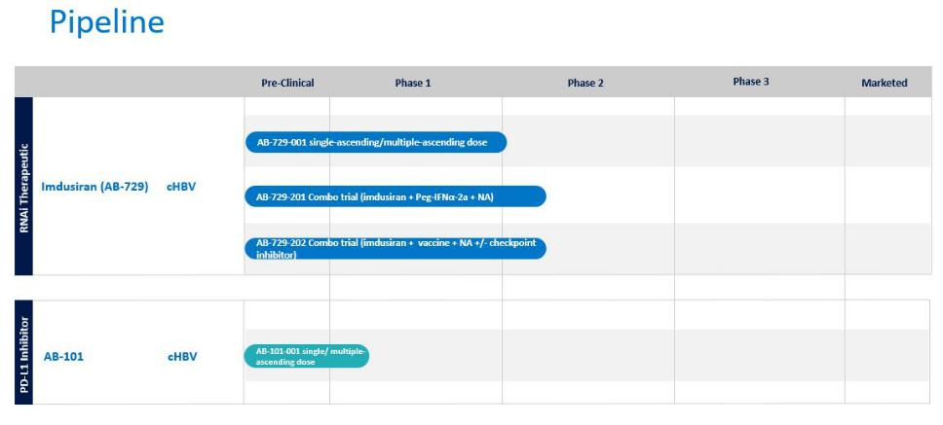

We continue to explore expansion opportunities for our pipeline through internal discovery and development activities and through potential strategic alliances.

RNAi therapeutic (imdusiran, AB-729)

RNAi therapeutics represent a significant advancement in drug development. RNAi therapeutics utilize a natural pathway within cells to silence genes by eliminating the disease-causing proteins that they code for. We are developing RNAi therapeutics that are designed to reduce HBsAg expression and other HBV antigens in people with cHBV infection. Reducing HBsAg is widely believed to be a key prerequisite to enable a patient’s immune system to reawaken and respond against the virus.

Imdusiran (AB-729) is a subcutaneously-delivered single-trigger RNAi therapeutic targeted to hepatocytes using our proprietary covalently conjugated GalNAc delivery technology. Imdusiran reduces all HBV antigens and inhibits viral replication.

Phase 1a/1b single- and multiple-dose clinical trial (AB-729-001)

In this three-part clinical trial, we investigated the safety, tolerability, pharmacokinetics, and pharmacodynamics of single- and multiple-doses of imdusiran in healthy subjects and in cHBV infected patients with the goal of identifying the most appropriate doses and dosing intervals to take forward into Phase 2 clinical development.

Data from Part 3 of the AB-729-001 clinical trial was presented at the 2022 European Association for the Study of the Liver (EASL) International Liver Congress™ (ILC) and showed that repeat dosing of 60mg and 90mg of imdusiran in 41 patients resulted in robust and comparable HBsAg declines in HBeAg positive/negative and HBV DNA positive/negative patients at week 48 (1.89 to 2.15 log₁₀ decline in HBsAg). Fifty percent of the patients (16 out of 32) maintained HBsAg levels below 100 IU/mL 24 weeks after their last dose of imdusiran. Some patients treated with imdusiran experienced an increase in HBV-specific T-cells activation and a decrease in exhausted T-cells. In this trial, imdusiran was generally safe and well-tolerated.

The clinical data for imdusiran continues to support its development as a potential cornerstone agent for a curative treatment regimen for cHBV infection. The efficacy and safety data for imdusiran, derived from up to one year of dosing, supported our view that 60 mg every 8 weeks was an appropriate dose to move forward in our Phase 2a clinical trials. Our strategy is to position imdusiran as a potential cornerstone therapeutic in future HBV combinations with AB-101 or other agents with

10

potentially complementary mechanisms of action. To advance these efforts, we are evaluating imdusiran in Phase 2a proof-of-concept combination clinical trials with other agents with potentially complementary mechanisms as described below.

Phase 2a proof-of-concept clinical trial to evaluate imdusiran in combination with Peg-IFNα-2a (AB-729-201)

We have completed enrollment in a randomized, open label, multicenter Phase 2a proof-of-concept clinical trial investigating the safety and antiviral activity of imdusiran in combination with short courses of Peg-IFNα-2a and ongoing NA therapy in 43 stably NA-suppressed, HBeAg negative, non-cirrhotic patients with cHBV infection. The primary objective of this trial is to initially lower HBsAg levels with imdusiran and then administer Peg-IFNα-2a as an immunomodulator to promote anti-HBV immune reawakening. We believe that if we can lower HBsAg and promote immune reawakening, we may achieve and sustain undetectable HBV DNA and HBsAg levels, potentially leading to a functional cure. After 24-weeks of dosing with imdusiran (60mg every 8 weeks), patients are randomized into one of four arms to receive ongoing Peg-IFNα-2a plus NA therapy for either 12 or 24 weeks, with or without additional doses of imdusiran. After completion of the assigned Peg-IFNα-2a treatment period, all patients will remain on NA therapy for the initial 24-week follow-up period, and will then discontinue NA treatment, provided they meet protocol-defined stopping criteria. Patients who stop NA therapy will enter an intensive follow-up period for 48 weeks.

At the EASL Congress in June 2023, we presented preliminary data from this clinical trial that suggests that the addition of Peg-IFNα-2a to imdusiran treatment was generally safe, well-tolerated and resulted in continued HBsAg declines in some patients. The mean HBsAg decline from baseline during the imdusiran lead-in phase was -1.6 log₁₀ at week 24 of treatment which is comparable to what was previously seen in other clinical trials with imdusiran. Four patients reached HBsAg below the lower limit of quantitation (LLOQ) for at least one timepoint during Peg-IFNα-2a treatment. We expect to provide end-of-treatment data for this clinical trial in the first half of 2024.

Phase 2a proof-of-concept clinical trial to evaluate imdusiran in combination with Barinthus’ VTP-300 (AB-729-202)

Through a clinical collaboration agreement with Barinthus that we entered into in July 2021, we have completed enrollment in AB-729-202, a Phase 2a proof-of-concept clinical trial evaluating the safety, antiviral activity and immunogenicity of Barinthus’ VTP-300, an HBV antigen specific immunotherapy, administered after imdusiran in patients with cHBV infection. The initial trial design enrolled 40 NA-suppressed, HBeAg negative or positive, non-cirrhotic cHBV infected patients. The primary objective of this trial is to initially lower HBsAg levels with imdusiran and then administer VTP-300 as an immunomodulator to promote anti-HBV immune reawakening. We believe that if we can lower HBsAg and promote immune reawakening, we may achieve and sustain undetectable HBV DNA and HBsAg levels, potentially leading to a functional cure. All patients will receive imdusiran (60mg every 8 weeks, 4 doses) plus NA therapy for 24 weeks. After week 24, treatment with imdusiran will stop. Patients will continue only on NA therapy and will be randomized to receive VTP-300 or placebo at week 26 and week 30. At week 48, all patients will be evaluated for eligibility to discontinue NA therapy and will be followed for an additional 24 to 48 weeks.

The preliminary data from this clinical trial were presented at the AASLD Liver Meeting in November 2023 and included a subset of patients that received the two-dose VTP-300 regimen (28/40 patients) and available follow-up data to week 48 (12/40 patients) and showed the following:

- Robust reductions of HBsAg were seen during the imdusiran treatment period (-1.86 log₁₀ mean reduction from baseline after 24 weeks of treatment). This decline in HBsAg is comparable to the declines seen with imdusiran in other clinical trials conducted to date.

- 97% of the imdusiran treated patients (33/34) had HBsAg <100 IU/mL at the time of the first VTP-300/placebo dose. One patient reached <LLOQ with 24 weeks of imdusiran plus NA therapy alone.
- VTP-300 treatment appears to contribute to the maintenance of low HBsAg levels in the early post-treatment period, as the mean HBsAg levels in the placebo group begin to increase starting ~12 weeks after the last dose of imdusiran.
- All VTP-300 treated patients have maintained HBsAg <100 IU/mL through week 48, 60% have maintained HBsAg <10 IU/mL, and all have qualified to stop NA therapy.

- Preliminary immunology data suggests HBV-specific T-cell IFN-γ production is enhanced in patients receiving imdusiran plus VTP-300 compared to placebo.

11

- The preliminary safety data from this trial demonstrate that imdusiran and VTP-300 were both safe and well-tolerated. There were no serious adverse events, Grade 3 or 4 adverse events or treatment discontinuations.

End-of-treatment data from this portion of the clinical trial are expected in the first half of 2024.

Additionally, we amended the AB-729-202 protocol to include another cohort that will receive imdusiran, VTP-300 and low dose nivolumab (Opdivo®), an approved PD-1 inhibitor. In this additional cohort, approximately twenty patients will receive imdusiran (60mg every 8 weeks, 4 doses) plus NA therapy for 24 weeks, followed by administration of VTP-300 plus up to two low doses of nivolumab while remaining on NA therapy. At week 48, all patients will be evaluated for eligibility to discontinue NA therapy, and will be followed for an additional 24 to 48 weeks. Preliminary data from this additional cohort are expected in the second half of 2024.

This clinical trial is being managed by us, subject to oversight by a joint development committee comprised of representatives from both companies. We and Barinthus retain full rights to our respective product candidates and will split all costs associated with the clinical trial. Pursuant to the agreement, the parties may undertake a larger Phase 2b clinical trial depending on the results of the initial Phase 2a clinical trial.

Phase 2a proof-of-concept clinical trial to evaluate imdusiran in combination with durvalumab (AB-729-203)

We intend to initiate an additional Phase 2a clinical trial in the first half of 2024 that will evaluate the safety, tolerability and antiviral activity of intermittent low doses of durvalumab, an approved anti-PD-L1 monoclonal antibody, in combination with imdusiran and ongoing standard-of-care NA therapy in patients with cHBV infection (AB-729-203). Insights gained from this clinical trial and the amended portion of the AB-729-202 clinical trial with nivolumab may inform dosing for our planned Phase 2 clinical trial combining imdusiran and AB-101.

Oral PD-L1 Inhibitor (AB-101)

PD-L1 inhibitors complement our pipeline of agents and could potentially be an important part of a combination therapy for the treatment of HBV by reawakening the immune system. Highly functional HBV-specific T-cells within our immune system are believed to be required for long-term HBV viral resolution. However, HBV-specific T-cells become functionally defective, and greatly reduced in their frequency during cHBV infection. One approach to boost HBV-specific T-cells is to prevent PD-L1 proteins from binding to PD-1 and thus inhibiting the HBV-specific immune function of T-cells. Immune checkpoints such as PD-1/PD-L1 play an important role in the induction and maintenance of immune tolerance and in T-cell activation.

AB-101 is our oral PD-L1 inhibitor candidate that we believe will allow for controlled checkpoint blockade while minimizing the systemic safety issues typically seen with checkpoint antibody therapies. Preclinical data generated thus far indicates that AB-101 mediates activation and reinvigoration of HBV-specific T-cells from cHBV infected patients. In June 2022, we presented a poster at the 2022 EASL ILC highlighting data from a study that was designed to assess the preclinical activity of AB-101 and the compound’s ability to reinvigorate patient HBV-specific T-cells. Studies were conducted using a transgenic MC38 tumor mouse model and peripheral blood mononuclear cells (PBMCs) from cHBV infected patients. The data presented showed that once daily oral administration of AB-101 resulted in profound tumor reduction that was associated with T-cell activation. In addition, AB-101 activates and reinvigorates HBV-specific T-cells in vitro. Additionally, preclinical data in an HBV mouse model were presented at the 2022 AASLD Liver Meeting showing that monotherapy with AB-101 reduced PD-L1 in liver immune cells, confirming liver target engagement of the compound. Combination treatment with AB-101 and an HBV-targeting GalNAc-siRNA agent resulted in activation and increased frequency of HBV-specific T-cells and greater anti-HBsAg antibody production. This favorable preclinical profile supports further development of AB-101 as a therapeutic modality for cHBV infection treatment. We believe AB-101, when used in combination with imdusiran or other approved and investigational agents, could potentially lead to a functional cure in HBV chronically infected patients.

12

In April 2023, we received verbal communication from the FDA that the AB-101 IND application had been placed on clinical hold. For purposes of clarity, the Phase 1 clinical trial had not been initiated and we had not dosed any patients with AB-101. In May 2023, we received the clinical hold letter from the FDA, which raised questions about certain preclinical data and aspects of the clinical trial design. We thus decided to pursue other regulatory pathways outside of the US while evaluating our path forward with the FDA. In July 2023, the New Zealand Medicine Safety Authority (Medsafe) approved our clinical trial application (CTA) for a Phase 1 clinical trial in New Zealand for AB-101, and we believe the protocol approved by Medsafe adequately addresses the clinical trial design and safety monitoring issues raised by the FDA. We included the clinical hold letter from the FDA as part of our CTA application with Medsafe.

Phase 1a/1b clinical trial to evaluate safety, tolerability and PK/PD of AB-101 (AB-101-001)

We are currently dosing healthy subjects in our Phase 1a/1b clinical trial for AB-101 (AB-101-001). The AB-101-001 clinical trial is designed to investigate the safety, tolerability and PK/PD of single and multiple-ascending oral doses of AB-101 for up to 28 days in healthy subjects and patients with cHBV infection. The trial will be conducted in three parts starting with single ascending doses in healthy subjects, followed by multiple ascending doses in healthy subjects and culminating with multiple doses in patients with cHBV infection. Safety and PK/PD assessments will be performed prior to dose escalation in all parts of the clinical trial. We are advancing into Part 2 of this clinical trial which involves multiple-ascending doses of AB-101 in healthy subjects. Preliminary data from healthy subjects in Part 1 of this clinical trial, including target engagement and receptor occupancy data, are expected in the first half of 2024.

Other Collaborations, Royalty Entitlements and Intellectual Property Litigation

Collaboration with Qilu Pharmaceutical Co., Ltd. (Qilu)

In December 2021, we entered into a technology transfer and license agreement (the License Agreement) with Qilu, pursuant to which we granted Qilu a sublicensable, royalty-bearing license, under certain intellectual property owned by us, which is non-exclusive as to development and manufacturing and exclusive with respect to commercialization of imdusiran, including pharmaceutical products that include imdusiran, for the treatment or prevention of hepatitis B in China, Hong Kong, Macau and Taiwan (the Territory).

In partial consideration for the rights granted by us, Qilu paid us a one-time upfront cash payment of $40 million on January 5, 2022 and agreed to pay us milestone payments totaling up to $245 million, net of withholding taxes, upon the achievement of certain technology transfer, development, regulatory and commercialization milestones. Qilu also agreed to pay us double-digit royalties into the low twenties percent based upon annual net sales of imdusiran in the Territory. The royalties are payable on a product-by-product and region-by-region basis, subject to certain limitations.

Qilu is responsible for all costs related to developing, obtaining regulatory approval for, and commercializing imdusiran for the treatment or prevention of hepatitis B in the Territory. Qilu is required to use commercially reasonable efforts to develop, seek regulatory approval for, and commercialize at least one imdusiran product candidate in the Territory. A joint development committee has been established between us and Qilu to coordinate and review the development, manufacturing and commercialization plans. Both parties also have entered into a supply agreement and related quality agreement pursuant to which we will manufacture or have manufactured and supply Qilu with all quantities of imdusiran necessary for Qilu to develop and commercialize in the Territory until we have completed manufacturing technology transfer to Qilu and Qilu has received all approvals required for it or its designated contract manufacturing organization to manufacture imdusiran in the Territory.

Concurrent with the execution of the License Agreement, we entered into a Share Purchase Agreement (the Share Purchase Agreement) with Anchor Life Limited, a company established pursuant to the applicable laws and regulations of Hong Kong and an affiliate of Qilu (the Investor), pursuant to which the Investor purchased 3,579,952 of our common shares at a purchase price of USD $4.19 per share, which was a 15% premium on the thirty-day average closing price of our common shares as of the close of trading on December 10, 2021 (the Share Transaction). We received $15.0 million of gross proceeds from the Share Transaction on January 6, 2022. The common shares sold to the Investor in the Share Transaction represented approximately 2.5% of our common shares outstanding immediately prior to the execution of the Share Purchase Agreement.

13

Alnylam Pharmaceuticals, Inc. (Alnylam) and Acuitas Therapeutics, Inc. (Acuitas)

We have two royalty entitlements to Alnylam’s global net sales of ONPATTRO.

In 2012, we entered into a license agreement with Alnylam that entitles Alnylam to develop and commercialize products with our lipid nanoparticle (LNP) delivery technology. Alnylam’s ONPATTRO, which represents the first approved application of our LNP technology, was approved by the FDA and the European Medicines Agency (EMA) during the third quarter of 2018 and was launched by Alnylam immediately upon approval in the United States. Under the terms of this license agreement, we are entitled to tiered royalty payments on global net sales of ONPATTRO ranging from 1.00% - 2.33% after offsets, with the highest tier applicable to annual net sales above $500 million. This royalty interest was sold to the Ontario Municipal Employees Retirement System (OMERS), effective as of January 1, 2019, for $20 million in gross proceeds before advisory fees. OMERS will retain this entitlement until it has received $30 million in royalties, at which point 100% of this royalty entitlement on future global net sales of ONPATTRO will revert to us. OMERS has assumed the risk of collecting up to $30 million of future royalty payments from Alnylam and we are not obligated to reimburse OMERS if they fail to collect any such future royalties. If this royalty entitlement reverts to us, it has the potential to provide an active royalty stream or to be otherwise monetized again in full or in part. From the inception of the royalty sale through December 31, 2023, an aggregate of $22.7 million of royalties have been collected by OMERS.

We also have rights to a second royalty interest ranging from 0.75% to 1.125% on global net sales of ONPATTRO, with 0.75% applying to sales greater than $500 million, originating from a settlement agreement and subsequent license agreement with Acuitas. This royalty entitlement from Acuitas has been retained by us and was not part of the royalty entitlement sale to OMERS.

Genevant Sciences, Ltd.

In April 2018, we entered into an agreement with Roivant Sciences Ltd. (Roivant), our largest shareholder, to launch Genevant Sciences Ltd. (Genevant), a company focused on a broad range of RNA-based therapeutics enabled by our LNP and ligand conjugate delivery technologies. We licensed rights to our LNP and ligand conjugate delivery platforms to Genevant for RNA-based applications outside of HBV, except to the extent certain rights had already been licensed to other third parties (the Genevant License). We retained all rights to our LNP and conjugate delivery platforms for HBV.

Under the Genevant License, as amended, if a third party sublicensee of intellectual property licensed by Genevant from us commercializes a sublicensed product, we become entitled to receive a specified percentage of certain revenue that may be received by Genevant for such sublicense, including royalties, commercial milestones and other sales-related revenue, or, if less, tiered low single-digit royalties on net sales of the sublicensed product. The specified percentage is 20% in the case of a mere sublicense (i.e., naked sublicense) by Genevant without additional contribution and 14% in the case of a bona fide collaboration with Genevant.

Additionally, if Genevant receives proceeds from an action for infringement by any third parties of our intellectual property licensed to Genevant, we would be entitled to receive, after deduction of litigation costs, 20% of the proceeds received by Genevant or, if less, tiered low single-digit royalties on net sales of the infringing product (inclusive of the proceeds from litigation or settlement, which would be treated as net sales).

In July 2020, Roivant recapitalized Genevant through an equity investment and conversion of previously issued convertible debt securities held by Roivant. We participated in the recapitalization of Genevant with an equity investment of $2.5 million. In connection with the recapitalization, the three parties entered into an Amended and Restated Shareholders Agreement that provides Roivant with substantial control of Genevant. We have a non-voting observer seat on Genevant’s Board of Directors.

As of December 31, 2023, we owned approximately 16% of the common equity of Genevant and the carrying value of our investment in Genevant was zero. Our entitlement to receive future royalties or sublicensing revenue from Genevant was not impacted by the recapitalization.

14

Moderna Inter Partes Review Petition

On February 21, 2018, Moderna Therapeutics, Inc. (Moderna) filed a petition requesting the United States Patent and Trademark Office to institute an Inter Partes Review of Arbutus United States Patent 9,404,127 (the ’127 Patent). In its petition, Moderna sought to invalidate all claims of the patent based on Moderna’s allegation that the claims are anticipated and/or obvious. We filed a response to Moderna’s petition on June 14, 2018. On September 12, 2018, the Patent Trial and Appeal Board (the PTAB) rendered its decision to institute Inter Partes Review of the ‘127 Patent. The ‘127 Patent represents only a fraction of our extensive LNP patent portfolio.

With respect to the ‘127 Patent, the PTAB held all claims as invalid on September 10, 2019, by reason of anticipatory prior art. However this decision was vacated and sent back (remanded) to the PTAB for a rehearing, pending the U.S. Supreme Court’s (Supreme Court) decision whether to grant certiorari in a different case, United States v. Athrex, Inc. (US v. Athrex), the holding of which could impact the findings in the ‘127 Patent matter. The Supreme Court granted certiorari in US v. Athrex on October 13, 2020 (i.e. agreed to review the decision appealed from a lower court). Until the Supreme Court rendered its opinion in US v. Athrex, the ‘127 Patent hearing remained in abeyance, with no decision reached as to the validity of its claims. The Supreme Court decided on the US v. Athrex case on June 21, 2021, following which the Federal Circuit reinstated the appeal sua sponte, requiring the parties to brief how the case should proceed in light of the Supreme Court’s opinion or for the Appellant to waive the challenge. We elected to waive the challenge and proceed with the appeal at the Federal Circuit. The opening brief was filed on October 25, 2021. Moderna’s responsive brief was filed on February 24, 2022 and our reply brief was filed on April 26, 2022. An oral hearing for this matter was held on November 4, 2022. On April 11, 2023, the Federal Circuit rendered its opinion, affirming the PTAB’s finding that all claims of the ‘127 Patent are invalid by reason of anticipation.

Moderna and Merck European Opposition

On April 5, 2018, Moderna and Merck, Sharp & Dohme Corporation (Merck) filed Notices of Opposition to Arbutus’ European patent EP 2279254 (the ’254 Patent) with the European Patent Office (EPO), requesting that the ‘254 Patent be revoked in its entirety for all contracting states. We filed a response to Moderna and Merck’s oppositions on September 3, 2018. A hearing was conducted before the Opposition Division of the EPO on October 10, 2019. At the conclusion of the hearing, the EPO upheld an auxiliary request adopting the amendment, as put forth by us, of certain claims of the ‘254 Patent. In February 2020 Moderna and Merck filed Notices of Appeal challenging the EPO’s grant of the auxiliary request. Merck filed its notice of appeal on February 24, 2020 and Moderna on February 27, 2020. Both Merck and Moderna perfected their appeals by filing Grounds of Appeal on April 30, 2020. We filed our responses to the appeals on September 18, 2020. On March 22, 2022, Moderna filed further written submissions to which we and Genevant responded in August 2022. On April 18, 2023, we and Genevant withdrew our auxiliary request, however, the original (main) request remains in the action. We and Moderna informed the Board of Appeals that we would not object to a remittance of the matter without a hearing to the Opposition Division of the EPO. The hearing in this matter before the Board of Appeals was subsequently cancelled and resubmitted to the Opposition Division (i.e. lower board) of the EPO. On October 31, 2023, the Opposition Division issued a summons for oral proceedings and provided its preliminary and non-binding opinion on the subject matter to be discussed at the hearing. On November 3, 2023, we responded to the summons and on January 15, 2024, Moderna and Merck filed their reply to the written opinion of the Opposition Division, as well as to our written submission of November 3, 2023. We have until April 5, 2024 to respond to Moderna and Merck’s reply. Oral proceedings are presently scheduled to be held on June 6, 2024.

While we are the patent holder, the ‘127 Patent, the ‘254 Patent, the other patents in our LNP portfolio have been licensed to Genevant and are included in the rights licensed by us to Genevant under the Genevant License.

15

Patent Infringement Litigation vs. Moderna

On February 28, 2022, we and Genevant filed a lawsuit in the U.S. District Court for the District of Delaware against Moderna, Inc. and a Moderna affiliate (collectively, Moderna) seeking damages for infringement of U.S. Patent Nos. 8,058,069, 8,492,359, 8,822,668, 9,364,435, 9,504,651, and 11,141,378 in the manufacture and sale of MRNA-1273, Moderna’s vaccine for COVID-19. The patents relate to nucleic acid-lipid particles and lipid vesicles, as well as compositions and methods for their use. The lawsuit does not seek an injunction or otherwise seek to impede the sale, manufacture or distribution of MRNA-1273. However, we seek fair compensation for Moderna’s use of our patented technology that was developed with great effort and at great expense, without which Moderna’s COVID-19 vaccine would not have been successful. On May 6, 2022, Moderna filed a partial motion to dismiss the claims “relating to Moderna’s sale and provision of COVID-19 vaccine doses to the U.S. Government.” On November 2, 2022, the Court issued an Order denying Moderna’s motion. On November 30, 2022, Moderna filed its Answer to the Complaint and Counterclaims. We and Genevant filed our Answer to Moderna’s Counterclaims on December 21, 2022. On February 14, 2023, the U.S. Department of Justice filed a Statement of Interest in the action. On February 16, 2023, the Court held an Initial Pretrial Conference after which it issued an Order, dated February 16, 2023, ordering that within 14 days of the issuance of the Order, the parties and the U.S. Government were to submit letters regarding the impact of the Governments’ Statement of Interest on the scheduling of the matter. On March 10, 2023, the Court reaffirmed its denial of Moderna’s motion to dismiss. On March 16, 2023, the Court held a Rule 16 scheduling conference, and on March 21, 2023, the Court issued a scheduling order in the matter without setting a trial date. On June 9, 2023, the Court granted the parties’ request to extend the time for claim construction briefing. The claim construction hearing was held on February 8, 2024. According to the Court Scheduling Order, which was issued on March 21, 2023, the court is expected to issue its claim construction order within 60 days of conclusion of the claim construction hearing. Expert testimony and depositions will then follow. A trial date has been set for April 21, 2025 and is subject to the Court’s availability.

Patent Infringement Litigation vs. Pfizer and BioNTech

On April 4, 2023, we and Genevant filed a lawsuit in the U.S. District Court for the District of New Jersey against Pfizer Inc. (Pfizer) and BioNTech SE (BioNTech) seeking damages for infringement of U.S. Patent Nos. 9,504,651; 8,492,359; 11,141,378; 11,298,320; and 11,318,098 in the manufacture and sale of any COVID-19 mRNA-LNP vaccines. The patents relate to nucleic acid-lipid particles and their composition, manufacture, delivery and methods of use. The lawsuit does not seek an injunction or otherwise seek to impede the sale, manufacture or distribution of any COVID-19 mRNA-LNP vaccines. However, we seek fair compensation for Pfizer’s and BioNTech’s use of our patented technology that was developed with great effort and at great expense, without which their COVID-19 mRNA-LNP vaccines would not have been successful. On July 10, 2023, Pfizer and BioNTech filed their answer to the complaint, affirmative defenses and counterclaims. We and Genevant filed our answer to these counterclaims on August 14, 2023. A scheduling conference was held on August 28, 2023 and the Court issued a Letter Order on September 7, 2023 setting dates up to but not including the date for a claim construction hearing. Scheduling of the claim construction hearing and subsequent case dates, including the date for trial, will be set at a later time that is yet to be determined. Document and written discovery in the action is ongoing.

Acuitas Declaratory Judgment Lawsuit

On March 18, 2022, Acuitas filed a lawsuit against us and Genevant in the U.S. District Court for the Southern District of New York, asking the court to enter declaratory judgment that Arbutus patent Nos. 8,058,069, 8,492,359, 8,822,668, 9,006,417, 9,364,435, 9,404,127, 9,504,651, 9,518,272, and 11,141,378 do not infringe Pfizer and BioNTech’s COVID-19 vaccine, COMIRNATY, which uses an mRNA lipid provided, under license, by Acuitas. Acuitas also seeks a declaration that each of the listed patents is invalid. On June 24, 2022, we and Genevant sought a pre-motion conference concerning our anticipated motion to dismiss all of Acuitas’ claims due to lack of subject matter jurisdiction. The request for a pre-motion conference was granted, but the case was subsequently re-assigned to a new judge who entered an order directing: (i) Acuitas to inform the court whether it intended to file an amended complaint; (ii) that Acuitas must file any amended complaint by a certain date; and (iii) that if Acuitas did not file an amended complaint, we and Genevant must file our motion to dismiss by a certain date. Acuitas filed its amended complaint on September 6, 2022. On October 4, 2022, we and Genevant filed our motion to dismiss the Acuitas action for lack of subject matter jurisdiction based on the lack of a case or controversy. Acuitas filed its opposition to the motion to dismiss on November 1, 2022, and we and Genevant filed our reply brief on November 16, 2022 at which point the motion was fully briefed. A status conference for the action was set for August 9, 2023, however on August 4, 2023, Acuitas voluntarily dismissed its complaint in the Southern District of New York and refiled a virtually identical complaint in

16

the District Court of New Jersey (D. N.J.) where the Pfizer/BioNTech matter is currently pending, except that the 9,404,127 patent is not at issue in the New Jersey action, and Acuitas also added two additional patents to its New Jersey declaratory judgment action ((U.S. Patent Nos. 11,298,320 and 11,318,098) that were not at issue in its New York action. On September 15, 2023, we and Genevant filed a letter with the Court seeking a premotion conference for a motion to dismiss and subsequently filed our and Genevant’s motion to dismiss on October 13, 2023. Acuitas filed its opposition on November 1, 2023 and we and Genevant filed our reply on November 16, 2023. Acuitas filed a request to commence discovery on November 18, 2023, to which we and Genevant responded on November 20, 2023. A ruling on the motion to dismiss, which is expected to be decided on the papers, has not yet issued. Discovery has not yet commenced in this action.

Potential Additional Payments Related to the Acquisition of Enantigen Therapeutics, Inc.

In October 2014, Arbutus Inc., our wholly-owned subsidiary, acquired all of the outstanding shares of Enantigen Therapeutics, Inc. (Enantigen) pursuant to a stock purchase agreement. The amount paid to Enantigen’s selling shareholders could be up to an additional $102.5 million in sales performance milestones in connection with the sale of the first commercialized product by us for the treatment of HBV, regardless of whether such product is based upon assets acquired under this agreement, and a low single-digit royalty on net sales of such first commercialized HBV product, up to a maximum royalty payment of $1.0 million that, if paid, would be offset against our performance milestone payment obligations.

Patents and Proprietary Rights

Our commercial success depends in part on our ability to obtain and maintain proprietary protection for our product candidates, novel discoveries, product development technologies and other know-how, to operate without infringing on the proprietary rights of others and to prevent others from infringing our proprietary rights. Our policy is to seek to protect our proprietary position by, among other methods, filing or in licensing United States and foreign patents and patent applications related to our proprietary technology, inventions and improvements that are important to the development and implementation of our business. We also rely on trademarks, trade secrets, know how, continuing technological innovation and potential in licensing opportunities to develop and maintain our proprietary position.

In addition to our proprietary expertise, we own a portfolio of patents and patent applications directed to HBV core/capsid protein assembly inhibitors, HBV surface antigens secretion inhibitors, coronavirus main protease inhibitors, LNP inventions, LNP compositions for delivering nucleic acids such as mRNA and RNAi, the formulation and manufacture of LNP-based pharmaceuticals, chemical modification of RNAi molecules, and RNAi drugs and processes directed at particular disease indications. In the United States our patents might be challenged by inter partes review or opposition proceedings. In Europe, upon grant, a period of nine months is allowed for notification of opposition to such granted patents. If our patents are subjected to inter partes review or opposition proceedings, we would incur significant costs to defend them. Further, our failure to prevail in any such proceedings could limit the patent protection available to our therapeutic HBV programs, coronavirus programs or RNAi platform, including our product candidates.

We own more than 55 patent families related to our compounds, formulations, and technology, but we cannot be certain that issued patents will be enforceable or provide adequate protection or that pending patent applications will result in issued patents.

The following table shows the estimated expiration dates, based on filing dates of pending patent applications, in the United States and the European Union for the primary patents for our product candidates currently in clinical trials.

Product candidate | Estimated Patent Expiration in US | Estimated Patent Expiration in EU
Imdusiran | 2038 | 2038
AB-101 | 2042 | 2042

17

Human Capital

Employee Composition

As of December 31, 2023, we had 73 full-time employees, 51 of whom were engaged in research and development, including two medical doctors, 28 individuals with Doctors of Philosophy (PhD) degrees, and another 21 individuals with Master of Science degrees. Our workforce is 50% female and 31% of our employees holding a position of vice president or higher are female. None of our employees are represented by a labor union or covered by a collective bargaining agreement, nor have we experienced any work stoppages. We believe that relations with our employees are good. We supplement our in-house expertise with outsourced capabilities when it would be cost prohibitive to build our own in-house capabilities. For example, we outsource a substantial portion of our clinical trial work to clinical research organizations and a majority of our drug manufacturing is out-sourced to contract manufacturers. Our in-house clinical development and manufacturing teams implement our development strategies and oversee the activities of our outside vendors.

Employee Oversight, Training and Development

We are invested in the professional development of our employees. In order to promote long-term retention and to maximize the potential of our employees, we provide individualized performance management programs. We also offer needs-based supplemental training to our employees. In order to monitor employee satisfaction and as well to identify ways in which employee satisfaction and engagement can be improved, we also survey our employees on a regular basis, reporting the results of the surveys to management and to our board of directors. We continue to score very well on our employee surveys and our voluntary employee turnover remains well under industry average based on market data.

Compensation and Benefits

Drug development is a complex endeavor that requires deep expertise and attracting and retaining qualified employees for specialized biopharmaceutical positions. Our compensation programs are designed to attract and retain top talent. We offer every employee a total compensation package consisting of base salary, cash target bonus targeting the 50th to 75th percentile of market based on company size and industry, a comprehensive benefit package, including medical, dental and vision health care coverage, a 401(k) plan with an employer match, tax-advantaged savings accounts and equity compensation for every employee, which includes stock options and restricted stock units. We also provide eligible employees the opportunity to participate in our employee stock purchase plan and our employee rewards and recognition programs. In addition, we provide our employees with wellness programs and we offer mental health support to our employees and dependents.

Work-life Balance

We aim to ensure our employees maintain a work-life balance by offering 25 paid days of time-off, 12 days of paid holidays, and we shut down in the last week of December. We provide paid parental leave to both birth and adoptive parents. In addition, we allow our employees to have a flexible work schedule and, to the extent possible, depending on the nature of the work, remote and hybrid work arrangements. We believe our focus on total rewards and work-life balance contributed to our having been named one of Philadelphia Business Journal’s Best Places to Work in 2022, a prestigious award that is based on employee survey results.

Environmental, Social and Governance

Environmental

We are a pre-commercial company of less than one hundred employees, engaged in research and development. Manufacturing activities to support these activities is almost entirely outsourced and biohazardous and chemical waste disposal is handled by

18

third party vendors. Although our environmental footprint is subsequently small, we regularly review and evaluate our energy use to identify ways in which we can maximize efficiencies and minimize waste.

Social

The culture at Arbutus reflects our commitment to our employees, to our community, and to making a meaningful contribution to world health. We are active in community outreach and participate in many local charities serving underserved communities in the Philadelphia area, including partnering with Life Sciences Cares Philadelphia.

Safety in the Workplace

We strive to provide a productive and safe working environment for our employees. To protect the health and safety of our employees, we have a Health and Safety Committee, officially certified by the Pennsylvania Department of Labor and Industry - Bureau of Workers Compensation, which is committed to the principles of leadership, responsibility, prevention, and compliance. We follow all recognized Environmental Health and Safety standards and management systems. We have also established an Occupational Health and Safety policy and related standard operating procedures, all of which are used to train our employees in the proper procedures for the workplace. We also solicit employee and contractor recommendations to improve on the safety of our working conditions.

Diversity, Equity and Inclusion

Our commitment to diversity and inclusion is demonstrated by our placement of ultimate responsibility for diversity, equity and inclusion with our board of directors, informed by the recommendations of management and the board’s Nominating and Governance Committee. Our Code of Business Conduct (the Code of Conduct) prohibits discrimination and harassment of any kind, including discrimination or harassment based on age, race, ethnicity, religion, gender, sexual preference and disability. In addition to our anti-harassment and human rights policies, we also require mandatory annual training in unconscious bias and anti-harassment. Some of the diversity and inclusion initiatives at Arbutus include the formation of a Diversity and Inclusion Committee comprised of Arbutus employees and the broadening of the geographical reach of our recruitment efforts. We also celebrate Juneteenth as a corporate holiday.

Our Contribution to World Health

We are dedicated to meaningfully contributing to world health. We are pursuing the mission of finding a functional cure for hepatitis B viral infections, an unmet medical need affecting over 290 million people worldwide.

Governance

As stated in our Code of Conduct, we are committed to complying with all applicable laws, rules and regulations not just in the United States and Canada, but in all the countries in which we operate. In addition to mandating training on our Code of Conduct on an annual basis, we also provide annual training on insider trading, anti-bribery and anti-corruption, among other topics. In addition, we require our suppliers’ agreements to comply with anti-bribery and anti-fraud provisions, and to comply with all applicable laws. All vendors also receive our Code of Conduct at the time of their engagement with us. We comply with all applicable regulations in conducting clinical trials, including FDA ethical regulations, the Declaration of Helsinki and the International Conference on Harmonisation - good Clinical Practices (ICH-GCP).

Competition

We face a broad range of current and potential competitors, from established global pharmaceutical companies with significant resources, to research-stage companies. In addition, we face competition from academic and research institutions and government agencies for the discovery, development and commercialization of novel therapeutics to treat HBV. Many of our competitors, either alone or with their collaborative partners, have significantly greater financial, product development, technical, manufacturing, sales, and marketing resources than we do. In addition, many of our direct competitors are large pharmaceutical companies with internal research and development departments that have significantly greater experience in

19

testing product candidates, obtaining FDA and other regulatory approvals of product candidates, and achieving widespread market acceptance for those products.

As a significant unmet medical need exists for HBV, there are several large and small pharmaceutical companies focused on delivering singular or combinations of therapeutics for the treatment of HBV. These companies include, but are not limited to, GlaxoSmithKline, Roche, Vir Biotechnology, Gilead Sciences, Assembly, Enanta Pharmaceuticals, Aligos Therapeutics, Barinthus, Ascletis Pharma, Inc. and Brii Biosciences Ltd. These companies are developing products such as antisense oligonucleotides, capsid inhibitors, RNAi therapeutics, immune modulators and surface antigen inhibitors. These product candidates are in various stages of preclinical and clinical development. Further, in addition to current investigational therapeutics in development, it is likely that additional drugs will become available in the future for the treatment of HBV.

We anticipate that we will face competition as new products enter the marketplace. Our competitors’ products may be safer, more effective, or more effectively marketed and sold than any product we may commercialize. Competitive singular or combination products may render one or more of our product candidates obsolete or non-competitive before we can recover the expenses of developing and commercializing any of our product candidates. It is also possible that the development of a cure or new treatment methods for HBV could render one or more of our product candidates non-competitive, obsolete, or reduce the demand for our product candidates.

We believe that our ability to compete depends, in part, upon our ability to develop products, successfully complete the clinical trials and regulatory approval processes, and effectively market any approved products. Further, we need to attract and retain qualified personnel, obtain patent protection or otherwise develop proprietary product candidates or processes, and secure sufficient capital resources for the substantial time period between the discovery of lead compounds and their commercial sales, if any.

Manufacturing

We currently rely on third-party manufacturers to supply drug substance and drug products, including imdusiran and AB-101, for our ongoing and anticipated clinical trials and non-clinical studies.

We currently have no plans to establish any large-scale internal manufacturing facilities for our product candidates.

Government Regulation

Regulation by governmental authorities in the United States and in other countries is a significant consideration in our product development, manufacturing and, if our product candidates are approved, marketing strategies. We expect that all our product candidates will require regulatory approval by the FDA and by similar regulatory authorities in foreign countries prior to commercialization and will be subjected to rigorous preclinical, clinical, and post-approval testing to demonstrate safety and effectiveness, as well as other significant regulatory requirements and restrictions in each jurisdiction in which we would seek to market our products. In the United States, we are subject to extensive regulation by the FDA and other federal, state, and local regulatory agencies. United States federal laws, such as the Federal Food, Drug, and Cosmetic Act (FD&C Act), and regulations issued thereunder, govern the testing, development, manufacture, quality control, safety, effectiveness, approval, storage, labeling, record keeping, reporting, distribution, import, export, sale, and marketing of all biopharmaceutical products intended for therapeutic purposes. We believe that we and the third parties that work with us are in compliance in all material respects with currently applicable laws, rules and regulations; however, any failure to comply could have a material negative impact on our ability to successfully develop and commercialize our products, and therefore on our financial performance. In addition, the laws, rules and regulations that apply to our business are subject to change and it is difficult to foresee whether, how, or when such changes may affect our business.

Obtaining governmental approvals to market our product candidates and maintaining ongoing compliance with applicable federal, state, local and foreign statutes and regulations following any such approvals will require the expenditure of significant financial and human resources.

20

Development and Approval

The process to develop and obtain approval for biopharmaceutical products for commercialization in the United States and many other countries is lengthy, complex and expensive, and the outcome is far from certain. Although foreign requirements for conducting clinical trials and obtaining approval may differ in certain respects from those in the United States, there are many similarities and they often are equally rigorous, and the outcome cannot be predicted with confidence. A key component of any submission for approval in any jurisdiction is preclinical and clinical data demonstrating the product candidate’s safety and effectiveness.

Preclinical Testing. Before testing any product candidate in humans in the United States, a company must develop preclinical data, generally including laboratory evaluation of the product candidate’s chemistry and formulation, as well as toxicological and pharmacological studies in animal species to assess safety and quality. Certain types of animal studies must be conducted in compliance with the FDA’s Good Laboratory Practice (GLP) regulations and the Animal Welfare Act, which is enforced by the Department of Agriculture.

IND Application. A person or entity sponsoring clinical trials in the United States to evaluate a product candidate’s safety and effectiveness must submit to the FDA, prior to commencing such trials, an investigational new drug (IND) application, which contains, among other data and information, preclinical testing results and provides a basis for the FDA to conclude that there is an adequate basis for testing the drug in humans. If the FDA does not object to the IND application within 30 days of submission, the clinical testing proposed in the IND may begin. Even after the IND has gone into effect and clinical testing has begun, the FDA may put the clinical trials on “clinical hold,” suspending (or in some cases, ending) them because of safety concerns or for other reasons.

Clinical Trials. Clinical trials involve administering a product candidate to human volunteers or patients under the supervision of a qualified clinical investigator. Clinical trials are subject to extensive regulation. In the United States, this includes compliance with the FDA’s bioresearch monitoring regulations and current good clinical practices (GCP) requirements, which establish standards for conducting, recording data from, and reporting the results of clinical trials, with the goals of assuring that the data and results are credible and accurate and that study participants’ rights, safety and well-being are protected. Each clinical trial must be conducted under a protocol that details, among other things, the study objectives and parameters for monitoring safety and the efficacy criteria, if any, to be evaluated. The protocol is submitted to the FDA as part of the IND and reviewed by the agency. Additionally, each clinical trial must be reviewed, approved and conducted under the auspices of an Institutional Review Board (IRB). The sponsor of a clinical trial, the investigators and IRBs each must comply with requirements and restrictions that govern, among other things, obtaining informed consent from each study subject, complying with the protocol and investigational plan, adequately monitoring the clinical trial, and timely reporting AEs. Foreign studies conducted under an IND must meet the same requirements applicable to studies conducted in the United States. However, if a foreign study is not conducted under an IND, the data may still be submitted to the FDA in support of a product application, if the study was conducted in accordance with GCP and the FDA is able to validate the data.

The sponsor of a clinical trial or the sponsor’s designated responsible party may be required to register certain information about the trial and disclose certain results on government or independent registry websites, such as clinicaltrials.gov.

Clinical testing is typically performed in three phases, which may overlap or be subdivided in some cases.

In Phase 1 trials, the product candidate is administered to a small number of human subjects to assess its safety and to develop detailed profiles of its pharmacological and pharmacokinetic actions (i.e., absorption, distribution, metabolism and excretion), assess the early safety profile, determine side effects associated with increasing doses, and, if possible, gain early evidence of effectiveness. Although Phase 1 trials are typically conducted in healthy human subjects, in some instances (including, for example, with some cancer therapies) the trial subjects are patients with the targeted disease or condition.

In Phase 2 trials, the product candidate is administered to a relatively small sample of the intended patient population to develop initial data regarding efficacy in the targeted disease, determine the optimal dose range, and generate additional information regarding the product candidate’s safety. Additional animal toxicology studies may precede this phase.

21

In Phase 3 trials, the product candidate is administered to a larger group of patients with the target disease or disorder, which may include patients with concomitant diseases and medications. Typically, Phase 3 trials are conducted at multiple study sites and may be conducted concurrently for the sake of time and efficiency. The purpose of Phase 3 clinical trials is to obtain additional information about safety and effectiveness necessary to evaluate the product candidate’s overall risk-benefit profile and to provide a basis for product labeling. Phase 3 data often form the core basis on which the FDA evaluates a product candidate’s safety and effectiveness when considering the product application.

The study sponsor, the FDA or an IRB may suspend or terminate a clinical trial at any time on various grounds, including a determination that study subjects are being exposed to an unacceptable health risk. Success in early-stage clinical trials does not assure success in later-stage clinical trials. Moreover, data from clinical trials are not always conclusive and may be subject to alternative interpretations that could delay, limit or prevent approval.

When a clinical trial is carried out in the European Union, the Clinical Trials Regulation (CTR) provides the regulatory framework. On January 31, 2022, this CTR repealed the Clinical Trials Directive (CTD) and national implementing legislation in the European Union Member States. From January 31, 2025, all trials approved under the old CTD that continue running after this date, will need to comply with the new CTR. Until January 30, 2023, clinical trial sponsors could choose whether to start a new clinical trial under the CTD or under the new CTR. However, from January 31, 2023 onwards, new clinical trials would automatically fall under the scope of the new CTR. The main characteristics of the CTR include: a streamlined application procedure to the EMA through a single entry point, the “Clinical Trials Information System” enabling sponsors to apply for clinical trial authorization in up to 30 European countries; a single set of documents to be prepared and submitted for the application as well as simplified reporting procedures for clinical trial sponsors; and a harmonized procedure for the assessment of applications for clinical trials.

NDA Submission and Review. After completing the clinical studies, a sponsor seeking approval to market a product candidate in the United States submits to the FDA a New Drug Application (NDA). The NDA is a comprehensive application intended to demonstrate the product candidate’s safety and effectiveness and includes, among other things, preclinical and clinical data, information about the product candidate’s composition, the sponsor’s plans for manufacturing and packaging and proposed labeling. When an NDA is submitted, the FDA makes an initial determination as to whether the application is sufficiently complete to be accepted for review. If the application is not, the FDA may refuse to accept the NDA for filing and request additional information. A refusal to file, which requires resubmission of the NDA with the requested additional information, delays review of the application.

FDA performance goals generally provide for action on an NDA within 10 months of the 60-day filing date, or within 12 months of the NDA submission. That deadline can be extended under certain circumstances, including by the FDA’s requests for additional information. The targeted action date can also be shortened to 6 months of the 60-day filing date, or 8 months after NDA submission for product candidates that are granted priority review designation because they are intended to treat serious or life-threatening conditions and demonstrate the potential to address unmet medical needs. The FDA has other programs to expedite development and review of product candidates that address serious or life-threatening conditions. For example, the Fast Track program is intended to facilitate the development and review of new drugs that demonstrate the potential to address unmet medical needs involving serious or life-threatening diseases or conditions. If a product candidate receives Fast Track designation, the FDA may review sections of the NDA on a rolling basis, rather than requiring the entire application to be submitted to begin the review. Product candidates with Fast Track designation also may be eligible for more frequent meetings and correspondence with the FDA about the product candidate’s development. Another FDA program intended to expedite development is the Accelerated Approval pathway, which allows approval on the basis of a surrogate endpoint that is reasonably likely to predict clinical benefit or on an intermediate clinical endpoint. To qualify for review under the Accelerated Approval pathway, a product candidate must treat a serious condition, provide a meaningful advantage over available therapies, and demonstrate an effect on a surrogate endpoint that is reasonably likely to predict clinical benefit or on an intermediate clinical endpoint. On December 29, 2022, Congress enacted the Consolidated Appropriations

Act of 2023, which included several changes to the Accelerated Approval pathway within the Food and Drug Omnibus Reform Act (FDORA). Under FDORA, the FDA must specify the conditions for any post-approval studies before granting an Accelerated Approval. FDORA gives the agency significant flexibility in setting forth such conditions, which may include enrollment targets, study protocol and milestones—including the target date of study completion. The FDA may also require, as appropriate, that certain post-approval studies be underway prior to Accelerated Approval or within a specified time from the

22

date of approval. Accelerated Approval sponsors are required to report progress every six months on required post-approval trials. Breakthrough Therapy designation, which is available for product candidates under development for serious or life-threatening conditions and where preliminary clinical evidence shows that the product candidate may have substantial improvement on at least one clinically significant endpoint over available therapies, means that a product candidate will be eligible for all of the benefits of Fast Track designation, as well as more intensive guidance from the FDA on an efficient drug development program and a commitment from the agency to involve senior FDA managers in such guidance. Even if a product candidate qualifies for Fast Track designation or Breakthrough Therapy designation, the FDA may later decide that the product no longer meets the conditions for designation and may rescind the designation, and/or may determine that the product does not meet the standards for approval. As applicable, we anticipate seeking to utilize these programs to expedite the development and review of our product candidates, but we cannot ensure that our product candidates will qualify for such programs, or that we will be able to maintain such designations if we qualify for such programs.

The FDA reviews applications to determine, among other things, whether a product is safe and effective for its intended use and whether the manufacturing controls are adequate to assure and preserve the product’s identity, strength, quality, and purity. For some NDAs, the FDA may convene an advisory committee to seek insights and recommendations on issues relevant to approval of the application. Although the FDA is not bound by the recommendation of an advisory committee, the agency considers such recommendations carefully when making decisions. Before approving a new drug product, the FDA also requires that the facilities at which the product will be manufactured or advanced through the supply chain be in compliance with current good manufacturing practices (GMP) requirements and regulations governing, among other things, the manufacture, shipment, and storage of the product. The FDA also can conduct audits to determine if the clinical trials were conducted in compliance with GCP. After review of an NDA, the FDA may grant marketing approval, request additional information, or issue a complete response letter (CRL) communicating the reasons for the agency’s decision not to approve the application. The CRL may request additional information, including additional preclinical or clinical data, for the FDA to reconsider the application. An NDA may be resubmitted with the deficiencies addressed, but resubmission does not guarantee approval. Data from clinical trials are not always conclusive, and the FDA’s interpretation of data may differ from the sponsor’s. Obtaining approval can take years, requires substantial resources and depends on a number of factors, including the severity of the targeted disease or condition, the availability of alternative treatments, and the risks and benefits demonstrated in clinical trials. Additionally, as a condition of approval, the FDA may impose restrictions that could affect the commercial prospects of a product and increase our costs, such as a Risk Evaluation and Mitigation Strategy (REMS), and/or post-approval commitments to conduct additional clinical trials or non-clinical studies or to conduct surveillance programs to monitor the product’s effects. Under the Pediatric Research Equity Act (PREA), certain applications for approval must also include an assessment, generally based on clinical study data, of the safety and effectiveness of the subject product in relevant pediatric populations, unless a waiver or deferral is granted.

Moreover, once a product is approved, information about its safety or effectiveness from broader clinical use may limit or prevent successful commercialization because of regulatory action, market forces or for other reasons. Post-approval modifications to a drug product, such as changes in indications, labeling or manufacturing processes or facilities, may require development and submission of additional information or data in a new or supplemental NDA, which would also require prior FDA approval.

Competition. The Drug Price Competition and Patent Term Restoration Act of 1984 (the Hatch-Waxman Act) establishes two abbreviated approval pathways for product candidates that are in some way follow-on versions of already approved branded NDA products: (i) generic versions of the approved reference listed drug (RLD), which may be approved under an abbreviated new drug application (ANDA) by showing that the generic product is the “same as” the approved product in key respects; and (ii) a product that is similar but not identical to a listed drug, which may be approved under a 505(b)(2) NDA, in which the sponsor relies to some degree on information from investigations that were not conducted by or for the applicant and for which the applicant has not obtained a right of reference, and submits its own product-specific data to support the differences between the product and the listed drug.

The sponsor of an ANDA or 505(b)(2) application seeking to rely on an approved product as the RLD or listed drug must make one of several certifications regarding each patent for the RLD that is listed in the FDA publication, Approved Drug Products with Therapeutic Equivalence Evaluations, which is referred to as the Orange Book. A “Paragraph I” certification is the sponsor’s statement that patent information has not been filed for the RLD. A “Paragraph II” certification is the sponsor’s

23

statement that the RLD’s patents have expired. A “Paragraph III” certification is the sponsor’s statement that it will wait for the patent to expire before obtaining approval for its product. A “Paragraph IV” certification is an assertion that the patent does not block approval of the later product, either because the patent is invalid or unenforceable or because the patent, even if valid, is not infringed by the new product. Once the FDA accepts for filing an ANDA or 505(b)(2) application containing a Paragraph IV certification, the applicant must within 20 days provide notice to the RLD or listed drug NDA holder and patent owner that the application has been submitted and provide the factual and legal basis for the applicant’s assertion that the patent is invalid or not infringed. If the NDA holder or patent owner files suit against the ANDA or 505(b)(2) applicant for patent infringement within 45 days of receiving the Paragraph IV notice, the FDA is prohibited from approving the ANDA or 505(b)(2) application for a period of 30 months or the resolution of the underlying suit, whichever is earlier.

Exclusivity and Patent Protection. In the United States and elsewhere, certain regulatory exclusivities and patent rights can provide an approved drug product with protection from certain competitors’ products for a period of time and within a certain scope. In the United States, those protections include regulatory exclusivity under the Hatch-Waxman Act, which provides periods of exclusivity for a branded drug product that would serve as an RLD for a generic drug applicant filing and an ANDA under section 505(j) of the FD&C Act or as a listed drug for an applicant filing an NDA under section 505(b)(2) of the FD&C Act. If such a product is a “new chemical entity” (NCE) generally meaning that the active moiety has never before been approved in any drug, there is a period of five years from the product’s approval during which the FDA may not accept for filing any ANDA or 505(b)(2) application for a drug with the same active moiety. An ANDA or 505(b)(2) application may be submitted after four years, however, if the sponsor of the application makes a Paragraph IV certification (as described above). Such a product that is not an NCE may qualify for a three-year period of exclusivity if its NDA contains new clinical data (other than bioavailability studies), derived from studies conducted by or for the sponsor, that were necessary for approval. In this instance, the three-year exclusivity period does not preclude filing or review of an ANDA or 505(b)(2) application; rather, the FDA is precluded from granting final approval to the ANDA or 505(b)(2) application until three years after approval of the RLD. This three-year exclusivity applies only to the conditions of approval that required submission of the clinical data.

The Hatch-Waxman Act also provides for the restoration of a portion of the patent term lost during product development and FDA review of an NDA if approval of the application is the first permitted commercial marketing of a drug containing the active ingredient. The patent term restoration period is generally one-half the time between the effective date of the IND or the date of patent grant (whichever is later) and the date of submission of the NDA, plus the time between the date of submission of the NDA and the date of FDA approval of the product. The maximum period of restoration is five years, and the patent cannot be extended to more than 14 years from the date of FDA approval of the product. Only one patent claiming each approved product is eligible for restoration and the patent holder must apply for restoration within 60 days of approval. The USPTO, in consultation with the FDA, reviews and approves the application for patent term restoration.

In the European Union, new medicinal products are granted a protection period of eight years of data exclusivity and an additional two years of market exclusivity. As such, for a period of eight years, generics cannot use the data of the innovator to obtain a marketing authorization. Only after eight years have lapsed, other parties that apply for a marketing authorization (generics or biosimilars) may make reference to the dossier of the originator product. Only after another two years (i.e., a total of ten years) may a generic or biosimilar medicinal product be placed on the market.

In April 2023, the European Commission published a proposal to reform this system. In this proposal, the current standard period of regulatory data protection will be reduced from eight years to six years. The legislative process for this reform is expected to take several years. It is currently uncertain if the proposal will be adopted in its current form, and it is uncertain if and when the revised legislation would enter into force.

Emergency Use Authorization (EUA). The Secretary of Health and Human Services may authorize unapproved medical products to be marketed in the context of an actual or potential emergency that has been designated by the U.S. government. The COVID-19 pandemic has been designated as such a national emergency. After an emergency has been announced, the Secretary of Health and Human Services may authorize the issuance of and the FDA Commissioner may issue EUAs for the use of specific products based on criteria established by the FDCA, including that the product at issue may be effective in diagnosing, treating, or preventing serious or life-threatening diseases when there are no adequate, approved, and available alternatives. Although the criteria of an EUA differ from the criteria for approval of an NDA, EUAs nevertheless require the development and submission of data to satisfy the relevant FDA standards, and a number of ongoing compliance obligations.

24

The FDA expects EUA holders to work toward submission of full applications, such as an NDA, as soon as possible. An EUA is also subject to additional conditions and restrictions and is product-specific. An EUA terminates when the emergency determination underlying the EUA terminates. An EUA is not a long-term alternative to obtaining FDA approval, licensure, or clearance for a product. The FDA may revoke an EUA for a variety of reasons, including where it is determined that the underlying health emergency no longer exists or warrants such authorization, so it is not possible to predict how long an EUA may remain in place.

Post-Approval Regulation

Once approved, drug products are subject to continuing extensive regulation by the FDA, including ongoing monitoring for safety information, maintaining appropriate registrations and licenses, and hosting periodic inspections. If ongoing regulatory requirements are not met, or if safety problems occur after a product reaches market, the FDA may take actions to change the conditions under which the product is marketed, such as requiring labeling modifications, restricting distribution, or even withdrawing approval. In addition to FDA regulation, our business is also subject to extensive federal, state, local and foreign regulation.

Good Manufacturing Practices. Companies engaged in manufacturing drug products or their components must comply with applicable GMP requirements, which include requirements regarding organization and training of personnel, building and facilities, equipment, control of components and drug product containers, closures, production and process controls, packaging and labeling controls, holding and distribution, laboratory controls and records and reports. The FDA inspects equipment, facilities and manufacturing processes before approval and conducts periodic re-inspections after approval. If, after receiving approval, a company makes a material change in manufacturing equipment, location, or process (all of which are, to some degree, incorporated in the NDA), additional regulatory review and approval may be required. Failure to comply with applicable GMP requirements or the conditions of the product’s approval may lead the FDA to take enforcement actions, such as issuing a warning letter, or to seek sanctions, including fines, civil penalties, injunctions, suspension of manufacturing operations, imposition of operating restrictions, withdrawal of FDA approval, seizure or recall of products, and criminal prosecution. Although we periodically monitor FDA compliance of the third parties on which we rely for manufacturing our product candidates, we cannot be certain that our present or future third-party manufacturers will consistently comply with GMP or other applicable FDA regulatory requirements.

Sales and Marketing. Once a product is approved, the advertising, promotion and marketing of the product will be subject to close regulation, including with regard to promotion to healthcare practitioners, direct-to-consumer advertising, communications regarding unapproved uses, industry-sponsored scientific and educational activities and promotional activities involving the internet. In addition to FDA restrictions on marketing of pharmaceutical products, state and federal fraud and abuse laws have been applied to restrict certain marketing practices in the pharmaceutical industry. Failure to comply with applicable requirements in this area may subject a company to adverse publicity, investigations and enforcement action by the FDA, the Department of Justice, the Office of the Inspector General of the Department of Health and Human Services, and/or state authorities. This could subject a company to a range of penalties that could have a significant commercial impact, including civil and criminal fines and agreements that materially restrict the manner in which a company promotes or distributes drug products.

New Legislation. New legislation is passed periodically in Congress, or at the state level, that could significantly change the statutory provisions governing the approval, manufacturing and marketing of products regulated by the FDA. Further, the FDA revises its regulations and guidance in light of new legislation in ways that may affect our business or product candidates. It is impossible to predict whether other changes to legislation, regulation, or guidance will be enacted, or what the impact of such changes, if any, may be.

However, an important and foreseeable example of new legislation is the forthcoming European Union pharmaceutical legislation revision. The European Commission presented a legislative proposal in April 2023 that would change European Union pharmaceutical law with respect to for example regulatory data exclusivity, environmental risk assessment, medicines shortages and other topics. The legislative process for this reform is expected to take several years. It is currently uncertain if the proposal will be adopted in its current form, and it is uncertain if and when the revised legislation would enter into force.

25

Other Requirements. Companies that manufacture or distribute drug products pursuant to approved NDAs must meet numerous other regulatory requirements, including adverse event reporting, submission of periodic reports, and record-keeping obligations.

Fraud and Abuse Laws. At such time as we market, sell and distribute any products for which we obtain marketing approval, it is possible that our business activities could be subject to scrutiny and enforcement under one or more federal or state health care fraud and abuse laws and regulations, which may constrain the business or financial arrangements and relationships through which we market, sell and distribute any products for which we obtain marketing approval. These restrictions under applicable federal and state health care fraud and abuse laws and regulations that may affect our ability to operate include:

- The U.S. federal Anti-Kickback Law, which prohibits, among other things, knowingly or willingly offering, paying, soliciting or receiving remuneration, directly or indirectly, in cash or in kind, to induce or reward the purchasing, leasing, ordering or arranging for or recommending the purchase, lease or order of any health care items or service for which payment may be made, in whole or in part, by federal healthcare programs such as Medicare and Medicaid. This statute has been interpreted to apply to arrangements between pharmaceutical companies on one hand and prescribers, purchasers and formulary managers on the other. Liability may be established under the U.S. federal Anti-Kickback Law without proving actual knowledge of the statute or specific intent to violate it. In addition, the government may assert that a claim including items or services resulting from a violation of the U.S. federal Anti-Kickback Law constitutes a false or fraudulent claim for purposes of the U.S. federal civil False Claims Act. Although there are a number of statutory exemptions and regulatory safe harbors to the U.S. federal Anti-Kickback Law protecting certain common business arrangements and activities from prosecution or regulatory sanctions, the exemptions and safe harbors are drawn narrowly, and practices that do not fit squarely within an exemption or safe harbor, or for which no exception or safe harbor is available, may be subject to scrutiny.

- The U.S. federal civil False Claims Act, which prohibits, among other things, individuals or entities from knowingly presenting, or causing to be presented, a false or fraudulent claim for payment of government funds or knowingly making, using or causing to be made or used, a false record or statement material to an obligation to pay money to the government or knowingly concealing or knowingly and improperly avoiding, decreasing or concealing an obligation to pay money to the federal government. Actions under the False Claims Act may be brought by the United States Attorney General or as a qui tam action by a private individual (a whistleblower) in the name of the government and the individual, and the whistleblower may share in any monetary recovery. Many pharmaceutical and other healthcare companies have been investigated and have reached substantial financial settlements with the federal government under the civil False Claims Act for a variety of alleged improper marketing activities, including: providing free product to customers with the expectation that the customers would bill federal programs for the product; providing sham consulting fees, grants, free travel and other benefits to physicians to induce them to prescribe the company’s products; and inflating prices reported to private price publication services, which are used to set drug payment rates under government healthcare programs. In addition, in recent years the government has pursued civil False Claims Act cases against a number of pharmaceutical companies for causing false claims to be submitted as a result of the marketing of their products for unapproved, and thus non-reimbursable, uses. Because of the threat of treble damages and mandatory penalties per false or fraudulent claim or statement, healthcare and pharmaceutical companies often resolve allegations without admissions of liability for significant and material amounts. Pharmaceutical and other healthcare companies also are subject to other federal false claim laws, including, among others, federal criminal healthcare fraud and false statement statutes that extend to non-government health benefit programs.

- The fraud provisions of the Health Insurance Portability and Accountability Act of 1996 (HIPAA), which impose criminal liability for knowingly and willfully executing a scheme to defraud any healthcare benefit program, including private third-party payors, and prohibit knowingly and willfully falsifying, concealing or covering up a material fact or making any materially false, fictitious or fraudulent statement or representation, or making or using any false writing or document knowing the same to contain any materially false fictitious or fraudulent statement or entry, in connection with the delivery of or payment for healthcare benefits, items or services.

- Analogous state and local laws and regulations, such as state anti-kickback and false claims laws, which may apply to sales or marketing arrangements and claims involving healthcare items or services reimbursed by non-governmental third-party payors, including private insurers; state and foreign laws that require pharmaceutical companies to comply

26

with the pharmaceutical industry’s voluntary compliance guidelines and the relevant compliance guidance promulgated by the federal government or otherwise restrict payments that may be made to healthcare providers; state laws that restrict the ability of manufacturers to offer co-pay support to patients for certain prescription drugs; and state and foreign laws that require drug manufacturers to report information related to clinical trials, or information related to payments and other transfers of value to physicians and other healthcare providers or marketing expenditures; state laws and local ordinances that require identification or licensing of sales representatives.

- The U.S. federal Physician Payment Sunshine Act, being implemented as the Open Payments Program, which requires manufacturers of drugs, devices, biologics, and medical supplies for which payment is available under Medicare, Medicaid or the Children’s Health Insurance Program (with certain exceptions) to report annually to the Centers for Medicare and Medicaid Services (CMS) information related to direct or indirect payments and other transfers of value to physicians, physician assistants, nurse practitioners, clinical nurse specialists, certified nurse anesthetists, certified nurse-midwives, and teaching hospitals, as well as ownership and investment interests held in the company by physicians and their immediate family members.

- The federal Foreign Corrupt Practices Act of 1997 and other similar anti-bribery laws in other jurisdictions generally prohibit companies and their intermediaries from providing money or anything of value to officials of foreign governments, foreign political parties or international organizations with the intent to obtain or retain business or seek a business advantage. Recently, there has been a substantial increase in anti-bribery law enforcement activity by United States regulators, with more frequent and aggressive investigations and enforcement proceedings by both the Department of Justice and the United States Securities and Exchange Commission (the SEC). Violations of United States or foreign laws or regulations could result in the imposition of substantial fines, interruptions of business, loss of supplier, vendor or other third-party relationships, termination of necessary licenses and permits and other legal or equitable sanctions. Other internal or government investigations or legal or regulatory proceedings, including lawsuits brought by private litigants, may also follow as a consequence.

Violations of any of the laws described above or any other governmental regulations are punishable by significant civil, criminal and administrative penalties, damages, imprisonment, fines and exclusion from government-funded healthcare programs, such as Medicare and Medicaid. Although compliance programs can mitigate the risk of investigation and prosecution for violations of these laws, the risks cannot be entirely eliminated. Moreover, achieving and sustaining compliance with applicable federal and state privacy, security and fraud laws may prove costly.

Privacy Laws. We are also subject to federal, state and foreign laws and regulations governing data privacy, the security of personal information, including health information, and the collection, use and disclosure, and protection of health-related and other personal information. The legislative and regulatory landscape for privacy and data protection continues to evolve, and there has been an increasing focus on privacy and data protection issues that may affect our business, including recently enacted laws in all jurisdictions where we operate. Numerous federal and state laws, including state security breach notification laws, state health information privacy laws, state genetic privacy laws, and federal and state consumer protection and privacy laws, (including, for example, Section 5 of the Federal Trade Commission Act (FTC Act), and the California Consumer Privacy Act (CCPA)) govern the collection, use and disclosure of personal information. These laws may differ from each other in significant ways, thus complicating compliance efforts. Federal regulators, state attorneys general, and plaintiffs’ attorneys have been and will likely continue to be active in this space. Activities outside of the U.S. implicate local and national data protection standards, impose additional compliance requirements and generate additional risks of enforcement for non-compliance. The European Union’s General Data Protection Regulation, including as implemented in the United Kingdom, (collectively, GDPR) and other data protection, privacy and similar national, state/provincial and local laws may restrict the access, use, storage, disclosure and other processing activities concerning patient health information abroad. Compliance efforts will likely be an increasing and substantial cost in the future.

Failure to comply with such laws and regulations could result in government enforcement actions and create liability for us (including the imposition of significant penalties), private litigation and/or adverse publicity that could negatively affect our business. In addition, if we successfully commercialize our product candidates, we may obtain patient health information from healthcare providers that prescribe our products and research institutions we collaborate with, and they are subject to privacy and security requirements under HIPAA. Although we are not directly subject to HIPAA other than potentially with respect to providing certain employee benefits, we could potentially be subject to criminal penalties if we, or our affiliates or our agents

27

knowingly receive individually identifiable health information maintained by a HIPAA-covered entity in a manner that is not authorized or permitted by HIPAA.

The Federal Trade Commission (FTC) also sets expectations for failing to take appropriate steps to keep consumers’ personal information secure, or failing to provide a level of security commensurate to promises made to individual about the security of their personal information (such as in a privacy notice), which may constitute unfair or deceptive acts or practices in violation of Section 5(a) of the FTC Act. The FTC expects a company’s data security measures to be reasonable and appropriate in light of the sensitivity and volume of consumer information it holds, the size and complexity of its business, and the cost of available tools to improve security and reduce vulnerabilities. Individually identifiable health information is considered sensitive data that merits stronger safeguards. With respect to privacy, the FTC also sets expectations for failing to honor the privacy promises made to individuals about how the company handles consumers’ personal

information; such failure may also constitute unfair or deceptive acts or practices in violation of the FTC Act. Enforcement by the FTC under the FTC Act can result in civil penalties or enforcement actions.

In California, the CCPA establishes certain requirements for data use and sharing transparency and provides California residents certain rights concerning the use, disclosure, and retention of their

personal information. The CCPA and its implementing regulations have already been amended multiple times since their enactment. In November 2020, California voters approved the California Privacy Rights Act (CPRA) ballot initiative which introduced significant amendments to the CCPA and established and funded a dedicated California privacy regulator, the California Privacy

Protection Agency (CPPA). The amendments introduced by the CPRA went into effect on January 1, 2023, and implementing regulations continue to be introduced by the CPPA. Failure to comply with the CCPA may result in, among other things, significant civil penalties and injunctive relief, or statutory or actual damages. In addition, California residents have the right to bring a private right of action in connection with certain types of incidents. These claims may result in significant liability and damages. Other states, including Virginia, Colorado, Utah, Indiana, Iowa, Tennessee, Montana, Texas and Connecticut have enacted privacy laws similar to the CCPA that impose new obligations or limitations in areas affecting our business and we continue to assess the impact of these state legislations on our business as additional information and guidance becomes available. Similarly, there are a number of legislative proposals in the United States, at both the federal and state level, that could impose new obligations or limitations in areas affecting our business. These laws and regulations are evolving and subject to interpretation, and may impose limitations on our activities or otherwise adversely affect our business.

Activities outside of the U.S. implicate local and national data protection standards, impose additional compliance requirements and generate additional risks of enforcement for non-compliance. The European Union’s/United Kingdom’s GDPR and other data protection, privacy and similar national, state/provincial and local laws may also restrict the access, use, storage, disclosure and other processing activities concerning patient health information abroad. We may be required to expend significant capital and other resources to ensure ongoing compliance with applicable privacy, data protection and cybersecurity laws, to protect against security breaches and hackers, or to alleviate problems caused by such breaches. Compliance with these laws is difficult, constantly evolving, time consuming, and requires a flexible privacy framework and substantial resources. Compliance efforts will likely be an increasing and substantial cost in the future. There are also a number of legislative proposals in the European Union, the United States, at both the federal and state level, and other jurisdictions that could impose new obligations or limitations in areas affecting our business. In addition, some countries are considering or have passed legislation implementing data protection requirements such as local storage and processing of data or similar requirements that could increase the cost and complexity of delivering our services and research activities. These laws and regulations, as well as any associated claims, inquiries, or investigations or any other government actions may lead to unfavorable outcomes including increased compliance costs, delays or impediments in the development of new products, negative publicity, increased operating costs, diversion of management time and attention, and remedies that harm our business, including fines or demands or orders that we modify or cease existing business practices. The GDPR imposes significant fines and other administrative penalties to which we could be subject in the event of any non-compliance, including fines of up to EUR 10,000,000 or up to 2% of our total worldwide annual turnover for certain comparatively minor offenses, or up to EUR 20,000,000 or up to 4% of our total worldwide annual turnover for more serious offenses. The GDPR also confers a private right of action on data subjects and consumer associations to lodge complaints with data protection authorities, seek judicial remedies, and obtain compensation for damages resulting from violations of the GDPR.

28

With regard to the transfer of personal data, the GDPR restricts the ability of companies to transfer personal data from the European Economic Area to the United States and other countries, which may adversely affect our ability to transfer personal data or otherwise may cause us to incur significant costsfor implementing lawful transfer mechanisms, conducting data transfer impact assessments, and implementing additional measures where necessary to ensure that personal data transferred are adequately protected in a manner essentially equivalent to the EU. The GDPR provides different transfer mechanisms we can use to lawfully transfer personal data from the EU to countries outside the EU. An example is relying on adequacy decisions of the European Commission, such as the EU-U.S. Data Privacy Framework which was adopted by the European Commission in July 2023. The adequacy decision concludes that the U.S. ensures an adequate level of protection (compared to that of the EU) for personal data transferred from the EU to U.S. companies participating in the EU-U.S. Data Privacy Framework. The adequacy decisions of the European Commission are subject to periodic reviews and may be amended or withdrawn. Another example of a lawful transfer mechanism is using the EU Standard Contractual Clauses as approved by the European Commission in June 2021, which are the most common used transfer mechanism used to transfer personal data out of the EU. In order to use the EU Standard Contractual Clauses mechanism, the exporter and the importer must ensure that the importer may guarantee a level of personal data protection in the importing country’s level of protection must be adequate that is essentially equivalent to that of the European Economic Area. Compliance with EU data transfer obligations involves conducting transfer impact assessments, which includes documenting detailed

analyses of data access and protection laws in the countries in which data importers are located, which can be costly and time-consuming. Data importers must also expend resources in analyzing their ability to comply with transfer obligations, including implementing new safeguards and controls to further protect personal data After the European Court of Justice’s ruling in July 2020, companies may no longer rely on the EU-U.S. Privacy Shield Framework as a basis to transfer personal data from the European Union to the United States, but U.S.-based companies may rely on other authorized means and procedures to transfer personal data provided by the GDPR.

Coverage and Reimbursement

Significant uncertainty exists as to the coverage and reimbursement status of any product candidates for which we may obtain regulatory approval. The regulations that govern marketing approvals, pricing and reimbursement for new drug products vary widely from country to country. Current and future legislation may significantly change the approval requirements in ways that could involve additional costs and cause delays in obtaining approvals. Some countries require approval of the sale price of a drug before it can be marketed. In many countries, the pricing review period begins after marketing or product licensing approval is granted. In some foreign markets, prescription pharmaceutical pricing remains subject to continuing governmental control even after initial approval is granted. As a result, we might obtain marketing approval for a product in a particular country, but then be subject to price regulations that delay our commercial launch of the product, possibly for lengthy time periods, which could negatively impact the revenues we are able to generate from the sale of the product in that particular country. Adverse pricing limitations may hinder our ability to recoup our investment in one or more product candidates even if our product candidates obtain marketing approval.

Our ability to commercialize any products successfully also will depend in part on the extent to which coverage and adequate reimbursement for these products and related treatments will be available in a timely manner from third-party payors, including government healthcare programs such as Medicare and Medicaid, commercial health insurers and managed care organizations. Government authorities and other third-party payors, such as private health insurers and health maintenance organizations, determine which medications they will cover and establish reimbursement levels. Third-party payors may limit coverage to specific products on an approved list, or formulary, which may not include all of the FDA-approved products for a particular indication. The process for determining whether a payor will provide coverage for a product may be separate from the process for setting the price or reimbursement rate that the payor will pay for the product once coverage is approved.

A primary trend in the United States healthcare industry and elsewhere is cost containment. Government healthcare programs and other third-party payors are increasingly challenging the prices charged for medical products and services and examining the medical necessity and cost-effectiveness of medical products and services, in addition to their safety and efficacy, and have attempted to control costs by limiting coverage and the amount of reimbursement for particular medications. Increasingly, third-party payors are requiring that drug companies provide them with predetermined discounts from list prices and are challenging the prices charged for medical products. We cannot be sure that coverage and reimbursement will be available promptly or at all for any product that we commercialize and, if reimbursement is available, what the level of reimbursement will be. Moreover, eligibility for coverage and reimbursement does not imply that any drug will be paid for in all cases. Limited coverage may impact the demand for, or the price of, any product candidate for which we obtain marketing approval.

29

If coverage and reimbursement are not available or reimbursement is available only to limited levels, we may not successfully commercialize any product candidate for which we obtain marketing approval.

Obtaining coverage and adequate reimbursement is a time-consuming and costly process. There may be significant delays in obtaining coverage and reimbursement for newly approved drugs, and coverage may be more limited than the purposes for which the drug is approved by the FDA or comparable foreign regulatory authorities. Moreover, eligibility for coverage and reimbursement does not imply that a drug will be paid for in all cases or at a rate that covers our costs, including research, development, manufacture, sale and distribution. Interim reimbursement levels for new drugs, if applicable, may also not be sufficient to cover our costs and may only be temporary. Reimbursement rates may vary according to the use of the drug and the clinical setting in which it is used, may be based on reimbursement levels already set for lower cost drugs and may be incorporated into existing payments for other services. Net prices for drugs may be reduced by mandatory discounts or rebates required by government healthcare programs or private payors and by any future relaxation of laws that presently restrict imports of drugs from countries where they may be sold at lower prices than in the United States. Limited coverage may impact the demand for, or the price of, any product candidate for which we obtain marketing approval. Third-party payors also may seek additional clinical evidence, including expensive pharmacoeconomic studies, beyond the data required to obtain marketing approval, demonstrating clinical benefits and value in specific patient populations, before covering our products for those patients. If reimbursement is available only for limited indications, we may not be able to successfully commercialize any product candidate for which we obtain marketing approval. Our inability to promptly obtain coverage and profitable reimbursement rates from both government-funded and private payors for any approved products that we develop could have a material adverse effect on our operating results, our ability to raise capital needed to commercialize products and our overall financial condition.

If we successfully commercialize any of our products, we may participate in the Medicaid Drug Rebate Program. Participation is required for federal funds to be available for our products under Medicaid and Medicare Part B. Under the Medicaid Drug Rebate Program, we would be required to pay a rebate to each state Medicaid program for our covered outpatient drugs that are dispensed to Medicaid beneficiaries and paid for by a state Medicaid program as a condition of having federal funds being made available to the states for our drugs under Medicaid and under Part B of the Medicare program. Rebates owed by manufacturers under the Medicaid Drug Rebate Program are no longer subject to a cap as of January 1, 2024, which could adversely affect our rebate liability.

Federal law requires that any company that participates in the Medicaid Drug Rebate Program also participate in the Public Health Service’s 340B drug pricing program in order for federal funds to be available for the manufacturer’s drugs under Medicaid and Medicare Part B. The 340B program requires participating manufacturers to agree to charge statutorily-defined covered entities no more than the 340B “ceiling price” for the manufacturer’s covered outpatient drugs. These 340B covered entities include a variety of community health clinics and other entities that receive health services grants from the Public Health Service, as well as hospitals that serve a disproportionate share of low-income patients.

Medicare is a federal program that is administered by the federal government that covers individuals age 65 and over or that are disabled as well as those with certain health conditions. Medicare Part B generally covers drugs that must be administered by physicians or other health care practitioners; among others. Medicare Part B generally pays for such drugs under a payment methodology based on the average sales price of the drugs. Manufacturers are required to report average sales price information to CMS on a quarterly basis. The manufacturer-submitted information may be used by CMS to calculate Medicare payment rates. Manufacturers are obligated to pay refunds to Medicare for single source drugs or biologicals, or biosimilar biological products, reimbursed under Medicare Part B and packaged in single-dose containers or single-use packages, for units of discarded drug reimbursed by Medicare Part B in excess of 10 percent of total allowed charges under Medicare Part B for that drug. Manufacturers that fail to pay refunds could be subject to civil monetary penalties of 125 percent of the refund amount. Further, the Inflation Reduction Act of 2022 (IRA) establishes a Medicare Part B inflation rebate scheme, under which, generally speaking, manufacturers will owe rebates if the average sales price of a Part B drug increases faster than the pace of inflation. Failure to timely pay a Part B inflation rebate is subject to a civil monetary penalty.

Medicare Part D generally provides coverage to enrolled Medicare patients for self-administered drugs (i.e., drugs that are not administered by a physician). Medicare Part D is administered by private prescription drug plans approved by the U.S. government and, subject to detailed program rules and government oversight, each drug plan establishes its own Medicare Part D formulary for prescription drug coverage and pricing, which the drug plan may modify from time to time. The prescription

30

drug plans negotiate pricing with manufacturers and pharmacies, and may condition formulary placement on the availability of manufacturer discounts. In addition, under the coverage gap discount program, manufacturers are required to provide a 70% discount on brand name prescription drugs utilized by Medicare Part D beneficiaries when those beneficiaries are in the coverage gap phase of the Part D benefit design. Civil monetary penalties could be due if a manufacturer were to fail to offer discounts under the coverage gap discount program. The IRA sunsets the coverage gap discount program starting in 2025 and replaces it with a new manufacturer discount program. Failure to pay a discount under this new program will be subject to a civil monetary penalty. In addition, the IRA established a Medicare Part D inflation rebate scheme, under which, generally speaking, manufacturers will owe additional rebates if the average manufacturer price of a Part D drug increases faster than the pace of inflation. Failure to timely pay a Part D inflation rebate is subject to a civil monetary penalty.

The IRA also creates a drug price negotiation program under which the prices for Medicare units of certain high Medicare spend drugs and biologicals without generic or biosimilar competition will be capped by reference to, among other things, a specified non-federal average manufacturer price starting in 2026. Failure to comply with requirements under the drug price negotiation program is subject to an excise tax and/or a civil monetary penalty. This or any other legislative change could impact the market conditions for our product candidates.

In addition, in order to be eligible to have its products paid for with federal funds under the Medicaid and Medicare Part B programs and purchased by the Department of Veterans Affairs (the VA), Department of Defense (DoD), Public Health Service, and Coast Guard (the Big Four Agencies) and certain federal grantees, a manufacturer also must participate in the VA Federal Supply Schedule (FSS) pricing program, established by Section 603 of the Veterans Health Care Act of 1992 (the VHCA). Under this program, the manufacturer is obligated to make its covered drugs (innovator multiple source drugs, single source drugs, and biologics) available for procurement on an FSS contract and charge a price to the Big Four Agencies that is no higher than the Federal Ceiling Price (FCP), which is a price calculated pursuant to a statutory formula. The FCP is derived from a calculated price point called the “non-federal average manufacturer price” (Non-FAMP), which we will be required to calculate and report to the VA on a quarterly and annual basis. Moreover, pursuant to Defense Health Agency (DHA) regulations, manufacturers must provide rebates on utilization of their innovator and single source products that are dispensed to TRICARE beneficiaries by TRICARE network retail pharmacies. The formula for determining the rebate is established in the regulations and is based on the difference between the annual non-federal average manufacturer price and the Federal Ceiling Price, each required to be calculated by us under the VHCA. The requirements under the Medicaid Drug Rebate Program, 340B program, FSS, and TRICARE programs could reduce the revenue we may generate from any products that are commercialized in the future and could adversely affect our business and operating results.

United States Healthcare Reform

The United States and many foreign jurisdictions have enacted or proposed legislative and regulatory changes affecting the healthcare system that could prevent or delay marketing approval of our product candidates, restrict or regulate post-approval activities and affect our ability to profitably sell any product candidate for which we obtain marketing approval. The United States government, state legislatures and foreign governments also have shown significant interest in implementing cost-containment programs to limit the growth of government-paid healthcare costs, including price controls, restrictions on reimbursement and requirements for substitution of generic products for branded prescription drugs. Additionally, some states have established Prescription Drug Affordability Boards (or similar entities) to review high-cost drugs and, in some cases, set upper payment limits.

In recent years, Congress has considered reductions in Medicare reimbursement levels for drugs administered by physicians. The Centers for Medicare & Medicaid Services (CMS), the agency that administers the Medicare and Medicaid programs, has authority to revise reimbursement rates and to implement coverage restrictions. Cost reduction initiatives and changes in coverage implemented through legislation or regulation could decrease utilization of and reimbursement for any approved products, which in turn would affect the price we can receive for those products. Any reduction in reimbursement from Medicare and other government programs may result in a similar reduction in payment from commercial payers. The implementation of cost containment measures or other healthcare reforms may prevent us from being able to generate revenue, attain profitability, or commercialize our products.

The Affordable Care Act, as amended (the Affordable Care Act), has substantially changed the way healthcare is financed by both governmental and private insurers, and has significantly impacted the pharmaceutical industry. The Affordable Care Act

31

was intended to broaden access to health insurance, reduce or constrain the growth of healthcare spending, enhance remedies against healthcare fraud and abuse, add new transparency requirements for healthcare and health insurance industries, impose new taxes and fees on pharmaceutical and medical device manufacturers, and impose additional health policy reforms.

Certain provisions of the Affordable Care Act have been subject to judicial challenges as well as efforts to modify them or to alter their interpretation and implementation. For example, the Tax Cuts and Jobs Act eliminated the tax-based shared responsibility payment for individuals who fail to maintain minimum essential coverage under section 5000A of the Internal Revenue Code of 1986, commonly referred to as the individual mandate. Additional legislative changes, regulatory changes, and judicial challenges related to the Affordable Care Act remain possible. It is unclear how efforts to modify or invalidate the Affordable Care Act or its implementing regulations, or portions thereof, will affect our business. Any such changes could decrease the number of individuals with health coverage. It is possible that the Affordable Care Act, as currently enacted or as it may be amended in the future, and other healthcare reform measures, including those that may be adopted in the future, could have a material adverse effect on our industry generally and on our ability to successfully commercialize our product candidates, if approved.

In addition, other legislative changes have been proposed since the Affordable Care Act was enacted. For example, the Budget Control Act of 2011, among other things, created the Joint Select Committee on Deficit Reduction to recommend to Congress proposals for spending reductions. The Joint Select Committee did not achieve a targeted deficit reduction, which triggered the legislation’s automatic reductions. In concert with subsequent legislation, this has resulted in aggregate reductions to Medicare payments to providers of, on average, 2% per fiscal year through 2031. Sequestration is currently set at 2% and will increase to 2.25% for the first half of fiscal year 2030, to 3% for the second half of fiscal year 2030, and to 4% for the remainder of the sequestration period that lasts through the first six months of fiscal year 2031. As long as these cuts remain in effect, they could adversely impact payment for any of our products that are reimbursed under Medicare, once commercialized.

We expect that the Affordable Care Act, as well as other healthcare reform measures that have been adopted and may be adopted in the future, may result in more rigorous coverage criteria and new payment methodologies, and in additional downward pressure on coverage and payment and the price that we receive for any approved product, and could seriously harm our future revenues. Any reduction in reimbursement from Medicare, Medicaid or other government programs may result in a similar reduction in payments from private payors. The implementation of cost containment measures or other healthcare reforms may prevent us from being able to generate revenue, attain profitability or commercialize our products.

Foreign Regulation

In addition to regulations in the United States, we will be subject to a number of significant regulations in other jurisdictions regarding research, clinical trials, approval, manufacturing, distribution,

marketing and promotion, safety reporting, privacy and pricing and reimbursement. These requirements and restrictions vary from country to country, but in many instances are similar to the United States requirements, and failure to comply with them could have similar negative effects as noncompliance in the United States.

Corporate Information

Tekmira Pharmaceuticals Corporation (Tekmira) was incorporated pursuant to the British Columbia Business Corporations Act (BCBCA) on October 6, 2005, and commenced active business on April 30, 2007, when Tekmira and its parent company, Inex Pharmaceuticals Corporation (Inex), were reorganized under a statutory plan of arrangement (the Plan of Arrangement) completed under the provisions of the BCBCA. Pursuant to the Plan of Arrangement, all of Inex’s business was transferred to Tekmira.

Protiva Biotherapeutics Inc. (Protiva) was acquired on May 30, 2008.

On March 4, 2015, we completed a business combination pursuant to which OnCore Biopharma, Inc. (OnCore) became our wholly-owned subsidiary of Tekmira.

32

On July 31, 2015, we changed our corporate name from Tekmira Pharmaceuticals Corporation to Arbutus Biopharma Corporation and OnCore changed its corporate name to Arbutus Biopharma, Inc.

On January 1, 2018, Protiva was amalgamated with Arbutus Biopharma Corporation.

We had one wholly-owned subsidiary as of December 31, 2023: Arbutus Biopharma, Inc.

Our principal executive office is located at 701 Veterans Circle, Warminster, Pennsylvania, USA, 18974, and our telephone number is (267) 469-0914.

Unless stated otherwise or the context otherwise requires, references herein to “Arbutus”, “we”, “us” and “our” refer to Arbutus Biopharma Corporation, and, unless the context requires otherwise, the subsidiaries through which we conduct business.

Investor Information

We are a reporting issuer in Canada under the securities laws of each of the Provinces of Canada. Our common shares trade on the Nasdaq Global Select Market under the symbol “ABUS”. We maintain a website at http://www.arbutusbio.com. The information on our website is not incorporated by reference into this Annual Report on Form 10-K and should not be considered to be a part of this Annual Report on Form 10-K. Our website address is included in this Annual Report on Form 10-K as an inactive technical reference only. Copies of this Annual Report on Form 10-K, and our other annual reports on Form 10-K, proxy statements, quarterly reports on Form 10-Q, current reports on Form 8-K and, if applicable, amendments to those reports filed or furnished pursuant to Section 13(a) or 15(d) of the Securities Exchange Act of 1934, as amended, are available free of charge through our website under “Investors – Financial Information – SEC Filings” as soon as reasonably practicable after we electronically file these materials with, or otherwise furnish them to, the SEC. The SEC maintains an Internet site that contains reports, proxy and information statements and other information regarding issuers that file electronically with the SEC at www.sec.gov.

33

Item 1A. Risk Factors

Our business is subject to substantial risks and uncertainties. The occurrence of any of the following risks and uncertainties, either alone or taken together, could materially and adversely affect our business, financial condition, results of operations or prospects. In these circumstances, the market price of our common shares could decline and you may lose all or part of your investment. The risks and uncertainties described below are not the only ones we face. Risks and uncertainties of general applicability and additional risks and uncertainties not currently known to us or that we currently deem to be immaterial may also materially and adversely affect our business, financial condition, results of operations or prospects.

Risks Related to Our Business, Our Financial Results and Need for Additional Capital

We are in the early stages of our development, and there is a limited amount of information about us upon which you can evaluate our product candidates.

We have not begun to market or generate revenues from the commercialization of any of our product candidates. We have only a limited history upon which you can evaluate our business and prospects as our product candidates are still at an early stage of development and thus we have limited experience and have not yet demonstrated an ability to successfully overcome many of the risks and uncertainties frequently encountered by companies in new and rapidly evolving fields, particularly in the biopharmaceutical area. For example, to execute our business plan, we will need to successfully:

- execute research and development activities using technologies involved in the development of our product candidates;

- build, maintain and protect a strong intellectual property portfolio;

- gain regulatory approval and market acceptance for the commercialization of any product candidates we develop;

- conduct sales and marketing activities if any of our product candidates are approved;

- develop and maintain successful strategic relationships; and

- manage our spending and cash requirements as our expenses are expected to continue to increase due to research and preclinical work, clinical trials, regulatory approvals, commercialization and maintaining our intellectual property portfolio.

If we are unsuccessful in accomplishing these objectives, we may not be able to develop our product candidates, raise capital, expand our business or continue our operations. The approach we are taking to discover and develop novel product candidates is unproven and may never lead to marketable products.

We are concentrating and intend to continue to concentrate our internal research and development efforts primarily on the discovery and development of product candidates targeting cHBV infection to ultimately develop a functional curative combination regimen. Our future success depends in part on the successful development of these product candidates. Our approach to the treatment of HBV is unproven, and we do not know whether we will be able to develop any products of commercial value.

There is no known functional cure for HBV. Any compounds that we develop may not effectively address HBV persistence. Even if we are able to develop compounds that address one or more of the key factors in the HBV life cycle (e.g., HBV replication, HBsAg expression and immune reactivation), targeting these key factors has not been proven to functionally cure HBV. If we cannot develop compounds to achieve our goal of functionally curing HBV internally, we may be unable to acquire additional product candidates on terms acceptable to us, or at all. Even if we are able to acquire or develop product candidates that address one of these mechanisms of action in preclinical studies, we may not succeed in demonstrating safety and efficacy of the product candidate in clinical trials. If we are unable to identify suitable compounds for preclinical and clinical development, we will not succeed in realizing our goal of a functional curative combination regimen for HBV.

We will require substantial additional capital to fund our operations. Additional funds may be dilutive to shareholders or impose operational restrictions. Further, if additional capital is not available, we may need to delay, limit or eliminate our research, development and commercialization programs and modify our business strategy.

Our principal sources of liquidity are cash, cash equivalents and investments in marketable securities, which were $132.3 million as of December 31, 2023. We believe that our $132.3 million of cash, cash equivalents and investments in marketable securities as of December 31, 2023 will be sufficient to fund our operations into the first quarter of 2026. However, changing circumstances may cause us to consume capital faster than we currently anticipate, and we may need to spend more money than

34

currently expected because of such circumstances. Within the next several years, substantial additional funds will be required to continue with the active development of our pipeline product candidates and technologies. In particular, our funding needs may vary depending on a number of factors including:

- revenues earned from our licensing partners, including Alnylam, Qilu and Acuitas;

- the extent to which we continue the development of our product candidates or form licensing arrangements to advance our product candidates;

- our decisions to in-license or acquire additional products, additional product candidates or technology for development;

- our ability to attract and retain development or commercialization partners, and their effectiveness in carrying out the development and ultimate commercialization of one or more of our product candidates;
- whether batches of product candidates that we manufacture fail to meet specifications resulting in clinical trial delays and investigational and remanufacturing costs;

- the decisions, and the timing of decisions, made by health regulatory agencies regarding our technology and product candidates;

- competing products, product candidates and technological and market developments; and

- prosecuting and enforcing our patent claims and other intellectual property rights.

We will seek to obtain funding to maintain and advance our business from a variety of sources including equity financings, debt financings, licensing agreements, partnerships, government grants and contracts and other strategic transactions and funding opportunities. There can be no assurance that we will be able to complete any such transaction on acceptable terms or otherwise.

If we are able to raise additional capital through the issuance of equity securities, the percentage ownership of our current shareholders will be reduced. In addition, we may issue equity as part of the consideration to our licensors, to compensate consultants or to settle outstanding payables, all of which could cause our shareholders to experience additional dilution in net book value per share. Any such additional equity securities may have rights, preferences and privileges senior to those of the holders of our common shares.

Debt financing, if available, will result in increased fixed payment obligations and may involve agreements that include covenants limiting or restricting our ability to take specific actions, such as incurring additional debt, making capital expenditures or declaring dividends. Any debt financing or additional equity that we raise may contain terms, such as liquidation and other preferences, which are not favorable to us or our existing shareholders. If we raise additional funds through corporate collaborations, partnerships or other strategic transactions, it may be necessary to relinquish valuable rights to our product candidates, our technologies or future revenue streams or to grant licenses or sell assets on terms that may not be favorable to us.

If we are unable to raise additional capital in sufficient amounts or on terms acceptable to us, we will need to curtail and reduce our operations and costs, and modify our business strategy which may require us to, among other things:

- significantly delay, scale back or discontinue the development or commercialization of one or more of our product candidates or one or more of our research and development initiatives;

- seek collaborators for one or more of our product candidates or one or more of our research and development initiatives at an earlier stage than otherwise would be desirable or on terms that are less favorable than might otherwise be available;

- sell or license on unfavorable terms our rights to one or more of our technologies, product candidates or research and development initiatives that we otherwise would seek to develop or commercialize ourselves; or
- cease operations.

35

We have incurred losses in nearly every year since our inception and we anticipate that we will not achieve profits for the foreseeable future. To date, we have had no product revenues.

With the exception of the years ended December 31, 2006 and December 31, 2012, we have incurred losses each fiscal year since inception through the year ended December 31, 2023 and have not received any revenues other than from research and development collaborations, royalties, license fees and milestone payments. From inception to December 31, 2023, we have an accumulated net deficit of approximately $1.3 billion. Investment in drug development is highly speculative because it entails substantial upfront capital expenditures and significant risk that a product candidate will fail to gain regulatory approval or become commercially viable. We continue to incur significant research, development and other expenses related to our ongoing operations, including development of our product candidates. We do not expect to achieve profits until such time as product sales, milestone payments and royalty payments, if any, generate sufficient revenues to fund our continuing operations. We cannot predict if we will ever achieve profitability and, if we do, we may not be able to remain consistently profitable or increase our profitability.

We expect to continue to incur significant expenses and operating losses for the foreseeable future. We anticipate that our expenses will continue to be significant if and as we:

- continue our research and preclinical and clinical development of our product candidates;

- initiate additional preclinical, clinical or other studies or trials for our product candidates;

- continue or expand our licensing arrangements with our licensing partners;

- change or add additional manufacturers or suppliers;

- seek regulatory approvals for our product candidates that successfully complete clinical trials;

- establish a sales, marketing and distribution infrastructure to commercialize any product candidates for which we may obtain regulatory approval;

- seek to identify and validate additional product candidates;

- acquire or in-license other product candidates and technologies;

- maintain, protect and expand our intellectual property portfolio;

- attract and retain skilled personnel;

- create additional infrastructure to support our research, product development and planned future commercialization efforts; and

- experience any delays or encounter issues with any of the above.

The net losses we incur may fluctuate significantly from quarter to quarter and year to year, such that a period-to-period comparison of our results of operations may not be a good indication of our future performance.

We do not generate revenues from product sales and may never be profitable.

Our ability to generate revenue and achieve profitability depends on our ability, alone or with strategic partners, to successfully complete the development of, and obtain the regulatory approvals necessary for, the manufacture and commercialization of our product candidates. We do not anticipate generating significant revenues from product sales for the foreseeable future, if ever. Our ability to generate future revenues from product sales depends heavily on our success in:

- completing research and preclinical and clinical development of our product candidates;

- seeking and obtaining regulatory approvals for product candidates for which we complete clinical trials;

- developing a sustainable, scalable, reproducible, and transferable manufacturing process for our product candidates;

- establishing and maintaining supply and manufacturing relationships with third parties that can provide adequate (in amount and quality) products and services to support clinical development and the market demand for our product candidates for which we obtain regulatory approval;
- launching and commercializing product candidates for which we obtain regulatory approval, either by collaborating with partners or, if launched independently, by establishing a sales force, marketing, sales operations and distribution infrastructure;
- obtaining market acceptance of our product candidates for which we obtain regulatory approval as viable treatment options;

- addressing any competing technological and market developments;

- implementing additional internal systems and infrastructure, as needed;

36

- identifying and validating new product candidates;

- negotiating favorable terms in any collaboration, licensing or other arrangements into which we may enter;

- maintaining, protecting and expanding our portfolio of intellectual property rights, including patents, trade secrets and know-how; and

- attracting, hiring and retaining qualified personnel.

Even if one or more of the product candidates that we develop is approved for commercial sale, we anticipate incurring significant costs associated with commercializing any approved product candidate. Our expenses could increase beyond expectations if we are required by the FDA or other regulatory authorities outside the United States to perform clinical trials or other studies in addition to those that we currently anticipate. Even if we are able to generate revenues from the sale of any approved product candidates, we may not become profitable and may need to obtain additional funding to continue operations.

Risks Related to Development, Clinical Testing, Regulatory Approval, Marketing, and Coverage and Reimbursement of our Product Candidates

Our product candidates are in early stages of development and must go through clinical trials, which are very expensive, time-consuming and difficult to design and implement. The outcomes of clinical trials are uncertain, and delays in the completion of or the termination of any clinical trial of our product candidates could harm our business, financial condition and prospects.

Our research and development programs are at an early stage of development. We must demonstrate our product candidates’ safety and efficacy in humans through extensive clinical testing, which is expensive and time-consuming and requires specialized knowledge and expertise.

Clinical trials are also expensive and difficult to design and implement, in part because they are subject to rigorous regulatory requirements. The clinical trial process is also time-consuming, and the outcome is not certain. We estimate that clinical trials of our product candidates will take multiple years to complete. Failure can occur at any stage of a clinical trial, and we could encounter problems that cause us to abandon or repeat clinical trials. The commencement and completion of clinical trials may be delayed or precluded by a number of factors, including:

- delay or failure in reaching agreement with the FDA or other regulatory authority outside the United States on the design of a given trial, or in obtaining authorization to commence a trial;

- delay or failure in reaching agreement on acceptable terms with prospective CROs and clinical trial sites;

- delay or failure in obtaining approval of an IRB or ethics committees before a clinical trial can be initiated at a given site;

- withdrawal of clinical trial sites from our clinical trials, including as a result of changing standards of care or the ineligibility of a site to participate;
- delay or failure in recruiting and enrolling subjects in our clinical trials;

- delay or failure in having subjects complete a clinical trial or return for post-treatment follow up;

- clinical sites or investigators deviating from trial protocol, failing to conduct the trial in accordance with applicable regulatory requirements, or dropping out of a trial;

- inability to identify and maintain a sufficient number of trial sites;

- failure of CROs to meet their contractual obligations or deadlines;

- the need to modify a trial protocol;

- unforeseen safety issues;

- emergence of dosing issues;

- lack of effectiveness data during clinical trials;

- changes in the standard of care of the indication being studied;

- reliance on third-party suppliers for the clinical trial supply of product candidates and failure by our third-party suppliers to comply with regulatory requirements or meet their contractual obligations to us in a timely manner, or at all;
- inability to monitor subjects adequately during or after treatment;

- limitations on our or our CROs’ ability to access and verify clinical trial data captured at clinical trial sites through monitoring and source document verification;

37

- lack of sufficient funding to finance the clinical trials; and

- changes in governmental regulations or administrative action.

We, the FDA, other regulatory authorities outside the United States, or an IRB may suspend a clinical trial at any time for various reasons, including if it appears that the clinical trial is exposing participants to unacceptable health risks or if the FDA or one or more other regulatory authorities outside the United States find deficiencies in our IND or similar application outside the United States or the conduct of the trial. If we experience delays in the completion of, or the termination of, any clinical trial of any of our product candidates, the commercial prospects of such product candidate will be harmed, and our ability to generate product revenues from such product candidate will be delayed or rendered impossible. In addition, any delays in completing our clinical trials will increase our costs, slow down our product candidate development and approval process, and jeopardize our ability to commence product sales and generate revenues.

Even if our clinical trials are successfully completed as planned, the results may not support approval of our product candidates under the laws and regulations of the FDA or other regulatory authorities outside the United States. The clinical trial process may fail to demonstrate that our product candidates are both safe and effective for their intended uses. Preclinical and clinical data and analyses are often able to be interpreted in different ways. Even if we view our results favorably, if a regulatory authority has a different view, we may still fail to obtain regulatory approval of our product candidates.

Any of these occurrences may harm our business, financial condition, results of operations, cash flows and prospects significantly.

Preclinical studies and preliminary and interim data from clinical trials of our product candidates are not necessarily predictive of the results or success of ongoing or later clinical trials of our product candidates. If we cannot replicate the results from our preclinical studies and initial clinical trials of our product candidates in later clinical trials, we may be unable to successfully develop, obtain regulatory approval for and commercialize our product candidates.

Preclinical studies and any positive preliminary and interim data from our clinical trials of our product candidates may not necessarily be predictive of the results of ongoing or later clinical trials. A number of companies in the pharmaceutical and biotechnology industries, including us and many other companies with greater resources and experience than we, have suffered significant setbacks in clinical trials, even after seeing promising results in prior preclinical studies and clinical trials. Even if we are able to complete our planned clinical trials of our product candidates according to our current development timeline, initial positive results from preclinical studies and clinical trials of our product candidates may not be replicated in subsequent clinical trials. The design of our later stage clinical trials could differ in significant ways (e.g., inclusion and exclusion criteria, endpoints, statistical analysis plan) from our earlier stage clinical trials, which could cause the outcomes of the later stage trials to differ from those of our earlier stage clinical trials. If we fail to produce positive results in our planned clinical trials of any of our product candidates, the development timeline and regulatory approval and commercialization prospects for our product candidates, and, correspondingly, our business and financial prospects, would be materially adversely affected.

Because we have limited resources, we may decide to pursue a particular product candidate and fail to advance product candidates that later demonstrate a greater chance of clinical and commercial success.

We are an early-stage company with limited resources and revenues. The product candidates we currently have under development will require significant development, preclinical and clinical testing and investment of significant funds before their commercialization. Because of this, we must make strategic decisions regarding resource allocations and which product candidates to pursue. There can be no assurance that we will be able to develop all potentially promising product candidates that we may identify. Based on preliminary results, we may choose to advance a particular product candidate that later fails to be successful, and simultaneously forgo or defer further investment in other product candidates that later are discovered to demonstrate greater promise in terms of clinical and commercial success. If we make resource allocation decisions that later are shown to be inaccurate, our business and prospects could be harmed.

Several of our current preclinical studies and clinical trials are being conducted outside the United States, and the FDA may not accept data from trials conducted in locations outside the United States.

38

Several of our current preclinical studies and clinical trials are being conducted outside the United States and we may conduct further preclinical studies and clinical trials outside the United States in the future. We are currently conducting clinical trials in the United States, Moldova, Thailand, Taiwan, South Korea, Hong Kong, the United Kingdom, Australia and New Zealand, among other countries. To the extent we do not conduct these clinical trials under an IND, the FDA may not accept data from such trials. Although the FDA may accept data from clinical trials conducted outside the United States that are not conducted under an IND, the FDA’s acceptance of these data is subject to certain conditions. For example, the clinical trial must be well designed and conducted and performed by qualified investigators in accordance with ethical principles. The trial population must also adequately represent the United States population, and the data must be applicable to the United States population and United States medical practice in ways that the FDA deems clinically meaningful. In general, the patient population for any clinical trials conducted outside of the United States must be representative of the population for whom we intend to label the product in the United States. In addition, while these clinical trials are subject to the applicable local laws, FDA acceptance of the data will be dependent upon its ability to verify the data and its determination that the trials complied with all applicable United States laws and regulations. We cannot assure you that the FDA will accept data from trials conducted outside of the United States that are not conducted under an IND. If the FDA does not accept the data from such clinical trials, we likely would need to conduct additional trials, which would be costly and time-consuming and could delay or permanently halt our development of our product candidates.

We cannot guarantee how long it will take regulatory agencies to review our applications for product candidates, and we may fail to obtain the necessary regulatory approvals to market our product candidates.

Before we can commercialize our product candidates in the United States, we must obtain approval from the FDA. We must similarly obtain approvals from comparable regulatory authorities to commercialize our product candidates in jurisdictions outside the United States.

To obtain marketing approval, United States laws require:

- controlled research and human clinical testing that comply with GLP and GCP, as applicable;

- establishment of the safety and efficacy of the product for each use sought;

- government review and approval of a submission containing, among other things, manufacturing, preclinical and clinical data; and

- compliance with GMP regulations.

The process of reviewing and approving a drug is time-consuming, unpredictable, and dependent on a variety of factors outside of our control. The FDA and corresponding regulatory authorities in jurisdictions outside the United States have a significant amount of discretion in deciding whether or not to approve a marketing application. Our product candidates could fail to receive regulatory approval from the FDA or comparable regulatory authorities outside the United States for several reasons, including:

- disagreement with the design or implementation of our clinical trials;

- failure to demonstrate that our product candidate is safe and effective for the proposed indication;

- failure of clinical trial results to meet the level of statistical significance required for approval;

- failure to demonstrate that the product candidate’s benefits outweigh its risks;

- disagreement with our interpretation of preclinical or clinical data; and

- inadequacies in the manufacturing facilities or processes of third-party manufacturers.

The FDA or comparable regulatory authorities outside the United States may require us to conduct additional preclinical and clinical testing, which may delay or prevent approval of a product candidate and our commercialization plans, or cause us to abandon the development program. Further, any approval we receive may be for fewer or more limited indications than we request, may not include labeling claims necessary for successful commercialization of the product candidate, or may be contingent upon our conducting costly post-marketing studies. Any of these scenarios could materially harm the commercial prospects of a product candidate, and our operations will be adversely effected.

If a particular product candidate causes undesirable side effects, then we may be unable to receive regulatory approval of or commercialize such product candidate.

39

We may experience numerous unforeseen events during, or as a result of, the testing process that could delay or prevent commercialization of any of our product candidates, including the occurrence of undesirable side effects. Such side effects could lead to clinical trial challenges, such as difficulties in subject recruitment, retention, and adherence, potential product liability claims, and possible termination by health authorities. These types of clinical trial challenges could in turn, delay or prevent regulatory approval of our product candidate. Side effects may also lead regulatory authorities to require stronger product warnings on the product label, costly post-marketing studies, and/or a Risk Evaluation and Mitigation Strategy (REMS), among other possible requirements. If the product candidate has already been approved, such approval may be withdrawn. Any delay in, denial, or withdrawal of marketing approval for one of our product candidates will adversely affect our business, including our results of operations and financial position. Even if one or more of our product candidates receives marketing approval, undesirable side effects may limit such product’s commercial viability. Patients may not wish to use our product, physicians may not prescribe our product, and our reputation may suffer. Any of these events may significantly harm our business and financial prospects.

We may find it difficult to enroll patients in our clinical trials, which could delay or prevent clinical trials of our product candidates.

Identifying and qualifying patients to participate in clinical trials of our product candidates is critical to our success. The timing of our clinical trials depends in part on the speed at which we can recruit patients to participate in testing our product candidates.

We may not be able to identify, recruit and enroll a sufficient number of patients, or those with required or desired characteristics to achieve diversity in a clinical trial, or complete our clinical trials in a timely manner. Subject enrollment is affected by a variety factors including, among others:

- severity of the disease under investigation;

- design of the trial protocol;

- prevalence of the disease/size of the patient population;

- eligibility criteria for the clinical trial in question;

- perceived risks and benefits of the product candidate under study;

- willingness or availability of patients to participate in the clinical trials;

- proximity and availability of clinical trial sites for prospective patients;

- ability to recruit clinical trial investigators with the appropriate competencies and experience;

- availability of competing therapies and clinical trials;

- efforts to facilitate timely enrollment in clinical trials;

- ability to obtain and maintain subject consents;

- patient referral practices of physicians;

- risk that patients enrolled in clinical trials will drop out of the trials before completion; and

- ability to monitor patients adequately during and after treatment.

If patients are unwilling to participate in our clinical trials, the timeline for recruiting patients, conducting clinical trials and obtaining regulatory approval of potential products may be delayed. These delays could result in increased costs, delays in advancing or testing our product candidates or termination of the clinical trials altogether.

It may take considerable time and expense to resolve the clinical hold that has been placed on our IND application of AB-101 by the FDA, and no assurance can be given that the FDA will remove the clinical hold, in which case our business and financial prospects may be adversely affected.

On April 25, 2023, we announced that we were notified via verbal communication from the FDA that our AB-101 IND application has been placed on clinical hold, meaning we must suspend any ongoing clinical investigation, may not recruit new subjects to the study, and may not administer AB-101 to any subjects in the United States. For purposes of clarity, the Phase 1 clinical trial had not been initiated and we had not dosed any patients with AB-101. In May 2023, we received the clinical hold letter from the FDA, which raised questions about certain preclinical data and aspects of the clinical trial design. In July 2023, Medsafe approved our CTA application for a Phase 1 clinical trial in New Zealand for AB-101; however, there are no assurances that FDA will accept the results of such clinical trial and may require us to conduct an additional Phase 1 clinical trial or additional nonclinical studies. If the FDA does not accept the results of our Phase 1 clinical trial in New Zealand for

40

AB-101 or requires us to conduct additional trials or studies, it may take a considerable period of time, the length of which is not certain at this time, and expense for us to fully address the FDA’s concerns. Even if we are able to fully respond to the FDA’s current concerns, the FDA may subsequently make additional requests that we would need to fulfill prior to the lifting of the clinical hold. It is possible that we will be unable to fully address the FDA’s concerns and, as a result, the clinical hold may never be lifted and we may never be able to initiate our AB-101 clinical program in the United States, which could have a material adverse effect on our business and financial prospects.

Several of our and our collaboration partner’s current and planned clinical trials have been impacted and could be further delayed or suspended as a result of the military action by Russia in Ukraine.

In February 2022, Russia commenced a military invasion of Ukraine. A portion of our clinical trial evaluating AB-836 and a cohort of Antios Therapeutics, Inc.’s (Antios) clinical trial evaluating a triple combination including imdusiran were being conducted in Ukraine at that time. We had also planned to conduct a portion of the following clinical trials in Ukraine: (i) our Phase 2a clinical trial evaluating imdusiran in combination with ongoing NA therapy and short courses of PEG-IFNα-2a in cHBV infected patients and (ii) our planned Phase 2a clinical trial to evaluate a triple combination of imdusiran with Barinthus’s VTP-300 and an NA therapy. As a result of such military invasion, we intend to utilize alternative clinical trial sites for our ongoing and planned clinical trials impacted by the military action in Ukraine.

Russia’s invasion and the ensuing response by Ukraine has disrupted our and our collaboration partners’ current clinical trials in such jurisdictions and could increase our costs and disrupt future planned clinical development activities. For example, enrollment was completed in a cohort of patients in Antios’ ongoing Phase 2a proof-of-concept clinical trial evaluating a triple combination of imdusiran, Antios’ proprietary Active Site Polymerase Inhibitor Nucleotide (ASPIN), ATI-2173, and Viread (tenofovir disoproxil fumarate), a nucleos(t)ide reverse transcriptase inhibitor. However, the majority of patients in this cohort were enrolled in Ukraine and, as a result, these patients have been lost to follow-up before completing the clinical trial. Antios terminated this clinical trial and we have terminated our clinical collaboration agreement with Antios.

Although the length and impact of Russia’s military action is highly unpredictable, actions by Russia, or potentially other countries, against Ukraine and surrounding areas may adversely affect our ability to adequately conduct or complete certain clinical trials and maintain compliance with relevant protocols due to, among other reasons, the prioritization of hospital resources away from clinical trials, reallocation or evacuation of site staff and subjects, or as a result of government-imposed curfews, warfare, violence, or other governmental action or events that restrict movement. These developments may also result in our inability to access sites for monitoring or to obtain data from affected sites or patients going forward. We could also experience disruptions in our supply chain or limits to our ability to provide sufficient investigational materials in Ukraine and surrounding regions. Alternative sites to fully and timely compensate for our clinical trial activities in Ukraine may not be available and we may need to find other countries to conduct these clinical trials. If these clinical trials are further interrupted, our clinical development plans for these product candidates could be significantly delayed, which would increase our costs, slow down our product candidate development and approval process and jeopardize our ability to commence product sales and generate revenues.

Even if our product candidates obtain regulatory approval, they will remain subject to ongoing regulatory requirements and oversight.

Approved drug products are subject to ongoing regulatory requirements and oversight, including requirements related to manufacturing, quality control, further development, labeling, packaging, storage, distribution, safety surveillance, import, export, advertising, promotion, recordkeeping and reporting. In addition, we will be subject to continued compliance with GMP and GCP requirements for any clinical trials that we conduct post-approval. If we or any of the third parties on which we rely fail to meet those requirements, the FDA or comparable regulatory authorities outside the United States could initiate enforcement actions. Other potential consequences include the issuance of fines, warning letters, untitled letters or holds on clinical trials, product seizure or detention or refusal to permit the import or export of our product candidates, permanent injunctions and consent decrees, or the imposition of civil or criminal penalties, any of which could significantly impair our ability to successfully commercialize a given product. If the FDA or a comparable regulatory authority outside the United States becomes aware of new safety information, it can impose additional restrictions on how the product is marketed or may seek to withdraw marketing approval altogether.

41

Further, the U.S. and state governments have shown significant interest in establishing cost containment measures to limit the growth of government-paid health care costs, including price controls, restrictions on reimbursement, and requirements for substitution of generic products for branded prescription drugs. For example, the Patient Protection and Affordable Care Act, as amended (the ACA), intended to reduce the cost of health care, and it has substantially changed the way health care is financed by both government and private insurers. While we cannot predict with certainty what impact on federal and other reimbursement policies this legislation will have in general or on our business specifically, the ACA may result in downward pressure on pharmaceutical reimbursement, which could negatively affect market acceptance of, and the price we may charge for, any products we develop that receives regulatory approval. Legislative changes to and regulatory changes under the ACA remain possible, but the nature and extent of such potential additional changes are uncertain at this time. We expect that the ACA, its implementation, efforts to modify or invalidate the ACA, or portions thereof, or its implementation, and other healthcare reform measures, including those that may be adopted in the future, could have a material adverse effect on our industry generally and on our ability to successfully commercialize our product candidates, if approved. Additionally, individual states in the U.S. have passed legislation and implemented regulations designed to control pharmaceutical and biological product pricing, including sometimes establishing Prescription Drug Affordability Boards (or similar entities) to review high-cost drugs and, in some cases, set upper payment limits and implementing marketing cost disclosure and transparency measures.

The marketability of any products for which we receive regulatory approval for commercial sale may suffer if the government and third-party payors fail to provide adequate coverage and reimbursement. In addition, cost containment measures in the United States has been an area or increasing emphasis, and we expect they will continue to increase the pressure on pharmaceutical pricing. Coverage policies and third-party reimbursement rates may change at any time. Even if favorable coverage and reimbursement status is attained for one or more products for which we receive regulatory approval, less favorable coverage policies and reimbursement rates may be adopted in the future.

We face significant competition from other biotechnology and pharmaceutical companies targeting HBV.

As a significant unmet medical need exists for HBV, there are several large and small pharmaceutical companies focused on delivering therapeutics for treatment of HBV. These companies include, but are not limited to Roche, Vir Biotechnology, GlaxoSmithKline, Gilead Sciences, Assembly, Enanta Pharmaceuticals, Aligos Therapeutics, Barinthus, Ascletis Pharma, Inc. and Brii Biosciences Ltd.. Further, in addition to current investigational therapeutics in development, it is likely that additional drugs will become available in the future for the treatment of HBV.

Many of our existing or potential competitors have substantially greater financial, technical and human resources than we do and significantly greater experience in the discovery and development of product candidates, as well as in obtaining regulatory approvals of those product candidates in the United States and other countries. Many of our current and potential future competitors also have significantly more experience commercializing drugs that have been approved for marketing.

We anticipate significant competition in the HBV market, with several early and late phase product candidates announced. We will also face competition for other product candidates that we expect to develop in the future. Competition may increase further as a result of advances in the commercial applicability of technologies and greater availability of capital for investment in these industries. Our competitors may succeed in developing, acquiring or licensing, on an exclusive basis, product candidates that are more effective or less costly than any product candidate that we may develop.

If we successfully develop product candidates, and obtain approval for them, we will face competition based on many different factors, including the following:

- safety and effectiveness of our products;

- ease with which our products can be administered and the extent to which patients and physicians accept new routes of administration;

- timing and scope of regulatory approvals for these products;

- availability and cost of manufacturing, marketing and sales capabilities;

- price;

- reimbursement coverage; and

42

- patent position.

Our competitors may develop or commercialize products with significant advantages over any products we develop based on any of the factors listed above, or on other factors. Our competitors may therefore be more successful in commercializing their products than we are, which could adversely affect our competitive position and business. Competitive products may make any products we develop and commercialize obsolete or uncompetitive before we can recover the expenses of developing and commercializing such products. Such competitors could also recruit our employees, which could negatively impact our level of expertise and the ability to execute on our business plan.

We are largely dependent on the future commercial success of our HBV product candidates.

Our ability to generate revenues and become profitable will depend in large part on the future commercial success of our HBV product candidates, if they are approved for marketing. If any product that we commercialize in the future does not gain an adequate level of acceptance among physicians, patients and third parties, or our estimates of the number of people who have cHBV infection are lower than expected, we may not generate significant product revenues or become profitable. Market acceptance by physicians, patients and third party payors of the products we may commercialize will depend on a number of factors, some of which are beyond our control, including:

- their efficacy, safety and other potential advantages in relation to alternative treatments;

- their relative convenience and ease of administration in relation to alternative treatments;

- the availability of adequate coverage or reimbursement by third parties, such as insurance companies and other healthcare payors, and by government healthcare programs, including Medicare and Medicaid;
- the prevalence and severity of adverse events;

- their cost of treatment in relation to alternative treatments, including generic products;

- the extent and strength of our third party manufacturer and supplier support;

- the extent and strength of marketing and distribution support;

- the limitations or warnings contained in a product’s approved labeling; and

- distribution and use restrictions imposed by the FDA or other regulatory authorities outside the United States or that are part of a REMS or voluntary risk management plan.

For example, even if our products have been approved by the FDA, physicians and patients may not immediately be receptive to them and may be slow to adopt them. If our products do not achieve an adequate level of acceptance among physicians, patients and third party payors, we may not generate meaningful revenues and we may not become profitable.

We may incur substantial liabilities and may be required to limit commercialization of our products in response to product liability lawsuits.

The testing and marketing of medical products entail an inherent risk of product liability. Product liability claims may be brought against us by patients, healthcare providers or others using, administering or selling our products. Large judgments have been awarded in class action lawsuits based on drugs that had unanticipated side effects, which is an example of just one possible product liability claim that may be brought against us. If we cannot successfully defend ourselves against product liability claims, we may incur substantial liabilities or be required to limit commercialization of our products. Our inability to obtain sufficient product liability insurance at an acceptable cost to protect against potential product liability claims could prevent or inhibit the commercialization of products we develop, alone or with partners. Although we currently have product liability insurance coverage for our clinical trials for expenses or losses, our insurance coverage is limited to $10 million per occurrence, and $10 million in the aggregate, and may not reimburse us or may not be sufficient to reimburse us for any or all expenses or losses we may suffer. Moreover, insurance coverage is becoming increasingly expensive and in the future, we may not be able to maintain insurance coverage at a reasonable cost or in sufficient amounts to protect us against losses due to liability. We intend to expand our insurance coverage to include the sale of commercial products if we obtain marketing approval for our product candidates in development, but we may be unable to obtain commercially reasonable product liability insurance for any products approved for marketing. Further, even if our agreements with any current or future partners entitle us to indemnification against losses, such indemnification may not be available or adequate should any claims arise. A successful product liability claim or series of claims brought against us could cause our share price to fall and, if judgments exceed our insurance coverage, could decrease our cash and adversely affect our business.

43

Coverage and adequate reimbursement may not be available for our product candidates, which could make it difficult for us to sell our products profitably.

Market acceptance and sales of any products that we develop will depend in part on the extent to which reimbursement for these products and related treatments will be available from third party payors, including government health administration authorities and private health insurers. Third party payors decide which drugs they will pay for and establish reimbursement levels. Third party payors often rely upon Medicare coverage policy and payment limitations in setting their own reimbursement policies. However, decisions regarding the extent of coverage and amount of reimbursement to be provided for each of our products will be made on a plan by plan basis. One payor’s determination to provide coverage for a product does not assure that other payors will also provide coverage, and adequate reimbursement, for the product. Additionally, a third party payor’s decision to provide coverage for a drug does not imply that an adequate reimbursement rate will be approved. Each plan determines whether or not it will provide coverage for a drug, what amount it will pay the manufacturer for the drug, and on what tier of its formulary the drug will be placed. The position of a drug on a formulary generally determines the copayment that a patient will need to make to obtain the drug and can strongly influence the adoption of a drug by patients and physicians. Patients who are prescribed treatments for their conditions and providers performing the prescribed services generally rely on third party payors to reimburse all or part of the associated healthcare costs. Patients are unlikely to use our products unless coverage is provided and reimbursement is adequate to cover a significant portion of the cost of our products.

A primary trend in the United States healthcare industry and elsewhere is cost containment. Third party payors have attempted to control costs by limiting coverage and the amount of reimbursement for particular medications. We cannot be sure that coverage and reimbursement will be available for any product that we commercialize and, if reimbursement is available, what the level of reimbursement will be. Inadequate coverage and reimbursement may impact the demand for, or the price of, any product for which we obtain marketing approval. If coverage and adequate reimbursement is not available, or is available only to limited levels, we may not be able to successfully commercialize any product candidates that we develop.

Additionally, there have been a number of legislative and regulatory proposals to change the healthcare system in the United States and in some jurisdictions outside the United States that could affect our ability to sell any future products profitably. These legislative and regulatory changes may negatively impact the reimbursement for any future products, following approval.

We are subject to United States and Canadian healthcare laws and regulations, which could expose us to criminal sanctions, civil penalties, contractual damages and reputational harm. fines, disgorgement, exclusion from participation in government healthcare programs, curtailment or restricting of our operations and diminished profits and future earnings.

Healthcare providers, physicians and others will play a primary role in the recommendation and prescription of any products for which we obtain marketing approval. Our future arrangements with healthcare providers, patients and third party payors will expose us to broadly applicable United States and Canadian fraud and abuse and other healthcare laws and regulations that may constrain the business or financial arrangements and collaborative partners through which we market, sell and distribute any products for which we obtain marketing approval. Restrictions under applicable federal and state healthcare laws and regulations are described in further detail in the section entitled Government Regulation – Post-Approval Regulation and include the following:

- the U.S. federal Anti-Kickback Law prohibits persons from, among other things, knowingly and willfully soliciting, offering, receiving or providing remuneration, directly or indirectly, in cash or in kind, to induce or reward, or in return for, the referral of an individual for the furnishing or arranging for the furnishing, or the purchase, lease or order, or arranging for or recommending purchase, lease or order, any good or service for which payment may be made under a federal healthcare program such as Medicare and Medicaid;

- the U.S. federal civil False Claims Act imposes civil penalties, sometimes pursued through whistleblower or qui tam actions, against individuals or entities for, among other things, knowingly presenting, or causing to be presented claims for payment of government funds that are false or fraudulent or making a false statement material to an obligation to pay money to the government or knowingly concealing or knowingly and improperly avoiding, decreasing, or concealing an obligation to pay money to the federal government;

44

- HIPAA imposes criminal liability for knowingly and willfully executing a scheme to defraud any healthcare benefit program, knowingly and willfully falsifying, concealing or covering up a material fact or making any materially false, fictitious or fraudulent statement or representation, or making or using any false writing or document knowing the same to contain any materially false fictitious or fraudulent statement or entry, in connection with the delivery of or payment for healthcare benefits, items or services;

- HIPAA and its implementing regulations also impose obligations on certain covered entity health care providers, health plans and health care clearinghouses as well as their business associates that perform certain services involving the use or disclosure of individually identifiable health information, including mandatory contractual terms, with respect to safeguarding the privacy, security and transmission of individually identifiable health information. We may obtain health information from third parties (including research institutions from which we obtain clinical trial data) that are subject to privacy and security requirements under HIPAA. Although we are not directly subject to HIPAA — other than with respect to providing certain employee benefits — we could potentially be subject to criminal penalties if we, our affiliates, or our agents knowingly receive individually identifiable health information maintained by a HIPAA-covered entity in a manner that is not authorized or permitted by HIPAA;

- numerous federal and state laws and regulations that address privacy and data security, including state data breach notifications laws, state health information and/or genetic privacy laws, and federal and state consumer protection laws (e.g., Section 5 of the FTC Act, the CCPA), govern the collection, use, disclosure and protection of health-related and other personal information, many of which differ from each other in significant ways, thus complicating the compliance efforts. Compliance with these laws is difficult, constantly evolving, and time-consuming, and companies that do not comply with these laws may face government enforcement actions, civil and/or criminal penalties, or private action, as well as adverse publicity that could negatively affect our operating results and business;

- activities outside of the U.S. implicate local and national data protection standards, impose additional compliance requirements and generate additional risks of enforcement for non-compliance. The European Union’s GDPR and other data protection, privacy and similar national, state/provincial and local laws may restrict the access, use, storage, disclosure or other processing activities concerning patient health information abroad. Compliance efforts will likely be an increasing and substantial cost in the future;

- the U.S. federal Physician Payment Sunshine Act, being implemented as the Open Payments Program, which requires manufacturers of drugs, devices, biologics, and medical supplies for which payment is available under Medicare, Medicaid or the Children’s Health Insurance Program (with certain exceptions) to report annually to CMS information related to direct or indirect payments and other transfers of value to physicians, certain other practitioners, and teaching hospitals, as well as ownership and investment interests held in the company by physicians and their immediate family members;

- price reporting requirements under the Medicaid Drug Rebate Program and the 340B Program and with respect to average sales price reporting under the Medicare Part B program, and rebate or discount liability under the Medicaid Drug Rebate Program, the 340B Program, and Medicare Part D, with respect to which we could be subject to civil monetary penalties for a failure to comply with our reporting or rebate or discount obligations, or termination from the Medicaid Drug Rebate Program or 340B program, which, in turn, could jeopardize the availability of federal funds for our products under Medicaid and Medicare Part B;

- the IRA, which, among other things, requires the U.S. Secretary of Health and Human Services to negotiate, with respect to Medicare units and subject to a specified cap, the price of a set number of certain high Medicare spend drugs and biologicals per year starting in 2026, penalizes manufacturers of certain Medicare Parts B and D drugs for price increases above inflation, and makes several changes to the Medicare Part D benefit, including a limit on annual out-of-pocket costs, and a change in manufacturer liability under the program which could negatively affect our business and financial condition; and

- analogous state laws and laws and regulations outside the United States, such as state anti-kickback and false claims laws, which may apply to sales or marketing arrangements and claims involving healthcare items or services reimbursed by non-governmental third-party payors, including private insurers; state laws and laws outside the United States that require pharmaceutical companies to comply with the pharmaceutical industry’s voluntary compliance guidelines and the relevant compliance guidance promulgated by the federal government or otherwise restrict payments that may be made to certain healthcare providers; state laws and laws outside the United States that require

45

drug manufacturers to report information related to clinical trials, or information related to payments and other transfers of value to physicians and other healthcare providers or marketing expenditures; state laws that restrict the ability of manufacturers to offer co-pay support to patients for certain prescription drugs; and state laws and local ordinances that require identification or licensing of sales representatives.

Efforts to ensure that our collaborations with third parties, and our business generally, will comply with applicable United States and Canadian healthcare laws and regulations will involve substantial costs. It is possible that governmental authorities will conclude that our business practices may not comply with current or future statutes, regulations or case law involving applicable fraud and abuse or other healthcare laws and regulations. If our operations are found to be in violation of any of these laws or any other governmental laws and regulations that may apply to us, we may be subject to significant civil, criminal and administrative penalties, damages, fines, imprisonment, exclusion of products from government funded healthcare programs, contractual damages, reputational harm, disgorgement, curtailment or restricting of our operations, any of which could substantially disrupt our operations and diminish our profits and future earnings. If any of the physicians or other providers or entities with whom we expect to do business is found not to be in compliance with applicable laws, they may be subject to criminal, civil or administrative sanctions, including exclusions from government funded healthcare programs. The risk of our being found in violation of these laws is increased by the fact that many of them have not been fully interpreted by the regulatory authorities or the courts, and their provisions are open to a variety of interpretations.

If we participate in the Medicaid Drug Rebate Program and other governmental pricing programs, failure to comply with obligations under these programs could result in additional reimbursement requirements, penalties, sanctions and fines, which could have a material adverse effect on our business, financial condition, results of operations and growth prospects.

Under the Medicaid Drug Rebate program, a participating manufacturer is required to pay a rebate to each state Medicaid program for its covered outpatient drugs that are dispensed to Medicaid beneficiaries and paid for by the state Medicaid program as a condition of having federal funds being made available for drugs under Medicaid and Medicare Part B. Those rebates are based on pricing data reported by the manufacturer on a monthly and quarterly basis to CMS. These data include the average manufacturer price and, in the case of innovator products, the best price for each drug, which, in general, represents the lowest price available from the manufacturer to any wholesaler, retailer, provider, health maintenance organization, nonprofit entity, or governmental entity in the U.S. in any pricing structure, calculated to include all sales and associated rebates, discounts, and other price concessions. If we fail to pay the required rebate amount or report pricing data on a timely basis, we may be subject to civil monetary penalties and/or termination from the Medicaid Drug Rebate program. Additionally, civil monetary penalties can be applied if we are found to have knowingly submitted any false price or product information to the government, if we fail to submit the required price data on a timely basis, or if we misclassify or misreport product information. CMS could also decide to terminate any Medicaid drug rebate agreement, in which case federal payments may not be available under Medicaid or Medicare Part B for our covered outpatient drugs, if commercialized.

The ACA made significant changes to the Medicaid Drug Rebate Program, and CMS issued a final regulation to implement the changes to the Medicaid Drug Rebate Program under the ACA. CMS also issued a final regulation that modified prior Medicaid Drug Rebate Program regulations to permit reporting multiple best price figures with regard to value-based purchasing arrangements; and provide definitions for “line extension,” “new formulation,” and related terms, with the practical effect of expanding the scope of drugs considered to be line extensions that are subject to an alternative rebate formula. While the regulatory provisions that purported to affect the applicability of the best price and average manufacturer price exclusions of manufacturer-sponsored patient benefit programs, in the context of pharmacy benefit manager (PBM) “accumulator” programs were invalidated by a court, such programs (including copayment “maximizer” programs) may continue to negatively affect us in other ways. Our failure to comply with these price reporting and rebate payment options, as well as PBM “accumulator” programs (including copayment “maximizer” programs), could negatively impact our financial results.

Federal law requires that a manufacturer also participate in the 340B Drug Pricing program in order for federal funds to be available for the manufacturer’s drugs under Medicaid and Medicare Part B. The 340B program requires participating manufacturers to agree to charge no more than the 340B “ceiling price” for the manufacturer’s covered outpatient drugs to a specified “covered entities,” including community health centers and other entities that receive certain federal grants, as well as hospitals that serve a disproportionate share of low-income patients. The 340B ceiling price is calculated using a statutory formula, which is based on the average manufacturer price and rebate amount for the covered outpatient drug as calculated

46

under the Medicaid Drug Rebate Program. If we are found to have knowingly and intentionally charged 340B covered entities more than the statutorily mandated ceiling price for any of our commercialized products, we could be subject to significant civil monetary penalties and/or such failure also could be grounds for HRSA to terminate our agreement to participate in the 340B program, in which case our covered outpatient drugs, once commercialized, would no longer be eligible for federal payment under the Medicaid or Medicare Part B program.

Further, the IRA establishes a Medicare Part D inflation rebate scheme (the first rebate period is in fourth quarter 2022 through third quarter 2023) and a drug price negotiation program, with the first negotiated prices to take effect in 2026. It also makes several changes to the Medicare Part D benefit, including the creation of a new manufacturer discount program in place of the current coverage gap discount program (beginning in 2025). Manufacturers may be subject to civil monetary penalties for certain violations of the negotiation and inflation rebate provisions and an excise tax during a noncompliance period under the negotiation program. Drug manufacturers may also be subject to civil monetary penalties with respect to their compliance with the new Part D manufacturer drug discount program.

Pricing and rebate calculations are complex, vary across products and programs, and are often subject to interpretation by the manufacturer, governmental agencies, and courts. A manufacturer that becomes aware that its Medicaid reporting for a prior quarter was incorrect, or has changed as a result of recalculation of the pricing data, is obligated to resubmit corrected data up to three years after those data originally were due. Restatements and recalculations increase the costs for complying with the laws and policies governing the Medicaid Drug Rebate program and could result in an overage or underage in our rebate liability for past quarters. They also may affect the 340B ceiling price and therefore liability under the 340B program.

Finally, in order to be eligible to have its products paid for with federal funds under the Medicaid and Medicare Part B programs and purchased by the Big Four Agencies and certain federal grantees, a manufacturer is required to participate in the FSS pricing program, established under Section 603 of the Veterans Health Care Act of 1992. Under this program, the manufacturer is obligated to make its covered drugs available for procurement on an FSS contract and charge a price to the Big Four Agencies that is no higher than the FCP, which is a price calculated pursuant to a statutory formula. The FCP is derived from a calculated price point called the Non-FAMP, which the manufacturer calculates and reports to the VA on a quarterly and annual basis. Pursuant to applicable law, knowing provision of false information in connection with a Non FAMP filing can subject a manufacturer to significant penalties for each item of false information. The FSS contract also contains extensive disclosure and certification requirements. If we overcharge the government in connection with the FSS contract or Tricare Retail Pharmacy Rebate Program, whether due to a misstated FCP or otherwise, we will be required to refund the difference to the government. Failure to make necessary disclosures and/or to identify contract overcharges can result in allegations against us under the False Claims Act and other laws and regulations. Unexpected refunds to the government, and any response to government investigation or enforcement action, would be expensive and time-consuming, and could have a material adverse effect on our business, financial condition, results of operations and growth prospects.

Under Section 703 of the National Defense Authorization Act for FY 2008, the manufacturer is required to pay quarterly rebates to DoD on utilization of its innovator products that are dispensed through DoD’s Tricare network pharmacies to Tricare beneficiaries. The rebates are calculated as the difference between the annual Non FAMP and FCP for the calendar year that the product was dispensed. A manufacturer that overcharges the government in connection with the FSS contract or Tricare Retail Pharmacy Rebate Program, whether due to a misstated FCP or otherwise, is required to refund the difference to the government. Failure to make necessary disclosures and/or to identify contract overcharges can result in allegations against us under the False Claims Act and other laws and regulations.

Failure to comply with the United States Foreign Corrupt Practices Act (FCPA), and potentially other global anti-corruption and anti-bribery laws such as the Canadian Corruption of Foreign Public Officials Act, could subject us to penalties and other adverse consequences.

We are subject to the FCPA, and potentially other applicable domestic or foreign anti-corruption or anti-bribery laws, which generally prohibit companies from engaging in bribery or other prohibited payments to foreign officials for the purpose of obtaining or retaining business and requires companies to maintain accurate books and records and internal controls, including at foreign-controlled subsidiaries.

47

Compliance with these anti-corruption laws and anti-bribery laws may be expensive and difficult, particularly in countries in which corruption is a recognized problem. In addition, these laws present particular challenges in the pharmaceutical industry, because, in many countries, hospitals are operated by the government, and physicians and other hospital employees are considered to be foreign officials. Certain payments to hospitals in connection with clinical trials and other work have been deemed to be improper payments to governmental officials and have led to FCPA enforcement actions.

We can make no assurance that our employees or other agents will not engage in prohibited conduct under our policies and procedures and anti-corruption laws and anti-bribery laws such as FCPA for which we might be held responsible. If our employees or other agents are found to have engaged in such practices, we could suffer severe penalties and other consequences that may have a material adverse effect on our business, financial condition and results of operations.

Risks Related to Our Dependence on Third Parties

We depend on our license agreement with Alnylam for the commercialization of ONPATTRO™ (Patisiran).

In 2012, we entered into a license agreement with Alnylam that entitles Alnylam to develop and commercialize products with our LNP technology. Alnylam received FDA approval in August 2018 and launched ONPATTRO immediately upon approval. We are entitled to low to mid-single-digit royalty payments escalating based on sales performance and received our first royalty payment in the fourth quarter of 2018. In July 2019, we sold this royalty entitlement to OMERS, the defined benefit pension plan for municipal employees based in the Province of Ontario, Canada, effective as of January 1, 2019, for $20 million in gross proceeds before advisory fees. OMERS will retain this royalty entitlement until it has received $30 million in royalties, at which point 100% of this royalty entitlement on future global net sales of ONPATTRO will revert to us. From the inception of the royalty sale through December 31, 2023, an aggregate of $22.7 million of royalties have been collected by OMERS. The possibility and timing of any possible reversion of the royalty entitlement is affected by many factors including:

- Alnylam’s and its distributors’ and sublicensees’ ability to effectively market and sell ONPATTRO in each country where sold;

- the manner of sale, whether directly by Alnylam or by sublicensees or distributors, and the terms of sublicensing and distribution agreements;

- the amount and timing of sales of Alnylam in each country;

- regulatory approvals, appropriate labeling, and desirable pricing, insurance coverage and reimbursement;

- competition; and

- commencement of marketing in additional countries.

If Alnylam’s commercialization of ONPATTRO does not continue to be successful, the royalty entitlement may never revert back to us.

We expect to depend in part on our licensing agreements for a significant portion of our revenues for the foreseeable future and to develop, conduct clinical trials with, obtain regulatory approvals for, and manufacture, market and sell some of our product candidates. If these licensing agreements are unsuccessful, or anticipated milestone or royalty payments are not received, our business could be materially adversely affected.

We expect that we will depend in part on our licensing agreements with Alnylam and Qilu to provide revenue to partially fund our operations, especially in the near term. Furthermore, our strategy is to enter into various additional arrangements with corporate and academic collaborators, licensors, licensees and others for the research, development, clinical testing, manufacturing, marketing and commercialization of our product candidates or other products based upon our technology. We may be unable to continue to establish such licensing agreements, and any licensing agreements we do establish may be unsuccessful, or we may not receive milestone payments or royalties as anticipated.

Should any licensing partner fail to develop or ultimately successfully commercialize any of the product candidates or technology to which it has obtained rights, our business may be adversely affected. In addition, once initiated, there can be no assurance that any of these licensing agreements will be continued or result in successfully commercialized products. Failure of a licensing partner to continue funding any particular program could delay or halt the development or commercialization of any products arising out of such program. In addition, there can be no assurance that the licensing partners will not pursue

48

alternative technologies or develop alternative products either on their own or in collaboration with others, including our competitors.

We will depend on Qilu for the development and commercialization of imdusiran in China, Hong Kong, Macau and Taiwan.

In December 2021, we entered into the License Agreement with Qilu, pursuant to which we granted Qilu an exclusive (except as to certain retained rights), sublicensable, royalty-bearing license, under certain intellectual property owned by us, to develop, manufacture and commercialize imdusiran in the Territory. The timing and amount of any milestone and royalty payments we may receive under the License Agreement will depend, in part, on the efforts of Qilu. We will depend on Qilu to comply with all applicable laws relative to the development and commercialization of imdusiran in the Territory. Under the License Agreement, Qilu is required to use commercially reasonable efforts to develop, seek regulatory approval for, and commercialize at least one imdusiran product candidate in the Territory. Any failure by Qilu to use such commercially reasonable efforts could have a material adverse impact on financial results and operations. Additionally, if Qilu were to violate, or was alleged to have violated, any laws or regulations during the performance of its obligations to us, we could suffer financial and reputational harm or other negative outcomes. Any termination, breach or expiration of the License Agreement could also have a material adverse impact on our business by reducing or eliminating the potential for us to receive milestone and royalty payments. If that were to occur, we may be required to devote additional time, costs and attention to pursue the manufacture, development and commercialization of imdusiran in the Territory. In certain situations, Qilu has the ability to terminate the License Agreement and retain all rights to manufacture, develop and commercialize imdusiran in the Territory with no obligation to make any additional milestone or royalty payments to us.

If conflicts arise between our collaboration or licensing partners and us, our collaboration or licensing partners may act in their best interest and not in our best interest, which could adversely affect our business.

Conflicts may arise with our collaboration or licensing partners, including Alnylam, Qilu, Assembly and Barinthus if they pursue alternative therapies for the diseases that we have targeted or develop alternative products either on their own or in collaboration with others. Competing products, either developed by our present collaboration or licensing partners or any future partners or to which our present partners or any future partners have rights, may result in development delays or the withdrawal of their support for one or more of our product candidates.

Additionally, conflicts may arise if there is a dispute about the progress of, or other activities related to, the clinical development of a product candidate, the achievement and payment of a milestone amount, the payment of royalties or the ownership of intellectual property that is developed during the course of the collaborative arrangement. Similarly, the parties to a licensing agreement may disagree as to which party owns newly developed products. If an agreement is terminated as a result of a dispute and before we have realized the benefits of the collaboration or licensing arrangement, our reputation could be harmed, and we might not obtain revenues that we anticipated receiving.

We rely on third parties to conduct our clinical trials, and if they fail to fulfill their obligations, perform services in a satisfactory manner, and/or comply with applicable legal or regulatory requirements, our development plans may be adversely affected.

We rely on independent clinical investigators, CROs and other third-party service providers to assist us in managing, monitoring and otherwise carrying out our clinical trials. We have contracted with, and we plan to continue to contract with, certain third parties to provide certain services, including site selection, enrollment, monitoring and data management. Although we depend heavily on these parties and have contractual agreements governing their activities, we do not control them and therefore, we cannot be assured that these third parties will adequately perform all of their contractual obligations to us. If our third-party service providers cannot adequately fulfill their obligations to us on a timely and satisfactory basis or if the quality or accuracy of our clinical trial data is compromised due to failure to adhere to our protocols or regulatory requirements, or if such third parties otherwise fail to meet deadlines or follow legal or regulatory requirements, our development plans may be delayed or terminated.

If any of our relationships with these third parties terminate, we may not be able to enter into arrangements with alternative third parties on commercially reasonable terms or at all. Switching or adding additional third-party service providers involves additional cost and requires management time and focus. In addition, there is a natural transition period when a new third-party

49

service provider begins work. As a result, delays may occur, which can materially impact our ability to meet our desired development timelines.

We rely exclusively on third parties to formulate and manufacture our product candidates, which exposes us to a number of risks that may delay development, regulatory approval and commercialization of our products or result in higher product costs.

We have limited experience in drug formulation or manufacturing, and we lack the resources and expertise to formulate or manufacture our own product candidates internally. Therefore, we rely on, and expect to continue to rely on, third-party expertise to support us in this area. We have entered into contracts with third-party manufacturers to manufacture, supply, store and distribute supplies of our product candidates for our clinical trials. If any of our product candidates receive FDA approval, we expect to rely on third-party contractors to manufacture our products. We have no current plans to build internal manufacturing capacity for any product candidate, and we have no long-term supply arrangements.

Our reliance on third-party manufacturers exposes us to potential risks, such as the following:

- we may be unable to contract with third-party manufacturers on acceptable terms, or at all, because the number of potential manufacturers is limited. Potential manufacturers of any product candidate that is approved will be subject to FDA compliance inspections and any new manufacturer would have to be qualified to produce our products;

- our third-party manufacturers might be unable to formulate and manufacture our product candidates and products in the volume and of the quality required to meet our clinical and commercial needs, if any;

- our third-party manufacturers may not perform as agreed or may not remain in the contract manufacturing business for the time required to supply our clinical trials through completion or to successfully produce, store and distribute our commercial products, if approved;

- drug manufacturers are subject to ongoing periodic unannounced inspection by the FDA and other government agencies to ensure compliance with cGMP and other government regulations and corresponding foreign standards. We do not have control over third-party manufacturers’ compliance with these regulations and standards, but we may ultimately be responsible for any of their failures;
- if any third-party manufacturer makes improvements in the manufacturing process for our product candidates, we may not own, or may have to share, the intellectual property rights to such improvements; and

- a third-party manufacturer may gain knowledge from working with us that could be used to supply one of our competitors with a product that competes with ours.

Each of these risks could delay or have other adverse impacts on our clinical trials and the approval and commercialization of our product candidates, potentially resulting in higher costs, reduced revenues or both.

Risks Related to Our Intellectual Property

Other companies or organizations may assert patent rights that prevent us from developing or commercializing our products.

RNAi, capsid inhibitors and RNA destabilizer, as well as our other novel HBV assets, have generated many different patent applications from organizations and individuals seeking to obtain patents in the field. These applications claim many different methods, compositions and processes relating to the discovery, development and commercialization of these therapeutic products. It is likely that there could be litigation and other proceedings, such as inter partes review and opposition proceedings in various patent offices, relating to patent rights in RNAi, capsid inhibitors, RNA destabilizer and other small molecule compounds targeted at HBV. We are aware of patents and patent applications owned by third parties that may in the future be alleged by such third parties to cover the use of one or more of our products. We may need to acquire or obtain a license from such third parties to any such issued patents to market or sell any such products, which may not be available on commercially acceptable terms or at all. If such third parties obtain valid and enforceable patents and successfully prove infringement of an approved Arbutus product, and we are not able to acquire such issued patents or negotiate a license on acceptable terms, and if such approved Arbutus product is determined to infringe any such issued patents, then we may be forced to pay royalties, damages and costs, or we may be prevented from commercializing such approved Arbutus product altogether, which could have a material adverse impact on our business.

50

Our patents and patent applications may be challenged and may be found to be invalid, which could adversely affect our business.

Certain United States, Canadian and international patents and patent applications we own involve complex legal and factual questions for which important legal principles are largely unresolved. For example, no consistent policy has emerged for the breadth of biotechnology patent claims that are granted by the USPTO or enforced by the United States federal courts. In addition, the coverage claimed in a patent application can be significantly reduced before a patent is issued. Also, we face at least the following intellectual property risks:

- some or all patent applications may not result in the issuance of a patent;

- patents issued to us may not provide us with any competitive advantages;
- patents could be challenged by third parties;

- competitors may find ways to design around our patents; and

- competitors could independently develop products which duplicate our products.

A number of industry competitors and institutions have developed technologies, filed patent applications or received patents on various technologies that may be related to or affect our business. Some of these technologies, applications or patents may conflict with our technologies or patent applications. Such conflict could limit the scope of the patents, if any, that we may be able to obtain or result in the denial of our patent applications. In addition, we could incur substantial costs in filing suits against others to have such patents declared invalid. As publication of discoveries in the scientific or patent literature often lags behind actual discoveries, we cannot be certain we or any licensor was the first creator of inventions covered by pending patent applications or that we or such licensor was the first to file patent applications for such inventions. Any future proceedings could result in substantial costs, even if the eventual outcomes are favorable. There can be no assurance that our patents, if issued, will be held valid or enforceable by a court or that a competitor’s technology or product would be found to infringe such patents.

We may incur substantial costs as a result of litigation or other proceedings relating to patent and other intellectual property rights which could have a material adverse effect on our business, financial condition and results of operations and could cause the market value of our common shares to decline.

There has been significant litigation in the biotechnology industry over contractual obligations, patents and other proprietary rights, and we may become involved in various types of litigation that arise from time to time. Involvement in litigation could consume a substantial portion of our resources, regardless of the outcome of the litigation. Counterparties in litigation may be better able to sustain the costs of litigation because they have substantially greater resources. If claims against us are successful, in addition to any potential liability for damages, we could be required to obtain a license, grant cross-licenses, and pay substantial milestones or royalties in order to continue to develop, manufacture or market the affected products. Involvement and continuation of involvement in litigation may result in significant and unsustainable expense, and divert management’s attention from ongoing business concerns and interfere with our normal operations. Litigation is also inherently uncertain with respect to the time and expenses associated therewith, and involves risks and uncertainties in the litigation process itself, such as discovery of new evidence or acceptance of unanticipated or novel legal theories, changes in interpretation of the law due to decisions in other cases, the inherent difficulty in predicting the decisions of judges and juries and the possibility of appeals. Ultimately we could be prevented from commercializing a product or be forced to cease some aspect of our business operations as a result of claims of patent infringement or violation of other intellectual property rights and the costs associated with litigation, which could have a material adverse effect on our business, financial condition, and operating results and could cause the market value of our common shares to decline.

Confidentiality agreements with employees and others, including collaborators, may not adequately prevent disclosure of trade secrets and other proprietary information.

Much of our know-how and technology may constitute trade secrets. There can be no assurance, however, that we will be able to meaningfully protect our trade secrets. In order to protect our proprietary technology and processes, we rely in part on confidentiality agreements with our collaborators, employees, vendors, consultants, outside scientific collaborators and sponsored researchers, and other advisors. These agreements offer only limited protection, and as such may not effectively

51

prevent disclosure of confidential information and also may not provide an adequate remedy in the event of unauthorized disclosure of confidential information. In addition, others may independently discover trade secrets and proprietary information, and in such cases we could not assert any trade secret rights against such party. Costly and time consuming litigation could continue to be necessary to enforce and determine the scope of our proprietary rights, and failure to obtain or maintain trade secret protection could adversely affect our competitive business position.

Risks Related to the Ownership of our Common Shares

The concentration of common share ownership will likely limit the ability of the other shareholders to influence corporate matters.

As of March 1, 2024, executive officers, directors, five percent or greater shareholders, and their respective affiliated entities beneficially owned, in the aggregate, approximately 41% of our outstanding common shares.

Entities associated with Roivant Sciences Ltd. (Roivant) collectively held as a group approximately 22% of our outstanding common shares as of March 1, 2024.

As a result, Roivant can significantly influence the outcome of matters requiring shareholder approval, including the election of directors, amendments of our organizational documents, or approval of any merger, sale of assets or other major corporate transaction. This may prevent or discourage unsolicited acquisition proposals or offers for our common shares that you may feel are in your best interest. The interests of Roivant may not always coincide with your interests or the interests of other shareholders and they may act in a manner that advances their best interests and not necessarily those of other shareholders, including seeking a premium value for their common shares. These actions might affect the prevailing market price for our common shares. In addition, Roivant and certain of our other principal shareholders that have held their shares for several years may be more interested in selling our company to an acquirer than other investors, or they may want us to pursue strategies that deviate from the interests of other shareholders. Such concentration of ownership control may also:

- delay, defer or prevent a change in control;

- entrench our management and/or the board of directors; or
- impede a merger, consolidation, takeover or other business combination involving us that other shareholders may desire.

We are incorporated in Canada, with our assets located both in Canada and the United States, with the result that it may be difficult for investors to enforce judgments obtained against us or some of our officers.

We are incorporated under the laws of the Province of British Columbia and some of our assets are located outside the United States. While we have appointed National Registered Agents, Inc. as our agent for service of process to effect service of process within the United States upon us, it may not be possible for you to enforce against us or our insiders in the United States, judgments obtained in United States courts based upon the civil liability provisions of the United States federal securities laws or other laws of the United States. In addition, there is doubt as to whether original action could be brought in Canada against us or our directors or officers based solely upon United States federal or state securities laws and as to the enforceability in Canadian courts of judgments of United States courts obtained in actions based upon the civil liability provisions of United States federal or state securities laws.

Conversely, all of our directors and officers reside outside Canada, and the majority of our physical assets are also located outside Canada. While we have appointed Farris LLP as our agent for service of process in Canada, it may not be possible for you to enforce in Canada against our assets or those directors and officers residing outside Canada, judgments obtained in Canadian courts based upon the civil liability provisions of the Canadian securities laws or other laws of Canada.

If we are deemed to be a “passive foreign investment company” for the current or any future taxable year, investors who are subject to United States federal taxation would likely suffer materially adverse United States federal income tax consequences.

We generally will be a “passive foreign investment company” under the meaning of Section 1297 of the Code (a PFIC) if (a) 75% or more of our gross income is “passive income” (generally, dividends, interest, rents, royalties, and gains from the

52

disposition of assets producing passive income) in any taxable year, or (b) if at least 50% or more of the quarterly average value of our assets produce, or are held for the production of, passive income in any taxable year. We have determined that we have not been a PFIC for the three taxable years ended December 31, 2023, however recent changes to Treasury regulations under the Code have made this determination more challenging for us, and we cannot provide any assurances that we will not become a PFIC in the future. If we are a PFIC for any taxable year during which a United States person holds our common shares, it would likely result in materially adverse United States federal income tax consequences for such United States person, including, but not limited to, any gain from the sale of our common shares would be taxed as ordinary income, as opposed to capital gain, and such gain and certain distributions on our common shares would be subject to an interest charge, except in certain circumstances. It may be possible for United States persons to fully or partially mitigate such tax consequences by making a “qualifying electing fund election,” as defined in the Code (a QEF Election), but although we have provided this information in the past, there is no requirement that we do so.

Our articles and certain Canadian laws could delay or deter a change of control.

Our preferred shares are available for issuance from time to time at the discretion of our board of directors, without shareholder approval. Our articles allow our board, without shareholder approval, to determine the special rights to be attached to our preferred shares, and such rights may be superior to those of our common shares.

In addition, limitations on the ability to acquire and hold our common shares may be imposed by the Competition Act in Canada. This legislation permits the Commissioner of Competition of Canada to review any acquisition of a significant interest in us. This legislation grants the Commissioner jurisdiction to challenge such an acquisition before the Canadian Competition Tribunal if the Commissioner believes that it would, or would be likely to, result in a substantial lessening or prevention of competition in any market in Canada. The Investment Canada Act subjects an acquisition of control of a Canadian-company by a non-Canadian to government review if the value of our assets, as calculated pursuant to the legislation, exceeds a threshold amount. A reviewable acquisition may not proceed unless the relevant minister is satisfied that the investment is likely to result in a net benefit to Canada. Any of the foregoing could prevent or delay a change of control and may deprive or limit strategic opportunities for our shareholders to sell their shares.

53

General Risk Factors

If we are unable to attract and retain qualified key management, scientific staff, consultants and advisors, our ability to implement our business plan may be adversely affected.

We depend upon our senior executive officers as well as key scientific, management and other personnel. The competition for qualified personnel in the biotechnology field is intense. We rely heavily on our ability to attract and retain qualified managerial, scientific and technical staff. The loss of the service of any of the members of our senior management, including Michael J. McElhaugh, our interim President and Chief Executive Officer, and Michael J. Sofia, our Chief Scientific Officer, may adversely affect our ability to develop our technology, add to our pipeline, advance our product candidates and manage our operations. We do not carry key person life insurance on any of our employees.

We rely on consultants and advisors, including scientific and clinical advisors, to assist us in formulating our research and development and commercialization strategy. Our consultants and advisors may be employed by other entities and may have commitments under consulting or advisory contracts with those entities that may limit their availability to us. If we are unable to continue to attract and retain highly qualified personnel, our ability to develop and commercialize our product candidates will be limited.

We could face liability from our controlled use of hazardous and radioactive materials in our research and development processes.

We use certain radioactive materials, biological materials and chemicals, including organic solvents, acids and gases stored under pressure, in our research and development activities. Our use of radioactive materials is regulated by the United States Nuclear Regulatory Commission and Pennsylvania Department of Environmental Protection for the possession, transfer, import, export, use, storage, handling and disposal of radioactive materials. Our use of biological materials and chemicals, including the use, manufacture, storage, handling and disposal of such materials and certain waste products is regulated by a number of federal, state and local laws and regulations. Although we believe that our safety procedures for handling such materials comply with the standards prescribed by such laws and regulations, the risk of accidental contamination or injury from these materials cannot be completely eliminated. In the event of such an accident, we could be held liable for any damages that result or penalized with fines, and any such liability could exceed our resources. We are not specifically insured with respect to this liability.

Our business, reputation, and operations could suffer in the event of information technology system failures, such as a cybersecurity breach.

We are increasingly dependent on sophisticated software applications and computing infrastructure to conduct critical operations. We depend on both our own systems, networks, and technology as well as the systems, networks and technology of our contractors, consultants, vendors and other business partners. Disruption, degradation, or manipulation of systems, networks or technology through intentional or accidental means could materially adversely impact key business processes. Despite the implementation of security measures, our systems, networks and technology and those of our contractors and consultants are vulnerable to damage from computer viruses (including ransomware), cybersecurity breaches and other forms of unauthorized access, as well as natural disasters, terrorism, war, telecommunication and electrical failures, cyberattacks, phishing or other fraudulent schemes, persons inside our organization, or persons with access to systems inside our organization or those with whom we do business. The risk of a cyberattack or other cybersecurity incidents has generally increased as the number, intensity and sophistication of attempted attacks and intrusions from around the world have increased. Although to date the cybersecurity incidents we have experienced have not resulted in any material losses, such events impacting either our own systems, networks and technology, or those of our contractors, consultants, vendors, or other business partners could threaten the confidentiality, integrity and availability of regulated personal information, confidential information or intellectual property. This could result in the modification of critical data, the loss of Company funds and/or the failure or interruption of critical operations. For example, the loss of preclinical trial data or data from completed or ongoing clinical trials for our product candidates could result in delays in our regulatory filings and development efforts and significantly increase our costs. There can be no assurance that our efforts to protect data and systems will prevent service interruption or the loss of critical or sensitive information from our or third party providers’ databases or systems. Additionally, while we have implemented security measures that we believe are appropriate and continue to enhance cybersecurity protections, a regulator could deem our

54

security measures not to be appropriate given the lack of prescriptive measures in certain data protection laws. To the extent that any disruption or cybersecurity incident results or appears to result in such interruption or loss, we could incur material financial, legal, business or reputational harm, including regulatory fines, penalties or intervention, or claims by third parties that we have breached privacy- or confidentiality-related obligations. Furthermore, the development of our product candidates could be delayed, and our insurance may not provide any or adequate coverage of any such losses.

We may acquire other assets or businesses, or form strategic alliances or collaborations or make investments in other companies or technologies that could harm our financial condition, results of operations or cash flows, dilute our shareholders’ ownership, incur debt or cause us to incur significant expense.

As part of our business strategy, we may pursue acquisitions of assets or businesses, or strategic alliances or collaborations, to expand our existing technologies and operations. We may not identify or complete these transactions in a timely manner, on a cost-effective basis, or at all, and we may not realize the anticipated benefits of any such transaction, any of which could have a detrimental effect on our financial condition, results of operations or cash flows. We may not be able to find suitable acquisition candidates, and if we make any acquisitions, we may not be able to integrate these acquisitions successfully into our existing business and we may incur debt or assume unknown or contingent liabilities in connection therewith. Integration of an acquired company or assets may also disrupt ongoing operations, require the hiring of additional personnel and the implementation of additional internal systems and infrastructure, especially the acquisition of commercial assets, and require management resources that would otherwise focus on developing our existing business. We may not be able to find suitable collaboration partners or identify other investment opportunities, and we may experience losses related to any such investments.

To finance any acquisitions or collaborations, we may choose to issue debt or equity securities as consideration. Any such issuance of shares would dilute the ownership of our shareholders. If the price of our common shares is low or volatile, we may not be able to acquire other assets or businesses or fund a transaction using our equity securities as consideration. Alternatively, it may be necessary for us to raise additional capital for acquisitions through public or private financings. Additional capital may not be available on terms that are favorable to us, or at all.

55

Item 1B. Unresolved Staff Comments

There are currently no unresolved staff comments.

Item 1C. Cybersecurity

We are increasingly dependent on sophisticated software applications and computing infrastructure to conduct key operations. We depend on both our own systems, networks, and technology as well as the systems, networks and technology of our contractors, consultants, vendors and other business partners.

Cybersecurity Program

Given the importance of cybersecurity to our business, we maintain a robust and comprehensive cybersecurity program to support both the effectiveness of our systems and our preparedness for information security risks. This program includes a number of administrative, physical and technical safeguards, with regular evaluations of our cybersecurity posture, including internal and external audits, as well as annual penetration tests. We also require cybersecurity training when onboarding new employees and contractors and on an annual basis thereafter. Our cybersecurity program leverages industry frameworks, including the National Institute of Standards and Technology (NIST) Cybersecurity Risk Assessment Framework to strengthen our program effectiveness and reduce cybersecurity risks.

We use a risk-based approach with respect to our oversight of third-party service providers. As part of our new vendor onboarding process, we assess all new third-party service providers for technical capabilities, reputation, financial stability, pricing, and other criteria and all new third-party service providers are reviewed and approved by our Finance and Legal departments. Foreign vendors are evaluated separately for compliance with the Foreign Corrupt Practices Act. Our contracts with third-party service provides include appropriate data security and privacy terms. For certain key third-party service providers, we obtain a SOC type 2 audit report from the vendor’s audit firm which provides detailed information and assurance about a service organization’s security, availability, processing integrity, confidentiality and privacy controls, in accordance with Statement on Standards for Attestation Engagements No. 18.

Process for Assessing, Identifying and Managing Material Risks from Cybersecurity Threats

In the event of a cybersecurity incident, we maintain a regularly tested Incident Management and Response program as well as business continuity and disaster recovery plans. Pursuant to the program and its escalation protocols, designated personnel are responsible for assessing the severity of an incident and associated threat and handling it in accordance with that severity level.

We have relationships with a number of third-party service providers to assist with cybersecurity evaluation, containment and remediation efforts.

Governance

Management Oversight

The controls and processes employed to assess, identify and manage material risks from cybersecurity threats are implemented and overseen by our Executive Director of IT and Information Security (ED, IT & IS), who reports to our Chief Financial Officer. Our ED, IT & IS has over 30 years of IT experience and an Advanced Graduate Certification in Cybersecurity. He is responsible for the day-to-day management of the cybersecurity program, including the prevention, detection, investigation, response to, and recovery from cybersecurity threats and incidents, and is regularly engaged to help ensure the cybersecurity program functions effectively in the face of evolving cybersecurity threats. He provides regular briefings (quarterly at a minimum) to our Computer Security Incident Response Team consisting of the Chief Financial Officer and General Counsel/Chief Compliance Officer on cybersecurity matters, including threats, events, and program enhancements.

56

Board Oversight

While the Board of Directors has overall responsibility for risk oversight, our Audit Committee oversees cybersecurity risk matters. The Audit Committee is responsible for reviewing, discussing with management, and overseeing our data privacy, information technology and security and cybersecurity risk exposures. On at least an annual basis, the ED, IT & IS reports to the Audit Committee on information security and cybersecurity matters, including significant information technology risks, material threats (and the potential impact of those exposures on our business, financial results, operations and reputation) and the steps implemented by management to monitor and mitigate exposures. He also apprises the Audit Committee promptly of any high priority cybersecurity incidents, consistent with our Incident Management and Response Policy, and provides updates to the full Board as needed.

Cybersecurity Risks

Management assesses the top organizational risks for the Company on an annual basis. Our cybersecurity risk is a component of our overall organizational risk assessment. Management also performs a specific cybersecurity risk assessment based on the NIST cybersecurity risk framework. As part of our cybersecurity risk assessment, department leaders identify, assess and evaluate risks impacting our operations across the Company, including those risks related to cybersecurity. Department leaders are asked to consider the severity and likelihood of certain risk factors, drawing upon their company knowledge and past business experience. Our cybersecurity risk assessment helps to inform our risk mitigation strategies. While we maintain a robust cybersecurity program, the techniques used to infiltrate information technology systems continue to evolve. Accordingly, we may not be able to timely detect threats or anticipate and implement adequate security measures. For additional information, see “Item 1A—Risk Factors.”

We also maintain cybersecurity insurance providing coverage for certain costs related to cybersecurity-related incidents that impact our own systems, networks, and technology or the systems, networks and technology of our contractors, consultants, vendors and other business partners.

In the last three years, we did not experience any material cybersecurity incidents or threats.

Item 2. Properties

Since November 1, 2016, we have had a lease agreement for our headquarters at 701 Veterans Circle, Warminster, Pennsylvania. The building has approximately 35,000 square feet of laboratory facilities and office space. The lease expires on April 30, 2027. We also have the option of extending the lease for two further five-year terms.

We believe that the total space available to us under our current leases will meet our needs for the foreseeable future and that additional space would be available to us on commercially reasonable terms if required.

Item 3. Legal Proceedings

Patent Infringement Litigation vs. Pfizer and BioNTech

On April 4, 2023, we and Genevant filed a lawsuit in the U.S. District Court for the District of New Jersey against Pfizer Inc. (Pfizer) and BioNTech SE (BioNTech) seeking damages for infringement of U.S. Patent Nos. 9,504,651; 8,492,359; 11,141,378; 11,298,320; and 11,318,098 in the manufacture and sale of any COVID-19 mRNA-LNP vaccines. The patents relate to nucleic acid-lipid particles and their composition, manufacture, delivery and methods of use. The lawsuit does not seek an injunction or otherwise seek to impede the sale, manufacture or distribution of any COVID-19 mRNA-LNP vaccines. However, we seek fair compensation for Pfizer’s and BioNTech’s use of our patented technology that was developed with great effort and at great expense, without which their COVID-19 mRNA-LNP vaccines would not have been successful. On July 10, 2023, Pfizer and BioNTech filed their answer to the complaint, affirmative defenses and counterclaims. We and Genevant filed our answer to these counterclaims on August 14, 2023. A scheduling conference was held on August 28, 2023 and the Court issued a Letter Order on September 7, 2023 setting dates up to but not including the date for a claim construction hearing.

57

Scheduling of the claim construction hearing and subsequent case dates, including the date for trial, will be set at a later time that is yet to be determined. Document and written discovery in the action is ongoing.

Patent Infringement Litigation vs. Moderna

On February 28, 2022, we and Genevant filed a lawsuit in the U.S. District Court for the District of Delaware against Moderna, Inc. and a Moderna affiliate (collectively, Moderna) seeking damages for infringement of U.S. Patent Nos. 8,058,069, 8,492,359, 8,822,668, 9,364,435, 9,504,651, and 11,141,378 in the manufacture and sale of MRNA-1273, Moderna’s vaccine for COVID-19. The patents relate to nucleic acid-lipid particles and lipid vesicles, as well as compositions and methods for their use. The lawsuit does not seek an injunction or otherwise seek to impede the sale, manufacture or distribution of MRNA-1273. However, we seek fair compensation for Moderna’s use of our patented technology that was developed with great effort and at great expense, without which Moderna’s COVID-19 vaccine would not have been successful. On May 6, 2022, Moderna filed a partial motion to dismiss the claims “relating to Moderna’s sale and provision of COVID-19 vaccine doses to the U.S. Government.” On November 2, 2022, the Court issued an Order denying Moderna’s motion. On November 30, 2022, Moderna filed its Answer to the Complaint and Counterclaims. We and Genevant filed our Answer to Moderna’s Counterclaims on December 21, 2022. On February 14, 2023, the U.S. Department of Justice filed a Statement of Interest in the action. On February 16, 2023, the Court held an Initial Pretrial Conference after which it issued an Order, dated February 16, 2023, ordering that within 14 days of the issuance of the Order, the parties and the U.S. Government were to submit letters regarding the impact of the Governments’ Statement of Interest on the scheduling of the matter. On March 10, 2023, the Court reaffirmed its denial of Moderna’s motion to dismiss. On March 16, 2023, the Court held a Rule 16 scheduling conference, and on March 21, 2023, the Court issued a scheduling order in the matter without setting a trial date. On June 9, 2023, the Court granted the parties’ request to extend the time for claim construction briefing. The claim construction hearing was held on February 8, 2024. According to the Court Scheduling Order, which was issued on March 21, 2023, the court is expected to issue its claim construction order within 60 days of conclusion of the claim construction hearing. Expert testimony and depositions will then follow. A trial date has been set for April 21, 2025 and is subject to the Court’s availability.

Acuitas Declaratory Judgment Lawsuit

On March 18, 2022, Acuitas Therapeutics Inc. (Acuitas) filed a lawsuit against us and Genevant in the U.S. District Court for the Southern District of New York, asking the court to enter declaratory judgment that Arbutus patent Nos. 8,058,069, 8,492,359, 8,822,668, 9,006,417, 9,364,435, 9,404,127, 9,504,651, 9,518,272, and 11,141,378 do not infringe Pfizer and BioNTech’s COVID-19 vaccine, COMIRNATY, which uses an mRNA lipid provided, under license, by Acuitas. Acuitas also seeks a declaration that each of the listed patents is invalid. On June 24, 2022, we and Genevant sought a pre-motion conference concerning our anticipated motion to dismiss all of Acuitas’ claims due to lack of subject matter jurisdiction. The request for a pre-motion conference was granted, but the case was subsequently re-assigned to a new judge who entered an order directing: (i) Acuitas to inform the court whether it intended to file an amended complaint; (ii) that Acuitas must file any amended complaint by a certain date; and (iii) that if Acuitas did not file an amended complaint, we and Genevant must file our motion to dismiss by a certain date. Acuitas filed its amended complaint on September 6, 2022. On October 4, 2022, we and Genevant filed our motion to dismiss the Acuitas action for lack of subject matter jurisdiction based on the lack of a case or controversy. Acuitas filed its opposition to the motion to dismiss on November 1, 2022, and we and Genevant filed our reply brief on November 16, 2022 at which point the motion was fully briefed. A status conference for the action was set for August 9, 2023, however on August 4, 2023, Acuitas voluntarily dismissed its complaint in the Southern District of New York and refiled a virtually identical complaint in the District Court of New Jersey (D. N.J.) where the Pfizer/BioNTech matter is currently pending, except that the 9,404,127 patent is not at issue in the New Jersey action, and Acuitas also added two additional patents to its New Jersey declaratory judgment action (U.S. Patent Nos. 11,298,320 and 11,318,098) that were not at issue in its New York action. On September 15, 2023, we and Genevant filed a letter with the Court seeking a premotion conference for a motion to dismiss and subsequently filed our and Genevant’s motion to dismiss on October 13, 2023. Acuitas filed its opposition on November 1, 2023 and we and Genevant filed our reply on November 16. Acuitas filed a request to commence discovery on November 18, 2023, to which we and Genevant responded on November 20, 2023. A ruling on the motion to dismiss, which is expected to be decided on the papers, has not yet issued. Discovery has not yet commenced in this action.

58

Moderna Inter Partes Review Petition

On February 21, 2018, Moderna Therapeutics, Inc. (Moderna) filed a petition requesting the United States Patent and Trademark Office to institute an Inter Partes Review of Arbutus United States Patent 9,404,127 (the ’127 Patent). In its petition, Moderna sought to invalidate all claims of the patent based on Moderna’s allegation that the claims are anticipated and/or obvious. We filed a response to Moderna’s petition on June 14, 2018. On September 12, 2018, the Patent Trial and Appeal Board (the PTAB) rendered its decision to institute Inter Partes Review of the ‘127 Patent. The ‘127 Patent represents only a fraction of our extensive LNP patent portfolio.

With respect to the ‘127 Patent, the PTAB held all claims as invalid on September 10, 2019, by reason of anticipatory prior art. However this decision was vacated and sent back (remanded) to the PTAB for a rehearing, pending the U.S. Supreme Court’s (Supreme Court) decision whether to grant certiorari in a different case, United States v. Athrex, Inc. (US v. Athrex), the holding of which could impact the findings in the ‘127 Patent matter. The Supreme Court granted certiorari in US v. Athrex on October 13, 2020 (i.e. agreed to review the decision appealed from a lower court). Until the Supreme Court rendered its opinion in US v. Athrex, the ‘127 Patent hearing remained in abeyance, with no decision reached as to the validity of its claims. The Supreme Court decided on the US v. Athrex case on June 21, 2021, following which the Federal Circuit reinstated the appeal sua sponte, requiring the parties to brief how the case should proceed in light of the Supreme Court’s opinion or for the Appellant to waive the challenge. We elected to waive the challenge and proceed with the appeal at the Federal Circuit. The opening brief was filed on October 25, 2021. Moderna’s responsive brief was filed on February 24, 2022 and our reply brief was filed on April 26, 2022. An oral hearing for this matter was held on November 4, 2022. On April 11, 2023, the Federal Circuit rendered its opinion, affirming the PTAB’s finding that all claims of the ‘127 Patent are invalid by reason of anticipation.

Moderna and Merck European Opposition

On April 5, 2018, Moderna and Merck, Sharp & Dohme Corporation (Merck) filed Notices of Opposition to Arbutus’ European patent EP 2279254 (the ’254 Patent) with the European Patent Office (EPO), requesting that the ‘254 Patent be revoked in its entirety for all contracting states. We filed a response to Moderna and Merck’s oppositions on September 3, 2018. A hearing was conducted before the Opposition Division of the EPO on October 10, 2019. At the conclusion of the hearing, the EPO upheld an auxiliary request adopting the amendment, as put forth by us, of certain claims of the ‘254 Patent. In February 2020 Moderna and Merck filed Notices of Appeal challenging the EPO’s grant of the auxiliary request. Merck filed its notice of appeal on February 24, 2020 and Moderna on February 27, 2020. Both Merck and Moderna perfected their appeals by filing Grounds of Appeal on April 30, 2020. We filed our responses to the appeals on September 18, 2020. On March 22, 2022, Moderna filed further written submissions to which we and Genevant responded in August 2022. On April 18, 2023, we and Genevant withdrew our auxiliary request, however, the original (main) request remains in the action. We and Moderna informed the Board of Appeals that we would not object to a remittance of the matter without a hearing to the Opposition Division of the EPO. The hearing in this matter before the Board of Appeals was subsequently cancelled and resubmitted to the Opposition Division (i.e. lower board) of the EPO. On October 31, 2023, the Opposition Division issued a summons for oral proceedings and provided its preliminary and non-binding opinion on the subject matter to be discussed at the hearing. On November 3, 2023, we responded to the summons and on January 15, 2024, Moderna and Merck filed their reply to the written opinion of the Opposition Division, as well as to our written submission of November 3, 2023. We have until April 5, 2024 to respond to Moderna and Merck’s reply. Oral proceedings are presently scheduled to be held on June 6, 2024.

While we are the patent holder, the ‘127 Patent, the ‘254 Patent, the other patents in our LNP portfolio have been licensed to Genevant and are included in the rights licensed by us to Genevant under the Genevant License.

59

Other Matters

We are also involved with various legal matters arising in the ordinary course of business. We make provisions for liabilities when it is both probable that a liability has been incurred and the amount of the loss can be reasonably estimated. Such provisions are reviewed at least quarterly and adjusted to reflect the impact of any settlement negotiations, judicial and administrative rulings, advice of legal counsel, and other information and events pertaining to a particular case. Litigation is inherently unpredictable. Although the ultimate resolution of these various matters cannot be determined at this time, we do not believe that such matters, individually or in the aggregate, will have a material adverse effect on our consolidated results of operations, cash flows, or financial condition.

Item 4. Mine Safety Disclosures

Not applicable.

60

PART II

Item 5. Market for Registrant’s Common Equity, Related Stockholder Matters and Issuer Purchases of Equity Securities

Our common shares trade on the Nasdaq Global Select Market under the symbol “ABUS”. As of March 1, 2024, there were 102 registered holders of common shares and 179,492,199 common shares issued and outstanding.

Securities Authorized for Issuance under Equity Compensation Plans

Information regarding securities authorized for issuance under equity compensation plans is incorporated by reference into the information in Part III, Item 12 of this Form 10-K.

Recent Sales of Unregistered Securities

Other than as previously disclosed on our Current Reports on Form 8-K or Quarterly Reports on Form 10-Q, we did not issue any unregistered equity securities during the twelve months ended December 31, 2023.

Purchases of Equity Securities by the Issuer and Affiliated Purchasers

We did not repurchase any of our equity securities during the year ended December 31, 2023.

Item 6. Reserved

61

Item 7. Management’s Discussion and Analysis of Financial Condition and Results of Operations

Overview

Arbutus Biopharma Corporation (“Arbutus”, the “Company”, “we”, “us”, and “our”) is a clinical-stage biopharmaceutical company leveraging its extensive virology expertise to identify and develop novel therapeutics with distinct mechanisms of action, which can potentially be combined to provide a functional cure for patients with chronic hepatitis B virus (cHBV) infection. We believe the key to success in developing a functional cure involves suppressing hepatitis B virus deoxyribonucleic acid (HBV DNA), reducing hepatitis B surface antigen (HBsAg) and boosting HBV-specific immune responses. Our pipeline of internally developed, proprietary compounds includes an RNAi therapeutic, imdusiran (AB-729), and an oral PD-L1 inhibitor, AB-101. Imdusiran has generated meaningful clinical data demonstrating an impact on both surface antigen reduction and reawakening of the HBV-specific immune response. Imdusiran is currently in two Phase 2a combination clinical trials. AB-101 is currently being evaluated in a Phase 1a/1b clinical trial.

Our product pipeline consists of the following programs:

Our strategy is to position imdusiran as a potential cornerstone therapeutic in combination with AB-101 or other agents with potentially complementary mechanisms of action. When our AB-101-001 clinical trial is completed, assuming success, we intend to initiate a Phase 2 clinical trial combining imdusiran, AB-101 and NA therapy in patients with cHBV infection. We are also conducting two Phase 2a clinical trials combining imdusiran with other agents.

Imdusiran is our proprietary subcutaneously-delivered RNAi therapeutic product candidate that suppresses all HBV antigens, including HBsAg expression, which is thought to be a key prerequisite to enable reawakening of a patient’s immune system to respond to HBV. Over 170 patients with cHBV infection have been dosed with imdusiran in our Phase 1 and Phase 2a clinical trials. Clinical data generated thus far has shown imdusiran to be generally safe and well-tolerated, while also providing meaningful reductions in HBsAg and HBV DNA.

AB-101 is our oral PD-L1 inhibitor that has the potential to reawaken patients’ HBV-specific immune response by inhibiting PD-L1. Preclinical data in an HBV mouse model that was presented at the 2022 AASLD Liver Meeting showed that combination treatment with AB-101 and an HBV-targeting GalNAc-siRNA agent resulted in activation and increased frequency of HBV-specific T-cells and greater anti-HBsAg antibody production.

62

Collaborations and Royalty Entitlements

Qilu Pharmaceutical Co., Ltd. (Qilu)

In December 2021, we entered into a technology transfer and license agreement (the License Agreement) with Qilu, pursuant to which we granted Qilu a sublicensable, royalty-bearing license, under certain intellectual property owned by us, which is non-exclusive as to development and manufacturing and exclusive with respect to commercialization of imdusiran, including pharmaceutical products that include imdusiran, for the treatment or prevention of hepatitis B in China, Hong Kong, Macau and Taiwan (the Territory).

In partial consideration for the rights granted by us, Qilu paid us a one-time upfront cash payment of $40 million on January 5, 2022 and agreed to pay us milestone payments totaling up to $245 million, net of withholding taxes, upon the achievement of certain technology transfer, development, regulatory and commercialization milestones. Qilu also agreed to pay us double digit royalties into the low twenties percent based upon annual net sales of imdusiran in the Territory. The royalties are payable on a product-by-product and region-by-region basis, subject to certain limitations.

Qilu is responsible for all costs related to developing, obtaining regulatory approval for, and commercializing imdusiran for the treatment or prevention of hepatitis B in the Territory. Qilu is required to use commercially reasonable efforts to develop, seek regulatory approval for, and commercialize at least one imdusiran product candidate in the Territory. A joint development committee has been established between us and Qilu to coordinate and review the development, manufacturing and commercialization plans. Both parties also have entered into a supply agreement and related quality agreement pursuant to which we will manufacture or have manufactured and supply Qilu with all quantities of imdusiran necessary for Qilu to develop and commercialize in the Territory until we have completed manufacturing technology transfer to Qilu and Qilu has received all approvals required for it or its designated contract manufacturing organization to manufacture imdusiran in the Territory.

Concurrent with the execution of the License Agreement, we entered into a Share Purchase Agreement (the Share Purchase Agreement) with Anchor Life Limited, a company established pursuant to the applicable laws and regulations of Hong Kong and an affiliate of Qilu (the Investor), pursuant to which the Investor purchased 3,579,952 of our common shares, without par value (the Common Shares), at a purchase price of USD $4.19 per share, which was a 15% premium on the thirty-day average closing price of the Common Shares as of the close of trading on December 10, 2021 (the Share Transaction). We received $15.0 million of gross proceeds from the Share Transaction on January 6, 2022. The Common Shares sold to the Investor in the Share Transaction represented approximately 2.5% of the Common Shares outstanding immediately prior to the execution of the Share Purchase Agreement.

Alnylam Pharmaceuticals, Inc. and Acuitas Therapeutics, Inc

We have a royalty entitlement on ONPATTRO® (Patisiran) (ONPATTRO), a drug developed by Alnylam Pharmaceuticals, Inc. (Alnylam) under a license agreement with us that incorporates our lipid nanoparticle delivery (LNP) technology. In July 2019, we received $20 million in gross proceeds before advisory fees from the sale of this royalty interest to Ontario Municipal Employees Retirement System (OMERS), effective as of January 1, 2019. The royalty interest will revert back to us after OMERS receives $30 million in royalty payments from Alnylam. We also have rights to a second, lower royalty interest on global net sales of ONPATTRO originating from a settlement agreement and subsequent license agreement with Acuitas Therapeutics, Inc. (Acuitas). The royalty entitlement from Acuitas has been retained by us and was not part of the royalty entitlement sale to OMERS.

Genevant Sciences, Ltd.

As of December 31, 2023, we owned approximately 16% of the common equity of Genevant Sciences Ltd. (Genevant), a company we launched with Roivant Sciences, Ltd. and to which we licensed rights to our lipid nanoparticle (LNP) and ligand conjugate delivery platforms for RNA-based applications outside of HBV, except to the extent certain rights had already been licensed to other third parties (the Genevant License). We retained all rights to our LNP and conjugate delivery platforms for HBV. Under the Genevant License, as amended, if a third party sublicensee of intellectual property licensed by Genevant from us commercializes a sublicensed product, we become entitled to receive a specified percentage of certain revenue that may be received by Genevant for such sublicense, including royalties, commercial milestones and other sales-related revenue, or, if

63

less, tiered low single-digit royalties on net sales of the sublicensed product. The specified percentage is 20% in the case of a mere sublicense (i.e., naked sublicense) by Genevant without additional contribution and 14% in the case of a bona fide collaboration with Genevant.

Additionally, if Genevant receives proceeds from an action for infringement by any third parties of our intellectual property licensed to Genevant, we would be entitled to receive, after deduction of litigation costs, 20% of the proceeds received by Genevant or, if less, tiered low single-digit royalties on net sales of the infringing product (inclusive of the proceeds from litigation or settlement, which would be treated as net sales).

Refer to “Item 1. Business.” and Note 9 of the Consolidated Financial Statements for a discussion of our clinical collaborations and other royalty entitlements.

CRITICAL ACCOUNTING POLICIES AND ESTIMATES

The accounting for our contingent consideration is a significant accounting policy that we believe is critical in fully understanding and evaluating our financial results. This accounting policy requires us to make certain estimates and assumptions. We believe that the estimates and assumptions upon which we rely are reasonable, based upon information available to us at the time that these estimates and assumptions are made. Actual results may differ from our estimates. Our critical accounting estimates affect the calculation of our net income or loss.

Contingent Consideration

In connection with the acquisition of Enantigen Therapeutics, Inc. (Enantigen) in October 2014, we have obligations to make potential future payments of up to $102.5 million upon the achievement of certain commercial milestones. The sales milestones are tied to the first commercial sales by us of a product indicated for the treatment of cHBV infection. These potential contingent payments are recorded as a liability and remeasured to fair value as of each reporting date. In assessing the fair value of the liability, significant judgments are required to be made by management to estimate the probability of program success, the timing and extent of future product sales, appropriate discount rates, and other estimates and assumptions that could materially affect the determination of fair value.

In order to estimate the probability of program success, we evaluate the status and progress of our clinical trials with our lead product candidate, imdusiran, in comparison to actual historical success rates for other clinical trials. We update our assumptions related to probability of success as imdusiran advances through clinical trials. For the timing and extent of future product sales, we also consider the status and progress of imdusiran, future revenue forecasts and other macroeconomic indicators that forecast market conditions. The discount rate at which we calculate the present value of our potential future liability is based on consideration of market-comparative data, market-based discount rates, and company-specific risk premiums.

As assumptions related to the probability of program success and timing and amount of potential future product sales are highly uncertain due to the unpredictable nature of product development, we assessed the sensitivity of the fair value measurement to changes in assumptions, and determined that changes within a reasonable range would not result in a materially different assessment of fair value.

Revenue from collaborations and licenses

We generate revenue primarily through collaboration agreements and license agreements. Such agreements may require us to deliver various rights and/or services, including intellectual property rights or licenses and research, development and manufacturing services. Under such agreements, we are generally eligible to receive non-refundable upfront payments, funding for research, development and manufacturing services, milestone payments, and royalties.

Our collaboration agreements fall under the scope of ASC Topic 808, Collaborative Arrangements, (ASC 808) when both parties are active participants in the arrangement and are exposed to significant risks and rewards. For certain arrangements under the scope of ASC 808, we analogize to ASC 606 for some aspects, including for the delivery of a good or service (i.e., a unit of account).

64

ASC 606, Revenue From Contracts with Customers (ASC 606) requires an entity to recognize the amount of revenue to which it expects to be entitled for the transfer of promised goods or services to customers under a five-step model: (i) identify contract(s) with a customer; (ii) identify the performance obligations in the contract; (iii) determine the transaction price; (iv) allocate the transaction price to the performance obligations in the contract; and (v) recognize revenue when or as a performance obligation is satisfied.

In contracts where we have more than one performance obligation to provide its customer with goods or services, each performance obligation is evaluated to determine whether it is distinct based on whether (i) the customer can benefit from the good or service either on its own or together with other resources that are readily available and (ii) the good or service is separately identifiable from other promises in the contract. The consideration under the contract is then allocated between the distinct performance obligations based on their respective relative stand-alone selling prices. The estimated stand-alone selling price of each deliverable reflects our best estimate of what the selling price would be if the deliverable was regularly sold on a stand-alone basis and is determined by reference to market rates for the good or service when sold to others or by using an adjusted market assessment approach if the selling price on a stand-alone basis is not available.

The consideration allocated to each distinct performance obligation is recognized as revenue when control is transferred to the customer for the related goods or services. Consideration associated with at-risk substantive performance milestones, including sales-based milestones, is recognized as revenue when it is probable that a significant reversal of the cumulative revenue recognized will not occur. Sales-based royalties received in connection with licenses of intellectual property are subject to a specific exception in the revenue standards, whereby the consideration is not included in the transaction price and recognized in revenue until the customer’s subsequent sales or usages occur.

Prior to recognizing revenue, we make estimates of the transaction price, including variable consideration that is subject to a constraint. Amounts of variable consideration are included in the transaction price to the extent that it is probable that a significant reversal in the amount of cumulative revenue recognized will not occur and when the uncertainty associated with the variable consideration is subsequently resolved. These estimates are re-assessed each reporting period as required.

For performance obligations satisfied over time, we estimate the efforts needed to complete the performance obligation and recognize revenue by measuring the progress towards complete satisfaction of the performance obligation using an input measure.

Management may be required to exercise considerable judgment in estimating revenue to be recognized. Judgment is required in identifying performance obligations, estimating the transaction price, estimating the stand-alone selling price of identified performance obligations, and estimating the progress towards satisfaction of performance obligations.

65

RESULTS OF OPERATIONS

The following summarizes our results of operations for the year ended December 31, 2023 compared to the year ended December 31, 2022:

 |  | Year Ended December 31,
 | 2023 |  |  |  | 2022
 |  | (in thousands)
Revenue | $ | 18,141 |  | $ | 39,019
Operating expenses |  | 96,244 |  |  | 104,475
Loss from operations |  | (78,103) |  |  | (65,456)
Other income |  | 5,254 |  |  | 444
Loss before income taxes |  | (72,849) |  |  | (65,012)
Income tax expense |  | — |  |  | (4,444)
Net loss | $ | (72,849) |  | $ | (69,456)

For the fiscal year ended December 31, 2023, our net loss attributable to common shares was $72.8 million, or a loss of $0.44 per basic and diluted common share, as compared to a net loss of $69.5 million, or a loss of $0.46 per basic and diluted common share, for the year ended December 31, 2022.

Revenue

Revenue for the years ended December 31, 2023 and 2022 is summarized in the following table:

 |  |  |  | Year ended December 31,
 |  | 2023 |  |  |  |  | 2022
 |  |  |  | (in thousands, except percentages)
Revenue from collaborations and licenses
Royalties from sales of Onpattro | $ | 3,608 |  | 20 % |  | $ | 5,316 |  | 14 %
Qilu Pharmaceutical Co., Ltd. |  | 10,666 |  | 59 % |  |  | 26,015 |  | 67 %
Other milestone and royalty payments |  | — |  | — % |  |  | 35 |  | — %
Non-cash royalty revenue
Royalties from sales of Onpattro |  | 3,867 |  | 21 % |  |  | 7,653 |  | 20 %
Total revenue | $ | 18,141 |  | 100 % |  | $ | 39,019 |  | 100 %

Revenue consists mainly of license revenue and royalties received from other companies for sales of products that utilize our licensed technologies.

Total revenue decreased $20.9 million for the year ended December 31, 2023 compared to 2022, due primarily to: i) a $15.3 million decrease in license revenue recognized related to our progress towards the satisfaction of our performance obligations with respect to our technology transfer and licensing agreement with Qilu; and ii) a $5.5 million decrease in license royalty revenue from Alnylam and Acuitas due to lower sales of Alnylam’s ONPATTRO in 2023 compared to 2022.

The royalty interest for ONPATTRO from Alnylam was sold to OMERS, effective as of January 1, 2019, for $20 million in gross proceeds before advisory fees. OMERS will retain this entitlement until it has received $30 million in royalties, at which point 100% of such royalty interest on future global net sales of ONPATTRO will revert back to us. OMERS has assumed the risk of collecting up to $30 million of future royalty payments from Alnylam and we are not obligated to reimburse OMERS if they fail to collect any such future royalties. During the term of this agreement, we recognize non-cash royalty revenue related to the sales of ONPATTRO. From the inception of the royalty sale through December 31, 2023, we have recorded an aggregate of $22.7 million of non-cash royalty revenue for royalties earned by OMERS. The royalty interest for ONPATTRO from

66

Acuitas was not part of the royalty sale to OMERS and we have retained the rights to receive those royalties. Revenue contracts are described in more detail in “Item 1. Business.”

Operating expenses

Operating expenses for the years ended December 31, 2023 and 2022 are summarized in the following table:

 |  |  |  | Year ended December 31,
 |  | 2023 |  |  |  |  | 2022
 |  |  |  | (in thousands, except percentages)
Research and development | $ | 73,700 |  | 77 % |  | $ | 84,408 |  | 81 %
General and administrative |  | 22,475 |  | 23 % |  |  | 17,834 |  | 17 %
Change in fair value of contingent consideration |  | 69 |  | — % |  |  | 2,233 |  | 2 %
Total operating expenses | $ | 96,244 |  | 100 % |  | $ | 104,475 |  | 100 %

Research and development

Research and development expenses consist primarily of personnel expenses, fees paid to clinical research organizations and contract manufacturers, consumables and materials, consulting, and other third party expenses to support our clinical and preclinical activities, as well as a portion of stock-based compensation and general overhead costs.

Research and development expenses decreased $10.7 million in 2023 compared to 2022 due primarily to a decrease in manufacturing expenses associated with supplying drug for our clinical trials and a decrease in clinical expenses due to the discontinuation of our AB-836 program in 2022. These decreases were partially offset by an increase in clinical expenses for our AB-101 Phase 1a/1b clinical trial.

A significant portion of our research and development expenses are not tracked by project, as they benefit multiple projects or our overall technology platform.

General and administrative

General and administrative expenses increased $4.6 million in 2023 compared to 2022, due primarily to increased legal fees, non-cash stock-based compensation expense and employee compensation costs.

Change in fair value of contingent consideration

In October 2014, Arbutus Inc., our wholly-owned subsidiary, acquired all of the outstanding shares of Enantigen pursuant to a stock purchase agreement. The amount paid to Enantigen’s selling shareholders could be up to an additional $102.5 million in sales performance milestones in connection with the sale of the first commercialized product by us for the treatment of HBV, regardless of whether such product is based upon assets acquired under this agreement, and a low single-digit royalty on net sales of such first commercialized HBV product, up to a maximum royalty payment of $1.0 million.

In general, increases in the fair value of the contingent consideration are related to the progress of our programs as they get closer to triggering these contingent payments. In 2023 and 2022, the fair value of our contingent consideration liability increased $0.1 million and $2.2 million, respectively, related to fair value adjustments for the passage of time, the progression of our programs through clinical trials and our assessment of the probability, timing and extent of future product sales.

67

Other income (losses)

Other income (losses) for the years ended December 31, 2023 and 2022 are summarized in the following table:

 |  |  |  | Year ended December 31,
 |  | 2023 |  |  |  |  | 2022
 |  |  |  | (in thousands, except percentages)
Interest income | $ | 5,688 |  | 108 % |  | $ | 2,192 |  | 494 %
Interest expense |  | (459) |  | (9)% |  |  | (1,726) |  | (389)%
Foreign exchange (loss) gain |  | 25 |  | — % |  |  | (22) |  | (5)%
Total other income | $ | 5,254 |  | 99 % |  | $ | 444 |  | 100 %

Interest income

Interest income increased $3.5 million in 2023 compared to 2022 due primarily to a general increase in market interest rates related to our investments in marketable securities.

Interest expense

Interest expense decreased $1.3 million in 2023 compared to 2022 due primarily to a decrease in the non-cash amortization of the discount and issuance costs related to the sale of a portion of our ONPATTRO royalty interest to OMERS in July 2019.

Income tax expense

Income tax expense for the years ended December 31, 2023 and 2022 is summarized in the following table:

 |  |  | Year ended December 31,
 |  | 2023 |  | 2022
 |  |  | (in thousands, except percentages)
Income tax expense | $ | — | — % $ | 4,444 | 100 %

We recognized income tax expense of $4.4 million during 2022 for withholding taxes paid to the Chinese taxing authority by Qilu on our behalf in connection with the upfront license fee Qilu paid us. There was no corresponding income tax expense during 2023.

68

LIQUIDITY AND CAPITAL RESOURCES

Since our incorporation, we have financed our operations through the sales of equity, debt, revenues from research and development collaborations and licenses with corporate partners, a royalty monetization, interest income on funds available for investment, and government contracts, grants and tax credits.

As of December 31, 2023, we had total cash, cash equivalents and investments in marketable securities of $132.3 million, of which $26.3 million was cash and cash equivalents and $106.0 million was investments in marketable securities. We had no outstanding debt as of December 31, 2023.

Sources of Liquidity

Sale Agreement

We have an Open Market Sale AgreementSM with Jefferies dated December 20, 2018, as amended by Amendment No. 1, dated December 20, 2019, Amendment No. 2, dated August 7, 2020 and Amendment No. 3, dated March 4, 2021 (as amended, the Sale Agreement), under which we may offer and sell common shares, from time to time.

On December 23, 2019, we filed a shelf registration statement on Form S-3 with the SEC (File No. 333-235674) and accompanying base prospectus, declared effective by the SEC on January 10, 2020 (the January 2020 Registration Statement), for the offer and sale of up to $150 million of our securities.

On August 28, 2020, we filed a shelf registration statement on Form S-3 with the SEC (File No. 333-248467) and accompanying base prospectus, declared effective by the SEC on October 22, 2020 (the October 2020 Registration Statement), for the offer and sale of up to $200 million of our securities. On March 4, 2021, we filed a prospectus supplement with the SEC in connection with the offering of up to an additional $75.0 million of our common shares pursuant to the Sale Agreement under the October 2020 Registration Statement, which we fully utilized during 2021. On October 8, 2021, we filed a prospectus supplement with the SEC for the offer and sale of up to an additional $75.0 million of our common shares pursuant to the Sale Agreement under the October 2020 Registration Statement.

On November 4, 2021, we filed a shelf registration statement on Form S-3 with the SEC (File No. 333-248467) and accompanying base prospectus, declared effective by the SEC on November 18, 2021 (the November 2021 Registration Statement), for the offer and sale of up to $250 million of our securities.

On March 3, 2022, we filed a prospectus supplement with the SEC (the March 2022 Prospectus Supplement) for the offer and sale of up to an additional $100.0 million of our common shares pursuant to the Sale Agreement under: (i) the January 2020 Registration Statement; (ii) the October 2020 Registration Statement; and (iii) the November 2021 Registration Statement, of which only the November 2021 Registration Statement remains active.

In October 2023, the October 2020 Registration Statement expired with $29.3 million that was not utilized under the October 2021 Prospectus Supplement, leaving $75.0 million remaining available under the March 2022 Prospectus Supplement pursuant to the November 2021 Registration Statement.

During the years ended December 31, 2023 and 2022, we issued 12,020,257 and 8,645,426 common shares, respectively, under the Sale Agreement resulting in net proceeds of approximately $29.9 million and $20.3 million, respectively. As of December 31, 2023, we had an aggregate of $70.9 million remaining available under the March 2022 Prospectus Supplement.

69

Royalty Entitlements

Additionally, we have a royalty entitlement on ONPATTRO, a drug developed by Alnylam that incorporates our LNP technology and was approved by the FDA and the EMA during the third quarter of 2018 and was launched by Alnylam immediately upon approval in the United States. In July 2019, we sold a portion of this royalty interest to OMERS, effective as of January 1, 2019, for $20 million in gross proceeds before advisory fees. OMERS will retain this entitlement until it has received $30 million in royalties, at which point 100% of such royalty interest on future global net sales of ONPATTRO will revert to us. OMERS has assumed the risk of collecting up to $30 million of future royalty payments from Alnylam and Arbutus is not obligated to reimburse OMERS if they fail to collect any such future royalties. From the inception of the royalty sale through December 31, 2023, we have recorded an aggregate of $22.7 million of non-cash royalty revenue for royalties earned by OMERS. If this royalty entitlement reverts to us, it has the potential to provide an active royalty stream or to be otherwise monetized again in full or in part. In addition to the royalty from the Alnylam LNP license agreement, we are also receiving a second, lower royalty interest on global net sales of ONPATTRO originating from a settlement agreement and subsequent license agreement with Acuitas. The royalty from Acuitas has been retained by us and was not part of the royalty sale to OMERS.

In December 2021, we entered into a technology transfer and exclusive licensing agreement with Qilu pursuant to which we granted Qilu an exclusive (with certain exceptions), sublicensable, royalty-bearing license, under certain intellectual property owned by us, to develop, manufacture and commercialize imdusiran for the treatment or prevention of cHBV infection in the Territory. In partial consideration for the rights granted by us, Qilu paid us a one-time upfront cash payment of $40 million and made an equity investment of $15.0 million, both received in January 2022, and agreed to pay us milestone payments totaling up to $245 million, net of withholding taxes, upon the achievement of certain technology transfer, development, regulatory and commercialization milestones. Qilu also agreed to pay us double digit royalties into the low twenties percent based upon annual net sales of imdusiran in the Territory.

Cash requirements

We believe that our $132.3 million of cash, cash equivalents and investments in marketable securities as of December 31, 2023 will be sufficient to fund our operations into the first quarter of 2026 based on our expectation of a net cash burn between $63.0 million and $67.0 million in 2024. In the future, substantial additional funds will be required to continue with the active development of our pipeline products and technologies. In particular, our funding needs may vary depending on a number of factors including:

- revenue earned from our legacy collaborative partnerships and licensing agreements, including potential royalty payments from Alnylam’s ONPATTRO;

- revenue earned from ongoing collaborative partnerships, including milestone and royalty payments;

- the potential requirement to make milestone payments related to our legacy agreements;

- the extent to which we continue the development of our product candidates, add new product candidates to our pipeline, or form collaborative relationships or licensing arrangements to advance our product candidates;
- delays in the development of our product candidates due to preclinical and clinical findings;

- our decisions to in-license or acquire additional products, product candidates or technology for development;

- our ability to attract and retain development or commercialization partners, and their effectiveness in carrying out the development and ultimate commercialization of one or more of our product candidates;
- whether batches of product candidates that we manufacture fail to meet specifications resulting in clinical trial delays and investigational and remanufacturing costs;

- the decisions, and the timing of decisions, made by health regulatory agencies regarding our technology and product candidates;

- competing products, product candidates and technological and market developments; and

- costs associated with prosecuting and enforcing our patent claims and other intellectual property rights, including

70

litigation and arbitration arising in the course of our business activities.

We intend to seek funding to maintain and advance our business from a variety of sources including public or private equity or debt financing, potential monetization transactions, collaborative or licensing arrangements with pharmaceutical companies and government grants and contracts. There can be no assurance that funding will be available at all or on acceptable terms to permit further development of our research and development programs.

If adequate funding is not available, we may be required to delay, reduce or eliminate one or more of our research or development programs or reduce expenses associated with our non-core activities. We may need to obtain funds through arrangements with collaborators or others that may require us to relinquish most or all of our rights to product candidates at an earlier stage of development or on less favorable terms than we would otherwise seek if we were better funded. Insufficient financing may also mean failing to prosecute our patents or relinquishing rights to some of our technologies that we would otherwise develop or commercialize.

Cash Flows

The following table summarizes our cash flow activities for the periods indicated:

 |  | Year ended December 31,
 | 2023 |  |  |  | 2022
 |  | (in thousands)
Net loss | $ | (72,849) |  | $ | (69,456)
Non-cash items |  | 5,146 |  |  | 4,857
Change in deferred license revenue |  | (10,664) |  |  | 22,455
Net change in operating items |  | (7,569) |  |  | 6,788
Net cash used in operating activities | $ | (85,936) |  | $ | (35,356)
Net cash provided by/(used in) investing activities |  | 50,773 |  |  | (74,942)
Issuance of common shares pursuant to Share Purchase Agreement |  | — |  |  | 10,973
Issuance of common shares pursuant to the Open Market Sale Agreement |  | 29,852 |  |  | 20,324
Other financing activities |  | 795 |  |  | 517
Net cash provided by financing activities |  | 30,647 |  |  | 31,814
Effect of foreign exchange rate changes on cash and cash equivalents |  | 25 |  |  | (22)
Decrease in cash and cash equivalents | $ | (4,491) |  | $ | (78,506)
Cash and cash equivalents, beginning of period |  | 30,776 |  |  | 109,282
Cash and cash equivalents, end of period | $ | 26,285 |  | $ | 30,776

Net cash used in operating activities in 2023 increased $50.6 million compared to 2022 due primarily to the upfront cash payment of $40.0 million received from Qilu in January 2022 in connection with the License Agreement and a $4.0 million premium paid by Qilu as part of their $15.0 million equity investment. These cash inflows were offset by $79.4 million of cash used in operations in 2022. Cash used in operations in 2023 was $85.9 million and there were no material transactional cash inflows in 2023.

Net cash provided by investing activities in 2023 was $50.8 million compared to net cash used in investing activities of $74.9 million in 2022, due primarily to the timing of acquisitions and maturities of investments in marketable securities.

Net cash provided by financing activities in 2023 decreased $1.2 million compared to 2022. Cash provided by financing activities in 2023 consisted primarily of $29.9 million of proceeds from sales of common shares under the Sale Agreement.

71

Cash provided by financing activities in 2022 consisted primarily of $20.3 million of proceeds from sales of common shares under the Sale Agreement and $11.0 million for the fair value of shares purchased by Qilu as part of their $15.0 million equity investment, of which the remaining $4.0 million was a premium paid by Qilu on the equity investment and was allocated to deferred revenue.

RECENT ACCOUNTING PRONOUNCEMENTS

From time to time, new accounting pronouncements are issued by the Financial Accounting Standards Board or other standard setting bodies that we adopt as of the specified effective date. Please refer to note 2 to our consolidated financial statements included in Part II, Item 8, “Financial Statements and Supplementary Data,” of this Annual Report on Form 10-K for a description of recent accounting pronouncements applicable to our business.

Item 7. Quantitative and Qualitative Disclosures about Market Risk

Not applicable.

72

Item 8. Financial Statements and Supplementary Data
 |  |  | INDEX TO CONSOLIDATED FINANCIAL STATEMENTS
 |  |  |  |  |  |  |  | Page
 | Report of Ernst & Young, LLP, Independent Registered Public Accounting Firm - PCAOB ID: 42 |  |  |  |  |  |  | 74
 | Consolidated Balance Sheets at December 31, 2023 and 2022 |  |  |  |  |  |  |  | 76
 | Consolidated Statements of Operations and Comprehensive Loss for the Years Ended December 31, 2023 and 2022 |  |  |  |  |  |  |  | 77
 | Consolidated Statements of Stockholders’ Equity for the Years Ended December 31, 2023 and 2022 |  |  |  |  |  |  | 78
 | Consolidated Statements of Cash Flows for the Years Ended December 31, 2023 and 2022 |  |  |  |  |  |  |  | 79
 | Notes to Consolidated Financial Statements |  |  |  |  |  |  |  | 80

73

Report of Independent Registered Public Accounting Firm

To the Shareholders and the Board of Directors of Arbutus Biopharma Corporation

Opinion on the Financial Statements

We have audited the accompanying consolidated balance sheets of Arbutus Biopharma Corporation (the Company) as of December 31, 2023 and 2022, and the related consolidated statements of operations and comprehensive loss, stockholders' equity, and cash flows for the years then ended, and the related notes (collectively referred to as the “consolidated financial statements”). In our opinion, the consolidated financial statements present fairly, in all material respects, the financial position of the Company at December 31, 2023 and 2022, and the results of its operations and its cash flows for the years then ended, in conformity with U.S. generally accepted accounting principles.

Basis for Opinion

These financial statements are the responsibility of the Company’s management. Our responsibility is to express an opinion on the Company’s financial statements based on our audits. We are a public accounting firm registered with the Public Company Accounting Oversight Board (United States) (PCAOB) and are required to be independent with respect to the Company in accordance with the U.S. federal securities laws and the applicable rules and regulations of the Securities and Exchange Commission and the PCAOB.

We conducted our audits in accordance with the standards of the PCAOB. Those standards require that we plan and perform the audit to obtain reasonable assurance about whether the financial statements are free of material misstatement, whether due to error or fraud. The Company is not required to have, nor were we engaged to perform, an audit of its internal control over financial reporting. As part of our audits we are required to obtain an understanding of internal control over financial reporting but not for the purpose of expressing an opinion on the effectiveness of the Company's internal control over financial reporting. Accordingly, we express no such opinion.

Our audits included performing procedures to assess the risks of material misstatement of the financial statements, whether due to error or fraud, and performing procedures that respond to those risks. Such procedures included examining, on a test basis, evidence regarding the amounts and disclosures in the financial statements. Our audits also included evaluating the accounting principles used and significant estimates made by management, as well as evaluating the overall presentation of the financial statements. We believe that our audits provide a reasonable basis for our opinion.

Critical Audit Matters

The critical audit matter communicated below is a matter arising from the current period audit of the financial statements that was communicated or required to be communicated to the audit committee and that: (1) relates to accounts or disclosures that are material to the financial statements and (2) involved our especially challenging, subjective or complex judgments. The communication of the critical audit matter does not alter in any way our opinion on the consolidated financial statements, taken as a whole, and we are not, by communicating the critical audit matter below, providing separate opinions on the critical audit matter or on the accounts or disclosures to which it relates.

74

Description of the Matter

How We Addressed the Matter in Our Audit

/s/ Ernst & Young LLP

Valuation of contingent consideration liability

As discussed in Note 10 to the consolidated financial statements, the Company’s contingent consideration liability, which consists of sales-based milestones and royalties, resulting from the acquisition of Enantigen in 2014, is remeasured to its estimated fair value each reporting period. As of December 31, 2023, the contingent consideration liability was $7.6 million.

Auditing the valuation of the contingent consideration liability was complex and highly judgmental due to the significant estimation required in determining the fair value. In particular, the fair value estimate was sensitive to significant assumptions such as the probability of successfully commercializing a treatment for the hepatitis B virus, the timing of future revenues related to commercial sales, and the discount rate. These assumptions are affected by expectations about future industry, regulatory, market or economic conditions and are forward-looking and inherently uncertain.

To test the estimated fair value of the contingent consideration liability, we performed audit procedures that included, among others, assessing the terms of the arrangement, evaluating the methodology used, and testing the significant assumptions discussed above used by the Company in its analysis. We also compared the significant assumptions to current industry, market and economic trends to corroborate the Company’s estimates and performed sensitivity analyses of significant assumptions to evaluate the changes in the contingent consideration liability that would result from changes in the significant assumptions. We also involved our valuation specialists to assist us in testing the discount rate.

We have served as the Company's auditor since 2019.

Philadelphia, Pennsylvania

March 5, 2024

75

ARBUTUS BIOPHARMA CORPORATION

Consolidated Balance Sheets

(Expressed in thousands of US Dollars, except share and per share amounts)

 |  | December 31, 2023 |  |  | December 31, 2022
Assets
Current assets:
Cash and cash equivalents | $ | 26,285 |  | $ | 30,776
Investments in marketable securities, current |  | 99,718 |  |  | 116,137
Accounts receivable |  | 1,776 |  |  | 1,352
Prepaid expenses and other current assets |  | 4,248 |  |  | 2,874
Total current assets |  | 132,027 |  |  | 151,139
Property and equipment, net of accumulated depreciation |  | 4,674 |  |  | 5,070
Investments in marketable securities, non-current |  | 6,284 |  |  | 37,363
Right of use asset |  | 1,416 |  |  | 1,744
Other non-current assets |  | — |  |  | 103
Total assets | $ | 144,401 |  | $ | 195,419
Liabilities and stockholders' equity
Current liabilities:
Accounts payable and accrued liabilities | $ | 10,271 |  | $ | 16,029
Deferred license revenue, current |  | 11,791 |  |  | 16,456
Lease liability, current |  | 425 |  |  | 372
Total current liabilities |  | 22,487 |  |  | 32,857
Liability related to sale of future royalties |  | 6,953 |  |  | 10,365
Deferred license revenue, non-current |  | — |  |  | 5,999
Contingent consideration |  | 7,600 |  |  | 7,531
Lease liability, non-current |  | 1,343 |  |  | 1,815
Total liabilities |  | 38,383 |  |  | 58,567
Stockholders’ equity
Common shares
Authorized: unlimited number without par value
Issued and outstanding: 169,867,414 and 157,455,363 as of December 31, 2023 and 2022, respectively. |  | 1,349,821 |  |  | 1,318,737
Additional paid-in capital |  | 81,270 |  |  | 72,406
Deficit |  | (1,276,652) |  |  | (1,203,803)
Accumulated other comprehensive loss |  | (48,421) |  |  | (50,488)
Total stockholders' equity |  | 106,018 |  |  | 136,852
Total liabilities and stockholders' equity | $ | 144,401 |  | $ | 195,419

See accompanying notes to the consolidated financial statements.

76

ARBUTUS BIOPHARMA CORPORATION

Consolidated Statements of Operations and Comprehensive Loss

(Expressed in thousands of US Dollars, except share and per share amounts)

 |  | Year ended December 31,
 |  | 2023 |  |  | 2022
Revenue
Collaborations and licenses | $ | 14,274 |  | $ | 31,366
Non-cash royalty revenue |  | 3,867 |  |  | 7,653
Total revenue |  | 18,141 |  |  | 39,019
Operating expenses
Research and development |  | 73,700 |  |  | 84,408
General and administrative |  | 22,475 |  |  | 17,834
Change in fair value of contingent consideration |  | 69 |  |  | 2,233
Total operating expenses |  | 96,244 |  |  | 104,475
Loss from operations |  | (78,103) |  |  | (65,456)
Other income
Interest income |  | 5,688 |  |  | 2,192
Interest expense |  | (459) |  |  | (1,726)
Foreign exchange (loss) gain |  | 25 |  |  | (22)
Total other income |  | 5,254 |  |  | 444
Loss before income taxes |  | (72,849) |  |  | (65,012)
Income tax expense |  | — |  |  | (4,444)
Net loss | $ | (72,849) |  | $ | (69,456)
Loss per share
Basic and diluted | $ | (0.44) |  | $ | (0.46)
Weighted average number of common shares
Basic and diluted |  | 165,960,379 |  |  | 150,939,337
Comprehensive loss
Unrealized gain/(loss) on available-for-sale securities | $ | 2,067 |  | $ | (2,153)
Comprehensive loss | $ | (70,782) |  | $ | (71,609)

See accompanying notes to the consolidated financial statements.

77

ARBUTUS BIOPHARMA CORPORATION

Consolidated Statement of Stockholders’ Equity

(Expressed in thousands of US Dollars, except share and per share amounts)

 | Common Shares
 | Number of shares |  |  | Share capital |  |  | Additional paid-in |  |  | Deficit |  |  | Accumulated other |  |  | Total stockholders'
 |  |  |  |  |  |  | capital |  |  |  |  |  | comprehensive loss |  |  | equity
Balance at December 31, 2021 | 144,987,736 |  | $ | 1,286,636 |  | $ | 65,485 |  | $ | (1,134,347) |  | $ | (48,335) |  | $ | 169,439
Stock-based compensation | — |  |  | — |  |  | 7,182 |  |  | — |  |  | — |  |  | 7,182
Certain fair value adjustments to liability stock option
awards | — |  |  | — |  |  | 26 |  |  | — |  |  | — |  |  | 26
Issuance of common shares pursuant to the Open Market
Sales Agreement | 8,645,426 |  |  | 20,324 |  |  | — |  |  | — |  |  | — |  |  | 20,324
Issuance of common shares pursuant to exercise of ESPP | 171,224 |  |  | 588 |  |  | (193) |  |  | — |  |  | — |  |  | 395
Issuance of common shares pursuant to exercise of stock
options | 71,025 |  |  | 216 |  |  | (94) |  |  | — |  |  | — |  |  | 122
Issuance of common shares pursuant to Share Purchase
Agreement | 3,579,952 |  |  | 10,973 |  |  | — |  |  | — |  |  | — |  |  | 10,973
Unrealized loss on available-for-sale securities | — |  |  | — |  |  | — |  |  | — |  |  | (2,153) |  |  | (2,153)
Net loss | — |  |  | — |  |  | — |  |  | (69,456) |  |  | — |  |  | (69,456)
Balance at December 31, 2022 | 157,455,363 |  | $ | 1,318,737 |  | $ | 72,406 |  | $ | (1,203,803) |  | $ | (50,488) |  | $ | 136,852
Stock-based compensation | — |  |  | — |  |  | 9,301 |  |  | — |  |  | — |  |  | 9,301
Issuance of common shares pursuant to the Open Market
Sales Agreement | 12,020,257 |  |  | 29,852 |  |  | — |  |  | — |  |  | — |  |  | 29,852
Issuance of common shares pursuant to exercise of ESPP | 290,438 |  |  | 774 |  |  | (239) |  |  | — |  |  | — |  |  | 535
Issuance of common shares pursuant to exercise of stock
options | 101,356 |  |  | 458 |  |  | (198) |  |  | — |  |  | — |  |  | 260
Unrealized gain on available-for-sale securities | — |  |  | — |  |  | — |  |  | — |  |  | 2,067 |  |  | 2,067
Net loss | — |  |  | — |  |  | — |  |  | (72,849) |  |  | — |  |  | (72,849)
Balance at December 31, 2023 | 169,867,414 |  | $ | 1,349,821 |  | $ | 81,270 |  | $ | (1,276,652) |  | $ | (48,421) |  | $ | 106,018

See accompanying notes to the consolidated financial statements.

78

ARBUTUS BIOPHARMA CORPORATION

Consolidated Statements of Cash Flows

(Expressed in thousands of US Dollars, except share and per share amounts)

 |  | Year ended December 31,
 | 2023 |  |  |  | 2022
OPERATING ACTIVITIES
Net loss | $ | (72,849) |  | $ | (69,456)
Non-cash items:
Depreciation |  | 1,404 |  |  | 1,427
Gain on sale of property and equipment |  | (20) |  |  | —
Stock-based compensation expense |  | 9,301 |  |  | 7,182
Change in fair value of contingent consideration |  | 69 |  |  | 2,233
Non-cash royalty revenue |  | (3,867) |  |  | (7,653)
Non-cash interest expense |  | 455 |  |  | 1,722
Net accretion and amortization of investments in marketable securities |  | (2,196) |  |  | (54)
Net change in operating items:
Accounts receivable |  | (424) |  |  | (453)
Prepaid expenses and other assets |  | (943) |  |  | 2,430
Accounts payable and accrued liabilities |  | (5,758) |  |  | 5,216
Deferred license revenue |  | (10,664) |  |  | 22,455
Other liabilities |  | (444) |  |  | (405)
Net cash used in operating activities |  | (85,936) |  |  | (35,356)
INVESTING ACTIVITIES
Purchase of investments in marketable securities |  | (80,509) |  |  | (130,430)
Disposition of investments in marketable securities |  | 132,270 |  |  | 56,000
Proceeds from sale of property and equipment |  | 20 |  |  | —
Acquisition of property and equipment |  | (1,008) |  |  | (512)
Net cash provided by/(used in) investing activities |  | 50,773 |  |  | (74,942)
FINANCING ACTIVITIES
Issuance of common shares pursuant to Share Purchase Agreement |  | — |  |  | 10,973
Issuance of common shares pursuant to the Open Market Sale Agreement |  | 29,852 |  |  | 20,324
Issuance of common shares pursuant to exercise of stock options |  | 260 |  |  | 122
Issuance of common shares pursuant to exercise of ESPP |  | 535 |  |  | 395
Net cash provided by financing activities |  | 30,647 |  |  | 31,814
Effect of foreign exchange rate changes on cash and cash equivalents |  | 25 |  |  | (22)
Decrease in cash and cash equivalents | $ | (4,491) |  | $ | (78,506)
Cash and cash equivalents, beginning of period | $ | 30,776 |  | $ | 109,282
Cash and cash equivalents, end of period | $ | 26,285 |  | $ | 30,776

See accompanying notes to the consolidated financial statements.

79

ARBUTUS BIOPHARMA CORPORATION

Notes to Consolidated Financial Statements

(Tabular amounts in thousands of US Dollars, except share and per share amounts)

1. Organization

Description of the Business

Arbutus Biopharma Corporation (“Arbutus” or the “Company”) is a clinical-stage biopharmaceutical company leveraging its extensive virology expertise to identify and develop novel therapeutics with distinct mechanisms of action, which can potentially be combined to provide a functional cure for patients with chronic hepatitis B virus (cHBV) infection. The Company believes the key to success in developing a functional cure involves suppressing HBV DNA, reducing surface antigen and boosting HBV-specific immune responses. The Company’s pipeline of internally developed, proprietary compounds includes an RNAi therapeutic, imdusiran (AB-729), and an oral PD-L1 inhibitor, AB-101. Imdusiran has generated meaningful clinical data demonstrating an impact on both surface antigen reduction and reawakening of the HBV-specific immune response. Imdusiran is currently in two Phase 2a combination clinical trials. AB-101 is currently being evaluated in a Phase 1a/1b clinical trial.

Liquidity

At December 31, 2023, the Company had an aggregate of $132.3 million in cash, cash equivalents and investments in marketable securities. The Company had no outstanding debt as of December 31, 2023. The Company believes it has sufficient cash, cash equivalents and investments in marketable securities to fund its operations for at least the next 12 months.

The success of the Company is dependent on obtaining the necessary regulatory approvals to bring its products to market and achieve profitable operations. The Company’s research and development activities and the commercialization of its products are dependent on its ability to successfully complete these activities and to obtain adequate financing through a combination of financing activities and operations. It is not possible to predict either the outcome of the Company’s existing or future research and development programs or the Company’s ability to continue to fund these programs in the future.

2. Significant accounting policies

Basis of presentation and principles of consolidation

These consolidated financial statements have been prepared in accordance with U.S. generally accepted accounting principles (GAAP) and include the accounts of Arbutus Biopharma Corporation and its one wholly-owned subsidiary, Arbutus Biopharma, Inc. All intercompany balances and transactions have been eliminated. Certain prior year amounts have been reclassified to conform to the current year presentation.

Use of estimates

The preparation of the consolidated financial statements in conformity with GAAP requires management to make estimates and assumptions about future events that affect the reported amounts of assets, liabilities, revenue, expenses and contingent liabilities as of the end or during the reporting period. Actual results could significantly differ from those estimates. Significant estimates in the accompanying consolidated financial statements impact contingent consideration, stock-based compensation, clinical trial accruals and the sale of future royalties liability.

80

Cash and cash equivalents

Cash and cash equivalents are all highly liquid instruments with an original maturity of three months or less when purchased. Cash equivalents are recorded at cost plus accrued interest. The carrying value of these cash equivalents approximates their fair value.

Investments in marketable securities

The Company’s short-term investments consist of marketable securities that have original maturities exceeding three months and remaining maturities of less than one year. The Company classifies investments with remaining maturities of one year or longer as non-current. These investments are accounted for as available-for-sale securities and are reported at fair value, with unrealized gains and losses reported in other comprehensive loss until their disposition. Realized gains and losses from the sale of marketable securities, if any, are calculated using the specific-identification method, and are recorded as a component of other income or loss. The Company reviews its available-for-sale securities at each period end to determine if they remain available-for-sale based on the Company’s current intent and ability to sell the security if it is required to do so. Declines in value judged to be other-than-temporary are included in interest expense in the Company’s statements of operations and comprehensive loss. As of December 31, 2023, the recorded value of the Company’s investments in marketable securities was deemed to be recoverable in all respects.

All investments are governed by the Company’s Investment Policy approved by the Company’s board of directors.

Foreign currency translation and functional currency conversion

The Company’s functional currency is the United States dollar. Monetary assets and liabilities denominated in foreign currencies are translated into United States dollars using exchange rates in effect at the balance sheet date. Opening balances related to non-monetary assets and liabilities are based on prior period translated amounts, and non-monetary assets and non-monetary liabilities are translated at the approximate exchange rate prevailing at the date of the transaction. Revenue and expense transactions are translated at the approximate exchange rate in effect at the time of the transaction. Foreign exchange gains and losses are included in the statement of operations and comprehensive loss as foreign exchange gains or losses.

Investment in Genevant

Arbutus accounts for its interest in Genevant as equity securities without readily determinable fair values. Accordingly, an estimate of the fair value of the securities is based on the original cost less previously recognized equity method losses, less impairments, plus or minus changes resulting from observable price changes in orderly transactions for identical or similar Genevant securities. As of December 31, 2023, Arbutus owned approximately 16% of the common equity of Genevant and the carrying value of Arbutus’ investment in Genevant was zero.

See note 5 for more information.

Property and equipment

Property and equipment is recorded at cost less impairment losses and accumulated depreciation. The Company records depreciation using the straight-line method over the estimated useful lives of the capital assets as follows:

 | Useful Life (Years)
Laboratory equipment |  | 5
Computer and office equipment | 2 | to | 5
Furniture and fixtures |  | 5

Leasehold improvements are depreciated over their estimated useful lives but in no case longer than the lease term, except where lease renewal is reasonably assured.

81

Property and equipment is reviewed for impairment whenever events or changes in circumstances indicate that the carrying amount of such assets may not be recoverable. If such a review should indicate that the carrying amount of long-lived assets is not recoverable, then such assets are written down to their fair values.

Revenue from collaborations and licenses

The Company generates revenue primarily through collaboration agreements and license agreements. Such agreements may require the Company to deliver various rights and/or services, including intellectual property rights or licenses and research, development and manufacturing services. Under such agreements, the Company is generally eligible to receive non-refundable upfront payments, funding for research, development and manufacturing services, milestone payments, and royalties.

The Company’s collaboration agreements fall under the scope of Accounting Standards Codification (ASC) Topic 808, Collaborative Arrangements (ASC 808), when both parties are active participants in the arrangement and are exposed to significant risks and rewards. For certain arrangements under the scope of ASC 808, the Company analogizes to ASC Topic 606, Revenue from Contracts with Customers (ASC 606), for some aspects, including for the delivery of a good or service (i.e., a unit of account).

ASC 606 requires an entity to recognize the amount of revenue to which it expects to be entitled for the transfer of promised goods or services to customers under a five-step model: (i) identify contract(s) with a customer; (ii) identify the performance obligations in the contract; (iii) determine the transaction price; (iv) allocate the transaction price to the performance obligations in the contract; and (v) recognize revenue when or as a performance obligation is satisfied.

In contracts where the Company has more than one performance obligation to provide its customer with goods or services, each performance obligation is evaluated to determine whether it is distinct based on whether: (i) the customer can benefit from the good or service either on its own or together with other resources that are readily available; and (ii) the good or service is separately identifiable from other promises in the contract. The consideration under the contract is then allocated between the distinct performance obligations based on their respective relative stand-alone selling prices. The estimated stand-alone selling price of each deliverable reflects the Company’s best estimate of what the selling price would be if the deliverable was regularly sold on a stand-alone basis and is determined by reference to market rates for the good or service when sold to others or by using an adjusted market assessment approach if the selling price on a stand-alone basis is not available.

The consideration allocated to each distinct performance obligation is recognized as revenue when control is transferred to the customer for the related goods or services. Consideration associated with at-risk substantive performance milestones, including sales-based milestones, is recognized as revenue when it is probable that a significant reversal of the cumulative revenue recognized will not occur. Sales-based royalties received in connection with licenses of intellectual property are subject to a specific exception in the revenue standards, whereby the consideration is not included in the transaction price and recognized in revenue until the customer’s subsequent sales or usages occur.

Leases

The Company accounts for its lease under ASC 842, Leases, which generally requires the recognition of operating and financing lease liabilities with corresponding right-of-use assets on the balance sheet. See note 6 for more information.

Research and development costs

Research and development costs include compensation and benefits for research and development employees, an allocation of overhead expenses and costs associated with materials and supplies used in clinical trials and research and development, outside contracted services including clinical and preclinical study costs, legal, regulatory compliance and fees paid to consultants or outside parties for research and development activities performed on the Company’s behalf. Such costs are charged to expense in the period in which they are incurred.

Research and development costs that are paid in advance of performance or receipt are recorded as prepaid expense and are amortized over the period that the services are performed.

82

Net loss per share

Net loss per share is calculated based on the weighted average number of common shares outstanding. Diluted net loss per share does not differ from basic net loss per share for the years ended December 31, 2023 and 2022, since the effect of including potential common shares would be anti-dilutive. For the year ended December 31, 2023, potential common shares of 20.4 million pertaining to outstanding stock options and unvested restricted stock units were excluded from the calculation of net loss per share. A total of approximately 15.5 million outstanding stock options were excluded from the calculation for the year ended December 31, 2022.

See note 12 and note 13 for more information about the Company’s common shares.

Deferred income taxes

Income taxes are accounted for using the asset and liability method of accounting. Deferred income taxes are recognized for the future income tax consequences attributable to differences between the carrying values of assets and liabilities and their respective income tax bases and for loss carry-forwards. Deferred income tax assets and liabilities are measured using enacted income tax rates expected to apply to taxable income in the periods in which temporary differences are expected to be recovered or settled. The effect on deferred income tax assets and liabilities of a change in tax laws or rates is included in earnings in the period that includes the enactment date. When realization of deferred income tax assets does not meet the more-likely-than-not criterion for recognition, a valuation allowance is provided.

Stock-based compensation

The Company measures and recognizes compensation expense for all share-based compensation arrangements based on estimated fair values. The Company uses the Black-Scholes option valuation model to estimate the fair value of stock options at the date of grant. The Black-Scholes option valuation model requires the input of subjective assumptions to calculate the value of stock options. For those assumptions, the Company uses historical data and other information to estimate the expected price volatility and risk-free interest rate for all awards. The expected life of stock options granted are estimated to be five years for employees and six years for directors and executives, based on the Company’s historical experience. Assumptions on the dividend yield are based on the fact that the Company has never paid cash dividends and has no present intention to pay cash dividends. The restricted stock units granted by the Company are measured at the grant-date price of the Company’s common shares. Expense is recognized over the vesting period for all awards and commences at the grant date for time-based awards. Forfeitures are recognized as they occur.

For the Company’s Employee Stock Purchase Plan, the fair value of the right to acquire stock at a discounted price under the plan is calculated using the Black-Scholes valuation model. Expense is recognized over the period the employee contributes to the plan through payroll deductions.

Segment information

As of December 31, 2023, the Company viewed its operations and managed its business as one operating segment consistent with how its chief operating decision-maker, the Chief Executive Officer, makes decisions regarding resource allocation and assessing performance. Substantially all of the Company’s premises, property and equipment are located in the United States.

Comprehensive loss

Comprehensive loss is comprised of net loss and adjustments for the change in unrealized gains and losses on investments in available-for-sale marketable securities. The Company includes comprehensive loss and its components in the consolidated statements of operations and comprehensive loss, net of tax effects if any.

83

Concentrations of Credit Risk

Financial instruments which potentially subject the Company to credit risk consist primarily of cash, cash equivalents and marketable securities. The Company holds these investments in highly rated financial institutions, and, by policy, limits the amounts of credit exposure to any one financial institution. These amounts at times may exceed federally insured limits. The Company has not experienced any credit losses in such accounts and does not believe it is exposed to any significant credit risk on these funds. The Company has no off-balance sheet concentrations of credit risk, such as foreign currency exchange contracts, option contracts or other hedging arrangements.

Recent accounting pronouncements

In June 2016, the Financial Accounting Standards Board (FASB) issued Accounting Standards Update (ASU) No. 2016-13, Financial Instruments - Credit Losses: Measurement of Credit Losses on Financial Instruments (ASC 326), which changes how entities account for credit losses on financial assets and other instruments that are not measured at fair value through net income, including available-for-sale debt securities. The Company implemented the guidance as of January 1, 2023 and there was not a material impact on its results of operations or financial position.

In November 2023, the FASB issued ASU No. 2023-07, Segment Reporting (Topic 280): Improvements to Reportable Segment Disclosures (ASC 2023-07), which requires disclosure of significant segment expenses and other segment items on an annual and interim basis under ASC 280. ASU 2023-07 is effective for fiscal years beginning after December 15, 2023, and for interim periods beginning after December 15, 2024. Early adoption is permitted and the amendments in this ASU should be applied on a retrospective basis to all periods presented. The Company has not determined the impact ASU 2023-07 may have on the Company’s financial statement disclosures.

In December 2023, the FASB issued ASU No. 2023-09, Income Taxes (Topic 740): Improvements to Income Tax Disclosures (ASU 2023-09), which improves income tax disclosures by requiring:

- consistent categories and greater disaggregation of information in the rate reconciliation, and (2) income taxes paid disaggregated by jurisdiction. It also includes certain other amendments to improve the effectiveness of income tax disclosures. ASU 2023-09 is effective for annual periods beginning after December 15, 2024. Early adoption is permitted. The ASU indicates that all entities will apply the guidance prospectively with an option for retroactive application to each period presented in the financial statements. The Company has not determined the impact ASU 2023-09 may have on the Company’s financial statement disclosures.

3. Fair value measurements

The Company measures certain financial instruments and other items at fair value.

To determine the fair value, the Company uses the fair value hierarchy for inputs used in measuring fair value that maximizes the use of observable inputs and minimizes the use of unobservable inputs by requiring that the most observable inputs be used when available. Observable inputs are inputs market participants would use to value an asset or liability and are developed based on market data obtained from independent sources. Unobservable inputs are inputs based on assumptions about the factors market participants would use to value an asset or liability. The three levels of inputs that may be used to measure fair value are as follows:

- Level 1 inputs are quoted market prices for identical instruments available in active markets. The Company’s cash and cash equivalents are measured using Level 1 inputs.

- Level 2 inputs are inputs other than quoted prices included within Level 1 that are observable for the asset or liability either directly or indirectly. If the asset or liability has a contractual term, the input must be observable for substantially the full term. An example includes quoted market prices for similar assets or liabilities in active markets. The Company’s investments in marketable securities are measured using Level 2 inputs.

- Level 3 inputs are unobservable inputs for the asset or liability and will reflect management’s assumptions about market assumptions that would be used to price the asset or liability. The Company’s liability-classified options and contingent consideration are measured using Level 3 inputs.

84

Assets and liabilities are classified based on the lowest level of input that is significant to the fair value measurements. Changes in the observability of valuation inputs may result in a reclassification of levels for certain securities within the fair value hierarchy.

The carrying values of cash and cash equivalents, accounts receivable, accounts payable and accrued liabilities approximate their fair values due to the immediate or short-term maturity of these financial instruments.

To determine the fair value of the contingent consideration (note 10), the Company uses a probability weighted assessment that considers the likelihood of successfully commercializing a treatment for cHBV, the timing of future revenues related to commercial sales, and a probability adjusted discount rate that reflects the early stage nature of the development program, time to complete the program development, and overall biotech indices. The Company determined that the fair value of the contingent consideration was $7.6 million as of December 31, 2023 and the increase of $0.1 million has been recorded within operating expenses in the statement of operations and comprehensive loss for the year ended December 31, 2023. The assumptions used in the discounted cash flow model are level 3 inputs as defined above. The Company assessed the sensitivity of the fair value measurement to changes in these unobservable inputs, and determined that changes within a reasonable range would not result in a materially different assessment of fair value.

The following tables present information about the Company’s assets and liabilities that are measured at fair value on a recurring basis, and indicates the fair value hierarchy of the valuation techniques used to determine such fair value:

 |  |  |  | Level 1 |  |  |  |  | Level 2 |  |  |  |  | Level 3 |  |  |  |  |  | Total
 | As of December 31, 2023 |  |  |  |  |  |  |  |  | (in thousands)
 | Assets
 | Cash and cash equivalents |  | $ |  | 26,285 |  |  | $ |  | — |  |  | $ |  | — |  |  | $ |  | 26,285
 | Investments in marketable securities, current |  |  |  | — |  |  |  |  | 99,718 |  |  |  |  | — |  |  |  |  | 99,718
 | Investments in marketable securities, non-current |  |  |  | — |  |  |  |  | 6,284 |  |  |  |  | — |  |  |  |  | 6,284
 | Total |  | $ |  | 26,285 |  |  | $ |  | 106,002 |  |  | $ |  | — |  |  | $ |  | 132,287
 | Liabilities
 | Contingent consideration |  |  |  | — |  |  |  |  | — |  |  |  |  | 7,600 |  |  |  |  | 7,600
 | Total |  | $ |  | — |  |  | $ |  | — |  |  | $ |  | 7,600 |  |  | $ |  | 7,600
 |  |  |  | Level 1 |  |  |  |  | Level 2 |  |  |  |  | Level 3 |  |  |  |  |  | Total
 | As of December 31, 2022 |  |  |  |  |  |  |  |  | (in thousands)
 | Assets
 | Cash and cash equivalents |  | $ |  | 30,776 |  |  | $ |  | — |  |  | $ |  | — |  |  | $ |  | 30,776
 | Investments in marketable securities, current |  |  |  | — |  |  |  |  | 116,137 |  |  |  |  | — |  |  |  |  | 116,137
 | Investments in marketable securities, non-current |  |  |  | — |  |  |  |  | 37,363 |  |  |  |  | — |  |  |  |  | 37,363
 | Total |  |  | $ | 30,776 |  |  |  | $ | 153,500 |  |  |  | $ | — |  |  |  | $ | 184,276
 | Liabilities
 | Contingent consideration |  |  |  | — |  |  |  |  | — |  |  |  |  | 7,531 |  |  |  |  | 7,531
 | Total |  |  | $ | — |  |  |  | $ | — |  |  |  | $ | 7,531 |  |  |  | $ | 7,531

85

The following table presents the changes in fair value of the Company’s contingent consideration:

 |  | Liability at beginning of the period |  | Increase in fair value of liability |  | Liability at end of the period
 |  |  |  | (in thousands)
Year ended December 31, 2023 | $ | 7,531 | $ | 69 | $ | 7,600
Year ended December 31, 2022 | $ | 5,298 | $ | 2,233 | $ | 7,531

86

4. Investments in marketable securities

Investments in marketable securities and cash equivalents consisted of the following:

 |  |  |  | Amortized Cost |  |  | Gross Unrealized Gain⁽¹⁾ |  |  | Gross Unrealized Loss⁽¹⁾ |  |  | Fair Value
 | As of December 31, 2023 |  |  |  |  |  | (in thousands)
 | Cash equivalents
 | Money market fund |  | $ | 18,029 |  | $ | — |  | $ | — |  | $ | 18,029
 | Total |  | $ | 18,029 |  | $ | — |  | $ | — |  | $ | 18,029
 | Investments in marketable short-term securities
 | US government agency bonds |  | $ | 17,918 |  | $ | — |  | $ | (44) |  | $ | 17,874
 | US corporate bonds |  |  | 71,045 |  |  | 30 |  |  | (189) |  |  | 70,886
 | Yankee bonds |  |  | 2,000 |  |  | — |  |  | (17) |  |  | 1,983
 | US government bonds |  |  | 9,001 |  |  | — |  |  | (26) |  |  | 8,975
 | Total |  | $ | 99,964 |  | $ | 30 |  | $ | (276) |  | $ | 99,718
 | Investments in marketable long-term securities
 | US corporate bonds |  | $ | 6,273 |  | $ | 18 |  | $ | (7) |  | $ | 6,284
 | Total |  | $ | 6,273 |  | $ | 18 |  | $ | (7) |  | $ | 6,284

- Gross unrealized gain (loss) is pre-tax and is reported in accumulated other comprehensive loss.

 |  |  |  | Amortized Cost |  |  | Gross Unrealized Gain⁽¹⁾ |  |  | Gross Unrealized Loss⁽¹⁾ |  |  | Fair Value
 | As of December 31, 2022 |  |  |  |  |  | (in thousands)
 | Cash equivalents
 | Money market fund |  | $ | 23,218 |  | $ | — |  | $ | — |  | $ | 23,218
 | Total |  | $ | 23,218 |  | $ | — |  | $ | — |  | $ | 23,218
 | Investments in marketable short-term securities
 | US government agency bonds |  | $ | 26,686 |  | $ | — |  | $ | (424) |  | $ | 26,262
 | US corporate bonds |  |  | 27,144 |  |  | — |  | $ | (303) |  | $ | 26,841
 | US treasury bills |  |  | 8,483 |  |  | — |  | $ | (16) |  |  | 8,467
 | US government bonds |  |  | 55,361 |  |  | — |  |  | (794) |  |  | 54,567
 | Total |  | $ | 117,674 |  | $ | — |  | $ | (1,537) |  | $ | 116,137
 | Investments in marketable long-term securities
 | US government agency bonds |  | $ | 3,724 |  | $ | — |  | $ | (130) |  | $ | 3,594
 | US corporate bonds |  |  | 25,433 |  |  | — |  |  | (336) |  |  | 25,097
 | US government bonds |  |  | 8,972 |  |  | — |  |  | (300) |  |  | 8,672
 | Total |  | $ | 38,129 |  | $ | — |  | $ | (766) |  | $ | 37,363

- Gross unrealized gain (loss) is pre-tax and is reported in accumulated other comprehensive loss.

The contractual maturity of the $99.7 million of short-term marketable securities held by the Company as of December 31, 2023 is less than one year. As of December 31, 2023, the Company held $6.3 million of long-term marketable securities with contractual maturities of more than one year, but less than five years. As of December 31, 2022, the Company’s $116.1 million of short-term marketable securities had contractual maturities of less than one year, while the Company’s $37.4 million of long-term marketable securities had maturities of more than one year, but less than five years.

87

At December 31, 2023 and December 31, 2022, the Company had 37 and 53, respectively, available-for-sale investment debt securities in an unrealized loss position without an allowance for credit losses. Unrealized losses on the Company’s investments in debt securities have not been recognized into income as the issuers’ bonds are of high credit quality and the decline in fair value is largely due to market conditions and/or changes in interest rates. The Company does not intend to sell and it is more likely than not that the Company will not be required to sell the securities prior to the anticipated recovery of their amortized cost basis. The issuers continue to make timely interest payments on the bonds. The fair value is expected to recover as the bonds approach maturity.

Accrued interest receivable on investments in marketable securities of $0.6 million at both December 31, 2023 and December 31, 2022 is included in prepaid expenses and other current assets.

The Company had realized gains on investments of less than $0.1 million and zero for the years ended December 31, 2023 and 2022, respectively.

5. Investment in Genevant

In April 2018, the Company entered into an agreement with Roivant Sciences Ltd. (Roivant), its largest shareholder, to launch Genevant Sciences Ltd. (Genevant), a company focused on a broad range of RNA-based therapeutics enabled by the Company’s LNP and ligand conjugate delivery technologies. The Company licensed rights to its LNP and ligand conjugate delivery platforms to Genevant for RNA-based applications outside of HBV, except to the extent certain rights had already been licensed to other third parties (the Genevant License). The Company retained all rights to its LNP and conjugate delivery platforms for HBV.

Under the Genevant License, as amended, if a third party sublicensee of intellectual property licensed by Genevant from the Company commercializes a sublicensed product, the Company becomes entitled to receive a specified percentage of certain revenue that may be received by Genevant for such sublicense, including royalties, commercial milestones and other sales-related revenue, or, if less, tiered low single-digit royalties on net sales of the sublicensed product. The specified percentage is 20% in the case of a mere sublicense (i.e., naked sublicense) by Genevant without additional contribution and 14% in the case of a bona fide collaboration with Genevant.

Additionally, if Genevant receives proceeds from an action for infringement by any third parties of the Company’s intellectual property licensed to Genevant, the Company would be entitled to receive, after deduction of litigation costs, 20% of the proceeds received by Genevant or, if less, tiered low single-digit royalties on net sales of the infringing product (inclusive of the proceeds from litigation or settlement, which would be treated as net sales).

The Company accounts for its interest in Genevant as equity securities without readily determinable fair values. Accordingly, an estimate of the fair value of the securities is based on the original cost less previously recognized equity method losses, less impairments, plus or minus changes resulting from observable price changes in orderly transactions for identical or a similar Genevant securities. As of December 31, 2023, the carrying value of the Company’s investment in Genevant was zero and the Company owned approximately 16% of the common equity of Genevant.

6. Leases

The Company had one operating lease for its office and laboratory space as of December 31, 2023. The Company’s corporate headquarters is located at 701 Veterans Circle, Warminster, Pennsylvania. The lease expires on April 30, 2027, and the Company has the option of extending the lease for two further five-year terms. The Company also previously leased office space located at 626 Jacksonville Road, Warminster, Pennsylvania under a lease that terminated on August 31, 2022.

The Company accounts for its leases under ASC 842, Leases. Leases with an initial term of 12 months or less are not recorded on the balance sheet. The Company determines if an arrangement is a lease at inception. Right-of-use assets represent the Company’s right to use an underlying asset for the lease term and lease liabilities represent the Company’s obligation to make lease payments arising from the lease. Operating lease right-of-use assets and lease liabilities are recognized based on the present value of lease payments over the lease term. The leases do not provide an implicit rate so in determining the present

88

value of lease payments, the Company utilized its incremental borrowing rate for the applicable lease, which was 9.0% for the 701 Veterans Circle lease and 7.6% for the 626 Jacksonville Road lease.

The Company recognizes lease expense on a straight-line basis over the remaining lease term.

During the years ended December 31, 2023 and 2022, the Company incurred total operating lease expenses of $0.6 million and $0.7 million, respectively, which included lease expenses associated with fixed lease payments of $0.5 million and $0.6 million, respectively, and variable payments associated with common area maintenance and similar expenses were $0.1 million in both years.

Weighted average remaining lease term and discount rate were as follows:

 |  |  | As of December 31, 2023
Weighted-average remaining lease term (years) |  |  |  | 3.3
Weighted average discount rate |  |  |  | 9.0%
The Company did not include options to extend its lease terms as part of its ROU asset and lease liabilities.
Supplemental cash flow information related to the Company’s operating leases was as follows:
 | 2023 |  |  | 2022
 |  |  | (in thousands)
Cash paid for amounts included in the measurement of lease liabilities | $ |  | 598 | $ | 641
Future minimum lease payments under operating leases that have remaining terms as of December 31, 2023 are as follows:
 |  |  |  | As of December 31, 2023
 |  |  |  | (in thousands)
2024 |  |  | $ |  | 616
2025 |  |  |  |  | 635
2026 |  |  |  |  | 654
2027 |  |  |  |  | 134
2028 |  |  |  |  | —
Thereafter |  |  |  |  | —
Total lease payments |  |  | $ |  | 2,039
Less: interest |  |  |  |  | (271)
Present value of lease payments |  |  | $ |  | 1,768

89

7. Property and equipment

The Company’s property and equipment balances as of the years ended December 31, 2023 and 2022 are as follows:

 |  |  | Cost |  |  |  | Accumulated depreciation |  |  |  |  |  | Net book value
 | December 31, 2023 |  |  |  |  |  | (in thousands)
 | Lab equipment |  | $ |  | 7,593 |  | $ | (5,892) |  |  |  | $ | 1,701
 | Leasehold improvements |  |  |  | 8,590 |  |  | (5,618) |  |  |  |  | 2,972
 | Computer hardware and software |  |  |  | 391 |  |  | (390) |  |  |  |  | 1
 |  |  | $ |  | 16,574 |  | $ | (11,900) |  |  |  | $ | 4,674
 |  |  | Cost |  |  |  | Accumulated depreciation |  |  |  |  |  | Net book value
 | December 31, 2022 |  |  |  |  |  | (in thousands)
 | Lab equipment |  | $ |  | 6,890 |  | $ | (5,679) |  |  |  | $ | 1,211
 | Leasehold improvements |  |  |  | 8,590 |  |  | (4,749) |  |  |  |  | 3,841
 | Computer hardware and software |  |  |  | 391 |  |  | (373) |  |  |  |  | 18
 |  |  | $ |  | 15,871 |  | $ | (10,801) |  |  |  | $ | 5,070
Depreciation expense for the years ended December 31, 2023 and 2022 was $1.4 million for both years.
8. Accounts payable and accrued liabilities
Accounts payable and accrued liabilities are comprised of the following:
 |  |  |  |  | December 31, 2023 |  |  |  |  |  |  | December 31, 2022
 |  |  |  |  |  |  | (in thousands)
 | Trade accounts payable |  | $ |  |  |  | 3,223 | $ |  |  |  |  | 3,520
 | Payroll accruals |  |  |  |  |  | 3,349 |  |  |  |  |  | 3,730
 | Research and development accruals |  |  |  |  |  | 2,884 |  |  |  |  |  | 8,261
 | Professional fee accruals |  |  |  |  |  | 815 |  |  |  |  |  | 512
 | Other accrued liabilities |  |  |  |  |  | — |  |  |  |  |  | 6
 | Total |  |  | $ |  |  | 10,271 |  |  | $ |  |  | 16,029

In connection with the Company’s decision in September 2023 to focus its pipeline on its HBV clinical stage compounds and discontinue certain research programs, the Company took steps to streamline the organization and reduced its workforce by 24% in November 2023, primarily affecting the research function. As a result, the Company incurred a one-time restructuring charge of approximately $1.1 million in the fourth quarter 2023, of which $0.2 million was accrued and included in payroll accruals as of December 31, 2023.

9. Sale of future royalties

On July 2, 2019, the Company entered into a Purchase and Sale Agreement (the Agreement) with the Ontario Municipal Employees Retirement System (OMERS), pursuant to which the Company sold to OMERS part of its royalty interest on future global net sales of ONPATTRO® (Patisiran) (ONPATTRO), an RNA interference therapeutic currently being sold by Alnylam Pharmaceuticals, Inc. (Alnylam).

90

ONPATTRO utilizes Arbutus’s LNP technology, which was licensed to Alnylam pursuant to the Cross-License Agreement, dated November 12, 2012, by and between the Company and Alnylam (the LNP License Agreement). Under the terms of the LNP License Agreement, the Company is entitled to tiered royalty payments on global net sales of ONPATTRO ranging from 1.00% to 2.33% after offsets, with the highest tier applicable to annual net sales above $500 million. This royalty interest was sold to OMERS, effective as of January 1, 2019, for $20 million in gross proceeds before advisory fees. OMERS will retain this entitlement until it has received $30 million in royalties, at which point 100% of such royalty interest on future global net sales of ONPATTRO will revert to the Company. OMERS has assumed the risk of collecting up to $30 million of future royalty payments from Alnylam and Arbutus is not obligated to reimburse OMERS if they fail to collect any such future royalties.

The $30 million in royalties to be paid to OMERS is accounted for as a liability, with the difference between the liability and the gross proceeds received accounted for as a discount. The discount, as well as $1.5 million of transaction costs, will be amortized as interest expense based on the projected balance of the liability as of the beginning of each period. As of December 31, 2023, the Company estimated an effective annual interest rate of approximately 2.1%. Over the course of the Agreement, the actual interest rate will be affected by the amount and timing of royalty revenue recognized and changes in the timing of forecasted royalty revenue. On a quarterly basis, the Company will reassess the expected timing of the royalty revenue, recalculate the amortization and effective interest rate and adjust the accounting prospectively as needed.

The Company recognizes non-cash royalty revenue related to the sales of ONPATTRO during the term of the Agreement. As royalties are remitted to OMERS from Alnylam, the balance of the recognized liability is effectively repaid over the life of the Agreement. From the inception of the royalty sale through December 31, 2023, an aggregate of $22.7 million of royalties have been collected by OMERS. There are a number of factors that could materially affect the amount and timing of royalty payments from Alnylam, none of which are within the Company’s control.

During the year ended December 31, 2023, the Company recognized non-cash royalty revenue of $3.9 million and $0.5 million of related non-cash interest expense. During the year ended December 31, 2022, the Company recognized non-cash royalty revenue of $7.7 million and related non-cash interest expense of $1.7 million.

The table below shows the activity related to the net liability for the years ended December 31, 2023 and December 31, 2022:

 |  | Twelve Months Ended December 31,
 | 2023 |  |  |  | 2022
 |  | (in thousands)
Net liability related to sale of future royalties - beginning balance | $ | 10,365 |  | $ | 16,296
Non-cash royalty revenue |  | (3,867) |  |  | (7,653)
Non-cash interest expense |  | 455 |  |  | 1,722
Net liability related to sale of future royalties - ending balance | $ | 6,953 |  | $ | 10,365

In addition to the royalty from the LNP License Agreement, the Company is also receiving a second royalty interest ranging from 0.75% to 1.125% on global net sales of ONPATTRO, with 0.75% applying to sales greater than $500 million, originating from a settlement agreement and subsequent license agreement with Acuitas Therapeutics, Inc. (Acuitas). The royalty from Acuitas has been retained by the Company and was not part of the royalty sale to OMERS.

10. Contingencies and commitments

Stock Purchase Agreement with Enantigen

In October 2014, Arbutus Inc., the Company’s wholly-owned subsidiary, acquired all of the outstanding shares of Enantigen Therapeutics, Inc. (Enantigen) pursuant to a stock purchase agreement. The amount paid to Enantigen’s selling shareholders could be up to an additional $102.5 million in sales performance milestones in connection with the sale of the first commercialized product by Arbutus for the treatment of HBV, regardless of whether such product is based upon assets acquired under this agreement, and a low single-digit royalty on net sales of such first commercialized HBV product, up to a maximum royalty payment of $1.0 million that, if paid, would be offset against Arbutus’ milestone payment obligations. Certain other

91

development milestones related to the acquisition were tied to programs which are no longer under development by Arbutus, and therefore the contingency related to those development milestones is zero.

The contingent consideration is a financial liability and is measured at its fair value at each reporting period, with any changes in fair value from the previous reporting period recorded in the statement of operations and comprehensive loss (note 3).

The fair value of the contingent consideration was $7.6 million as of December 31, 2023.

11. Collaborations and royalty entitlements

Collaborations

Qilu Pharmaceuticals Co, Ltd.

In December 2021, the Company entered into a technology transfer and exclusive licensing agreement (the License Agreement) with Qilu, pursuant to which the Company granted Qilu an exclusive (except as to certain retained rights), sublicensable, royalty-bearing license, under certain intellectual property owned by the Company, to develop, manufacture and commercialize imdusiran, including pharmaceutical products that include imdusiran, for the treatment or prevention of hepatitis B in China, Hong Kong, Macau and Taiwan (the Territory).

In partial consideration for the rights granted by the Company, Qilu paid the Company a one-time upfront cash payment of $40.0 million on January 5, 2022 and agreed to pay the Company milestone payments totaling up to $245 million, net of withholding taxes, upon the achievement of certain technology transfer, development, regulatory and commercialization milestones (the Milestone Payments). Qilu paid $4.4 million of withholding taxes to the Chinese taxing authority on the Company’s behalf, related to the upfront cash payment. In addition, Qilu also agreed to pay the Company double digit royalties into the low twenties percent based upon annual net sales of imdusiran in the Territory. The royalties are payable on a product-by-product and region-by-region basis, subject to certain limitations.

Qilu is responsible for all costs related to developing, obtaining regulatory approval for, and commercializing imdusiran for the treatment or prevention of hepatitis B in the Territory. Qilu is required to use commercially reasonable efforts to develop, seek regulatory approval for, and commercialize at least one imdusiran product candidate in the Territory. A joint development committee has been established between the Company and Qilu to coordinate and review the development, manufacturing and commercialization plans. Both parties also have entered into a supply agreement and related quality agreement pursuant to which the Company will manufacture or have manufactured and supply Qilu with all quantities of imdusiran necessary for Qilu to develop and commercialize in the Territory until the Company has completed manufacturing technology transfer to Qilu and Qilu has received all approvals required for it or its designated contract manufacturing organization to manufacture imdusiran in the Territory.

Concurrent with the execution of the license agreement, the Company entered into a Share Purchase Agreement (the Share Purchase Agreement) with Anchor Life Limited, a company established pursuant to the applicable laws and regulations of Hong Kong and an affiliate of Qilu (the Investor), pursuant to which the Investor purchased 3,579,952 of the Company’s common shares, without par value (the Common Shares), at a purchase price of USD $4.19 per share, which was a 15% premium on the thirty-day average closing price of the Common Shares as of the close of trading on December 10, 2021 (the Share Transaction). The Company received $15.0 million of gross proceeds from the Share Transaction on January 6, 2022. The Common Shares sold to the Investor in the Share Transaction represented approximately 2.5% of the Common Shares outstanding immediately prior to the execution of the Share Purchase Agreement.

The License Agreement falls under the scope of ASC 808 as both parties are active participants in the arrangement and are exposed to significant risks and rewards. While this arrangement is in the scope of ASC 808, the Company analogizes to ASC 606 for some aspects of this arrangement, including for the delivery of a good or service (i.e., a unit of account). In accordance with the guidance, the Company identified the following commitments under the arrangement: (i) rights to develop, use, sell, have sold, offer for sale and import any product comprised of Licensed Product (the Qilu License); and (ii) drug supply

92

obligations and manufacturing technology transfer (the Manufacturing Obligations). The Company determined that these two commitments are not distinct performance obligations for purposes of recognizing revenue as the manufacturing process is highly specialized and Qilu would not be able to benefit from the Qilu License without the Company’s involvement in the manufacturing activities until the transfer of the manufacturing know-how is complete. As such, the Company will combine these commitments into one performance obligation to which the transaction price will be allocated to and will recognize this transaction price associated with the bundled performance obligation over time using an inputs method based on labor hours expended by the Company on its Manufacturing Obligations.

The Company determined the initial transaction price of the combined performance obligation to be $50.4 million, which includes the $40.0 million upfront fee, $4.4 million of withholding taxes paid by Qilu on behalf of the Company and the premium paid for the Share Transaction of $4.1 million. The Company determined the Milestone Payments to be variable consideration subject to constraint at inception. At the end of each subsequent reporting period, the Company will reevaluate the probability of achievement of the future development, regulatory, and sales milestones subject to constraint and, if necessary, will adjust its estimate of the overall transaction price. Any such adjustments will be recorded on a cumulative catch-up basis, which would affect revenues and earnings in the period of adjustment.

The following table outlines the transaction price and the changes to the related liability balance:

 |  | Transaction Price |  | Cumulative Collaboration Revenue |  | Deferred License Revenue
 |  | Transaction Price |  | Recognized |  | Deferred License Revenue
 |  |  |  | (in thousands)
Combined performance obligation | $ | 50,445 | $ | 36,681 | $ | 13,764
Less contract asset |  |  |  |  | $ | (1,973)
Total deferred license revenue |  |  |  |  | $ | 11,791

The Company recognized $10.7 million of revenue based on labor hours expended by the Company on its Manufacturing Obligations during the twelve months ended December 31, 2023, and $26.0 million during the twelve months ended December 31, 2022.

As of December 31, 2023, the balance of the deferred license revenue was $11.8 million. The $4.4 million of withholding taxes paid by Qilu on behalf of the Company was recorded as income tax expense during the twelve months ended December 31, 2022.

The Company incurred $0.6 million of incremental costs in obtaining the Qilu License, which the Company capitalized in other current assets and other assets and amortizes as a component of general and administrative expense commensurate with the recognition of the combined performance obligation. The Company recognized $0.1 million of related amortization expense for the twelve months ended December 31, 2023.
The Company reevaluates the transaction price and the total estimated labor hours expected to be incurred to satisfy the performance obligations and adjusts the deferred revenue at the end of each reporting period. Such changes will result in a change to the amount of collaboration revenue recognized and deferred revenue.

Assembly Biosciences, Inc.

In August 2020, the Company entered into a clinical collaboration agreement with Assembly Biosciences, Inc. (Assembly) to evaluate imdusiran in combination with Assembly’s first-generation HBV core inhibitor (capsid inhibitor) candidate vebicorvir (VBR) and standard-of-care NA therapy for the treatment of patients with HBV infection. Assembly has completed enrollment in the clinical trial. In July 2022, Assembly announced its plan to discontinue development of VBR. Despite this, in consultation with Assembly, the Company continued dosing patients in this Phase 2a proof-of-concept clinical trial in order to fully and accurately assess the results. Preliminary data from 65 patients indicated that adding VBR to imdusiran and NA therapy does not positively or negatively impact the reduction of HBsAg compared to imdusiran and NA therapy alone. Accordingly, the Company and Assembly mutually agreed to discontinue the clinical trial following completion of the final, on-

93

treatment visit at week 48. The Company and Assembly shared in the costs of the collaboration. The Company incurred $1.3 million and $2.8 million of costs related to the collaboration during the years ended December 31, 2023 and 2022, respectively, and reflected those costs in research and development in the statements of operations and comprehensive loss. Except to the extent necessary to carry out Assembly’s responsibilities with respect to the collaboration trial, the Company has not provided any license grant to Assembly for use of the Company’s imdusiran compound.

Barinthus Biotherapeutics plc

In July 2021, the Company entered into a clinical collaboration agreement with Barinthus Biotherapeutics plc (Barinthus), formerly Vaccitech plc, to evaluate imdusiran followed by Barinthus’ VTP-300, an HBV antigen specific immunotherapy, and ongoing nucleos(t)ide analogue therapy in patients with cHBV infection. Recently, the clinical trial was amended and is now dosing patients in an additional treatment arm that includes an approved PD-1 monoclonal antibody inhibitor, nivolumab (Opdivo®).

The Company is responsible for managing this Phase 2a proof-of-concept clinical trial, subject to oversight by a joint development committee comprised of representatives from the Company and Barinthus. The Company and Barinthus retain full rights to their respective product candidates and will split all costs associated with the clinical trial. The Company incurred $1.8 million and $0.8 million of costs related to the collaboration, net of Barinthus’s 50% share, during the years ended December 31, 2023 and 2022, respectively, and reflected those net costs in research and development in the statements of operations and comprehensive loss.

Royalty Entitlements

Alnylam Pharmaceuticals, Inc. and Acuitas Therapeutics, Inc.

The Company has two royalty entitlements to Alnylam’s global net sales of ONPATTRO.

In 2012, the Company entered into a license agreement with Alnylam Pharmaceuticals, Inc. (Alnylam) that entitles Alnylam to develop and commercialize products with the Company’s LNP technology. Alnylam’s ONPATTRO, which represents the first approved application of the Company’s LNP technology, was launched by Alnylam in 2018. Under the terms of this license agreement, the Company is entitled to tiered royalty payments on global net sales of ONPATTRO ranging from 1.00% - 2.33% after offsets, with the highest tier applicable to annual net sales above $500 million. This royalty interest was sold to OMERS, effective as of January 1, 2019, for $20 million in gross proceeds before advisory fees. OMERS will retain this entitlement until it has received $30 million in royalties, at which point 100% of this royalty entitlement on future global net sales of ONPATTRO will revert back to the Company. OMERS has assumed the risk of collecting up to $30.0 million of future royalty payments from Alnylam and the Company is not obligated to reimburse OMERS if they fail to collect any such future royalties. If this royalty entitlement reverts to the Company, it has the potential to provide an active royalty stream or to be otherwise monetized again in full or in part. From the inception of the royalty sale through December 31, 2023, an aggregate

of $22.7 million of royalties have been earned by OMERS. See note 9 for further details.

The Company also has rights to a second royalty interest ranging from 0.75% to 1.125% on global net sales of ONPATTRO, with 0.75% applying to sales greater than $500 million, originating from a settlement agreement and subsequent license agreement with Acuitas Therapeutics, Inc. (Acuitas). This royalty entitlement from Acuitas has been retained by the Company and was not part of the royalty entitlement sale to OMERS.

94

Gritstone Oncology, Inc.

On October 16, 2017, the Company entered into a license agreement with Gritstone that granted them worldwide access to its portfolio of proprietary and clinically validated LNP technology and associated intellectual property to deliver Gritstone’s self-replicating, non-mRNA, RNA-based neoantigen immunotherapy products. Gritstone paid the Company an upfront payment, and will make payments for achievement of development, regulatory, and commercial milestones and royalties. As a result of the Company’s agreement with Genevant (see note 5 for details), from April 11, 2018 going forward, Genevant is entitled to 50% of the revenues earned by the Company from Gritstone. The Company is the agent in this arrangement and records revenue on a net basis. Milestone payments that are not within the control of the Company or the licensee, such as those that require regulatory approvals, are not considered probable of being achieved until those approvals are received. The Company did not receive any payments from Gritstone during the years ended December 31, 2023 or 2022.

Revenues from the Company’s royalty entitlements are summarized in the following table:

 |  | Year ended December 31,
 | 2023 |  |  |  | 2022
 |  | (in thousands)
Revenue from collaborations and licenses
Royalties from sales of Onpattro | $ | 3,608 |  | $ | 5,316
Qilu Pharmaceutical Co., Ltd. |  | 10,666 |  |  | 26,015
Other milestone and royalty payments |  | — |  |  | 35
Non-cash royalty revenue
Royalties from sales of Onpattro |  | 3,867 |  |  | 7,653
Total revenue | $ | 18,141 |  | $ | 39,019

12. Shareholders’ equity

Authorized share capital

The Company’s authorized share capital consists of an unlimited number of common shares and preferred shares, without par value, and 1,164,000 Series A participating convertible preferred shares, without par value.

Open Market Sale Agreement

The Company has an Open Market Sale Agreement with Jefferies LLC (Jefferies) dated December 20, 2018, as amended by Amendment No. 1, dated December 20, 2019, Amendment No. 2, dated August 7, 2020 and Amendment No. 3, dated March 4, 2021 (as amended, the Sale Agreement), under which the Company may issue and sell common shares, from time to time.

On December 23, 2019, the Company filed a shelf registration statement on Form S-3 with the Securities and Exchange Commission (the SEC) (File No. 333-235674) and accompanying base prospectus, which was declared effective by the SEC on January 10, 2020 (the January 2020 Registration Statement), for the offer and sale of up to $150.0 million of the Company’s securities. The January 2020 Registration Statement also contained a prospectus supplement in connection with the offering of up to $50.0 million of the Company’s common shares pursuant to the Sale Agreement. This prospectus supplement was fully utilized during 2020. On August 7, 2020, the Company filed a prospectus supplement with the SEC (the August 2020 Prospectus Supplement) in connection with the offering of up to an additional $75.0 million of its common shares pursuant to the Sale Agreement under the January 2020 Registration Statement. The August 2020 Prospectus Supplement was fully utilized during 2020. The January 2020 Registration Statement expired in January 2023.

On August 28, 2020, the Company filed a shelf registration statement on Form S-3 with the SEC (File No. 333-248467) and accompanying base prospectus, which was declared effective by the SEC on October 22, 2020 (the October 2020 Registration Statement), for the offer and sale of up to $200.0 million of the Company’s securities. On March 4, 2021, the Company filed a

95

prospectus supplement with the SEC (the March 2021 Prospectus Supplement) in connection with the offering of up to an additional $75.0 million of its common shares pursuant to the Sale Agreement under October 2020 Registration Statement. The March 2021 Prospectus Supplement was fully utilized during 2021. On October 8, 2021, the Company filed a prospectus supplement with the SEC (the October 2021 Prospectus Supplement) in connection with the offering of up to an additional $75.0 million of its common shares pursuant to the Sale Agreement under the October 2020 Registration Statement. The October 2020 Registration Statement expired in October 2023 with $29.3 million that was not utilized under the October 2021 Prospectus Supplement.

On November 4, 2021, the Company filed a shelf registration statement on Form S-3 with the SEC (File No. 333-260782) and accompanying base prospectus, declared effective by the SEC on November 18, 2021 (the November 2021 Registration Statement), for the offer and sale of up to $250.0 million of the Company’s securities.

On March 3, 2022, the Company filed a prospectus supplement with the SEC (the March 2022 Prospectus Supplement) in connection with the offering of up to an additional $100.0 million of its common shares pursuant to the Sale Agreement under: (i) the January 2020 Registration Statement; (ii) the October 2020 Registration Statement; and (iii) the November 2021 Registration Statement, of which only the November 2021 Registration Statement remains active.

During the years ended December 31, 2023 and 2022, the Company issued 12,020,257 and 8,645,426 common shares, respectively, under the Sale Agreement, resulting in net proceeds of approximately $29.9 million and $20.3 million, respectively.

As of December 31, 2023, there was approximately $70.9 million remaining available under the March 2022 Prospectus Supplement, pursuant to the November 2021 Registration Statement.

13. Stock-based compensation

Awards outstanding and available for issuance

During the year ended December 31, 2023, the Company had stock options outstanding under the following plans (collectively, the Plans): the 2016 Omnibus Share and Incentive Plan (the 2016 Plan), the 2011 Omnibus Share Compensation Plan (the 2011 Plan); the 2023 and 2019 inducement grants; and the OnCore Option Plan. During the year ended December 31, 2023, the Company had restricted stock units outstanding under the 2016 Plan.

As of December 31, 2023, the aggregate number of shares authorized for awards under all Plans was 32,290,202. As of December 31, 2023, the Company had 19,164,765 options and 1,231,450 restricted stock units outstanding and 7,672,299 awards available for issuance under the Plans.

The Company issues new common shares of stock to settle options exercised.

The 2011 Plan expired in June 2021. Under the 2016 Plan, the Company’s board of directors may grant options, and other types of awards, to employees, directors and consultants of the Company. The exercise price of the options is determined by the Company’s board of directors but will be at least equal to the closing market price of the common shares on the date of grant and the term may not exceed 10 years. Options granted generally vest over four years for employees and for directors’ initial grants, and immediately for directors’ annual grants.

In June 2019, the Company provided an inducement grant of 1,112,000 options to its newly hired Chief Executive Officer. These options were awarded in a separate plan as non-qualified awards and are governed by the substantially the same terms as the 2016 Plan. In July 2023, the Company provided an inducement grant of 500,000 options to its newly hired General Counsel and Chief Compliance Officer and are governed by substantially the same terms as the 2016 Plan.

Hereafter, information on options governed by the 2016 Plan, the 2011 Plan and the 2023 and 2019 inducement grants (the Arbutus Plans) is presented on a consolidated basis as the terms of the plans are similar. Information on the OnCore Option Plan is presented separately.

96

Stock options under the Arbutus Plans

The following table summarizes activity related to the Company’s equity-classified stock options, including its performance options, for the year ended December 31, 2023:

 | Stock Options Outstanding |  |  |  |  | Vested Stock Options |  | Non-Vested Stock Options
 | Number |  | Weighted-Average Exercise |  |  | Number |  | Number |  |  | Weighted-Average Grant-
 |  |  | Price |  |  |  |  |  |  |  | Date Fair Value
Balance as of December 31, 2022 | 15,349,998 |  | $ | 3.76 |  | 9,631,779 |  | 5,718,219 |  | $ | 2.39
Options granted | 5,082,640 |  | $ | 2.78 |  | — |  | 5,082,640 |  | $ | 2.15
Options exercised | (101,356) |  | $ | 2.56 |  | (101,356) |  | — |  | $ | —
Options forfeited, canceled or expired | (1,267,117) |  | $ | 4.39 |  | (698,937) |  | (568,180) |  | $ | 2.24
Options vested | — |  | $ | — |  | 3,500,403 |  | (3,500,403) |  | $ | 2.33
Balance as of December 31, 2023 | 19,064,165 |  | $ | 3.47 |  | 12,331,889 |  | 6,732,276 |  | $ | 2.25

The intrinsic value of options exercised under the Arbutus Plans during 2023 and 2022 are less than $0.1 million and $0.1 million, respectively.

The following table summarizes additional information related to the Company’s equity-classified stock options, including its performance options, as of December 31, 2023:

 |  |  |  |  |  |  |  | As of December 31, 2023
 | Options outstanding and expected to vest
 | Number of stock options outstanding |  |  |  |  |  |  | 19,064,165
 | Weighted-average exercise price |  |  |  | $ |  |  | 3.47
 | Intrinsic value (in $000s) |  |  |  | $ |  |  | 857
 | Weighted-average term remaining |  |  |  |  |  |  | 7.0 years
 | Vested stock options
 | Number of vested stock options |  |  |  |  |  |  | 12,331,889
 | Weighted-average exercise price |  |  |  | $ |  |  | 3.74
 | Intrinsic value (in $000s) |  |  |  | $ |  |  | 657
 | Weighted-average term remaining |  |  |  |  |  |  | 6.2 years
The assumptions used in the Black-Scholes option-pricing for grants made during the years ended December 31, 2023 and 2022 are as follows:
 |  |  |  | December 31, 2023 |  |  |  | December 31, 2022
 | Expected average option term |  |  |  | 5.6 years |  |  | 5.5 years
 | Expected volatility |  |  |  | 97.1 % |  |  | 97.0 %
 | Expected dividends |  |  |  | — % |  |  | — %
 | Risk-free interest rate |  |  |  | 3.57 % |  |  | 1.77 %

The Company considers all available information when estimating the fair value of its stock option grants.

97

Stock options under the other plans

As of December 31, 2023, the Company also has 20,000 liability option awards outstanding with a weighted average exercise price of $12.10 and 80,600 stock option awards outstanding under the OnCore Option Plan with a weighted average exercise price of $0.56.

Restricted Stock Units under the Arbutus Plans

The following table summarizes activity related to the Company’s restricted stock units, for the year ended December 31, 2023:

 | Restricted Stock Units Outstanding |  |  |  |  | Vested Restricted Stock Units |  | Non-Vested Restricted Stock Units
 | Number |  |  | Weighted-Average Grant- |  | Number |  | Number |  |  | Weighted-Average Grant-
 |  |  |  | Date Fair Value |  |  |  |  |  |  | Date Fair Value
Balance as of December 31, 2022 | — |  | $ | — |  | — |  | — |  | $ | —
Restricted stock units granted | 1,344,550 |  | $ | 2.90 |  | — |  | 1,344,550 |  | $ | 2.90
Restricted stock units vested | — |  | $ | — |  | — |  | — |  | $ | —
Restricted stock units forfeited, canceled or expired | (113,100) |  | $ | — |  | — |  | (113,100) |  | $ | 2.90
Restricted stock units vested | — |  | $ | — |  | — |  | — |  | $ | —
Balance as of December 31, 2023 | 1,231,450 |  | $ | 2.90 |  | — |  | 1,231,450 |  | $ | 2.90

The restricted stock units vest over three years in equal annual installments beginning one year from the grant date.

Employee Stock Purchase Plan

In May 2020, the Company’s stockholders approved the 2020 Employee Stock Purchase Plan (the ESPP) which became effective on May 28, 2020. A total of 1,500,000 common shares were reserved for issuance under the ESPP. Company employees contribute funds via payroll deductions, which are used to buy Company common shares at a discount of up to 15% based on the lower of the price at the start of the offering period and at the end of the relevant purchase period within such offering period. The initial offering period under the ESPP was September 1, 2020 through August 31, 2021 with purchase dates set on February 26, 2021 and August 31, 2021, with subsequent offering periods beginning on September 1 and ending on August 31. The Company issued 290,438 and 171,224 shares under its ESPP for the years ended December 31, 2023 and 2022, respectively. As of December 31, 2023, there were 842,001 shares remaining for issuance under the ESPP. For both of the years ended December 31, 2023 and 2022, the Company recognized $0.2 million of stock-based compensation expense related to the ESPP. The fair value of the right to acquire stock at a discounted price under the ESPP is calculated using the Black-Scholes valuation model and recorded as stock-based compensation. Expense is recognized over the period the employee contributes to the plan through payroll deductions.

Stock-based compensation expense

Total stock-based compensation expense was comprised of vesting of options and restricted stock units awarded to employees under the Arbutus and OnCore Plans calculated in accordance with the fair value method as described above and amortization of compensation cost related to the ESPP.

The Company recognizes forfeitures as they occur, and the effects of forfeitures are reflected in stock-based compensation expense.

Stock-based compensation has been recorded in the consolidated statement of operations and comprehensive loss as follows:

98

 |  | Year Ended December 31,
 | 2023 |  |  |  | 2022
 |  | (in thousands)
Research and development | $ | 3,684 |  | $ | 2,912
General and administrative |  | 5,617 |  |  | 4,270
Total | $ | 9,301 |  | $ | 7,182

At December 31, 2023, there remained $10.6 million and $1.9 million of unrecognized compensation expense related to unvested equity employee stock options and restricted stock units, respectively, to be recognized as expense over a weighted-average periods of approximately 2.3 years and 2.1 years, respectively.

For each of the years ended December 31, 2023 and 2022, the Company had zero performance-based stock compensation expense.

14. Income taxes

The Company is subject to taxation and files income tax returns in Canadian federal and provincial, United States federal and several state jurisdictions. In December 2022, the United States Internal Revenue service completed its examination of the Company’s federal tax return for 2018. In May 2022, The Canada Revenue Agency completed its examination of the Company’s Canadian tax returns for 2018 and 2019, with no adjustments proposed.

Income tax expense varies from the amounts that would be computed by applying the combined Canadian federal and provincial income tax rate of 27% (2022 - 27%) to the loss before income taxes as shown in the following tables:

 |  | Year ended December 31,
 | 2023 |  |  |  | 2022
 |  | (in thousands)
Computed taxes (benefits) at Canadian federal and provincial tax rates | $ | (19,668) |  | $ | (17,554)
Withholding taxes |  | — |  |  | 4,444
Other |  | (2,108) |  |  | 761
Permanent and other differences |  | 198 |  |  | 869
Federal R&D credit |  | (1,741) |  |  | —
Foreign tax credit applied |  | — |  |  | (4,444)
Federal and Provincial ITCs applied |  | (179) |  |  | (324)
Change in valuation allowance |  | 18,425 |  |  | 14,563
Difference due to income taxed at foreign rates |  | 5,260 |  |  | 5,625
Stock-based compensation |  | (187) |  |  | 504
Income tax expense | $ | — |  | $ | 4,444

As of December 31, 2023, the Company had investment tax credits available to reduce Canadian federal income taxes of $7.1 million, versus $7.2 million as of December 31, 2022, which expire between 2031 and 2037, and provincial income taxes of $2.0 million as of both December 31, 2023 and 2022, which expire between 2024 and 2027. The investment tax credits are accounted for under a flow-through method. In addition, the Company had research and development credits of $7.3 million as of December 31, 2023, and $3.7 million as of December 31, 2022, which expire between 2031 and 2038 and which can be used to reduce future taxable income in the United States.

As of December 31, 2023, the Company had scientific research and experimental development expenditures of $61.9 million available for indefinite carry-forward, versus $62.2 million as of December 31, 2022. The Company also had net operating

99

losses of $148.1 million as of both December 31, 2023 and 2022, which are due to expire between 2035 and 2038 and which can be used to offset future taxable income in Canada.

As of December 31, 2023 and 2022, the Company had $11.7 million of net operating losses due to expire in 2035 which can be used to offset future taxable income in the United States. United States net operating loss carryforwards arising in 2019 and future periods have an indefinite carryforward period. As of December 31, 2023, the Company had $230.2 million of net operating losses subject to an indefinite carryforward period which can be used to offset future taxable income in the United States. Future use of a portion of the United States loss carryforwards are subject to limitations under Internal Revenue Code Section 382.

As a result of ownership changes occurring on October 1, 2014 and March 4, 2015, the Company’s ability to use these losses may be limited. Losses incurred to date may be further limited if a subsequent change in control occurs.

The Company generated $14.8 million of pre-tax domestic income and $87.7 million in pre-tax foreign losses, respectively, for the year ended December 31, 2023. The Company generated $28.7 million of pre-tax domestic income and $93.7 million in pre-tax foreign losses, respectively, for the year ended December 31, 2022. The Company used accumulated domestic net operating losses to offset the taxable income in both years.

As required by the 2017 Tax Cuts and Jobs Act and effective in 2022, the deferred tax asset as of December 31, 2023 and 2022 included $27.3 million and $16.5 million, respectively, related to the mandatory capitalization and amortization of research and development expenses.

100

Significant components of the Company’s deferred tax assets and liabilities are shown below:

 |  | As of December 31,
 | 2023 |  |  |  | 2022
 |  | (in thousands)
Deferred tax assets (liabilities):
Operating loss carryforwards | $ | 89,090 |  | $ | 83,564
Canadian research and development deductions |  | 16,726 |  |  | 16,791
Book amortization in excess of tax |  | (451) |  |  | (461)
Revenue recognized for tax purposes in excess of revenue recognized for accounting purposes |  | 1,878 |  |  | 2,799
Tax value in excess of accounting value in lease inducements |  | 74 |  |  | 93
Deferred revenue |  | 3,184 |  |  | 6,063
Canadian Federal investment tax credits |  | 5,147 |  |  | 5,278
Canadian Provincial investment tax credits |  | 1,953 |  |  | 1,953
Equity method investment |  | 3,375 |  |  | 3,375
U.S. Federal research and development credits |  | 7,254 |  |  | 3,633
Deductible stock options |  | 6,058 |  |  | 3,681
U.S. research and experimental expenditures capitalization |  | 27,265 |  |  | 16,471
Accrued interest payable |  | 1,722 |  |  | 1,507
Amortization |  | 322 |  |  | 387
Other |  | 114 |  |  | 153
Total deferred tax assets | $ | 163,711 |  | $ | 145,287
Valuation allowance |  | (163,711) |  |  | (145,287)
Net deferred tax assets (liabilities) | $ | — |  | $ | —

101

Item 9. Changes in and Disagreements with Accountants on Accounting and Financial Disclosure

None.

Item 9A. Controls and Procedures

Disclosure Controls and Procedures

Our management, including our principal executive officer and principal financial officer, has evaluated the effectiveness of the design and operation of our disclosure controls and procedures (as defined in Rules 13a-15(e) and 15d-15(e) under the Securities Exchange Act of 1934, as amended (the Exchange Act)), as of the end of the period covered by this Annual Report on Form 10-K. Based upon that evaluation, our interim Chief Executive Officer (our principal executive officer) and Chief Financial Officer (our principal financial officer), concluded that, as of December 31, 2023, our disclosure controls and procedures were effective to provide reasonable assurance that (a) the information required to be disclosed by us in the reports that we file or submit under the Exchange Act is recorded, processed, summarized and reported within the time periods specified in the SEC’s rules and forms, and (b) such information is accumulated and communicated to our management, including our Chief Executive Officer and Chief Financial Officer, as appropriate, to allow timely decisions regarding required disclosure.

In designing and evaluating our disclosure controls and procedures, our management recognized that any controls and procedures, no matter how well designed and operated, can provide only reasonable assurance of achieving the desired control objectives, and our management necessarily was required to apply its judgment in evaluating the cost-benefit relationship of possible controls and procedures.

Management’s Annual Report on Internal Control over Financial Reporting

Management is responsible for establishing and maintaining adequate internal control over financial reporting, as such term is defined in Exchange Act Rules 13a-15(f) and 15d-15(f). Under the supervision and with the participation of our management, including our principal executive officer and our principal financial officer, we conducted an evaluation of the effectiveness of our internal control over financial reporting based on the framework in the Internal Control - Integrated Framework (2013) issued by the Committee of Sponsoring Organizations of the Treadway Commission (COSO 2013).

Our internal control over financial reporting is a process designed to provide reasonable assurance regarding the reliability of financial reporting and the preparation of financial statements for external purposes in accordance with generally accepted accounting principles in the United States of America. Our internal control over financial reporting includes those policies and procedures that (i) pertain to the maintenance of records that, in reasonable detail, accurately and fairly reflect the transactions and dispositions of our assets; (ii) provide reasonable assurance that transactions are recorded as necessary to permit preparation of financial statements in accordance with generally accepted accounting principles, and our receipts and expenditures are being made only in accordance with authorizations of our management and directors; and (iii) provide reasonable assurance regarding prevention or timely detection of unauthorized acquisition, use, or disposition of our assets that could have a material effect on the financial statements.

Because of its inherent limitations, internal control over financial reporting may not prevent or detect misstatements. Also, projections of any evaluation of effectiveness to future periods are subject to the risk that controls may become inadequate because of changes in conditions, or that the degree of compliance with the policies or procedures may deteriorate. Based on our evaluation under the framework in COSO 2013, our management concluded that our internal control over financial reporting was effective as of December 31, 2023.

Changes in Internal Control over Financial Reporting

There have not been changes in our internal control over financial reporting during the quarter ended December 31, 2023 that have materially affected or are reasonably likely to materially affect the Company’s internal control over financial reporting.

102

Item 9B. Other Information

During the three months ended December 31, 2023, none of our directors or officers adopted, modified or terminated a “Rule 10b5-1 trading arrangement” or a “non-Rule 10b5-1 trading arrangement” as such terms are defined under Item 408 of Regulation S-K.

Item 9C. Disclosure Regarding Foreign Jurisdictions that Prevent Inspections.

Not applicable.

103

PART III

Item 10. Directors, Executive Officers and Corporate Governance

The information required by this item is incorporated herein by reference to our Proxy Statement for the 2024 Annual General Meeting of the Stockholders to be filed with the SEC within 120 days of the fiscal year ended December 31, 2023.

We have adopted a code of business conduct for directors, officers and employees (the Code of Conduct), which is available on our website at http://investor.arbutusbio.com/corporate-governance-0 and also at www.sedar.com. We intend to satisfy the disclosure requirement under Item 5.05 of Form 8-K regarding any amendment to, or waiver from, a provision of this Code of Conduct by posting such information on the website address and location specified above.

Item 11. Executive Compensation

The information required by this item is incorporated herein by reference to our Proxy Statement for the 2024 Annual General Meeting of the Stockholders to be filed with the SEC within 120 days of the fiscal year ended December 31, 2023.

Item 12. Security Ownership of Certain Beneficial Owners and Management and Related Stockholder Matters

The information required by this item is incorporated herein by reference to our Proxy Statement for the 2024 Annual General Meeting of the Stockholders to be filed with the SEC within 120 days of the fiscal year ended December 31, 2023.

Item 13. Certain Relationships and Related Transactions, and Director Independence

The information required by this item is incorporated herein by reference to our Proxy Statement for the 2024 Annual General Meeting of the Stockholders to be filed with the SEC within 120 days of the fiscal year ended December 31, 2023.

Item 14. Principal Accounting Fees and Services

The information required by this item is incorporated herein by reference to our Proxy Statement for the 2024 Annual General Meeting of the Stockholders to be filed with the SEC within 120 days of the fiscal year ended December 31, 2023.

104

PART IV

Item 15. Exhibits and Financial Statement Schedules

Exhibit |  |  | Description
2.1 |  |  | Agreement and Plan of Merger and Reorganization, dated January 11, 2015, by and among Tekmira Pharmaceuticals Corporation, TKM Acquisition
 |  |  | Corporation and OnCore Biopharma, Inc. (incorporated herein by reference to Exhibit 2.1 to the Registrant’s Current Report on Form 8-K/A, filed with
 |  |  | the SEC on January 26, 2015).
3.1 |  |  | Notice of Articles and Articles of the Company, as amended (incorporated herein by reference to Exhibit 3.1 to the Registrant’s Annual Report on Form
 |  |  | 10-K for the year ended December 31, 2017, filed with the SEC on March 16, 2018).
3.2 |  |  | Amendment to Articles of the Company (incorporated herein by reference to Exhibit 3.1 to the Registrant’s Quarterly Report on Form 10-Q for the
 |  |  | quarter ended September 30, 2018, filed with the SEC on November 7, 2018).
4.1** |  |  | Description of Securities Registered Pursuant to Section 12 of the Securities Exchange Act of 1934.
10.1**# |  |  | Form of Arbutus Biopharma Corporation Indemnity Agreement.
10.2† |  |  | License Agreement between the University of British Columbia and Inex Pharmaceuticals Corporation executed on July 30, 2001 (incorporated herein
 |  |  | by reference to Exhibit 4.17 to the Registrant’s Annual Report on Form 20-F for the year ended December 31, 2010, filed with the SEC on June 3,
 |  |  | 2011).
10.3† |  |  | Amendment Agreement between the University of British Columbia and Inex Pharmaceuticals Corporation dated July 11, 2006 (incorporated herein by
 |  |  | reference to Exhibit 4.18 to the Registrant’s Annual Report on Form 20-F for the year ended December 31, 2010, filed with the SEC on June 3, 2011).
10.4† |  |  | Second Amendment Agreement between the University of British Columbia and Inex Pharmaceuticals Corporation dated January 8, 2007 (incorporated
 |  |  | herein by reference to Exhibit 4.19 to the Registrant’s Annual Report on Form 20-F for the year ended December 31, 2010, filed with the SEC on June
 |  |  | 3, 2011).
10.5† |  |  | Consent Agreement of the University of British Columbia to Inex/Alnylam Sublicense Agreement dated January 8, 2007 (incorporated herein by
 |  |  | reference to Exhibit 4.20 to the Registrant’s Annual Report on Form 20-F for the year ended December 31, 2010, filed with the SEC on June 3, 2011).
10.6# |  |  | Tekmira 2011 Omnibus Share Compensation Plan approved by shareholders on June 22, 2011 (incorporated herein by reference to Exhibit 4.25 to the
 |  |  | Registrant’s Annual Report on Form 20-F for the year ended December 31, 2011, filed with the SEC on March 27, 2012).
10.7† |  |  | Settlement Agreement and General Release, by and among Tekmira Pharmaceuticals Corporation, Protiva Biotherapeutics Inc., Alnylam
 |  |  | Pharmaceuticals, Inc., and AlCana Technologies, Inc., dated November 12, 2012 (incorporated herein by reference to Exhibit 4.26 to the Registrant’s
 |  |  | Annual Report on Form 20-F for the year ended December 31, 2012, filed with the SEC on March 27, 2013).
10.8† |  |  | Cross-License Agreement by and among Alnylam Pharmaceuticals, Inc., Tekmira Pharmaceuticals Corporation and Protiva Biotherapeutics Inc., dated
 |  |  | November 12, 2012 (incorporated herein by reference to Exhibit 4.27 to the Registrant’s Annual Report on Form 20-F for the year ended December 31,
 |  |  | 2012, filed with the SEC on March 27, 2013).
10.9† |  |  | Stock Purchase Agreement by and among OnCore Biopharma, Inc. and each of the stockholders of Enantigen Therapeutics, Inc., dated as of October 1,
 |  |  | 2014 (incorporated herein by reference to Exhibit 10.3 to the Registrant’s Quarterly Report on Form 10-Q for the quarter ended March 31, 2015, filed
 |  |  | with the SEC on May 6, 2015).
10.10# |  |  | Executive Employment Agreement, dated effective as of July 11, 2015, between OnCore Biopharma, Inc. and Michael J. Sofia (incorporated herein by
 |  |  | reference to Exhibit 10.8 to the Registrant’s Quarterly Report on Form 10-Q for the quarter ended June 30, 2015, filed with the SEC on August 7, 2015).
10.11# |  |  | Amended 2011 Omnibus Share Compensation Plan (incorporated herein by reference to Exhibit 10.1 to the Registrant’s Quarterly Report on Form 10-Q
 |  |  | for the quarter ended June 30, 2016, filed with the SEC on August 4, 2016).

105

10.12† | Lease Agreement between the Company and ARE-PA Region No. 7, LLC dated August 9, 2016 (incorporated herein by reference to Exhibit 10.1 to the
 | Registrant’s Quarterly Report on Form 10-Q for the quarter ended September 30, 2016, filed with the SEC on November 3, 2016).
10.13† | First Amendment to Lease Agreement between Arbutus Biopharma, Inc. and ARE-PA Region No. 7, LLC dated October 7, 2016 (incorporated herein
 | by reference to Exhibit 10.2 to the Registrant’s Quarterly Report on Form 10-Q for the quarter ended September 30, 2016, filed with the SEC on
 | November 3, 2016).
10.14 | Acknowledgment of Commencement Date in connection with Lease Agreement between the Company and ARE-PA Region No. 7, LLC dated August
 | 9, 2016 and as amended on October, 7, 2016 (incorporated herein by reference to Exhibit 10.3 to the Registrant’s Quarterly Report on Form 10-Q for the
 | quarter ended September 30, 2016, filed with the SEC on November 3, 2016).
10.15** | Tenant Estoppel Certificate between Arbutus Biopharma, Inc. and Novitia Equities, LLC dated October 23, 2023.
10.16** | Subordination,Non-Disturbance and Attornment Agreement by and among, the Company, Univest Bank and Trust Co., and Veterans Circle Group, LLC
 | dated December 12, 2023.
10.17 | Master Contribution And Share Subscription Agreement, by and between the Company, Genevant Sciences Ltd. and Roivant Sciences LTD.
 | (incorporated herein by reference Exhibit 10.1 to the Registrant's Quarterly Report on Form 10-Q for the quarter ended March 31, 2018, filed with the
 | SEC on May 4, 2018).
10.18 | Open Market Sale AgreementSM, dated December 20, 2018, by and between the Company and Jefferies LLC (incorporated herein by reference to
 | Exhibit 1.1 of the Current Report on Form 8-K, filed with the SEC on December 20, 2018).
10.19 | Amendment No. 1 to the Open Market Sale AgreementSM, dated December 20, 2019, by and between the Company and Jefferies LLC (incorporated
 | herein by reference to Exhibit 1.3 to the Registrant’s Registration Statement on Form S-3, filed with the SEC on December 20, 2019).
10.20 | Amendment No. 2 to the Open Market Sale AgreementSM, dated August 7, 2020, by and between the Company and Jefferies LLC (incorporated herein
 | by reference to Exhibit 1.1 to the Registrant’s Current Report on Form 8-K, filed with the SEC on August 7, 2020).
10.21# | Amendment No. 3 to the Open Market Sale AgreementSM, dated March 4, 2021, by and between Arbutus Biopharma Corporation and Jefferies LLC
 | (incorporated herein by reference to Exhibit 10.1 to the Registrant’s Current Report on Form 8-K, filed with the SEC on March 4, 2021.)
10.22# | Executive Employment Agreement, dated June 11, 2018, by and between the Company and David Hastings (incorporated herein by reference to Exhibit
 | 10.52 of the Registrant’s Annual Report on Form 10-K for the year end December 31, 2018, filed with the SEC on March 7, 2019).
10.23**# | Executive Employment Agreement, dated July 10, 2015, by and between the Company and Michael McElhaugh, as amended by the First Amendment to
 | Executive Employment Agreement, dated April 20, 2016, the Second Amendment to Executive Employment Agreement dated December 11, 2018, the
 | Third Amendment to the Executive Employment Agreement dated November 1, 2022 and the Fourth Amendment to the Executive Employment
 | Agreement.
10.24† | Purchase and Sale Agreement, dated July 2, 2019, by and between the Company and OCM IP Healthcare Portfolio LP (incorporated herein by reference
 | to Exhibit 10.6 to the Registrant’s Quarterly Report on Form 10-Q for the quarter ended June 30, 2019, filed with the SEC on August 5, 2019).
10.25# | Arbutus Biopharma Corporation 2020 Employee Stock Purchase Plan (incorporated herein by reference to Exhibit 10.2 to the Registrant’s Current
 | Report on Form 8-K, filed with the SEC on June 1, 2020).
10.26# | Form of Arbutus Biopharma Corporation Option Agreement (incorporated herein by reference to Exhibit 10.8 to the Registrant’s Quarterly Report on
 | Form 10-Q for the quarter ended June 30, 2019, filed with the SEC on August 5, 2019).
10.27# | Option Agreement, dated June 24, 2019 by and between the Company and William H. Collier (incorporated herein by reference to Exhibit 10.9 to the
 | Registrant’s Quarterly Report on Form 10-Q for the quarter ended June 30, 2019, filed with the SEC on August 5, 2019).

106

10.28† | Cross License Agreement, dated April 11, 2018, by and between the Company and Genevant Sciences Ltd. (incorporated herein by reference to Exhibit
 | 10.3 to the Registrant’s Quarterly Report on Form 10-Q for the quarter ended June 30, 2020, filed with the SEC on August 7, 2020).
10.29† | First Amendment to Cross License Agreement, dated June 27, 2018, by and among the Company, Genevant Sciences Ltd and Genevant Sciences
 | GmbH. (incorporated herein by reference to Exhibit 10.4 to the Registrant’s Quarterly Report on Form 10-Q for the quarter ended June 30, 2020, filed
 | with the SEC on August 7, 2020).
10.30† | Second Amendment to Cross License Agreement, dated June 27, 2018, by and among the Company, Genevant Sciences Ltd. and Genevant Sciences
 | GmbH. (incorporated herein by reference to Exhibit 10.5 to the Registrant’s Quarterly Report on Form 10-Q for the quarter ended June 30, 2020, filed
 | with the SEC on August 7, 2020).
10.31† | License Agreement, dated December 9, 2021, by and between the Company and Genevant Sciences GmbH (incorporated herein by reference to Exhibit
 | 10.1 to the Registrant’s Current Report on Form 8-K, filed with the SEC on December 10, 2021).
10.32† | Technology Transfer and Exclusive License Agreement, dated December 13, 2021, by and between the Company and Qilu Pharmaceutical Co., Ltd.
 | (incorporated herein by reference to Exhibit 10.41 to the Registrant’s Quarterly Report on Form 10-K for the year ended December 31, 2022, filed with
 | the SEC on March 3, 2022).
10.33# | Form of Arbutus Biopharma Corporation Restricted Stock Unit Agreement. (incorporated herein by reference to Exhibit 10.41 of the Registrant’s
 | Annual Report on Form 10-K for the year end December 31, 2022, filed with the SEC on March 2, 2023).
10.34**# | Separation and Release Agreement, dated effective as of July 7, 2023, between Arbutus Biopharma Corporation and Elizabeth A. Howard.
10.35**# | Consulting Agreement, dated effective July 7, 2023, by and between Elizabeth A. Howard and Arbutus Biopharma Corporation.
10.36# | Executive Employment Agreement, dated effective as of July 10, 2023, between Arbutus Biopharma, Inc. and Karen Sims, MD, PhD (incorporated
 | herein by reference to Exhibit 10.1 to the Registrant’s Quarterly Report on Form 10-Q for the quarter ended June 30, 2023, filed with the SEC on August
 | 3, 2023).
10.37# | Executive Employment Agreement, dated effective as of July 10, 2023, between Arbutus Biopharma, Inc. and J. Christopher Naftzger (incorporated
 | herein by reference to Exhibit 10.2 to the Registrant’s Quarterly Report on Form 10-Q for the quarter ended June 30, 2023, filed with the SEC on August
 | 3, 2023).
10.38# | Option Agreement, dated July 10, 2023, by and between Arbutus Biopharma Corporation and J. Christopher Naftzger (incorporated herein by reference
 | to Exhibit 10.3 to the Registrant’s Quarterly Report on Form 10-Q for the quarter ended June 30, 2023, filed with the SEC on August 3, 2023).
10.39# | Arbutus Biopharma Corporation 2016 Omnibus Share and Incentive Plan, as supplemented and amended (incorporated herein by reference to Exhibit
 | 10.1 to the Registrant’s Current Report on Form 8-K, filed with the SEC on May 30, 2023).
10.40# | Separation and Release Agreement, dated December 31, 2023, by and between William Collier and Arbutus Biopharma Corporation (incorporated
 | herein by reference to Exhibit 10.1 to the Registrant’s Current Report on Form 8-K, filed with the SEC on January 4, 2024).
10.41# | Consulting Agreement, effective December 31, 2023, by and between William Collier and Arbutus Biopharma Corporation (incorporated herein by
 | reference to Exhibit 10.2 to the Registrant’s Current Report on Form 8-K, filed with the SEC on January 4, 2024).
21.1** | List of Subsidiaries.
23.1** | Consent of Ernst and Young LLP, an Independent Registered Public Accounting Firm.
31.1** | Certification of Interim President and Chief Executive Officer pursuant to Rule 13a-14 or 15d-14 of the Securities Exchange Act of 1934, as adopted
 | pursuant to Section 302 of the Sarbanes-Oxley Act of 2002.
31.2** | Certification of Chief Financial Officer pursuant to Rule 13a-14 or 15d-14 of the Securities Exchange Act of 1934, as adopted pursuant to Section 302
 | of the Sarbanes-Oxley Act of 2002.

107

32.1** | Certification of Interim President and Chief Executive Officer pursuant to 18 U.S.C. Section 1350, as adopted pursuant to Section 906 of the Sarbanes-
 | Oxley Act of 2002.
32.2** | Certification of Chief Financial Officer pursuant to 18 U.S.C. Section 1350, as adopted pursuant to Section 906 of the Sarbanes-Oxley Act of 2002.
97** | Arbutus Biopharma Corporation Incentive Compensation Recovery Policy.
101.INS** | XBRL Instance Document
101.SCH** | XBRL Taxonomy Extension Schema Document
101.CAL** | XBRL Taxonomy Extension Calculation Linkbase Document
101.DEF** | XBRL Taxonomy Extension Definition Linkbase Document
101.LAB** | XBRL Taxonomy Extension Label Linkbase Document
101.PRE** | XBRL Taxonomy Extension Presentation Linkbase Document
104** | Cover Page Interactive Data File (formatted as Inline XBRL and Contained in Exhibit 101).

** Filed or furnished herewith, as applicable

- Certain confidential portions of the agreement were omitted by means of marking such portions with brackets (due to the registrant customarily and actually treating such information as private or confidential and such omitted information not being material) pursuant to Item 601 of Regulation S-K promulgated by the SEC. Arbutus agrees to supplementally furnish a copy of any confidential portions to the SEC upon request.

# Management Contract or Compensatory Arrangement.

Financial Statements

See Index to Consolidated Financial Statements under Item 8 of Part II.

Financial Statement Schedules

None.

Item 16. Form 10-K Summary

None.

108

SIGNATURES

Pursuant to the requirements of Section 13 or 15(d) of the Securities Exchange Act of 1934, the Registrant has duly caused this report to be signed on its behalf by the undersigned, thereunto duly authorized on March 5, 2024.

ARBUTUS BIOPHARMA CORPORATION

By: | /s/ Michael J. McElhaugh
 | Michael J. McElhaugh
 | Interim President and Chief Executive Officer

Pursuant to the requirements of the Securities Exchange Act of 1934, this report has been signed below by the following persons on behalf of the Registrant and in the capacities indicated on March 5, 2024.

Signatures | Capacity in Which Signed
/s/ Frank Torti, M.D. | Director (Chairman)
Frank Torti, M.D.
/s/ Michael J. McElhaugh | Interim President and Chief Executive Officer and Director
Michael J. McElhaugh | (Principal Executive Officer)
/s/ David C. Hastings | Chief Financial Officer
David C. Hastings | (Principal Financial Officer and Principal Accounting Officer)
/s/ Daniel Burgess | Director
Daniel Burgess
/s/ Richard C. Henriques | Director
Richard C. Henriques
/s/ Keith Manchester, M.D. | Director
Keith Manchester, M.D.
/s/ James Meyers | Director
James Meyers
/s/ Melissa V. Rewolinski, Ph.D. | Director
Melissa V. Rewolinski, Ph.D.

109

Exhibit 4.1

DESCRIPTION OF THE REGISTRANT’S SECURITIES
REGISTERED PURSUANT TO SECTION 12 OF THE

SECURITIES EXCHANGE ACT OF 1934

As of the date of the Annual Report on Form 10-K of which this exhibit forms a part, the only class of securities of Arbutus Biopharma Corporation (“we,” “us” and “our”) registered under Section 12 of the Securities Exchange Act of 1934, as amended (the “Exchange Act”), is our common shares, without par value.

CAPITAL STOCK

The following description of our capital stock summarizes provisions of our Notice of Articles and Articles, as amended, or our Articles, the Investment Canada Act (Canada), the Competition Act (Canada) and the Business Corporations Act (British Columbia). The following description does not purport to be complete and is subject to, and qualified in its entirety by, our

Articles, which are incorporated by reference as exhibits to the Annual Report on Form 10-K of which this exhibit is a part, and to the applicable provisions of the Investment Canada Act, the Competition Act and the Business Corporations Act.

Authorized and Outstanding Shares

Our authorized share capital consists of (i) an unlimited number of common shares, without par value, (ii) an unlimited number of preferred shares, without par value, and (iii) 1,164,000 Series A Participating Convertible Preferred Shares. As of March 1, 2024 there were (a) 179,492,199 common shares outstanding and (b) 0 Series A Participating Convertible Preferred Shares outstanding. None of our common shares or preferred shares are held by us or on behalf of us.

Voting Rights

The holders of our common shares are entitled to receive notice of any meeting of our shareholders and to attend and vote thereat, except those meetings at which only the holders of shares of another class or of a particular series are entitled to vote. Each common share entitles its holder to one vote. There are no cumulative voting rights.

Dividends

Subject to the rights of the holders of preferred shares, the holders of common shares are entitled to receive on a pro rata basis such dividends as our Board of Directors may declare out of funds legally available for payment of dividends.

Liquidation Rights

In the event of the dissolution, liquidation, winding-up or other distribution of our assets, those holders are entitled to receive on a pro rata basis all of our assets remaining after payment of all of our liabilities, subject to the rights of holders of preferred shares.

Other Rights and Preferences.

The terms of our common shares do not include any preemptive, conversion or subscription rights, nor any redemption or sinking fund provisions. The common shares are not subject to future calls or assessments by us.

Limitations to Control due to Certain Provisions of Canadian and British Columbian Law and our Articles

Unless such offer constitutes an exempt transaction, an offer made by a person, or an offeror, to acquire outstanding shares of a Canadian entity that, when aggregated with the offeror’s holdings (and those of persons or companies acting jointly with the offeror), would constitute 20% or more of the outstanding shares, would be subject to the take-over provisions of Canadian securities laws. The

foregoing is a limited and general summary of certain aspects of applicable securities law in the provinces and territories of Canada, all in effect as of the date hereof.

In addition to the take-over bid requirements noted above, the acquisition of shares may trigger the application of additional statutory regimes including amongst others, the Investment Canada Act (Canada) and the Competition Act (Canada).

As well, under the Business Corporations Act (British Columbia), unless otherwise stated in our Articles, certain corporate actions require the approval of a special majority of shareholders, meaning

holders of shares representing 66 2/3% of those votes cast in respect of a shareholder vote addressing such matter. Those items requiring the approval of a special majority generally relate to fundamental changes with respect to our business, and include amongst others, resolutions: (i) removing a

director prior to the expiry of his or her term; (ii) altering our Articles, (iii) approving an amalgamation; (iv) approving a plan of arrangement; and (v) providing for a sale of all or substantially all of our assets.

The Nasdaq Global Select Market

Our common shares are listed on the Nasdaq Global Select Market under the symbol “ABUS.”

Transfer Agent and Registrar

The transfer agent and registrar for our common shares is TSX Trust Company.

Exhibit 10.1

INDEMNITY AGREEMENT

THIS AGREEMENT has been entered into as of the __ day of ____, 20__

BETWEEN:

ARBUTUS BIOPHARMA CORPORATION, a company duly incorporated under the laws of the Province of British Columbia, and having an office at 701 Veterans Circle, Warminster, PA 18974

(the “Indemnitor”)

AND:
_________[insert name]____________, with an address c/o 701 Veterans Circle, Warminster, PA 18974 USA

(the “Indemnitee”)

WHEREAS:

- the Indemnitor has requested the Indemnitee to act as a director or officer of the Indemnitor and may ask the Indemnitee to act in a similar capacity with affiliates of the Indemnitor; and

- the Indemnitee has agreed, subject to the granting of the indemnities and releases herein provided for, to act as a director or officer of the Indemnitor and act in a similar capacity with affiliates of the Indemnitor if requested;

NOW THEREFORE in consideration of these premises, the mutual covenants and agreements herein contained and other good and valuable consideration, the receipt and sufficiency of which is acknowledged by each of the parties hereto, the parties hereto covenant and agree as set forth below.

- INDEMNITY

1.1 Subject to §1.2, and §2.6(b) below the Indemnitor shall indemnify and save harmless the Indemnitee, and the Indemnitee’s successors, heirs and personal representatives (together with the Indemnitee, the “Indemnified Parties”) against and from:

- any and all actions and claims, whether current, threatened, pending or completed, whether civil, criminal, quasi-criminal or administrative, of every nature and kind whatsoever which may be brought or made by any person, firm, corporation or government, or by any governmental department, body, commission, board, bureau, agency or instrumentality against the Indemnified Parties in connection with the Indemnitee’s execution of the duties of his office held as a director or officer with the Indemnitor or any affiliate of the Indemnitor from time to time;

- any and all costs, damages, charges, expenses (including legal fees and disbursements, on a full indemnity basis), fines, liabilities (statutory or otherwise), losses and penalties which the Indemnitee may sustain, incur or be liable for in consequence of

28183|8048555_2

- 2 -

his acting as a director or officer of the Indemnitor or any affiliate of the Indemnitor from time to time, whether sustained or incurred by reason of the Indemnitee’s negligence, default, breach of duty, breach of trust, failure to exercise due diligence or otherwise in relation to the Indemnitor or any of its affiliates from time to time, or any of their respective affairs; and

- without in any way limiting the generality of the foregoing, any and all costs, damages, charges, expenses (including legal fees and disbursements on a full indemnity basis), fines, liabilities, losses and penalties which the Indemnified Parties may sustain, incur or be liable for as a result of or arising by operation of statute and incurred by or imposed upon the Indemnified Parties in relation to the affairs of the Company in the Indemnitee’s capacity as director or officer, including but not limited to, all statutory obligations to creditors, employees, suppliers, contractors, subcontractors and any government or agency or division of any government, whether federal, provincial, state, regional or municipal whether existing at the date hereof or incurred hereafter,

and without in any way limiting the generality of the foregoing, the Indemnitor agrees that should any payment or reimbursement made pursuant to this Agreement, including without limitation the payment of insurance premiums or any payment made by an insurer under an insurance policy, be deemed to constitute a taxable benefit or otherwise be or become subject to any tax or levy upon the Indemnified Parties, then the Indemnitor shall pay such amount as may be necessary to ensure that the amount received by or on behalf of the Indemnified Parties, after the payment of or withholding for such tax, fully reimburses the Indemnified Parties for the actual cost, expense or liability incurred by or on his or her behalf.

1.2 Notwithstanding the provisions of §1.1, the Indemnitor shall not be obligated to indemnify or save harmless the Indemnified Parties against and from any action, claim, cost, damage, charge, expense, fine, liability, loss or penalty:

- if in respect thereof the Indemnitee failed to act honestly and in good faith with a view to the best interests of the Indemnitor or its affiliate as the case may be;

- in the case of a criminal or administrative action or proceeding, if the Indemnitee did not have reasonable grounds for believing that his conduct was
lawful;

- arising out of any act, error or omission of the Indemnitee that is fraudulent or malicious and that is committed by the Indemnitee with actual fraudulent or malicious purpose or intent; or

- for which he is entitled to indemnity pursuant to any valid and collectible policy of insurance, to the extent of such insurance. Where partial indemnity is provided by such policy of insurance, the obligation of the Indemnitor under §1.1 shall continue in effect but be limited to that portion of the liability for which indemnity is not provided by such policy.

1.3 The determination of any claim by judgment, order, settlement or conviction, or upon a plea of “nolo contendere” or its equivalent, will not, of itself, create any presumption for the purposes of this Agreement that the Indemnitee did not act honestly and in good faith with a view to the best interests of the Indemnitor or with the care, diligence, and skill of a reasonably prudent person or, in the case of a criminal or administrative action or proceeding, that he or she did not have reasonable grounds for believing that his conduct was lawful (unless the judgment or order of a court specifically finds otherwise) or that the Indemnitee had committed wilful neglect or gross default.

28183|8048555_2

- 3 -

- DEFENSE

2.1 For the purposes of this section 2:

“Action” means any action, inquiry, investigation, suit or other proceeding before a court or other tribunal in which a Claim is brought, made or advanced by or against the Indemnitee;

“Claim” means any allegation of charge, claim, cost, damage, expense, fine, liability, loss or penalty contemplated by §1.1;

“Judgment” means an award of damages or other monetary compensation made in an Action or any amounts the Indemnitee is ordered to pay by any court or other tribunal or any government, governmental department, body, commission, board, bureau, agency or instrumentality having proper jurisdiction as a result of any Claim brought, made or advanced of or against the Indemnitee; and

“Settlement” means an agreement to compromise a Claim or an Action.

2.2 Upon the Indemnitee becoming aware of any pending or threatened Claim or Action, the Indemnitee must provide written notice of it to the Indemnitor as soon as is reasonably practicable.

2.3 The Indemnitor shall have full power and authority to conduct such investigation of each Claim as is reasonably necessary in the circumstances and shall pay all costs of such investigation.

2.4 Subject to this subsection and §2.6(b), the Indemnitor shall defend, on behalf of the Indemnitee, any Claim or Action, even if the basis for the Claim or Action is groundless, false or fraudulent. If the Indemnitor has reasonable grounds for believing that any of the circumstances described in §1.2 apply to the Claim or Action, then the Indemnitor, upon giving the Indemnitee written notice of its belief and the grounds therefore, may refuse to so defend the Claim or Action, but such refusal shall not relieve the Indemnitor from any of its obligations of indemnity hereunder if it has determined that none of the provisions of §1.2 apply to the Claim or Action.

2.5 The Indemnitor shall consult with and pay reasonable heed to the Indemnitee concerning the appointment of any defence counsel to be engaged by the Indemnitor in fulfillment of its obligation to defend a Claim or Action, pursuant to §2.4.

2.6 With respect to a Claim or Action for which the Indemnitor is obliged to indemnify the Indemnitee hereunder:

- the Indemnitor may conduct negotiations towards a Settlement and, with the written consent of the Indemnitee (which the Indemnitee agrees not to unreasonably withhold), the Indemnitor may make such Settlement as it (in its sole judgment) deems appropriate or expedient in the circumstances, provided, however, that the Indemnitee shall not be required, as part of any proposed Settlement, to admit liability or agree to indemnify the Indemnitor in respect of, or make contribution to, any compensation or other payment for which provision is made by such Settlement; and

- if the Indemnitee fails to give his consent to the terms of a proposed Settlement which is otherwise acceptable to the Indemnitor and the claimant, the Indemnitor may require the Indemnitee to negotiate or defend the Claim or Action independently of the Indemnitor and in such event any amount recovered by such claimant in excess of the

28183|8048555_2

- 4 -

amount for which Settlement could have been made by the Indemnitor, shall not be recoverable under this Indemnity, it being further agreed by the parties that the Indemnitor shall only be responsible for legal fees and costs up to the time at which such Settlement could have been made.

2.7 The Indemnitor shall have the right to negotiate a Settlement in respect of any Claim or Action which is founded upon any of the acts specified in §1.2. In the event that the Indemnitor negotiates a Settlement in respect of any of the acts specified in §1.2, the Indemnitee shall pay any compensation or other payment for which provision is made under the Settlement (and shall not seek indemnity or contribution from the Indemnitor), within 60 days of the Indemnitor making demand therefor, together with all fees, costs and expenses (including legal fees and disbursements on a full indemnity basis) which result from the defence of the Claim or the Action in respect of which the Settlement was made, including the cost of any investigation undertaken by the Indemnitor in connection therewith, to the date the Settlement was made.

2.8 The Indemnitor shall pay any Judgment which may be given against the Indemnitee unless any of the circumstances set out in §1.2 applies to the Action in respect of which the Judgment is given or unless and to the extent the Indemnitee is otherwise entitled to indemnity under the policy of insurance as contemplated by §1.2(d) in either case, the Indemnitee shall pay to the Indemnitor, within 60 days of the Indemnitor making demand therefore, all, fees, costs and expenses (including legal fees and disbursements on a full indemnity basis) which result from the defence and appeal of the Action, including the costs of any investigation undertaken by the Indemnitor in connection with the Action.

2.9 Upon the request of the Indemnitee and subject to the restrictions set out in the Business Corporations Act (British Columbia), the Indemnitor shall pay the expenses of the Indemnitee incurred in relation to a Claim or an Action indemnified hereunder, provided the Indemnitee hereby gives an undertaking to repay such expenses if it is finally determined that such payments are not indemnifiable under this agreement or prohibited by the Business Corporations Act (British Columbia).

- GENERAL

3.1 Nothing herein contained shall in any way affect the Indemnitee’s right to resign from his position as director or officer of the Indemnitor at any time.

3.2 The indemnity and release herein provided for shall survive the termination of the Indemnitee’s position as director or officer of the Indemnitor, the termination of this Agreement, and shall continue in full force and effect thereafter.

3.3 This Agreement supersedes all prior agreements between the parties with respect to its subject matter. Notwithstanding the forgoing, nothing in this Agreement shall be deemed to diminish or otherwise restrict an Indemnified Party’s right to indemnification under any provision of the Indemnitor’s articles or under applicable corporate law.

3.4 Unless stated otherwise, all monies to be paid hereunder shall be paid within 10 days of becoming payable.

3.5 The Indemnitee acknowledges that he or she has been advised to obtain independent legal advice with respect to entering into this Agreement, that he or she has obtained such independent legal advice or has expressly waived such advice, and that he or she is entering into this Agreement with full knowledge of the contents hereof, of his own free will and with full capacity and authority to do so.

28183|8048555_2

- 5 -

3.6 If any provision of this Agreement is determined to be invalid or unenforceable in whole or in part, such invalidity or unenforceability shall attach only to such provision or part thereof and the remaining part of such provision and all other provisions hereof shall continue in full force and effect. The parties hereto agree to negotiate in good faith to agree to a substitute provision which shall be as close as possible to the intention of any invalid or unenforceable provision as may be valid or enforceable. The invalidity or unenforceability of any provision in any particular jurisdiction shall not affect its validity or enforceability in any other jurisdiction where it is valid or enforceable.

3.7 Each party hereto agrees to do all such things and take all such actions as may be necessary or desirable to give full force and effect to the matters contemplated by this Agreement.

3.8 This Agreement shall enure to the benefit of and be binding upon the parties hereto and their respective heirs, executors, administrators, legal representatives, successors and permitted assigns.

3.9 Time shall be of the essence of this Agreement.

3.10 This Agreement and the application or interpretation hereof shall be governed exclusively by its terms and by the laws of the Province of British Columbia and the laws of Canada applicable therein and the parties hereto hereby irrevocably attorn to the jurisdiction of the courts of the Province of British Columbia.

IN WITNESS WHEREOF parties hereto have duly executed this Agreement as of the date first written above.

ARBUTUS BIOPHARMA CORPORATION

Per:
Authorized Signatory

28183|8048555_2

- 6 -

 |  | )
Signed, Sealed and Delivered by ________[insert name]__________ in the |  | )
 |  | )
presence of: |  | )
 |  | )
 |  | )
 |  | )
Witness (Signature) |  | ) |  | [insert name and sign above]
 |  | )
 |  | )
Name (please print) |  | )
 |  | )
 |  | )
Address |  | )
 |  | )
 |  | )
City, Province |  | )
 | Occupation

28183|8048555_2

- 7 -

Schedule to Exhibit 10.1

The following directors and executive officers are parties to an Indemnity Agreement with the Company, each of which are substantially identical in all material respects to the representative Indemnity Agreement filed herewith as Exhibit 10.1 except as to the name of the signatory and the effective date of each signatory’s Indemnity Agreement. The name of each signatory to the Indemnity Agreement is set forth below. The actual Indemnity Agreements are omitted pursuant to Instruction 2 to Item 601 of Regulation S-K.

INDEMNITEE

Michael J. McElhaugh
David C. Hastings
Michael J. Sofia PhD
Karen Sims MD, PhD
J. Christopher Naftzger

Frank Torti, MD
James Meyers
Daniel Burgess
Richard C. Henriques
Keith Manchester MD

Melissa V. Rewolinski, PhD

28183|8048555_2

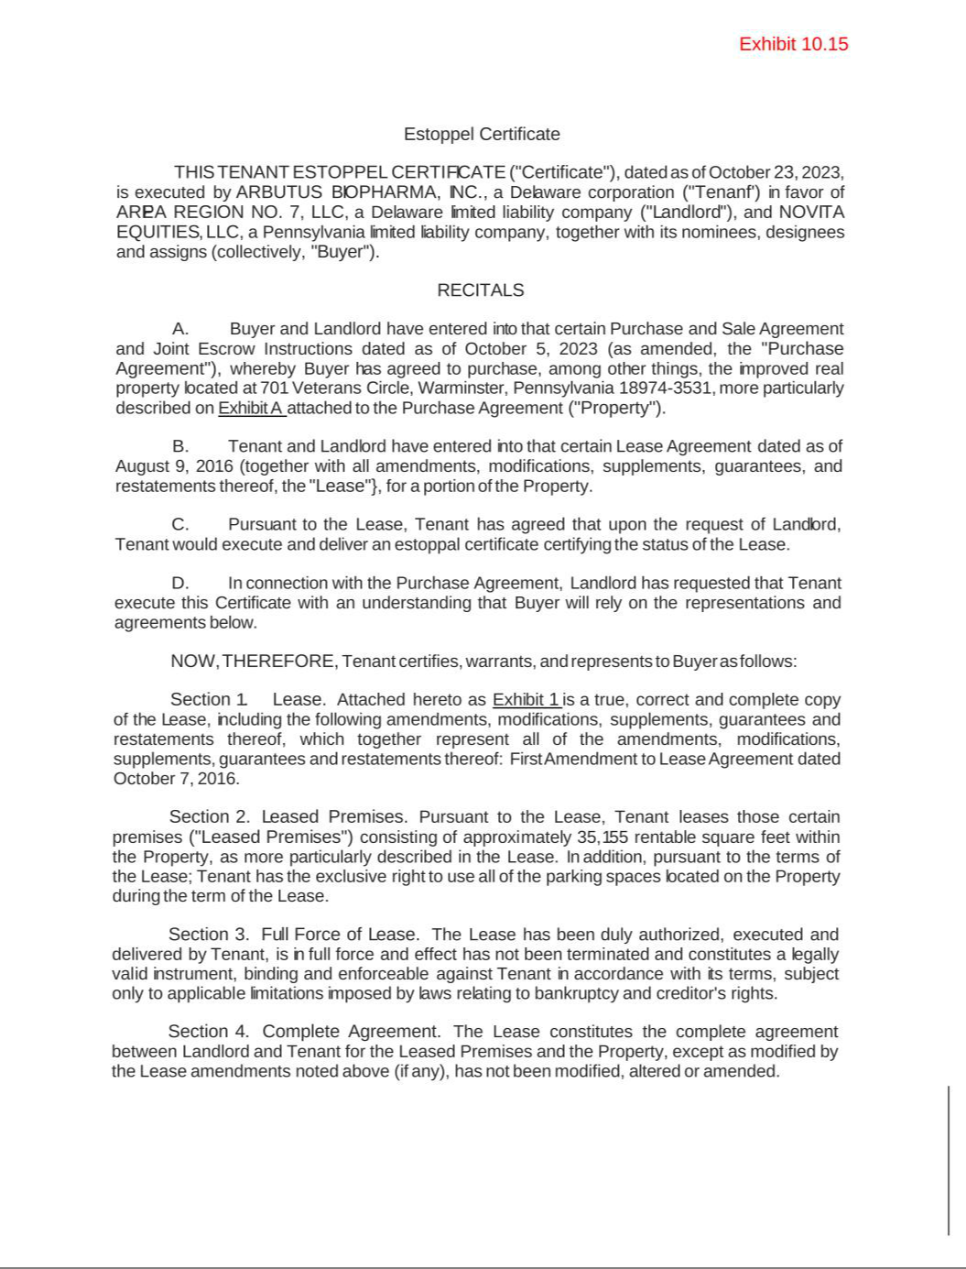

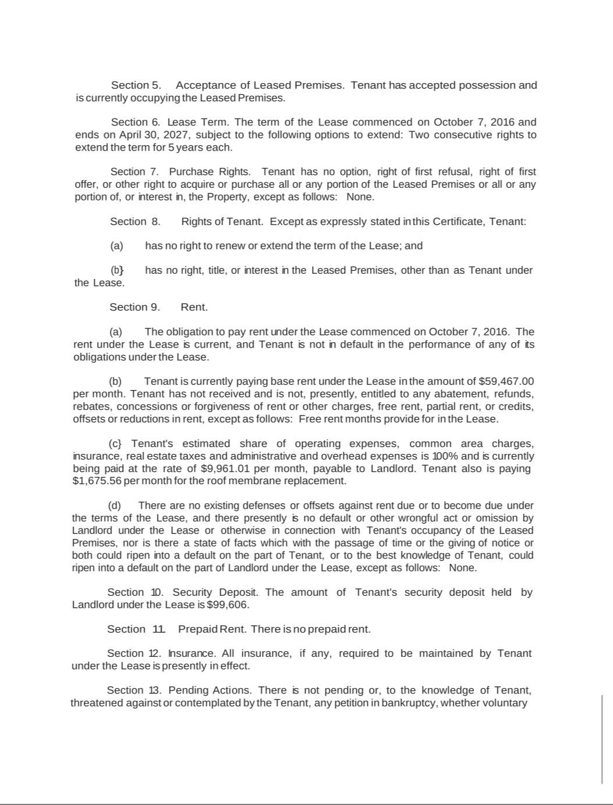

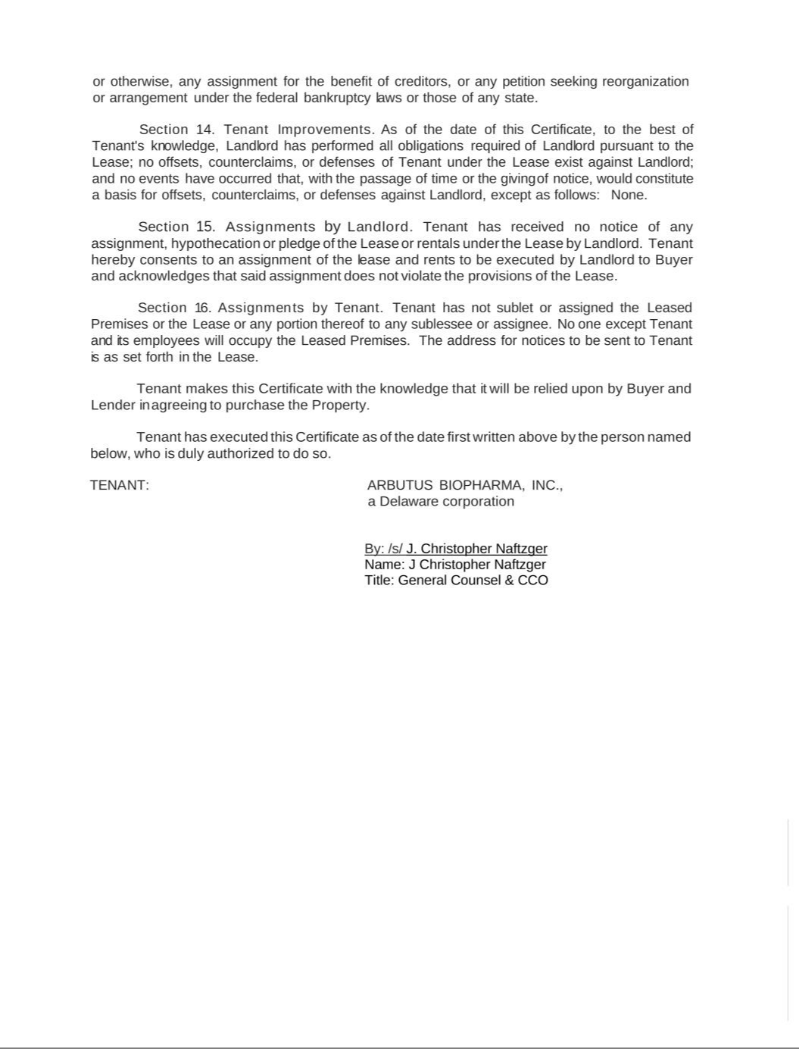

Exhibit 10.16

PREPARED BY AND
RECORD AND RETURN TO:

Christopher W. Rosenbleeth, Esquire
Stradley Ronon Stevens & Young, LLP
2600 One Commerce Square

Philadelphia, PA 19103

Location: 701 Veterans Circle
Municipality: Warminster Township
County: Bucks

State: Pennsylvania

SUBORDINATION, NON-DISTURBANCE AND ATTORNMENT AGREEMENT

THIS SUBORDINATION, NON-DISTURBANCE AND ATTORNMENT AGREEMENT (this “Agreement”) is dated as of December ___, 2023 (the “Effective Date”), by and among UNIVEST BANK AND TRUST CO. (“Bank”), VETERANS CIRCLE GROUP, LLC, a Pennsylvania limited liability company (“Landlord”), and ARBUTUS BIOPHARMA, INC., a Delaware corporation (“Tenant”).

RECITALS

- Landlord is the legal and record owner of the real property in Warminster Township, Bucks County, Pennsylvania, as more fully set forth and referred to on the legal description attached as Exhibit “A” to this Agreement (the “Property”).

- Landlord has leased a portion of the Property to Tenant pursuant to the terms of that certain Lease Agreement, dated as of August 9, 2016 (as amended, restated, modified or supplemented from time to time, the “Lease”).

- On or about the date hereof, as collateral for certain financing provided to Landlord by Bank, Landlord has executed and delivered to Bank a certain Open-End Mortgage and Security Agreement (as amended, restated, modified or supplemented from time to time, the “Mortgage”), and a separate Assignment of Rents and Leases (as amended, restated, modified or supplemented from time to time, the “Assignment of Rents and Leases”) which, among other things, grant and create a mortgage lien on Landlord’s interest in the Property, and all rental, lease and other payments made with respect to the Property. The Mortgage and the Assignment of Rents and Leases are sometimes referred to, collectively, as the “Mortgage Documents”. The Mortgage Documents and all related agreements, documents and instruments executed by Landlord in favor of Bank, as the same may be as amended, restated, modified or supplemented from time to time, are sometimes referred to below as the “Loan Documents”.

- The parties hereto desire to confirm that the Lease is subordinate to the lien of the Mortgage Documents, to establish rights of quiet possession for the benefit of Tenant under the Lease and to define the terms, covenants and conditions precedent therefor.

NOW, THEREFORE, in consideration of the above premises, and other good and valuable consideration, the receipt and sufficiency of which are hereby acknowledged, it is hereby agreed by the parties as follows, with the intent to be legally bound:

Subordination. The Lease (including all of the terms, covenants and provisions thereof) is and shall be subject and subordinate in all respects to the Mortgage Documents and all advances made thereunder and under the other Loan Documents, to the full extent of any and all amounts from time to time secured thereby and interest thereon, all with the same force and effect as if the Mortgage Documents had been executed, delivered, and recorded prior to the execution and delivery of the Lease.

Attornment. Tenant, for itself and its successors and assigns, agrees that it will attorn to and recognize any purchaser of the Property at a foreclosure sale under the Mortgage, or any transferee who acquires the Property by deed in lieu of foreclosure or otherwise, and the successors and assigns of such purchaser or transferee, as its landlord for the unexpired balance (and any extensions or renewals, if previously, at that time or thereafter exercised by Tenant) of the term of the Lease upon the same terms and conditions set forth in the Lease, which Lease shall remain in full force and effect as the current Lease between Tenant and Landlord, subject to the other terms of this Agreement.

Non-Disturbance. Bank, for itself and its successors and assigns, for any purchaser at a foreclosure sale under the Mortgage, for any transferee who acquires the Property by deed in lieu of foreclosure or otherwise, and for the successors and assigns of such purchaser and transferee (Bank and each such other party being a “New Landlord”), covenants and agrees with Tenant that if Bank or other New Landlord shall commence any proceedings to foreclose the Mortgage for any reason whatsoever, or shall succeed to the interest of Landlord by foreclosure, deed in lieu thereof or otherwise, provided that (a) the Lease is at all times in full force and effect; (b) Tenant is in possession of the Property; and (c) Tenant is not then in default under the Lease, then: (i) Tenant shall not be named as a party defendant in any foreclosure action unless Tenant is required by applicable law, order, regulation, rule or decision to be a necessary party; (ii) the right of possession by Tenant to the Property and any or all of Tenant’s rights under the Lease shall not be terminated by Bank (or by anyone claiming by, through or under Bank) in the exercise of any of Bank’s rights under the Mortgage Documents, or as successor or assignee of Landlord under the Lease; (iii) Tenant’s possession of the Property and Tenant’s rights and privileges under the Lease shall not be diminished, interfered with, or disturbed by such Bank or such other New Landlord by any steps or proceedings taken by Bank in exercise of any of its rights under the Mortgage, including, without limitation, foreclosure under the Mortgage or by any such attempt to foreclose or to succeed to the interests of Landlord by foreclosure, deed in lieu thereof or otherwise, or by any termination of the Lease, except upon a default by Tenant under the terms of the Lease; and (iv) the Lease shall not be terminated or affected by said exercise of any of its right provided for under the Mortgage, and Bank hereby covenants that any sale by it of the Property pursuant to the exercise of any rights and remedies under the Mortgage or otherwise, shall be made subject to the Lease and the rights of Tenant thereunder.

If Bank or any other New Landlord shall succeed to the interest of Landlord under the Lease, Tenant agrees that:

- Bank or such other New Landlord shall not be bound by (I) any rent or additional rent which Tenant shall have paid more than one (1) month in advance to any prior landlord (including Landlord); (II) any covenant to undertake or complete any improvement to the Property (except to the extent such improvement has commenced but not yet completed); or (III) any amendment or modification to the Lease, or waiver of any provision of the Lease, which has not been consented to in writing by Bank (provided, however, that this subpart (III) shall not apply to amendments, modifications, or waivers, which were effectuated prior to the Effective Date of this Agreement);

  - 2 -

- Unless otherwise agreed in writing by New Landlord, no New Landlord (including, without limitation, Bank) shall be liable for: (I) any act or omission of any prior landlord (including Landlord) except for acts or omissions of a continuing nature which continue after such time as New Landlord comes into possession of or acquires title to all or any portion of the Property; (II) return of any security deposit made by Tenant to Landlord, unless such New Landlord shall have actually received such security deposit from Landlord and as provided in the Lease; or (III) any payment to Tenant of any sums, or the granting to Tenant of any credit, in the nature of a contribution towards the cost of preparing, furnishing, or moving into the Property or any portion thereof (provided, for clarity, nothing in subparts (I), (II), and/or (III) shall preclude Tenant from pursuing or enforcing a remedy or right available to it under the Lease or in accordance with law, which remedy or right arises or relates to acts or omissions that occur prior to New Landlord’s exercise of rights provided hereunder); and

- No partner, officer, director, shareholder or agent of Bank or other New Landlord, or any successor or assign of any of the foregoing, shall have any personal liability, directly or indirectly, under or in connection with the Lease or this Agreement or any amendment or amendments to either thereof made at any time or times, heretofore or hereafter. Tenant forever and irrevocably waives and releases any and all such personal liability, as described in the foregoing sentence. The limitation of liability provided in this Section is in addition to, and not in limitation of, any limitation on liability applicable to Bank or such other New Landlord provided by law or by any other contract, agreement or instrument.

Bank’s Consent. Landlord’s consent, approval or waiver under or with respect to the Lease or the Property, or any matter related thereto shall not be effective unless such consent, approval or waiver is accompanied by the written consent of Bank. Without limiting the generality of the foregoing, Tenant will not, without the prior written consent of Bank: (a) enter into any agreement amending the Lease; (b) terminate, cancel the term of, or surrender, the Lease except as a result of a default by Landlord thereunder and subject to Bank’s rights pursuant to Section 5 below; or (c) assign or sublet all or any part of the Property, except only pursuant to any assignment or sublease which, under the express provisions of the Lease, Tenant is entitled to make without the consent of Landlord.

Cure Right. Notwithstanding anything to the contrary contained in the Lease, Tenant hereby agrees that in the event of any act, omission or default by Landlord or Landlord’s agents, employees, contractors, licensees or invitees which would give Tenant the right, either immediately or after the lapse of a period of time, to terminate the Lease, or to claim a partial or total eviction, or to reduce the rent payable thereunder or credit or offset any amounts against future rents payable thereunder, Tenant will not exercise any such right (a) until it has given written notice of such act, omission or default to Lender by delivering notice of such act, omission or default, in accordance with this Agreement; and (b) until a period of not less than thirty (30) days for remedying such act, omission or default shall have elapsed following the giving of such notice. Notwithstanding the foregoing, in the case of any default of Landlord which cannot be cured within such thirty (30) day period, if Bank shall within such period commence and diligently pursue the cure of the same (including such time as may be necessary to acquire possession of the Property if possession is necessary to effect such cure) and thereafter shall prosecute the curing of such default with diligence, then the time within which such default may be cured by Bank shall be extended for such period as may be reasonably necessary to complete the curing of the same with diligence. Bank’s cure of Landlord’s default shall not be considered an assumption by Bank of Landlord’s other obligations under the Lease. Unless Bank otherwise agrees in writing or becomes a New Landlord, Landlord shall remain solely liable to perform Landlord’s obligations under the Lease (but only to the extent required by and subject to the limitation included with the Lease), both before and after Bank’s exercise of any other right or remedy under this Agreement. If Bank or any successor or assign becomes obligated to perform as Landlord under the Lease, such person or entity will be released from

- 3 -

those obligations arising or owed after the effective date on which such person or entity assigns, sells or otherwise transfers its interest in the Property.

Estoppel Certificate. Tenant agrees at any time and from time to time to execute, deliver and acknowledge to Landlord, to Bank or to any third party reasonably designated by Landlord or by Bank within ten (10) days following Landlord’s or Bank’s written request therefor: a statement in writing (a) certifying that the Lease is in full force and effect, that Landlord is not in default thereunder (or specifying any default by Landlord which Tenant alleges), that rent has not been prepaid more than one (1) month in advance, and specifying any further information as required by the Lease; (b) that Tenant will recognize Bank as assignee of Landlord’s rights under the Lease, as applicable, pursuant to this Agreement; and (c) acknowledging or denying receipt of notice of any conditional or security assignment of the Lease to any third party. Tenant understands that Bank and/or prospective purchasers, or other secured parties will rely on such certificates. Tenant’s obligation to deliver such certificates within ten (10) days as described above is a material obligation of Tenant, under this Agreement.

Further Subordination. Tenant, for itself and its successors and assigns, agrees that, without the prior written consent of Bank, Tenant shall not: (a) enter into any subordination agreement with any person other than Bank; or (b) agree to attorn to or recognize any purchaser of the Property at any foreclosure sale under any lien other than that of Bank or any transferee who acquires the Property by deed in lieu of foreclosure or otherwise under any lien other those of the Mortgage Documents (provided, however, that this provision shall not be deemed to constitute Bank’s consent to the placing of any lien, other than as created by the Mortgage Documents, on the Property).

Reserved.

- Limitation of Liability. To the fullest extent permitted by applicable law, Tenant and Landlord shall not assert, and hereby waive any claim against Bank, on any theory of liability, for special, indirect, consequential, exemplary, speculative or punitive damages (but excluding direct or actual damages) arising out of, in connection with or as a result of, this Agreement, the Loan Documents, the transactions contemplated hereby or thereby or any loan or the use of the proceeds.

- Notice. Each notice, demand or other communication in connection with this Agreement shall be in writing and shall be deemed to be given to and served upon the addressee thereof on the earlier of (a) actual delivery to such addressee at its address set forth below; or (b) the third business day after the deposit thereof in the United States mails, registered or certified mail, return receipt requested, first class postage prepaid, addressed to such addressee at its address set out above. By notice complying with this Section, any party from time to time may designate a different address as its address for the purpose of the receipt of notice hereunder.

If to Bank:

Univest Bank and Trust Co.
14 North Main Street
Souderton, PA 18964

Attn: Robert M. Castro

If to Landlord: Veterans Circle Group, LLC
5110 Campus Drive, Suite 110
Plymouth Meeting, PA 19462

Attn: Christopher R. DiPaolo

If to Tenant: Arbutus Biopharma, Inc.

701 Veterans Circle

- 4 -

Warminster, PA 18974-3531
Attn: General Counsel

- Binding Effect. This Agreement shall be binding upon and shall inure to the benefit of the parties hereto, and their respective successors and assigns.

  - Governing Law; Recording. This Agreement is subject to the laws of the Commonwealth of Pennsylvania without regard to principles of conflict of laws. The parties hereto agree that this Agreement may be recorded in the public records of any county in which the Property is located.

    - Counterparts. This Agreement may be executed in any number of counterparts and by each of the undersigned on separate counterparts, and each such counterpart shall be deemed to be an original, but all such counterparts shall together constitute but one and the same Agreement.

      - WAIVER OF TRIAL BY JURY. EACH PARTY KNOWINGLY, VOLUNTARILY, INTENTIONALLY AND IRREVOCABLY WAIVES EACH RIGHT IT MAY HAVE TO A TRIAL BY JURY WITH RESPECT TO, AND IN, ANY ACTION OR OTHER LEGAL PROCEEDING, OF ANY NATURE RELATING TO THIS AGREEMENT, ANY TRANSACTION CONTEMPLATED HEREIN OR ANY NEGOTIATION, ADMINISTRATION, PERFORMANCE OR ENFORCEMENT OF THIS AGREEMENT.

[REMAINDER OF PAGE INTENTIONALLY LEFT BLANK]

- 5 -

IN WITNESS WHEREOF, the parties hereto have caused this Agreement to be signed by their duly authorized officers as of the date set forth above.

BANK:

UNIVEST BANK AND TRUST CO.

By: /s/ Robert M. Castro
Name: Robert M. Castro
Title: Senior Vice President

[SIGNATURES CONTINUE ON FOLLOWING PAGE]

[Signature Page to Subordination, Non-Disturbance and Attornment Agreement]

LANDLORD:

VETERANS CIRCLE GROUP, LLC

By: /s/ Christipher R. DiPaolo
Name: Christopher R. DiPaolo
Title: Manager

[SIGNATURES CONTINUE ON FOLLOWING PAGE]

[Signature Page to Subordination, Non-Disturbance and Attornment Agreement]

TENANT:

ARBUTUS BIOPHARMA, INC.

By: /s/ J. Christopher Naftzger
Name: J. Christopher Naftzger
Title: General Counsel & CCO

[Signature Page to Subordination, Non-Disturbance and Attornment Agreement]

EXHIBIT “A”

LEGAL DESCRIPTION OF THE PROPERTY

All that certain lot, parcel, tract of land lying and being situate in the Township of Warminster, County of Bucks and Commonwealth of Pennsylvania, bounded and described as follows:

Beginning at a concrete monument to be set by others along the Eastern most right of way of Veterans Circle being the corner of Lot 8 (erroneously referred to as Lot 2 in prior chain deeds) and being the point of beginning; thence along Lot 8 (erroneously referred to as Lot 2 in prior chain deeds) South 52° 55’ 39” East a distance of 441.48 feet to a concrete monument to be set by others along Lot 3; thence along Lot 3 South 37° 04’ 21” West a distance of 300.00 feet to a concrete monument to be set by others along Lot 6; thence along Lot 6 North 52° 55’ 39” West distance of 469.49 feet to a concrete monument to be set by others along the right of way Veterans Circle; thence along the right of way of Veterans Circle North 37° 04’ 21” East a distance of 237.38 feet to a concrete monument to be set by others; thence continuing along the right of way along a curve to the right having a radius of 25.00 feet an arc length of 20.89 feet an included angle of 47° 53’ 15” and a chord bearing and distance of North 61° 00’ 59” East 20.29 feet to a concrete monument to be set by others; thence continuing along the right of way along a curve to the left having a radius of 60.00 feet an arc length of 49.71 feet an included angle of 47° 28’ 13” and a chord bearing and distance of North 61° 13’ 29” East 48.30 feet to a concrete monument to be set by others being the point of beginning.

The above described Lot being as shown as Lot #7 on the plan entitled "Amended Final Subdivision Plan Franklin Corporate Center" as prepared by Liberty Engineering, Inc., latest revision dated 8/3/2004 and recorded at the Recorder of Deeds Office in and for the County of Bucks, Pennsylvania on August 9, 2004 in Plan Book 319, page 37.

The above is also shown as Lot #7 on Site Layout Plan recorded at the Recorder of Deeds Office in and for the County of Bucks, Pennsylvania on December 23, 2005 in Plan Book 335, page 30.

Being designated as Tax Parcel No. 49-009-528.

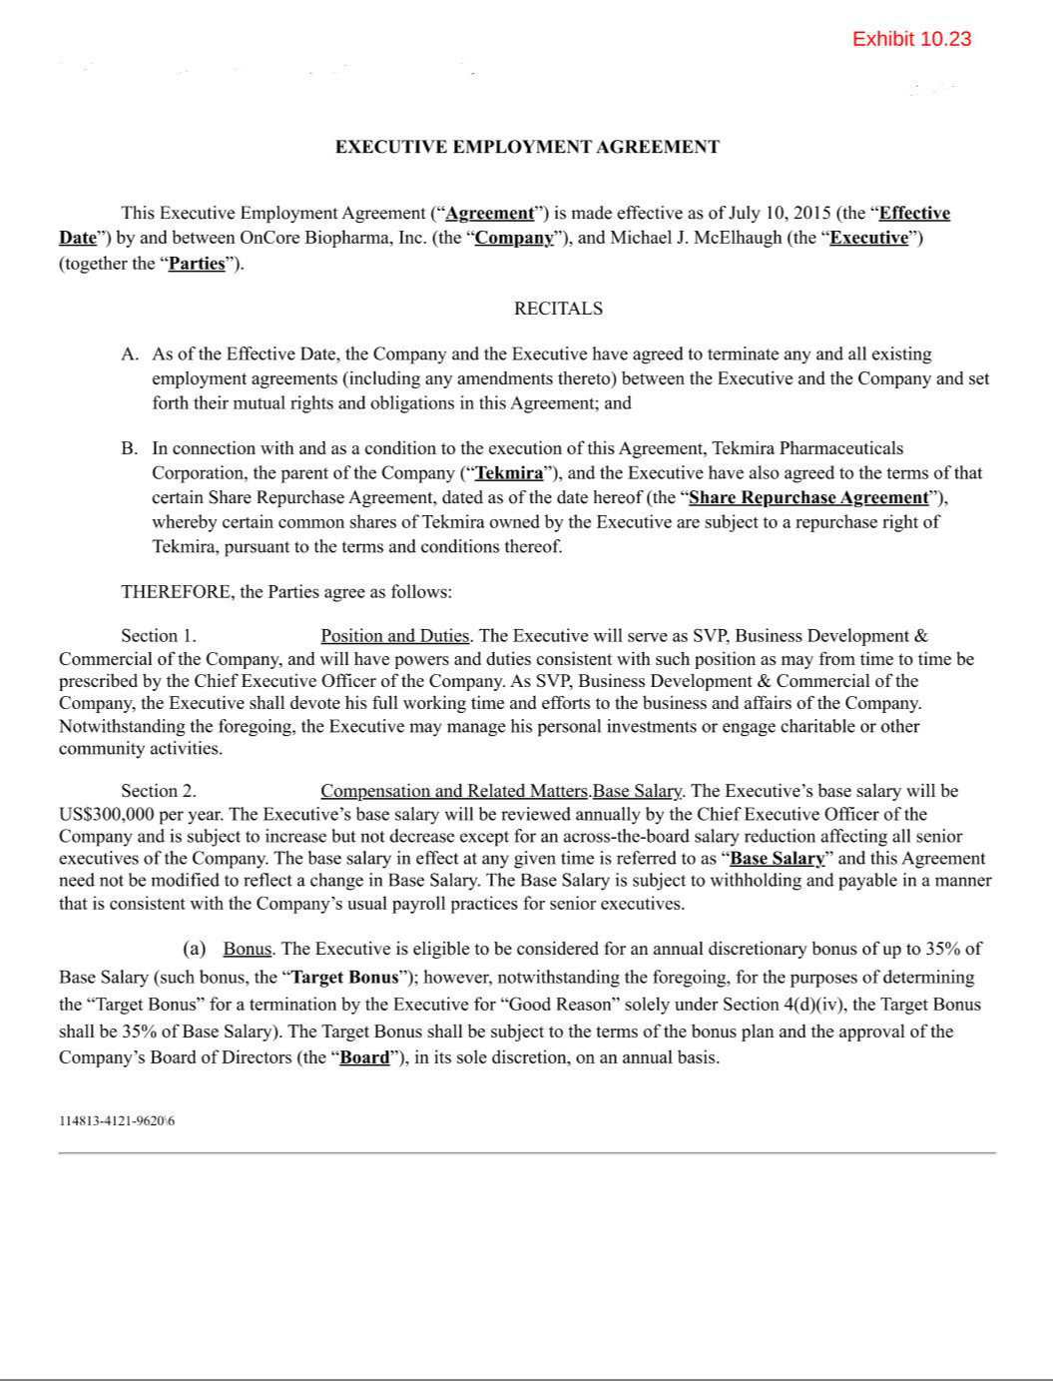

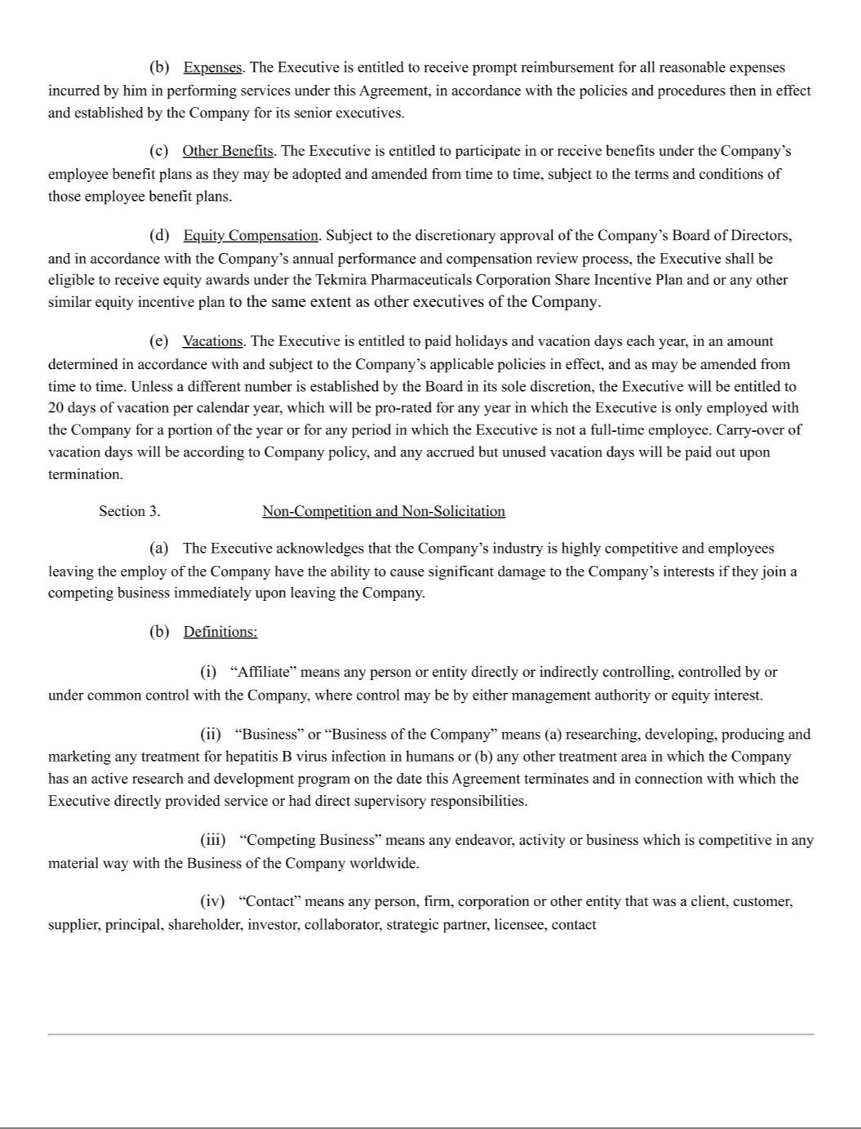

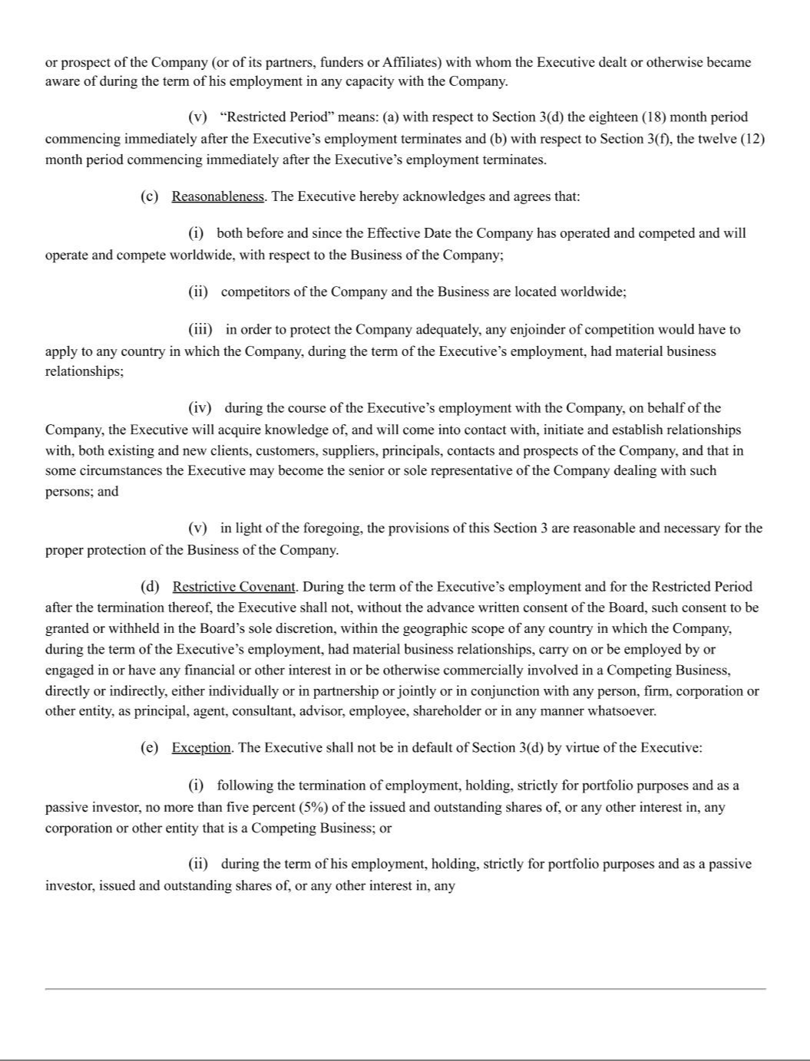

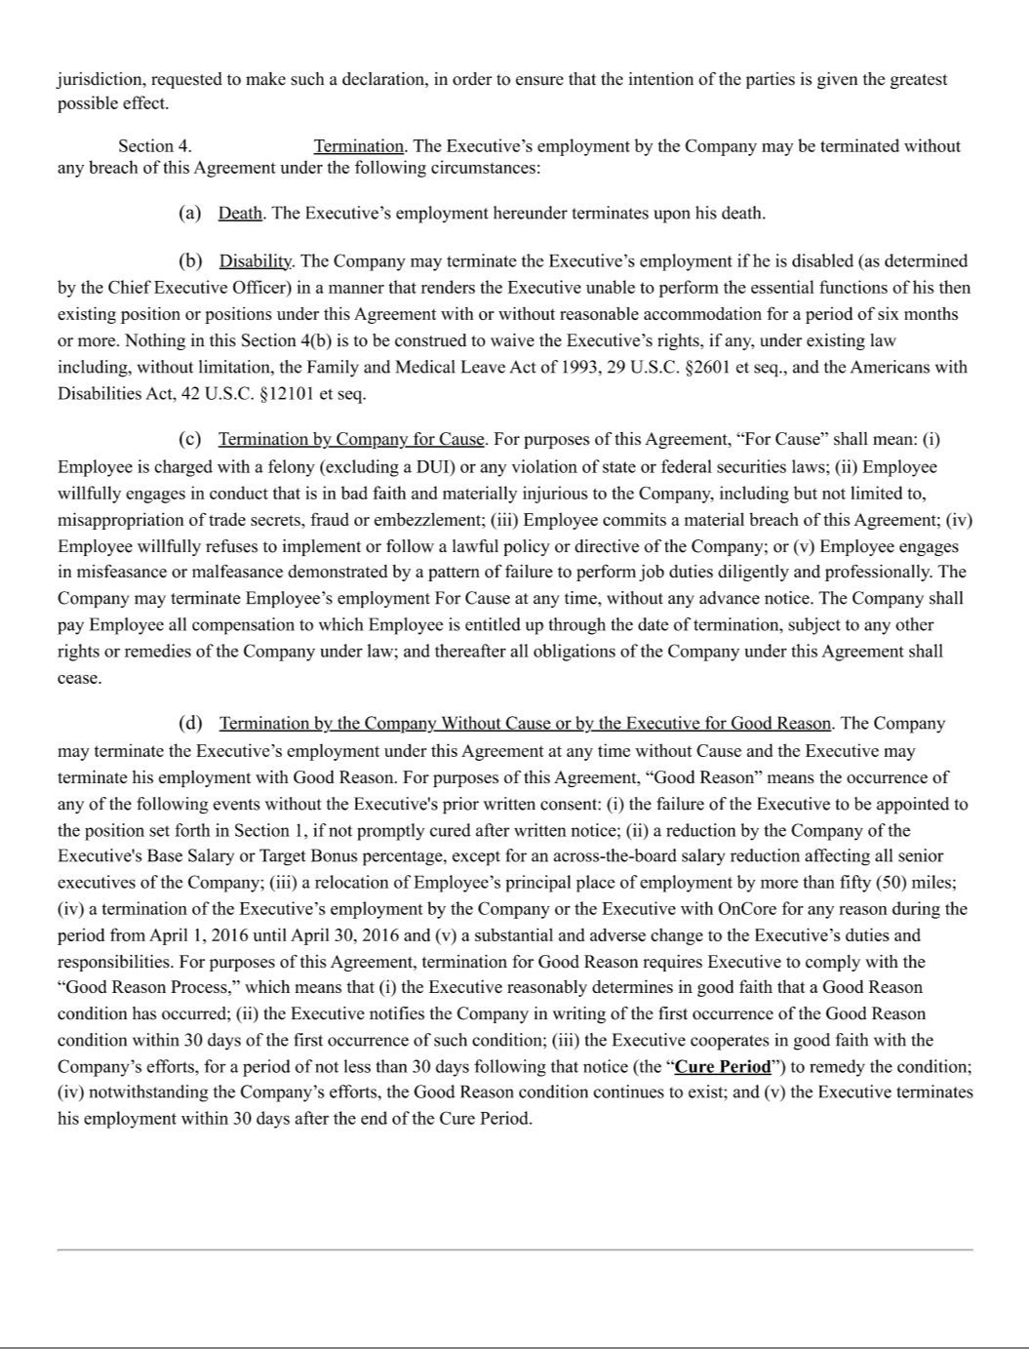

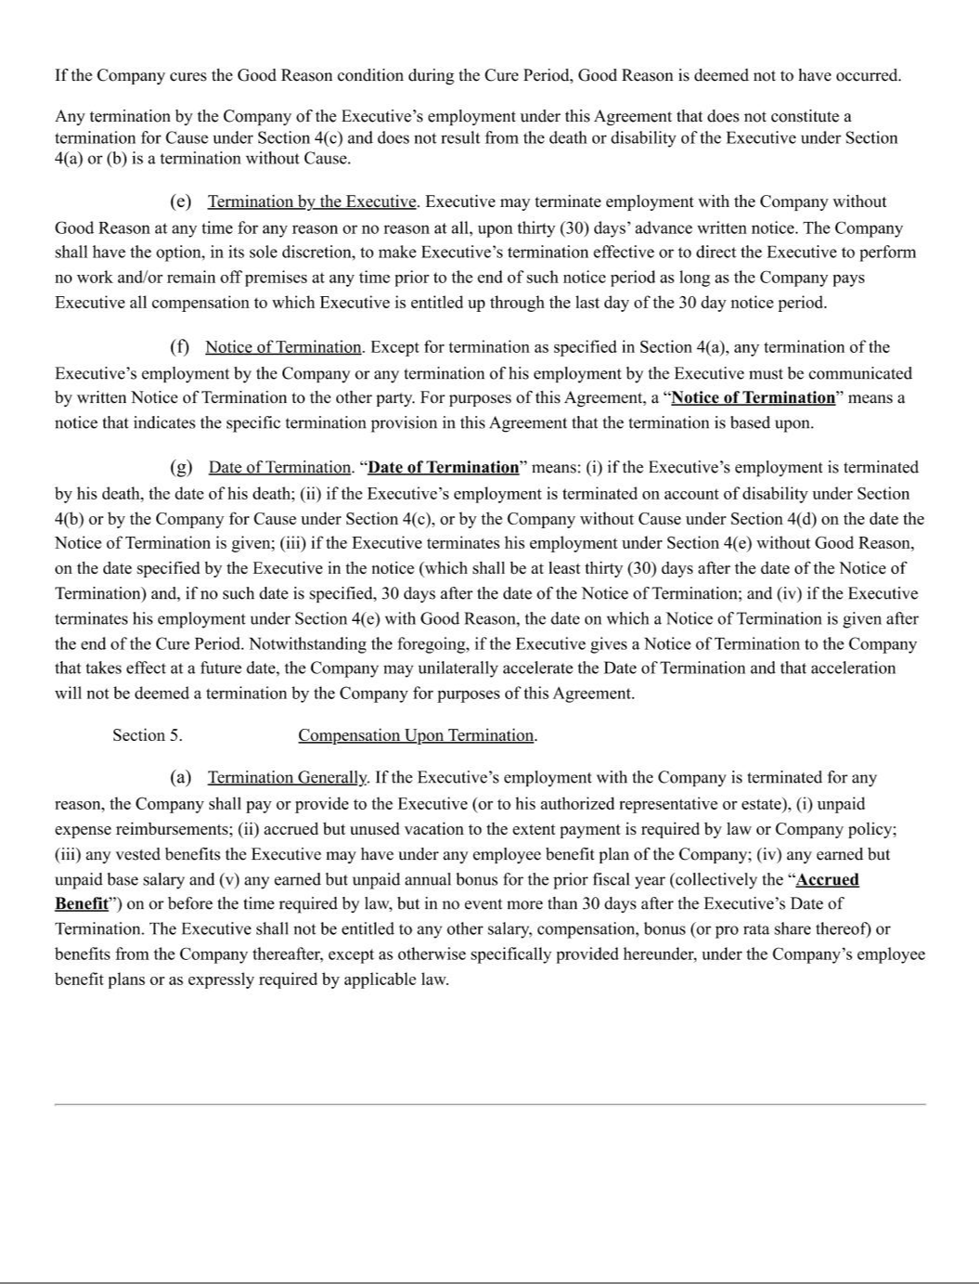

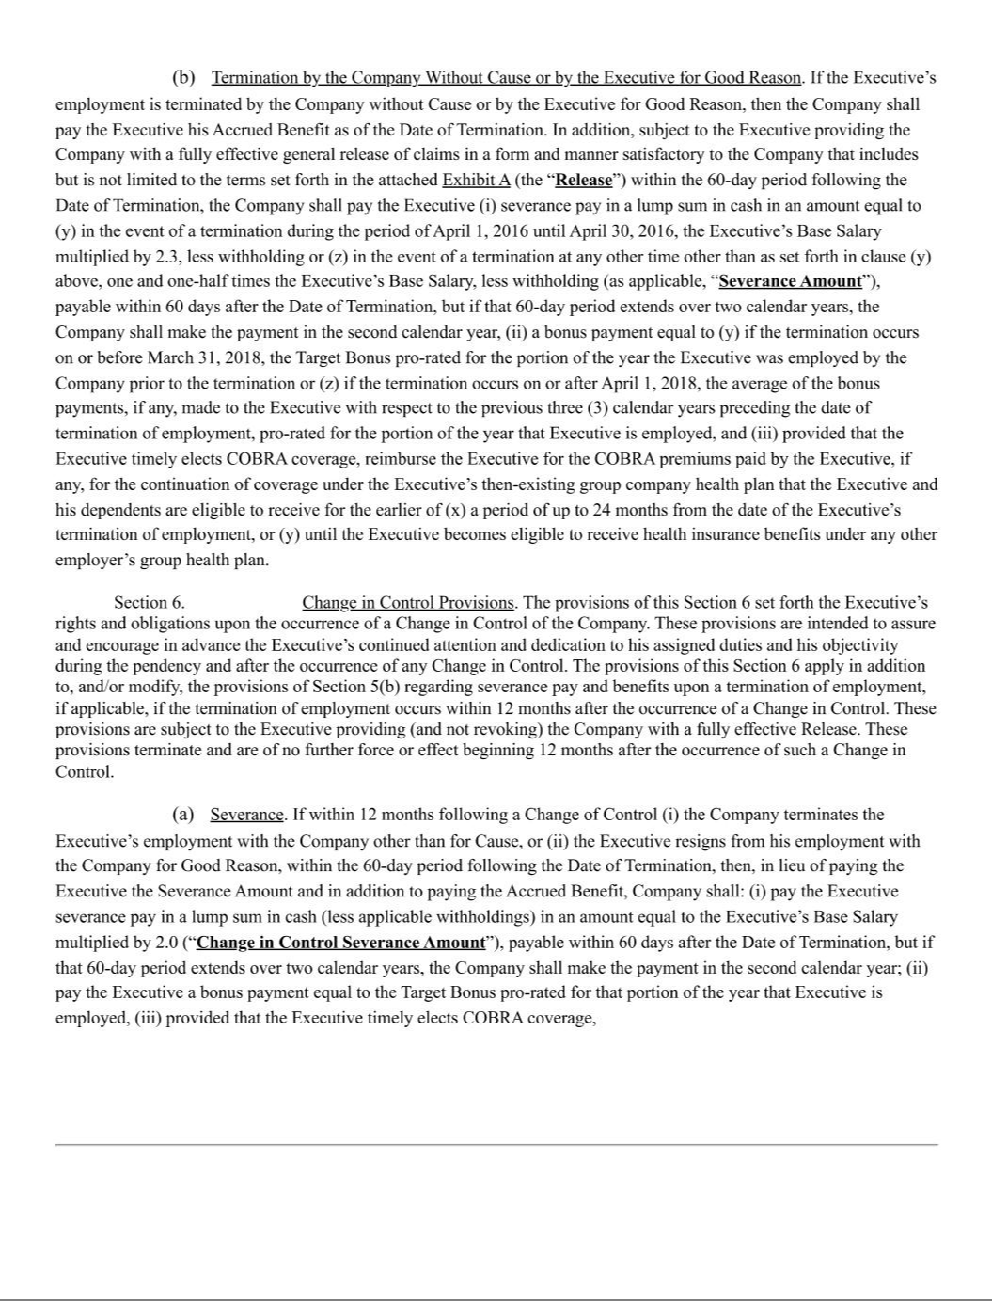

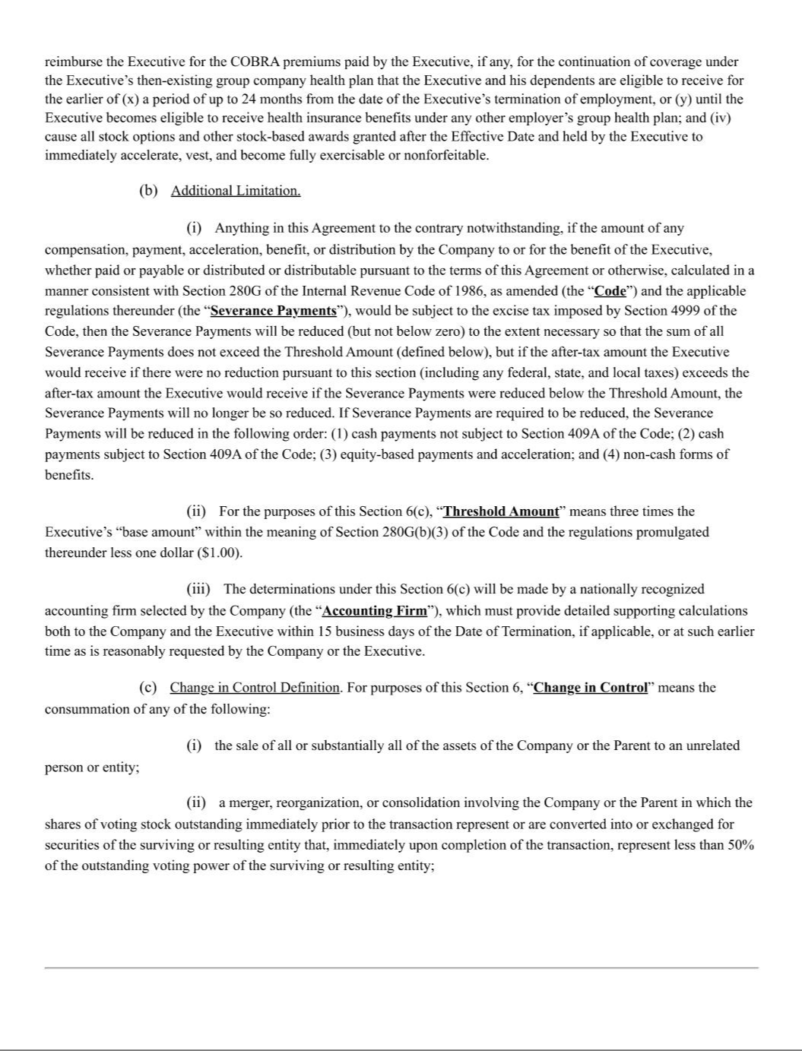

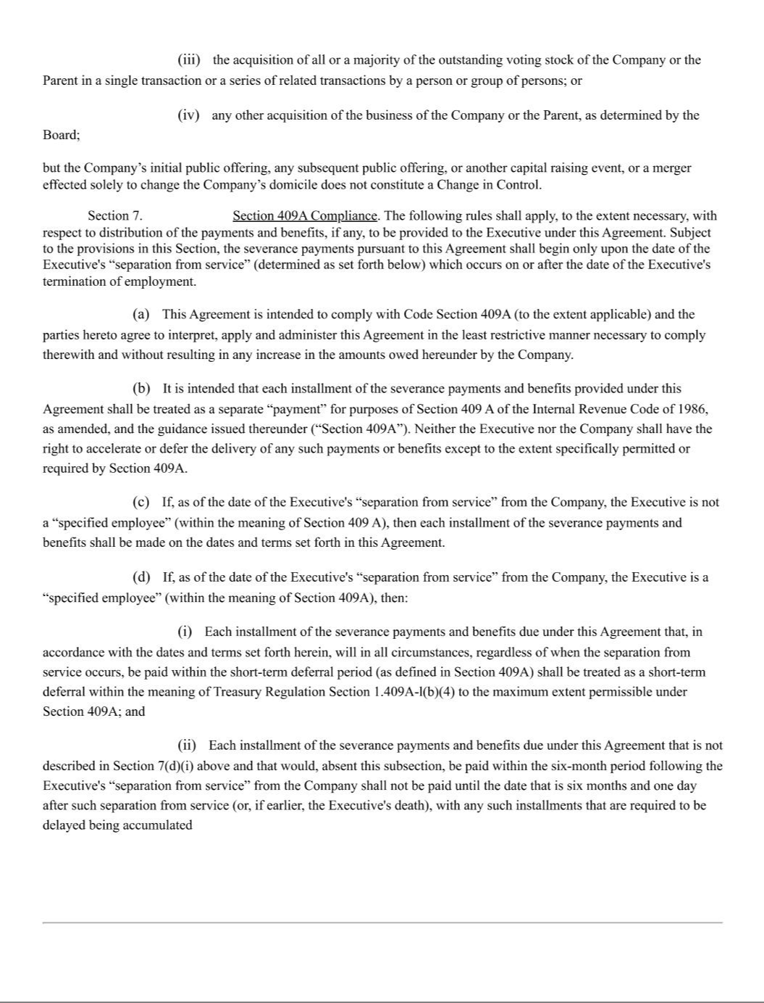

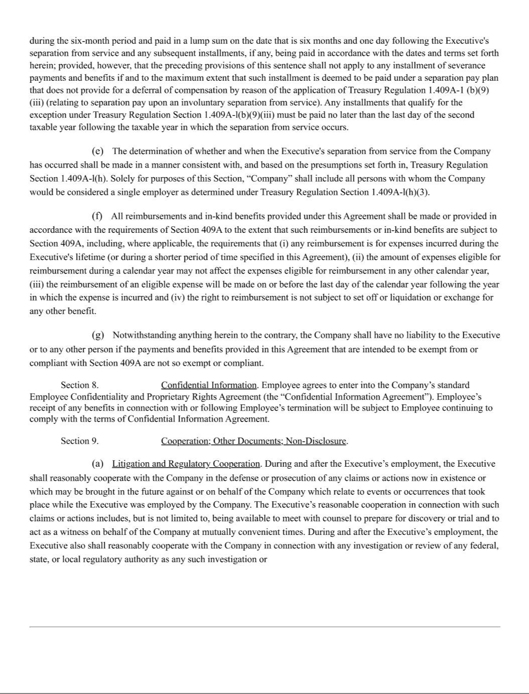

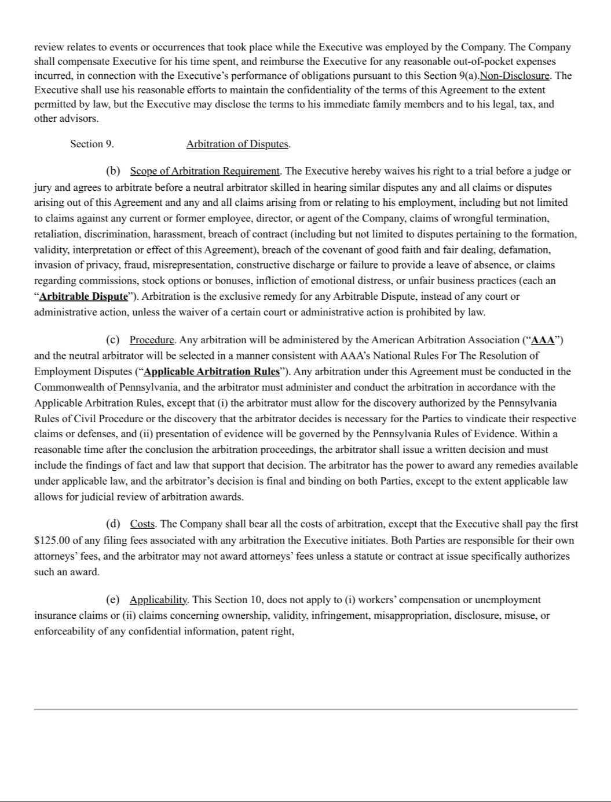

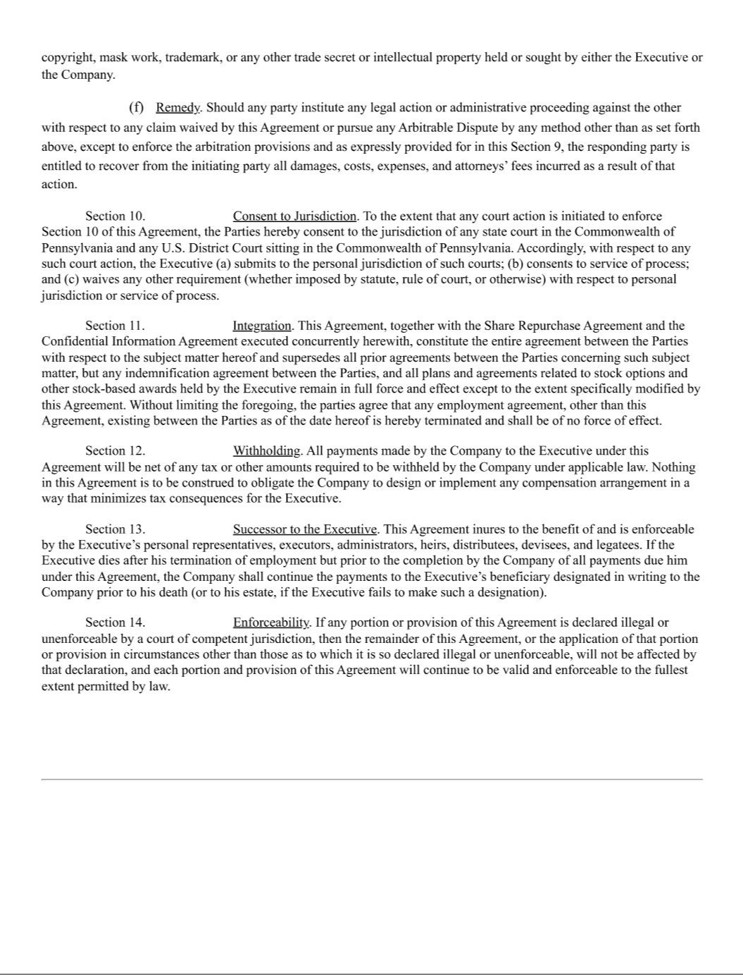

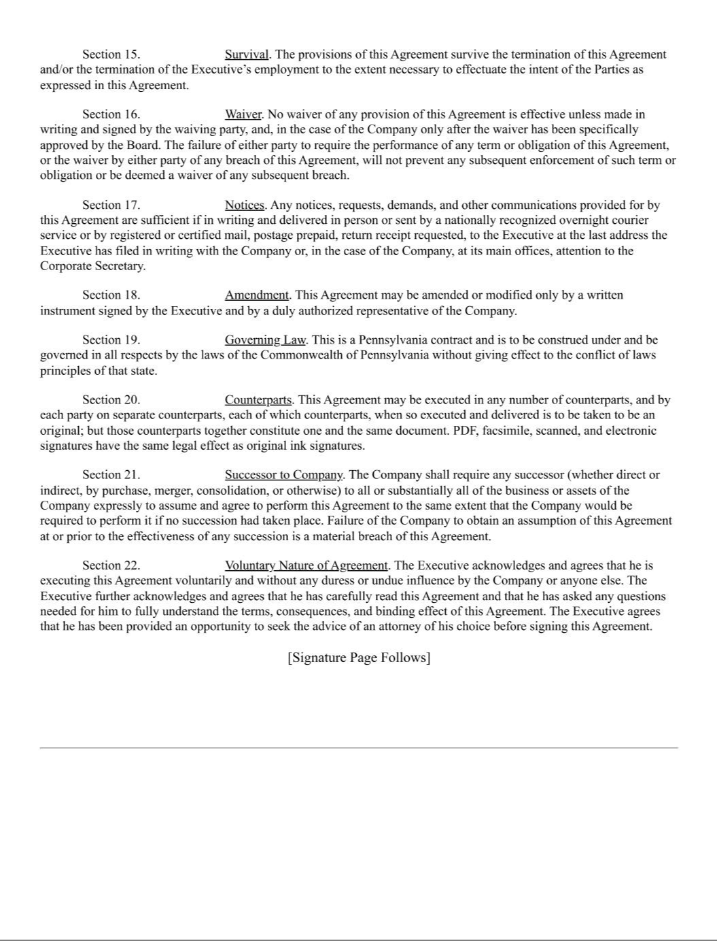

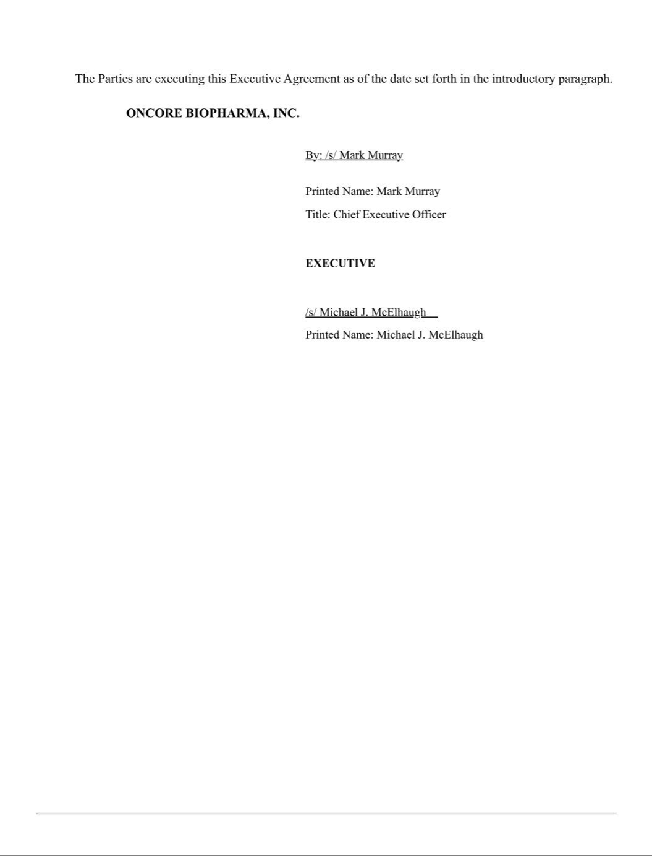



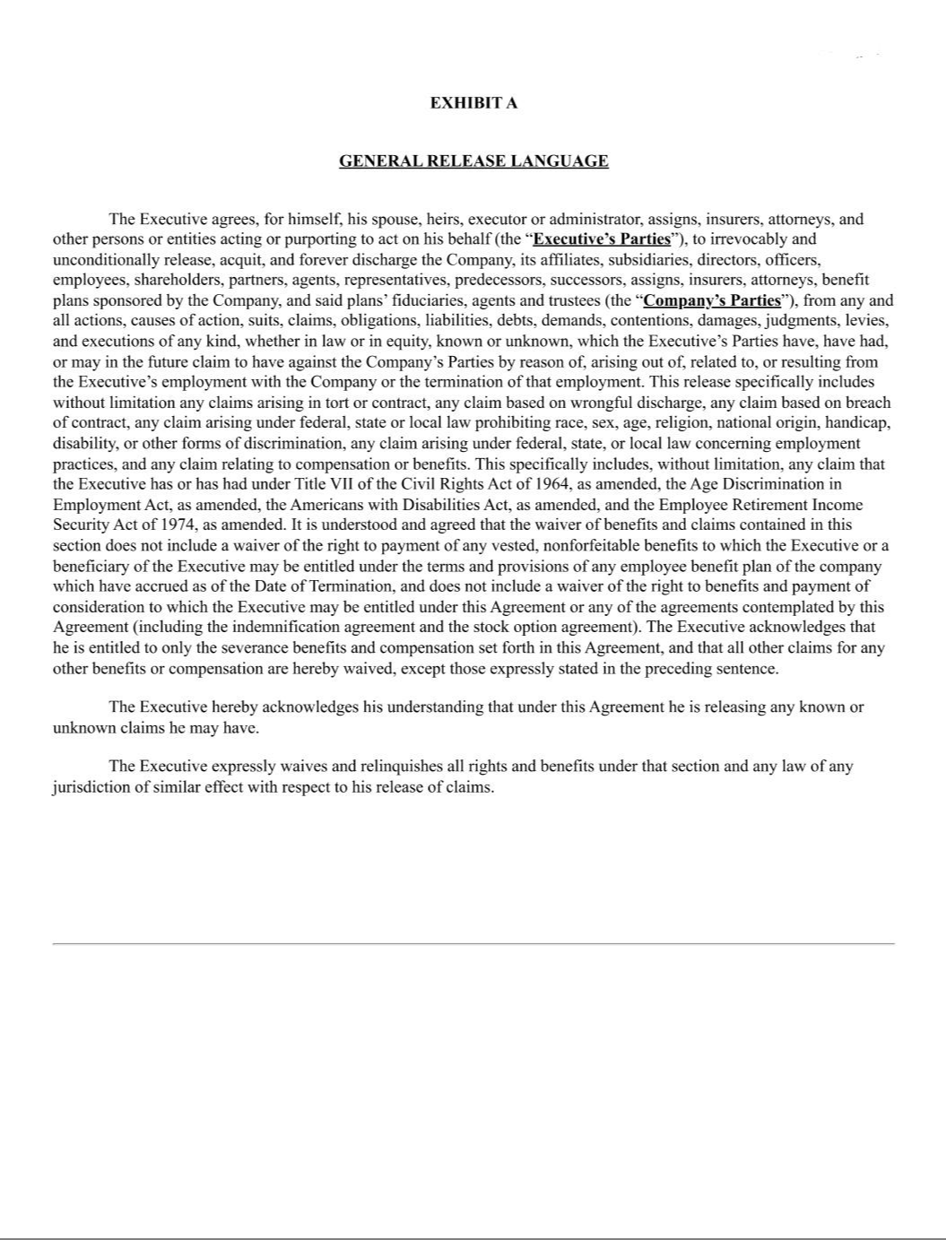

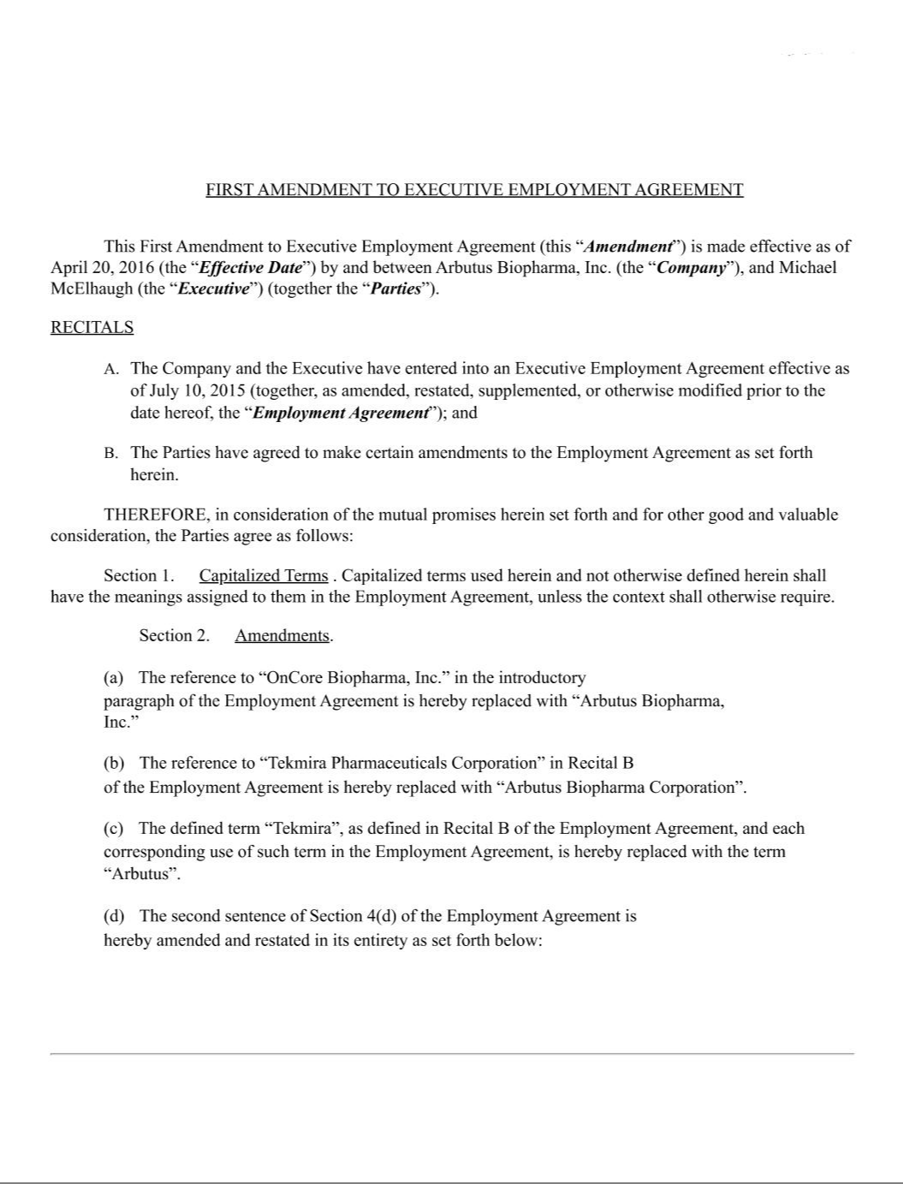

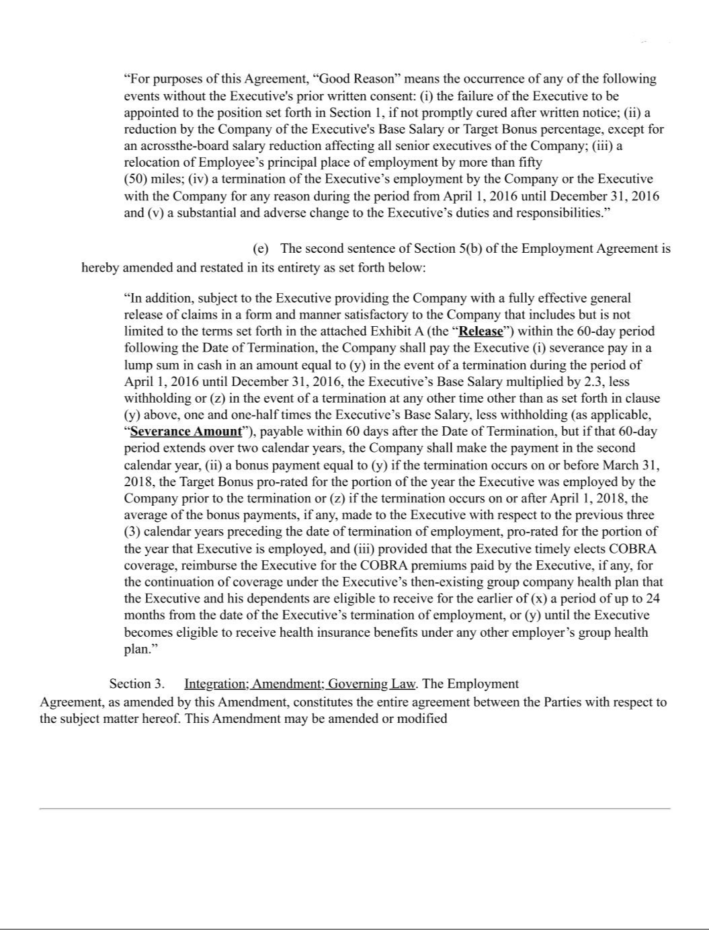

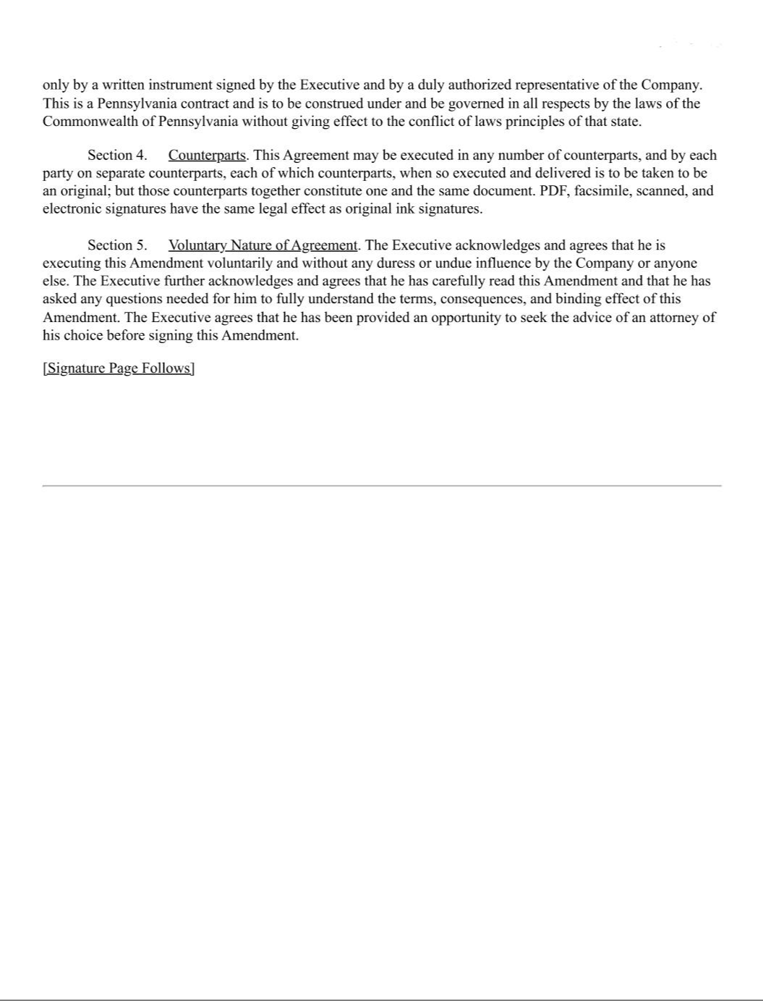

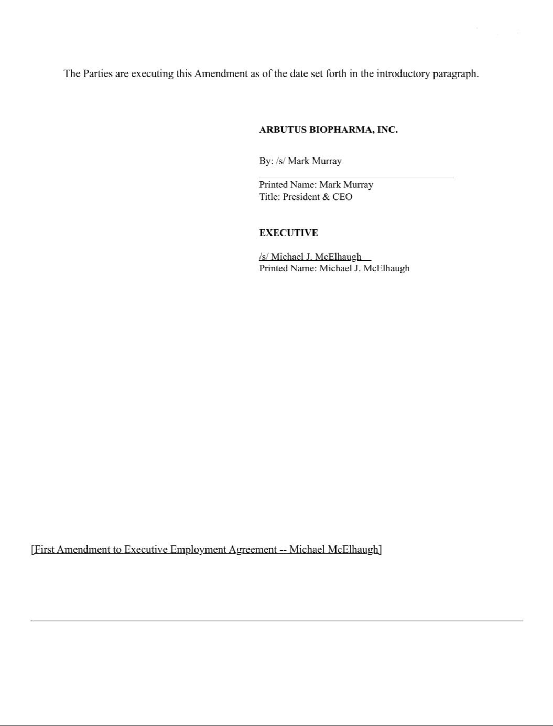

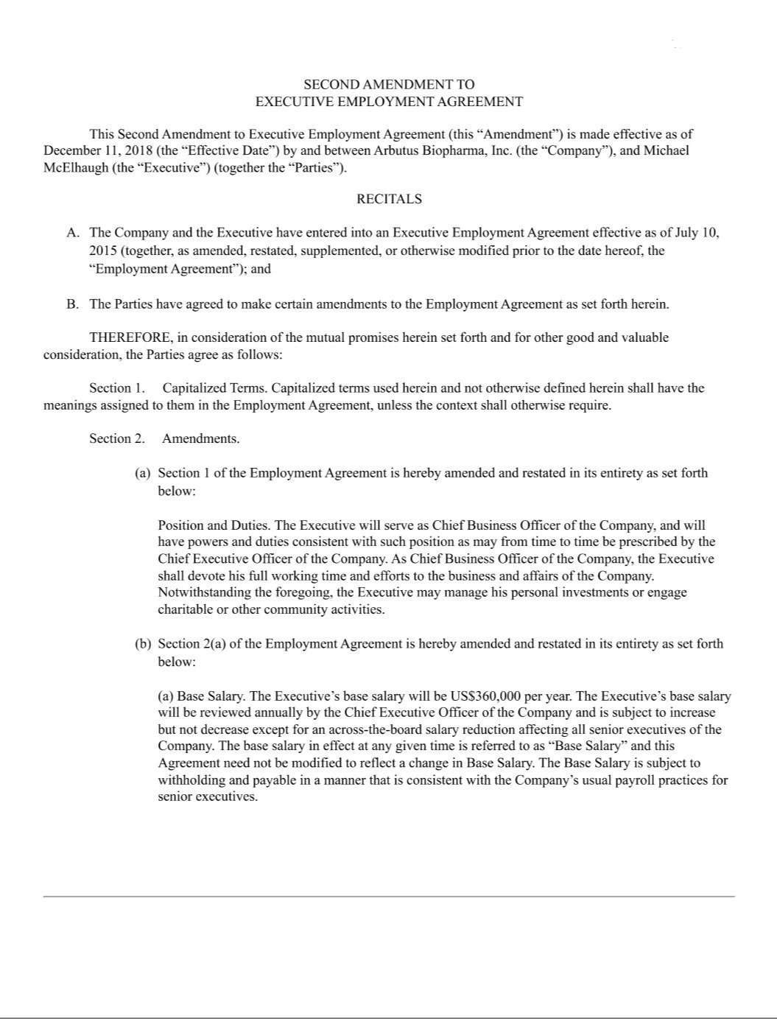

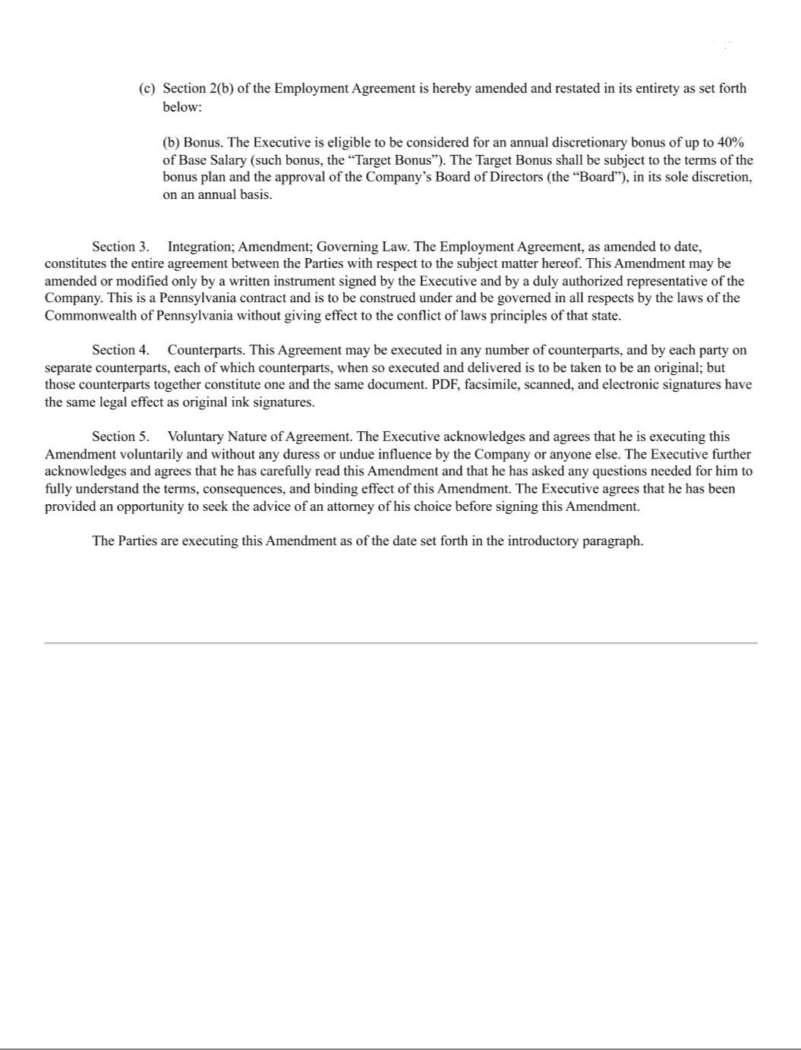

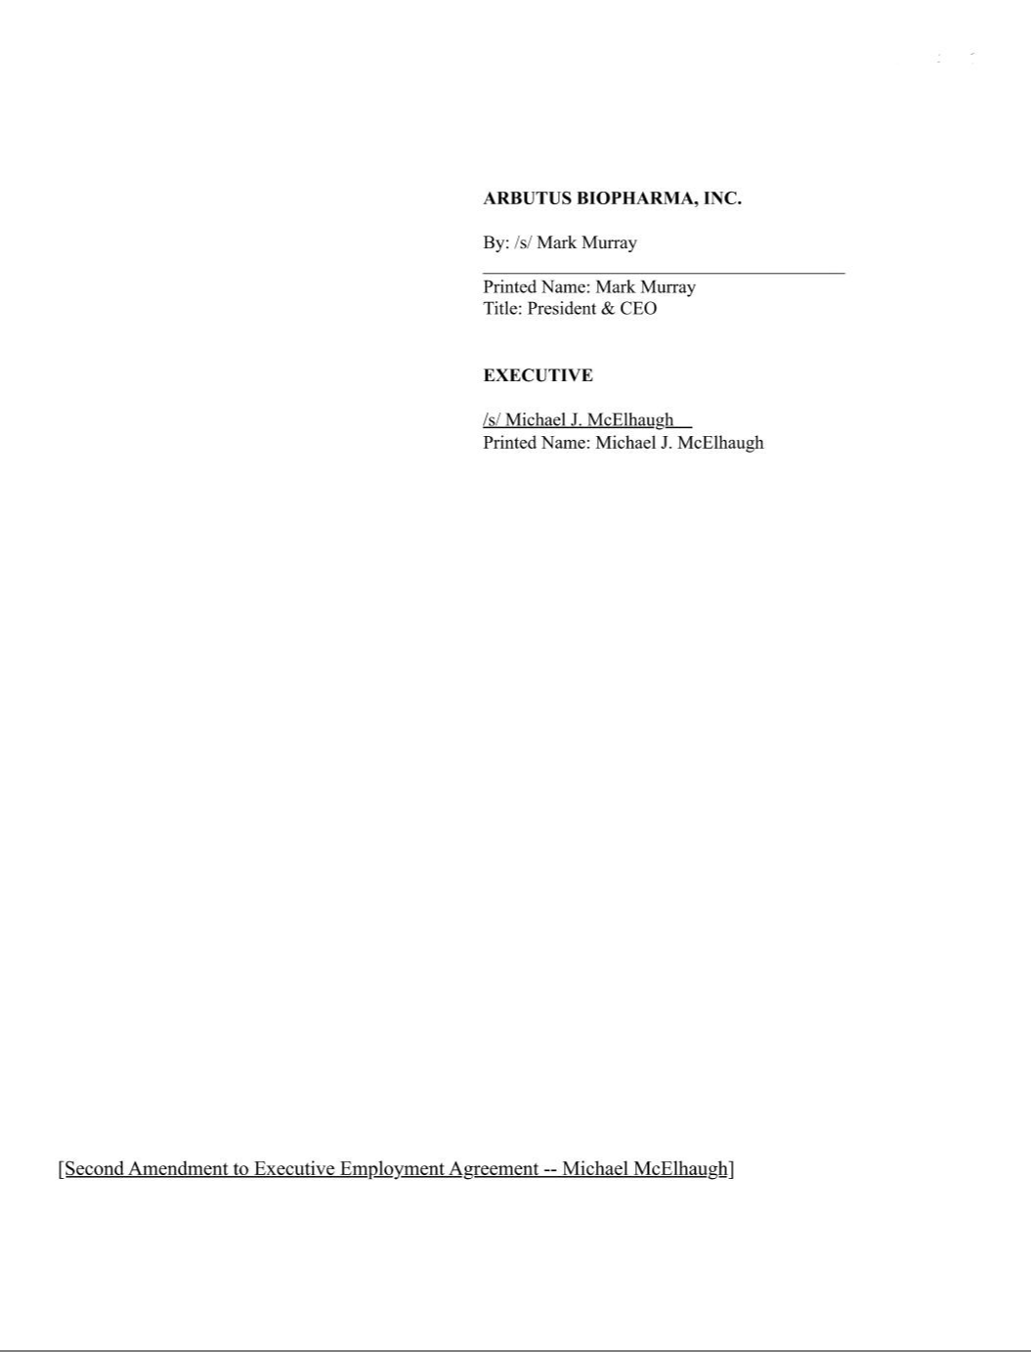

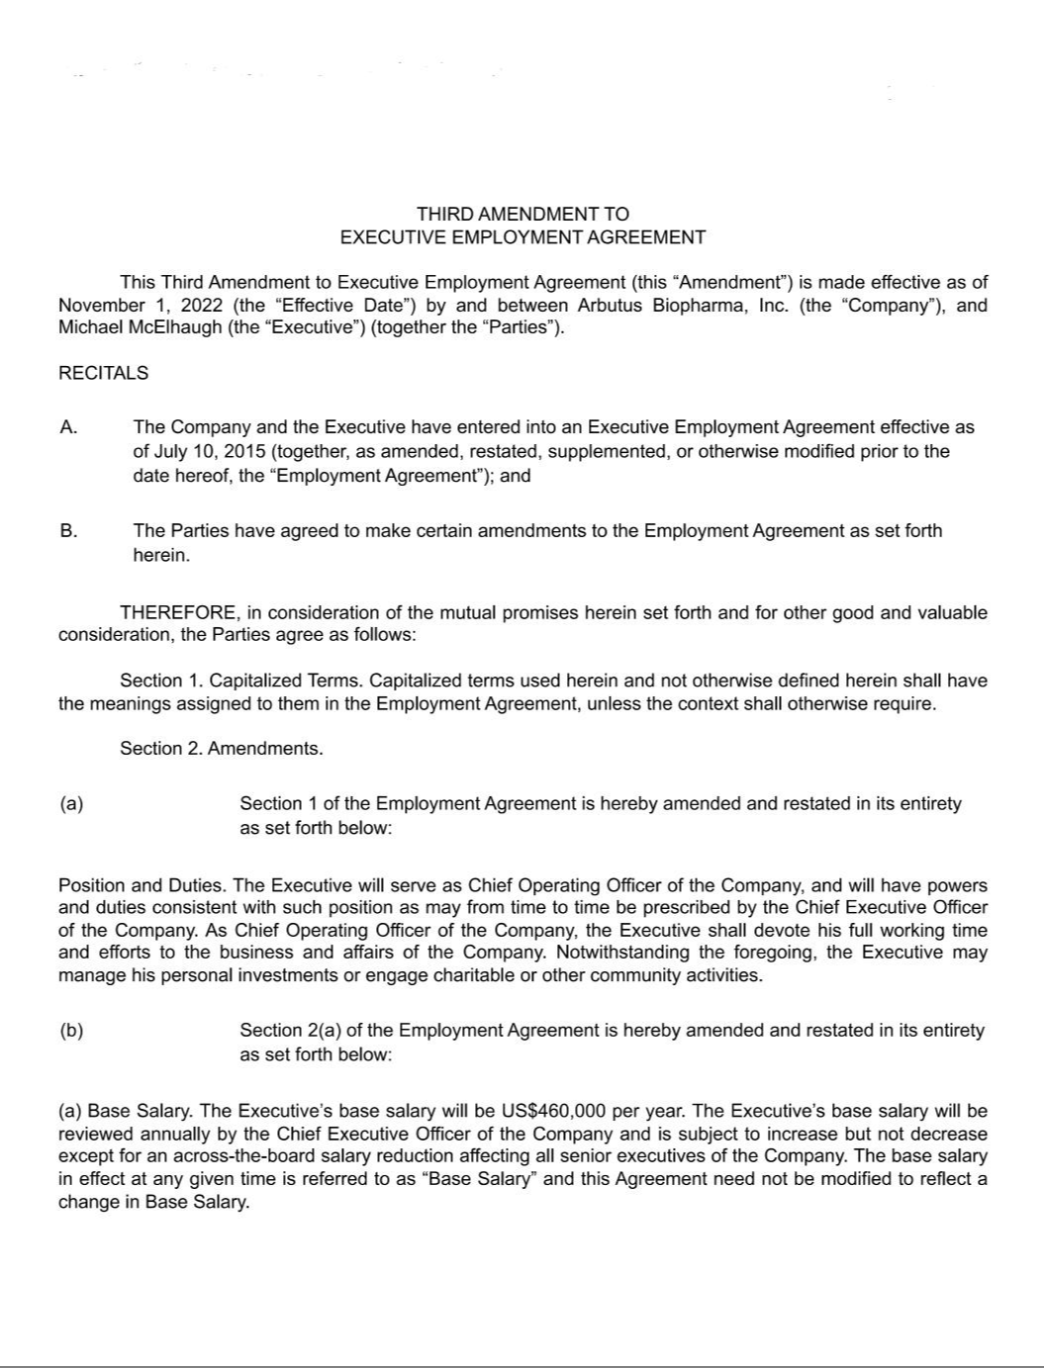

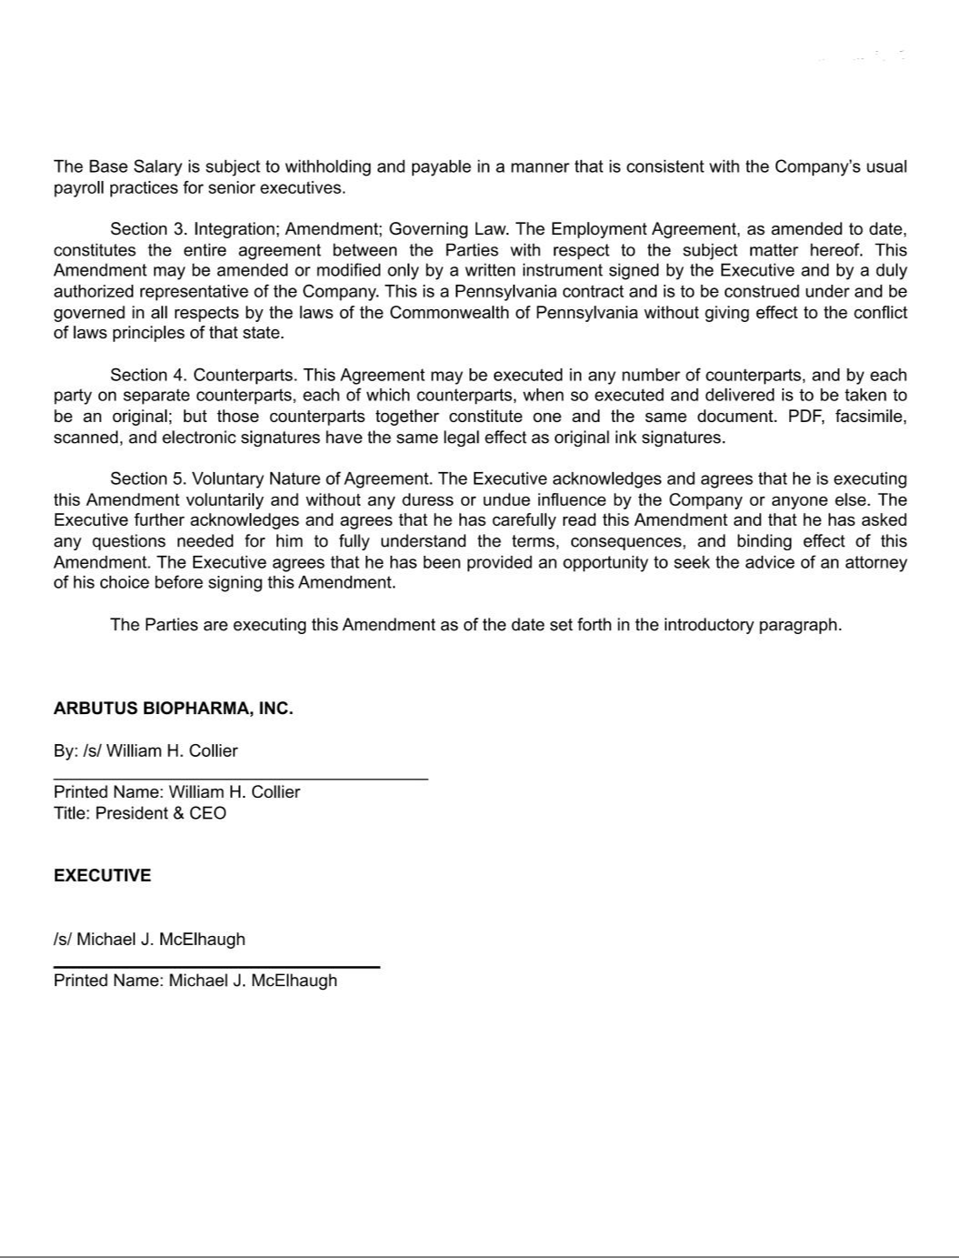

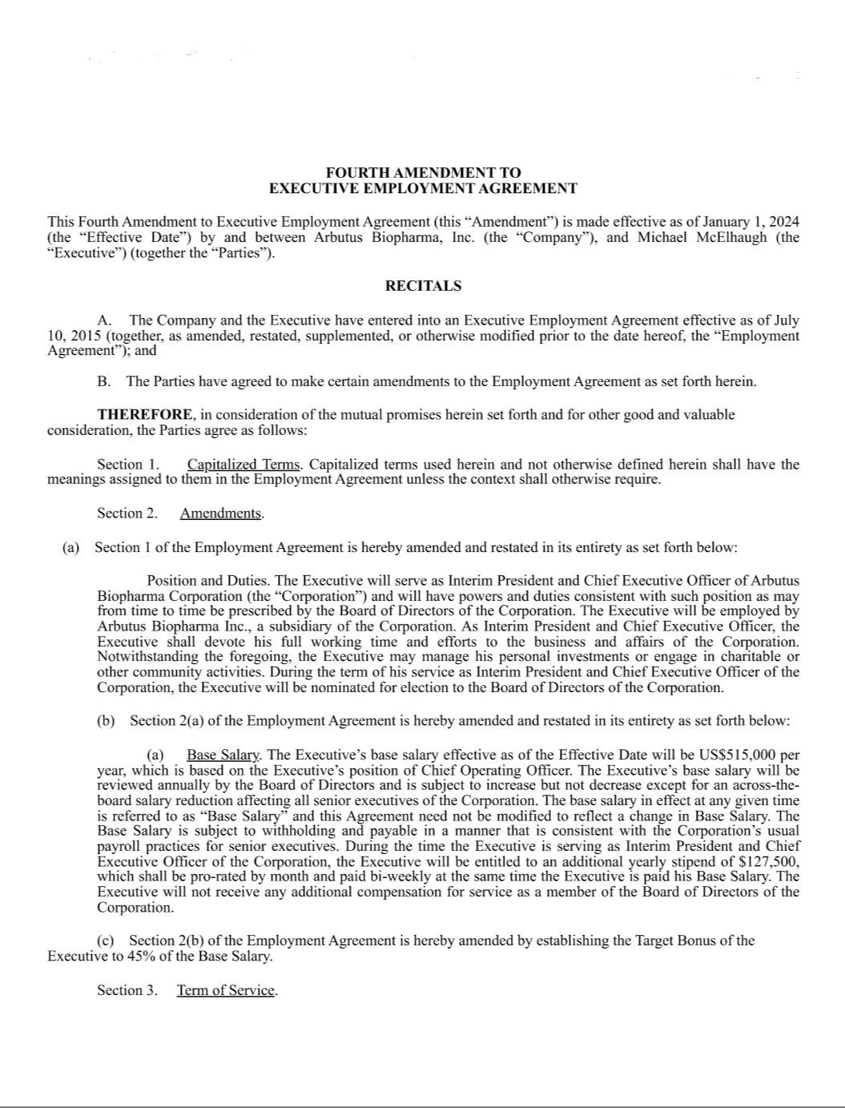

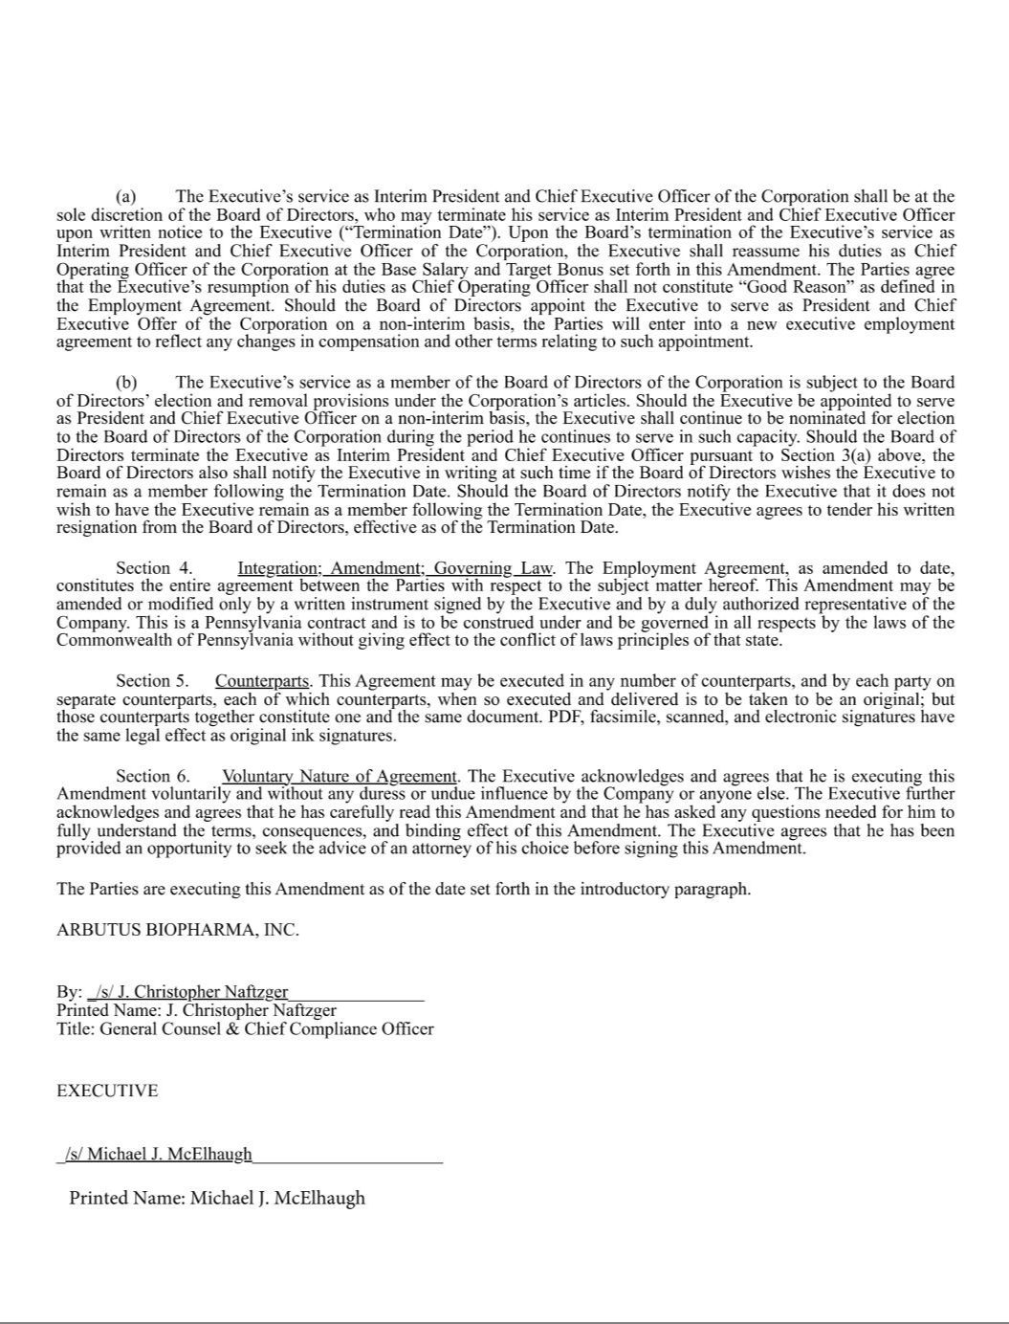

Exhibit 10.34

Separation and Release Agreement
By and Between Elizabeth A. Howard, J.D., Ph.D. and Arbutus Biopharma Corporation.

This Confidential Separation and Release Agreement (“Agreement”) is entered into between Elizabeth A. Howard, J.D., Ph.D. (“Executive”) and Arbutus Biopharma Corporation and is in consideration of the mutual undertakings set forth below.

Executive and Arbutus Biopharma Corporation have mutually agreed to terminate Executive’s employment with Arbutus Biopharma Corporation’s wholly-owned subsidiary, Arbutus Biopharma Inc. (unless otherwise specified, the defined term “Company” shall refer to Arbutus Biopharma Corporation and Arbutus Biopharma Inc.). In order to assist Executive in her transition and to acknowledge the past contributions of Executive, the Company has decided to offer Executive the benefits described below in exchange for certain protections of the business of the Company that the Company will require in return. To clearly set forth the terms and conditions of Executive’s departure, the parties agree as follows:

- The purpose of this Agreement is to set forth the mutual understanding of the parties. This Agreement is subject to, and governed by, the Employment Agreement between Executive and Arbutus Biopharma, Inc., dated effective March 7, 2016 (“Executive Employment Agreement”), with the exception of the terms set forth in paragraphs 2 through 4 below, which supersede and replace any terms in the Executive Employment Agreement inconsistent with said paragraphs 2 through 4 below. Except for those provisions of the Executive Employment Agreement that survive termination of employment pursuant to their terms consistent with Section 17 of the Executive Employment Agreement, including but not limited to Sections 4 (Non-Competition and Non-Solicitation), 8 (Section 409A Compliance), 9 (Confidential Information), 10 (Cooperation; Other Documents; Non-Disclosure), and 11 (Arbitration of Disputes), which shall all remain in full force and effect subject to applicable law, the Executive Employment Agreement shall terminate as of the End Date as that term is defined below.

- Executive’s employment with the Company shall terminate effective July 7, 2023 (“End Date”). Executive will be paid on the End Date for all working time through and including the End Date, in addition to the value of any accrued and unused paid time off. Executive will also be reimbursed for all appropriate expenses incurred through of the End Date. Executive is entitled to the vested benefits, if any, Executive may have in the Company’s 401(k) Plan, which Executive may exercise in accordance with the terms of the Company’s 401(k) Plan. By signing this Agreement, Executive acknowledges and agrees that, except as noted below, Executive has been fully paid any and all compensation due and owing to Executive, including all wages, salary, commissions, bonuses, options, shares, stock, incentive payments, equity interests, profit-sharing payments, expense reimbursements, accrued but unused vacation pay, leave or other benefits.

Executive has agreed to perform services for the Company as an independent contractor after the End Date pursuant to the terms of the Consulting Agreement dated July 7, 2023 between the Company and the Executive (the “Consulting Agreement”). The Consulting Agreement describes, in addition to the fees for post-employment services, the continuing post-employment vesting and exercise rights provided to Executive under those restricted stock unit awards and stock option awards provided to Executive prior to the End Date. Any compensation provided to Executive as a result of Executive’s work as an independent contractor is governed by the separate Consulting Agreement.

DCACTIVE-72975020.1

- Subject to Executive executing and returning the General Release and Waiver attached as Exhibit A within twenty-one (21) days of the End Date, without revoking same, and in full satisfaction of its obligations under the terms of the Agreement, the Company shall, within sixty (60) days of the End Date, pay to Executive:

  - a lump-sum, all-inclusive payment in the amount of $657,000.00, less normal payroll taxes and deductions, representing Executive’s 2023 Base Salary for a period of eighteen months; and

  - a lump-sum, all-inclusive payment in the amount of $90,240.00, less normal payroll taxes and deductions, representing Executive’s prorated 2023 annual discretionary target bonus.

- Except as noted in Paragraphs 2 and 3 of this Agreement, no other payments will be provided to Executive and no perquisites or benefits of any nature or kind will be provided or continued after the End Date (except as provided in the Consulting Agreement). Executive acknowledges and agrees that as of the End Date, as Executive has not been receiving healthcare benefits from the Company, she is not entitled to the COBRA-related severance benefits set forth in Section 6(b)(iii) of the Executive Employment Agreement.

- Release.

The payments and other terms described above are in full satisfaction of all matters and claims related to Executive’s employment with the Company upon Executive’s execution of the General Release and Waiver, attached as Exhibit A to this Agreement.

- Confidentiality and Non-Solicitation

The Company reminds Executive that she has on-going obligations to the Company regarding Confidentiality and Non-Solicitation as set out in Section 4 of the Executive Employment Agreement. By signing this Agreement and accepting the payments referred to above in Paragraph 3, Executive acknowledges and agrees that she is bound by these obligations and affirms that she will abide by these obligations. Nothing in this Agreement or the Executive Employment Agreement prevents Executive from discussing or disclosing information about unlawful acts in the workplace, such as harassment or discrimination or any other conduct that Executive may have reason to believe is unlawful.

7. Non-Disparagement.

The Company and the Executive shall treat each other respectfully and professionally and not disparage the other party, and the other party’s officers, directors, employees, shareholders and agents, in any manner likely to be harmful to them or their business, business reputation or personal reputation; provided that both Executive and the Company will respond accurately and fully to any question, inquiry or request for information when required by the legal process. Nothing in this Agreement prevents Executive from discussing or disclosing information about unlawful acts in the workplace, such as harassment or discrimination or any other conduct that Executive may have reason to believe is unlawful. Further, this prohibition does not preclude

Executive from providing truthful testimony if compelled by law nor does it prohibit the disclosure 2

DCACTIVE-72975020.1

of factual information that may be disclosed pursuant to California Code of Civil Procedure 1001.

- Litigation and Regulatory Cooperation

The Company also reminds Executive that she has on-going obligations to: (i) reasonably cooperate with the Company in the defense or prosecution of any claims or actions now in existence or which may be brought in the future against or on behalf of the Company which relate to events or occurrences that took place while the Executive was employed by the Company, including but not limited to, being available to meet with counsel to prepare for discovery or trial and to act as a witness on behalf of the Company at mutually convenient times; and (ii) reasonably cooperate with the Company in connection with any investigation or review of any federal, state or local regulatory authority relating to events or occurrences that took place while the Executive was employed by the Company; provided that any “services provided by the Executive shall be governed by, and subject to, the terms of Consulting Agreement, including the Consulting Agreement’s compensation obligations.

- Communication Coordination.

Executive and the Company shall cooperate to coordinate appropriate internal and external communications concerning Executive’s separation from the Company. The Company shall have final approval on all communications.

- Retention of Rights Regarding Government Agencies

Notwithstanding anything in this Agreement, the attached General Release, or the terms of the Executive Employment Agreement (collectively the “Agreements”), nothing in the Agreements prohibits Executive from reporting possible violations of United States federal law or regulation to any United States governmental agency or entity, including but not limited to the Department of Justice, the Securities Exchange Commission, the Congress, and any agency Inspector General, or making other disclosures that are protected under the whistleblower provisions of United States federal law or regulation without prior authorization or any notice to the Company.

- Internal Revenue Code Section 409A.

The Company and the Executive intend to comply with the requirements of section 409A of the Internal Revenue Code of 1986, as amended (“Section
409A”). All payments under this Agreement are intended to either be exempt from or comply with the requirements of Section 409A. All payments made under this Agreement shall be strictly paid in accordance with the terms of this Agreement. The Company and the Executive expressly understand that the provisions of this Agreement shall be construed and interpreted to avoid the imputation of any additional tax, penalty or interest under Section 409A and to preserve (to the nearest extent reasonably possible) the intended benefits payable to Executive hereunder. The severance benefits paid under this Agreement shall be treated as a separate payment of compensation for purposes of Section 409A. Any reimbursements or in-kind benefits provided under this Agreement that are subject to Section 409A shall be made or provided in accordance with the requirements of Section 409A, including, where applicable, the requirement

that (i) any reimbursement is for expenses incurred during the period of time specified in the Agreement, (ii) the amount of 3

DCACTIVE-72975020.1

expenses eligible for reimbursement, or in-kind benefits provided, during a calendar year may not affect the expenses eligible for reimbursement, or in-kind benefits to be provided, in any other calendar year, (iii) the reimbursement of an eligible expense will be made no later than the last day of the calendar year following the year in which the expense is incurred, and (iv) the right to reimbursement or in-kind benefits is not subject to liquidation or exchange for another benefit. Executive’s right to any deferred compensation, as defined under Section 409A, shall not be subject to borrowing, anticipation, alienation, sale, transfer, assignment, pledge, encumbrance, attachment, or garnishment by creditors, to the extent necessary to avoid additional tax, penalties and/or interest under Section 409A. Nothing herein, including the foregoing sentence, shall change the Company’s rights and/or remedies under the Agreement and/or applicable law. In no event shall the Company be liable for any penalties, costs, damages, levies or taxes imposed on Executive pursuant to Section 409A.

- Execution.

Executive understands and agrees that this Agreement shall be null and void and have no legal or binding effect whatsoever if: (1) Executive signs but then timely revokes the Agreement before the seven day revocation period or (2) the Agreement is not signed by Executive on or before the twenty-first (21st) day after Executive receives it.

- Severability.

Executive acknowledges that the provisions of this Agreement (and the Release attached hereto) are both reasonable and enforceable, but the provisions are severable, and the invalidity of any one or more provisions shall not affect or limit the enforceability of the remaining provisions. Should any provision be held unenforceable for any reason, then such provision shall be enforced to the maximum extent permitted by law.

- Disputes

In the event of any dispute concerning the validity, interpretation, enforcement or breach of this Agreement or in any way related to Executive’s employment by the Company or the termination of such employment, the dispute shall be resolved by arbitration under the same terms as set forth in the Executive Employment Agreement.

- Choice of Law.

This Agreement, including the Release shall be governed in accordance with the laws of the State of California without giving effect to the conflict of laws principles of that state.

- Integration

This Agreement, together with Executive’s continuing post-employment obligations as expressed in the Executive Employment Agreement and the Consulting Agreement, represent and contain the entire understanding between the parties in connection with its subject matter, and supersedes any prior written or oral agreements or understandings. No modification or waiver of any provision of this Agreement shall be valid unless in writing and signed by

Executive and the Chief Executive Officer of the Company. Executive acknowledges that in signing this Agreement she has not relied upon any 4

DCACTIVE-72975020.1

representation or statement not set forth in this Agreement made by the Company or any of its representatives.

IN WITNESS WHEREOF, and intending to be legally bound, Executive and the authorized representative of the Company have executed this Agreement on the dates indicated below.

ARBUTUS BIOPHARMA CORPORATION ELIZABETH A. HOWARD, J.D., PH.D.

By: /s/ William Collier By: /s/ Elizabeth Howard

Printed Name: William Collier Date: Jul 21, 2023

Title: President & CEO

Date: Jul 20, 2023

5

DCACTIVE-72975020.1

EXHIBIT A

GENERAL RELEASE AND WAIVER

This General Release and Waiver (“Release”) is made and entered into as of July 21, 2023 (the “Release Date”), by and between Arbutus Biopharma, Inc. (the “Company”), and Elizabeth A. Howard, J.D., Ph.D. (the “Executive”). The Company and/or Executive may hereinafter be referred to individually as a “Party” or collectively as the “Parties.”

In consideration of the mutual covenants hereinafter set forth, the Parties hereby agree as follows:

- Separation. Executive’s employment with the Company ended effective July 7, 2023 without Cause.

- Payment and Benefits. In consideration of the promises made in this Release and as full and complete satisfaction of any and all obligations owing to Executive pursuant to the Employment Agreement between Executive and the Company dated effective March 7, 2016 (“Executive Employment Agreement”), including without limitation, any and all amounts due and owing to Executive upon Executive’ separation from employment without Cause pursuant to Section 6(b) of the Executive Employment Agreement, the Company has agreed to pay Executive the benefits described in the Separation and Release Agreement to which this Release is attached (the “Separation and Release Agreement”). Executive understands and acknowledges that the benefits described in the Separation and Release Agreement constitute benefits in excess of those to which Executive would be entitled without entering into this Release. Executive acknowledges that such benefits are being provided by the Company as consideration for Executive entering into this Release, including the release of claims and waiver of rights provided in Section 3 of this Release, and are above and beyond any compensation, wages or salary or other sums to which Executive was entitled as a result of Executive’s employment with the Company, or under any contract or law.

- Release of Claims and Waiver of Rights.

- Executive, on Executive’s own behalf and that of Executive’s spouse, heirs, executors or administrators, assigns, insurers, attorneys and other persons or entities acting or purporting to act on Executive’s behalf (the “Executive’s Parties”), hereby irrevocably and unconditionally release, acquit and forever discharge the Company and Arbutus Biopharma Corporation, their respective affiliates, subsidiaries, directors, officers, employees, shareholders, partners, agents, representatives, predecessors, successors, assigns, insurers, attorneys, benefit plans sponsored by the Company and/or Arbutus Biopharma Corporation and said plans’ fiduciaries, agents and trustees (collectively, the “Released Parties”), from any and all actions, cause of action, suits, claims, obligations, liabilities, debts, demands, contentions, damages, judgments, levies and executions of any kind, whether in law or in equity, known or unknown, which the Executive’s Parties have, have had, or may in the future claim to have against the Released Parties by reason of, arising out of, related to, or resulting from Executive’s employment with the Company (including under the Executive Employment Agreement) or the termination thereof. This release specifically includes without limitation any claims arising in tort or contract or under statute, any claim based on wrongful discharge, any claim based on breach of contract, notice of termination or payment in lieu, severance pay or severance benefits, any claim arising under federal, state or local law prohibiting race, sex, age, religion, national origin, handicap, disability or other forms of discrimination, any claim arising under federal,

DCACTIVE-72975020.1

state or local law concerning employment practices, and any claim relating to compensation or benefits. This specifically includes, without limitation, any claim which the Executive has or has had under Title VII of the Civil Rights Act of 1964; 42 U.S.C. §§ 1981-1988; the Americans with Disabilities Act; the Age Discrimination in Employment Act (and the Older Workers Benefit Protection Act), the Fair Labor Standards Act; the Family and Medical Leave Act; the Workers Adjustment and Retraining Notification Act, as amended; the Occupational Safety and Health Act, as amended; the Sarbanes-Oxley Act of 2002; the Dodd-Frank Wall Street Reform and Consumer Protection Act; the California Family Rights Act; the California Fair Employment and Housing Act; the California Equal Pay Law, California Labor Code Section 1197.5; the Unruh Civil Rights Act, California Civil Code Section 51 et seq.; the California Worker Adjustment and Retraining Notification Act, California Labor Code Sections 1400 et seq.; the California Labor Code; the California Constitution; statutory provision regarding retaliation/discrimination for filing a workers’ compensation claim under Cal. Labor Code § 132a; the Pennsylvania Human Relations Act; the Pennsylvania Minimum Wage Act; the Pennsylvania Wage Payment and Collection Law; wrongful discharge, discrimination, retaliation, or other violation of the Pennsylvania Whistleblower Law; or violation of any British Columbia, Canada statute or law including without limitation the Employment Standards Act, RSBC 1996, c.113 (as am.) or the Human Rights Code, RSBC 1996, c210 (as am.) and/or any other claims of whatever nature arising in connection with Executive’s employment with the Company or her separation from such employment, and any and all other claims arising under federal, state or local law.

Executive acknowledges she received any and all leaves of absence to which she may have been entitled during employment, and that she suffers from no workplace injuries arising from her employment at the Company. It is understood and agreed that the waiver of benefits and claims contained in this Section does not include: (i) a waiver of the right to payment of any vested, nonforfeitable benefits to which Executive or a beneficiary of Executive may be entitled under the terms and provisions of any employee benefit plan of the Company or Arbutus Biopharma Corporation which have accrued as of the separation or would continue to accrue under the Consulting Agreement as specifically provided therein; (ii) a waiver of any rights to indemnification under the Certificate of Incorporation, Bylaws or similar organizational documents of the Company, Arbutus Biopharma Corporation or an subsidiary of the Company of Arbutus Biopharma Corporation or under applicable law and regulation; (iii) a waiver of the right for claims of unemployment insurance, workers’ compensation benefits, or state disability compensation; (iv) a waiver of the right to challenge the validity of this release pursuant to the Age Discrimination in Employment Act; (v) a waiver of any other rights that cannot by law be released by private agreement; (vi) rights under outstanding equity award agreements (stock options and restricted stock units) between Executive and the Company or that would continue to accrue under the Consulting Agreement; and (vii) the Executive’s rights under the Consulting Agreement. Executive acknowledges that she is only entitled to the severance benefits and compensation set forth in the Separation and Release Agreement and the Consulting Agreement, and that all other claims for any other benefits or compensation, including but not limited to any additional bonuses, are hereby waived, except those expressly stated in the preceding sentence.

Nothing in this Release shall be deemed to require the waiver or release of any claim that may not be released or waived under applicable federal or state law. Notwithstanding the foregoing or any other provisions here, nothing in this Release is intended to, or shall, limit or interfere, in any way, with Executive’s right or ability, under federal, state, or local law, to file or initiate a charge, claim, or complaint of discrimination, or any other unlawful employment practice, that cannot

legally be waived, or to communicate with any federal, state, or local government agency charged with the enforcement and/or investigation of claims of unlawful 2

DCACTIVE-72975020.1

employment practices, including but not limited to the U.S. Equal Employment Opportunity Commission and any state or city fair employment practices agency. Further, nothing in this Agreement is intended to, or shall, limit or interfere, in any way, with Executive’s right or ability to participate in or cooperate with any investigation or proceeding conducted by any such agency. Further, nothing in this Agreement shall be construed as, or shall interfere with, abridge, limit, restrain, or restrict Executive’s right to engage in any activity or conduct protected by Section 7 or any other provision of the National Labor Relations Act, or to report possible violations of federal, state, or local law or regulation to any government agency or entity. Executive and the Company acknowledge and agree that Executive’s right and ability to engage and participate in the activities described in this Paragraph shall not be limited or abridged, in any way, by any term, condition, or provision of, or obligation imposed by, this Agreement. Notwithstanding the foregoing, Executive understands that the waivers and releases in this Release shall be construed and enforced to the maximum extent permitted by law. Executive also understand and acknowledge that, by signing this Release, Executive has completely waived her right to receive any individual relief, including monetary damages, in connection with any such claim, charge, complaint, investigation, or proceeding, and if Executive is awarded individual relief and/or monetary damages in connection therewith, Executive hereby unconditionally assign to the Company, and agrees to undertake any and all measures necessary to effectuate such assignment of, any right or interest she may have to receive such individual relief and/or monetary damages.

- Executive hereby acknowledges that she understands that under this Release she is releasing any known or unknown claims she may have arising out of, related to, or resulting from Executive’s employment with the Company or the termination thereof (the “Released Claims”). Executive therefore acknowledges that she has read and understands Section 1542 of the California Civil Code, which reads as follows:

A GENERAL RELEASE DOES NOT EXTEND TO CLAIMS THAT THE CREDITOR OR RELEASING PARTY DOES NOT KNOW OR SUSPECT TO EXIST IN HIS OR HER FAVOR AT THE TIME OF EXECUTING THE RELEASE AND THAT, IF KNOWN BY HIM OR HER, WOULD HAVE MATERIALLY AFFECTED HIS OR HER SETTLEMENT WITH THE DEBTOR OR RELEASED PARTY.

Even though Executive is aware of this right, Executive nevertheless hereby voluntarily waives the right described in Section 1542 and any other statutes of similar effect, and elects to assume all risks for claims that now exist in Executive favor, known or unknown, arising from the subject matter of the Release. Executive acknowledges that different or additional facts may be discovered in addition to what Executive now knows or believes to be true with respect to the matters released in this Release, and Executive agrees that this Release will be and remain in effect in all respects as a complete and final release of the matters released, notwithstanding any such different or additional facts. Executive expressly waives and relinquishes all rights and benefits under that section and any law of any jurisdiction of similar effect with respect to the Released Claims.

- Indemnification of Executive. Company shall continue to indemnify Executive pursuant to the terms of the Indemnity Agreement, dated as of March 7, 2016, by and between Company and Executive during the term of the Consulting Agreement.

- Acknowledgment of Waiver of Claims under ADEA. Executive acknowledges that Executive is waiving and releasing any rights Executive may have
under the Age

3

DCACTIVE-72975020.1

Discrimination in Employment Act of 1967 (“ADEA’’), as amended by the Older Workers’ Benefit Protection Act (“OWBPA”), and that this waiver and release is knowing and voluntary. Executive acknowledges that Executive has been advised by this writing that:

- Executive is receiving consideration, a sufficient portion of which is in addition to anything of value to which she otherwise would have been entitled;
and

- Executive fully understands the terms of this Release and that she enters into it voluntarily without any coercion on the part of any person or entity;
and

- Executive was given adequate time to consider all implications and to freely and fully consult with and seek the advice of whomsoever she deemed appropriate and has done so; and

- Executive represents that she has carefully read and fully understand all of the provisions and effects of this Release; and

- Executive was advised in writing by way of this document to consult an attorney before signing this Release; and

- Executive was advised that she had twenty-one (21) calendar days within which to consider this Release before signing it, though she may voluntarily sign before the end of this period; and

- Executive has seven (7) calendar days after executing this Release within which to revoke this Release. This Release shall not become effective or enforceable until seven (7) days after Executive executes this Release. If the seventh day is a weekend or national holiday, Executive has until the next business day to revoke. If Executive elects to revoke this Agreement, she agrees to notify Shannon Briscoe, in writing, of her revocation. Any determination of whether Executive’s revocation was timely shall be determined by the date of actual receipt by Shannon Briscoe.

- Representation of No Filings. To the full extent permitted by law, Executive represents that she has not filed, will not file and will not authorize any third party acting on her behalf to file, any suits, charges, claims or the like regarding her employment by, or separation of employment from the Company or Arbutus Biopharma Corporation. Although it is recognized that the right to file a claim under certain federal statutes cannot be waived, Executive agrees to forego any personal recovery. To the extent that Executive or any third party does seek redress for any claim covered and released by this Release, and a settlement or judgment of said claim is reached or entered, Executive shall designate the Company as the recipient of any such monies allocated to Executive by the payor or, if that is not possible, Executive shall pay to the Company the amount received from the payor within seventy-two (72) hours of Executive’s receipt of said monies.

- No Admissions. The Company denies that it, Arbutus Biopharma Corporation or any of their respective employees or agents has taken any improper action against Executive. Nothing contained herein shall be deemed as an admission by the Company or Arbutus Biopharma Corporation of any liability of any kind

to Executive, all such liability being expressly denied. Further, this Release shall not be admissible in any proceeding as evidence of 4

DCACTIVE-72975020.1

improper action by the Company, Arbutus Biopharma Corporation or any of their respective employees or agents.

- Amendment; Waiver. No amendment or variation of the terms of this Release shall be valid unless made in writing and signed by Executive and the Company. A waiver of any term or condition of this Agreement shall not be construed as a general waiver by the Company. Failure of either the Company or Executive to enforce any provision or provisions of this Agreement shall not waive any enforcement of any continuing breach of the same provision or provisions or any breach of any provision or provisions of this Agreement.

[Remainder of page left blank intentionally; Signature page follows.]
5

DCACTIVE-72975020.1

IN WITNESS WHEREOF, and intending to be legally bound, Executive and the authorized representative of the Company have executed this Agreement on the dates indicated below.

ARBUTUS BIOPHARMA INC. |  |  |  |  |  | ELIZABETH A. HOWARD, J.D., PH.D.
By: /s/ William CollierBy: /s/ Elizabeth Howard
Printed Name: William Collier |  |  |  |  |  | Date: Jul 21, 2023

Title: President & CEO

Date: Jul 20, 2023

6

DCACTIVE-72975020.1

Exhibit 10.35

CONSULTING AGREEMENT

Consultant Name: Elizabeth A. Howard, J.D., Ph.D. (“Consultant”)

Effective Date: July 7, 2023

As a condition of becoming retained by Arbutus Biopharma Corporation, a British Columbia corporation, Arbutus Biopharma Inc., a Delaware Corporation, or any of its current or future subsidiaries, affiliates, successors or assigns (collectively, “Arbutus”), and in consideration of Consultant’s consulting relationship with Arbutus and receipt of the compensation now and hereafter paid by Arbutus, Consultant hereby agrees to the following:

- Services and Fees

  - Services to be Performed. While engaged by Arbutus under this consulting agreement (“Agreement”), Consultant will provide the consulting services set forth on each Statement of Work (“SOW”), a sample of which is attached hereto, under the heading “Description of Services” (the “Services”) and shall initially report to Arbutus’s General Counsel regarding the performance of such Services. Consultant represents that Consultant is duly licensed (as applicable) and has the qualifications, the experience and the ability to properly perform the Services. By signing this Agreement, Consultant also confirms with Arbutus that Consultant is under no contractual or other legal obligations that would prohibit performance of Services and further agrees Consultant will not enter into any agreement or obligation in conflict with this Agreement or any of Consultant’s obligations under it. Arbutus and Consultant agree that no services shall commence and no payment shall be made until an SOW is complete and this Agreement signed by both parties.

  - Fees. As consideration for the Services provided by Consultant and other obligations, Consultant shall invoice and Arbutus shall pay to Consultant the amounts and in the manner specified in the applicable SOW, under the heading “Compensation”, including the continued vesting and exercise periods of the restricted stock units and stock options described in the SOW and subject to the respective plans. Following the final completion of each SOW Consultant shall perform timely final budget or accounting management to ensure all fees and out-of-pocket costs reasonably incurred by Consultant are correctly itemized and invoiced. Arbutus shall have no obligation to pay any invoices issued by Consultant in respect of such SOW after the later of (a) final budget reconciliation occurs and final payment or credit is issued or (b) three (3) months after the final completion of such SOW. Arbutus reserves the right to make reports to applicable government agencies disclosing information associated with any compensation paid under this Agreement in order to comply with applicable laws, which information may be published on government records available to the public. Arbutus is not required to provide Consultant advanced notice prior to making any such disclosures.

  - Statements of Work. The execution of each SOW will be at the sole option of Arbutus, and no SOW will be binding until duly executed by Arbutus and Consultant. Each SOW so executed will be governed by the terms and conditions of this Agreement, all of which terms and conditions herein will be incorporated by reference and will form a part of each SOW.

- Confidential Information.

  - Protection of Information. Consultant understands that during the Term, Arbutus intends to provide Consultant with certain information, including Confidential Information (as defined below), without which Consultant would not be able to perform Services. At all times during the Term and thereafter, Consultant shall hold in strictest confidence, and not use, except to the extent necessary to perform the Services, and not disclose to any person or entity, without

written authorization from Arbutus in each instance, any Confidential Information that Consultant obtains from Arbutus or otherwise obtains, accesses or creates in connection with, or as a result of, the Services during the Term, until such Confidential Information becomes publicly known and made generally available through no wrongful act of Consultant as to the item or items involved. Consultant shall not make copies of such Confidential Information unless in the ordinary course of the provision of Services. Notwithstanding anything to the contrary in the foregoing, Consultant may disclose the terms of this Agreement to Consultant’s immediate family members and to Consultant’s legal, tax and other advisors. Nothing in this Agreement prevents Consultant from discussing or disclosing information about unlawful acts in the workplace, such as harassment or discrimination or any other conduct that Consultant may have reason to believe is unlawful.

  - Confidential Information. Consultant understands that “Confidential Information” means any and all information and physical manifestations thereof not generally known or available outside Arbutus and information and physical manifestations thereof entrusted to Arbutus in confidence by third parties, whether or not such information is patentable, copyrightable or otherwise legally protectable. Confidential Information includes, without limitation: inventions, technical data, trade secrets, know-how, research, products, software codes and designs, algorithms, patent applications, laboratory notebooks, processes, formulas, techniques, biological materials, agreements with third parties, lists of, or information relating to, employees and consultants of Arbutus (including, e.g., the names, contact information, jobs, compensation, and expertise of such employees and consultants), lists of, or information relating to, suppliers and customers (including, but not limited to, customers of Arbutus), price lists, pricing methodologies, cost data, market share data, marketing plans, licenses, contract information, business plans, financial forecasts, historical financial data, budgets or other business information disclosed to Consultant by Arbutus either directly or indirectly.

  - Third Party Information. During the Term and thereafter, Consultant will not improperly use or disclose to Arbutus any confidential, proprietary or secret information of Consultant’s current or former clients or any other person, and Consultant will not bring any such information onto Arbutus’s property or place of business

  - U.S. Defend Trade Secrets Act. Notwithstanding the foregoing, the U.S. Defend Trade Secrets Act of 2016 (“DTSA”) provides that an individual shall not be held criminally or civilly liable under any federal or state trade secret law for the disclosure of a trade secret that is made (i) in confidence to a federal, state, or local government official, either directly or indirectly, or to an attorney; and (ii) solely for the purpose of reporting or investigating a suspected violation of law; or
- in a complaint or other document filed in a lawsuit or other proceeding, if such filing is made under seal. In addition, DTSA provides that an individual who files a lawsuit for retaliation by an employer for reporting a suspected violation of law may disclose the trade secret to the attorney of the individual and use the trade secret information in the court proceeding, if the individual (A) files any document containing the trade secret under seal; and (B) does not disclose the trade secret, except pursuant to court order.

- Term and Termination.

  - Term. Consultant shall serve as a consultant to Arbutus commencing on the Effective Date and terminating one (1) year after the Effective Date unless this Agreement is renewed by written consent of Arbutus and Consultant (the “Term”). In the event of a renewal, the terms of this Agreement will apply to the renewed Agreement unless otherwise agreed by the parties in writing.

-2-

  - Termination for Convenience. Following the initial one-year period after the Effective Date, either party may terminate this Agreement at any time upon thirty (30) days’ written notice. In the event of such termination, Consultant shall be paid for any portion of the Services that has been performed prior to the termination.

  - Termination for Cause. Should either party default in the performance of this Agreement or materially breach any of its obligations under this Agreement, the non-breaching party may terminate this Agreement immediately without obligation to make further payments except such compensation as is earned pursuant to the Statement of Work attached hereto as Exhibit A.

  - Arbutus Property; Returning Arbutus Documents. At the time of termination of the Agreement, Consultant will deliver to Arbutus (and will not keep in Consultant’s possession, recreate or deliver to anyone else) any and all devices, records, data, notes, reports, proposals, lists, correspondence, specifications, drawings, blueprints, sketches, laboratory notebooks, materials, flow charts, equipment, other documents or property, or reproductions of any of the aforementioned items developed by Consultant or Consultant’s personnel pursuant to this Agreement or otherwise belonging to Arbutus, its successors or assigns.

  - Survival. The provisions of this Agreement survive the termination of this Agreement to the extent necessary to effectuate the intent of the parties as expressed in this Agreement.

- Independent Consultant and Taxes.

  - Consultant’s relationship with Arbutus will be that of an independent contractor and not that of an employee. Consultant is responsible for the provision of and the expenses associated with any office space, equipment (including hardware and software), tools, machinery and personnel required by Consultant for performance of the Services. Consultant agrees: (i) to be solely responsible for determining the method, details and means of performing the Services; (ii) to have no authority to enter into contracts that bind Arbutus or create obligations on the part of Arbutus without the prior written authorization of Arbutus; (iii) to be ineligible for any Arbutus employee benefits; and (iv) to have full responsibility for all applicable taxes for all compensation paid to Consultant under this Agreement, including any withholding requirements that apply to any such taxes, and for compliance with all applicable labor and employment requirements with respect to Consultant’s self-employment, sole proprietorship or other form of business organization, including state worker’s compensation insurance coverage requirements, if any, and any U.S. immigration visa requirements. If Consultant is not a sole proprietor, Consultant shall pay and be responsible for all customary corporate source deductions and income taxes payable by Consultant in connection with the delivery of the Services. The payments set out in each invoice shall exclude all sales, value-added, excise, goods and services or other taxes or duties payable by Arbutus in respect of this Agreement. Consultant shall itemize all such taxes or duties on any invoice provided to Arbutus. To the extent possible under applicable tax laws, Consultant shall minimize any taxes applicable to the Services, including the use of tax exemption certificates, as appropriate. Arbutus shall not be responsible for any tax liability due to Consultant’s failure to make timely payments, or to meet any obligation owed by Consultant to any tax authority. Arbutus shall have no obligation to pay any taxes not invoiced by Consultant within one year following Arbutus’ payment of such invoice.

  - Tax Filing. Company and its wholly owned affiliates are required by the United States Internal Revenue Service to file IRS Form 1099 for all payees. Accordingly, all US Consultants must provide Company with his/her U.S. Social Security or Federal Identification Number upon execution of this Agreement.

-3-

  - IT Policies. Consultant acknowledges that to the extent the Services require access to Arbutus’s computing system, Consultant and any employee or subcontractor of Consultant who provide services under this Agreement has received a copy of Arbutus’s information technology (IT) policies and has read, understood and will comply with the terms of such policies.

- Conflicts of Interest. Consultant represents and warrants that Consultant does not currently have any business, professional, or personal relationships that would constitute a conflict of interest, and to the extent that any relationships could reasonably be perceived as a conflict of interest, any such circumstances have been previously disclosed and approved by Arbutus in writing.

- Certain Regulations.

  - Debarment. Consultant represents and warrants that Consultant has never been (i) under investigation for debarment or debarred pursuant to the Generic Drug Enforcement Act of 1992, 21 U.S.C. §335(a), as amended, or any similar state law or regulation or (ii) disqualified or restricted by the FDA pursuant to
- C.F.R. 312.70 or any other regulatory authority. During the Services, Consultant represents and warrants that Consultant will provide immediate written notice to Arbutus regarding any notice or other information related to (i) a pending or prospective investigation of Consultant for debarment or debarred pursuant to the Generic Drug Enforcement Act of 1992, 21 U.S.C. §335(a), as amended, or any similar state law or regulation or (ii) a pending or prospective disqualification or restriction of Consultant by the FDA pursuant to 21 C.F.R. 312.70 or any other regulatory authority. Upon the delivery of such written notice, Consultant will reasonably cooperate with Arbutus in connection with the foregoing.

  - Insider Trading. Consultant acknowledges that Consultant may in connection with this Agreement become aware of material non-public information regarding Arbutus, and that national, provincial and state securities laws prohibit Consultant and Consultant’s family from purchasing or selling any securities on the basis of such material non-public information and from assisting any others to do so. Consultant agrees that Consultant shall not violate and shall inform Consultant’s family members that they must not violate any applicable law or regulation bearing on trading in securities of Arbutus.

  - Code of Conduct and Business Ethics. Consultant agrees that in the performance of this Agreement, Consultant shall comply with all applicable laws and regulations including those which: (a) prohibit or penalize insider trading, fraud, theft, bribery or otherwise illegal transactions, and which (b) promote human rights, workplace safety practices and whistle blower protection. In addition, Consultant agrees that in the performance of this Agreement, Consultant shall conduct herself in an honest and ethical manner, respect the intellectual property rights and confidential information of third parties in addition to those of Arbutus, refrain from falsifying and misrepresenting information in the course of performing this Agreement, refrain from accepting or giving improper payments or gifts, and accurately document and record financial transactions related to this Agreement. Consultant acknowledges that Consultant has read and understood Arbutus’s code of conduct which embodies the principles described in this Section, and Consultant will comply with the principles set out in the Code in all activities related to the Services.

  - Anti-kickback, Anti-fraud and Anti-bribery.

    - Both Arbutus and Consultant intend for this Agreement to comply with the federal Anti-Kickback Statute, as set forth in 42 U.S.C. 1320a-7b and the regulations promulgated thereunder or any similar anti-kickback or anti-corruption statutes in other jurisdictions in which Arbutus and Consultant operate.

-4-

- Consultant agrees that all payments by Arbutus pursuant to this Agreement represent fair market value for the Services to be provided by Consultant. Consultant represents and warrants that payments or items of value received pursuant to this Agreement will not influence any decision that Consultant or any payee under this Agreement may make in order to assist Arbutus to secure an improper advantage or obtain or retain business.

- Consultant further represents and warrants that neither Consultant nor any payee under this Agreement has taken or will take any action that violates or could be perceived as violating any applicable anti-corruption legislation, including but not limited to the U.S. Foreign Corrupt Practices Act (the “FCPA”), and anti-bribery legislation in the location(s) where Consultant works or resides. Accordingly, and without limitation, Consultant or any payee under this Agreement has not and will not directly or indirectly pay, offer or promise to pay, give, solicit, accept, or receive or agree to receive, anything of value (including money or other tangible or intangible benefits) to or from any person or entity, where the thing of value is, or could reasonably be perceived as being, provided for purposes of (a) influencing any act or decision; (b) inducing the recipient to do or omit to do any act in violation of their lawful duty; (c) obtaining, retaining, or directing business or an advantage in business, or any other improper advantage; (d) bringing about or rewarding the improper performance by the recipient or another person of a relevant function or activity; or (e) inducing the recipient to use their influence to affect or influence any act or decision of a Public Official. For the purposes of this Section, “Public Official” means a government (whether national, state, provincial, or local) or public international organization such as the United Nations or World Bank or instrumentality thereof (including state-owned companies); any person holding a legislative, administrative, or judicial office, including any person working on behalf of a governmental entity or instrumentality thereof, government-controlled enterprise, or a public international organization; any political party, political official, or candidate for political office; or a member of a royal family or tribe.

- Consultant will provide Arbutus with all information required for Arbutus to fully and accurately reflect every transaction under this Agreement, including but not limited to invoices for all payments made by Arbutus, detailing the Services provided to Arbutus and the fair market value thereof. Consultant agrees to maintain accurate and complete records of all transactions having to do with this Agreement in accordance with generally accepted accounting principles and, if applicable, the requirements of the FCPA.

- Consultant agrees that Consultant will immediately notify Arbutus in writing if at any time it becomes aware or suspects that anyone involved in providing Services or receiving payment in connection with this Agreement is a Public Official.

- Consultant agrees that Consultant will immediately notify Arbutus if at any time Consultant becomes aware or suspect that there has been a request to take any action that would violate any portion of this Section.

- Arbutus reserves the right to conduct initial and periodic reviews of Consultant to ensure their proper qualifications, abilities, reputation, affiliations, and performance, and/or to conduct an audit of Consultant’s records and accounts for compliance with the terms of this Section. At the request of Arbutus, Consultant shall allow Arbutus or its representatives (staffed as Arbutus deems appropriate) to review or audit Consultant’s books, records, and files relating to this Agreement and Consultant will provide information and answer any reasonable questions that Arbutus or its representatives may have relating to Consultant’s performance of this Agreement.

- Consultant and Arbutus represent that the execution of this Agreement is not linked to any past, present, or future agreement to purchase, lease, recommend, prescribe, use, supply, or procure Arbutus’s products, or to provide any improper advantage to Arbutus.

-5-

    - Consultant agrees to fully adhere to all applicable transparency and disclosure requirements relating to this Agreement, including by fully disclosing the purpose and scope of this Agreement to any employer, professional body, institution, government agency, or otherwise locally designated competent authority. If applicable, Consultant shall also obtain written approval from Consultant’s employer. In addition, to the extent required by any applicable disclosure obligations, Consultant shall disclose that the Services are performed for Arbutus.

    - Consultant will not, engage in any activity, practice or conduct that would breach or contravene all applicable laws regarding tax evasion or the facilitation of tax evasion in connection with this Agreement.

  - Duty to Report Violations. If at any time any representation or warranty of Consultant set forth in this Section 6 are no longer accurate, Consultant will immediately notify Arbutus of such fact. In addition to other rights or remedies under this Agreement or at law, Arbutus may terminate this Agreement if Consultant breaches any such representations or warranties or if Arbutus learns that improper payments are being or have been made to or by Consultant or any individual or entity acting on its or their behalf. In case of such termination, no further payment will be due to Consultant, and Consultant will refund to Arbutus all payments made under this Agreement if requested by Arbutus, which shall not limit any other claims or rights that Arbutus may have against Consultant.

  - Reporting of Compensation. Notwithstanding any confidentiality obligations under this Agreement, Arbutus reserves the right to make reports to applicable government agencies disclosing information associated with any compensation paid under this Agreement in order to comply with applicable laws, which information may be published on government records available to the public. Arbutus is not required to provide Consultant advanced notice prior to making any such disclosure.

- Indemnification. Arbutus shall defend, indemnify and hold harmless the Consultant (and her heirs) from and against any claims (including attorneys’ fees and related disbursements) by any third party relating to Consultant’s Services hereunder other than in accordance with those situations set forth in Section 1.2 of Arbutus’ Form of Indemnity Agreement existing on the date hereof and filed as Exhibit 10.4 to Arbutus’ Form 10-K for the year ended December 31, 2022, and Consultant shall be treated as an “officer” for purposes of any Arbutus indemnification policies or by-laws.

- Miscellaneous.

  - Subcontractors. Consultant agrees that Consultant will not retain any agent, subcontractor, or consultant in connection with the Services performed under this Agreement without obtaining express prior written approval from Arbutus.

  - Governing Law. The validity, interpretation, construction and performance of this Agreement, and all acts and transactions pursuant hereto and the rights and obligations of the parties hereto shall be governed, construed and interpreted in accordance with the laws of the state of New York without giving effect to principles of conflicts of law.

  - Litigation and Regulatory Cooperation. During and after the Term, Consultant will reasonably cooperate with Arbutus in the defense or prosecution of any claims or actions now in existence or which may be brought in the future against or on behalf of Arbutus which relate to events or occurrences that took place during the Term. Consultant’s reasonable cooperation in connection with such claims or actions includes, but is not limited to, being available to meet with counsel to prepare for discovery or trial and to act as a witness on behalf

-6-

of Arbutus at mutually convenient times. During and after the Term, Consultant will also reasonably cooperate with Arbutus in connection with any investigation or review of any federal, state, or local regulatory authority as any such investigation or review relates to events or occurrences that took place during the Term. Arbutus will compensate Consultant for Consultant’s time spent, and reimburse Consultant for any reasonable out-of-pocket expenses incurred in connection with Consultant’s performance of obligations pursuant to this Section.

- Entire Agreement. Except as noted below, this Agreement sets forth the entire agreement and understanding of the parties relating to the Consultant’s services (provided following her termination of employment) and supersedes all prior or contemporaneous discussions, understandings and agreements, whether oral or written, between them relating to such post-employment services; provided that the following agreements shall remain in full force and effect: (i) the 2016 Employment Agreement (including, specifically, the Arbutus obligation to provide severance under Section 6(b) thereof); (ii) any stock option or restricted stock unit award agreements granted to the Consultant while an employee of Arbutus and as modified under the Statement of Work attached hereto; and (iii) any agreements and/or obligations that are referenced and incorporated into such 2016 Employment Agreement, stock option, or restricted stock unit award agreements.

To the extent Arbutus and the Consultant enter into a Confidential Separation and Release Agreement after the date of this Agreement, such Confidential Separation and Release Agreement shall not supersede anything in this Agreement unless specifically provided therein.

- Amendments and Waivers. No modification of or amendment to this Agreement, nor any waiver of any rights under this Agreement, shall be effective unless in writing signed by the parties to this Agreement. No delay or failure to require performance of any provision of this Agreement shall constitute a waiver of that provision as to that or any other instance.

- Construction. This Agreement is the result of negotiations between and has been reviewed by each of the parties hereto and their respective counsel, if any; accordingly, this Agreement shall be deemed to be the product of all of the parties hereto, and no ambiguity shall be construed in favor of or against any one of the parties hereto.

- Counterparts. This Agreement may be executed in any number of counterparts, each of which when so executed and delivered shall be deemed an original, and all of which together shall constitute one and the same agreement. Execution of a facsimile or scanned copy will have the same force and effect as execution of an original, and a facsimile or scanned signature will be deemed an original and valid signature.

- Electronic Delivery. Arbutus may, in its sole discretion, decide to deliver any documents related to this Agreement or any notices required by applicable law or Arbutus’s Certificate of Incorporation or Bylaws by email or any other electronic means. Consultant hereby consents to (i) conduct business electronically (ii) receive such documents and notices by such electronic delivery and (iii) sign documents electronically and agrees to participate through an on-line or electronic system established and maintained by Arbutus or a third party designated by Arbutus.

- Notice. All payments, reports and notices or other documents that are to be delivered by one party to the other party under this Agreement may be delivered only by personal delivery, registered or certified mail, or facsimile transmission, or by email, all postage and other charges prepaid, at the address set forth below or at such other address as either party may hereinafter designate in writing:

-7-

If to CONSULTANT:

If to ARBUTUS:

[Signature Page Follows]

-8-

IN WITNESS WHEREOF, and intending to be legally bound, Consultant and the authorized representative of Arbutus have executed this Agreement on the dates indicated below, to be effective as of the Effective Date first above written.

ARBUTUS BIOPHARMA INC. |  |  |  |  |  |  |  |  |  | CONSULTANT
By: /s/ William Collier |  |  |  |  |  |  | By: /s/ Elizabeth Howard
Printed Name: William Collier |  |  |  |  |  |  |  |  |  | Printed Name: Elizabeth Howard
Title: President & CEO |  |  |  |  |  |  | Date: July 7, 2023
Date: Jul 7, 2023

-9-

STATEMENT OF WORK

To the Consulting Agreement dated effective July 7, 2023

DESCRIPTION OF SERVICES

During the Term, you shall provide the following consulting services (“Services”):

- Initial training for new General Counsel
- Matters related to litigation
- Other items as needed

SUPERVISION OF SERVICES

All of the services to be performed by Consultant, including but not limited to the Services, will be as agreed between Consultant and Arbutus’s General Counsel. Consultant will be required to report to Arbutus’s General Counsel monthly concerning the Services performed under this Agreement. The nature and frequency of these reports will be left to the discretion of Arbutus’s General Counsel.

COMPENSATION

Arbutus will pay Consultant an hourly rate of $400.00 for such hours per week to be determined by the Company’s General Counsel and Chief Compliance Officer for the performance of the Services.

Consultant and Arbutus acknowledge and agree that during her employment Consultant has received certain stock option awards and restricted stock unit awards pursuant to the Arbutus 2011 Omnibus Share Compensation Plan and the Arbutus 2016 Omnibus Share and Incentive Plan (collectively, the “Plans”).

Such restricted stock unit awards will continue to vest (and to be paid) pursuant to the terms and conditions of the Plans as long as Consultant is providing services (or is willing to provide services) under the Agreement.

Any such stock option awards will continue to vest and shall remain exercisable pursuant to the terms and conditions of the Plans as long as Consultant is providing services (or is willing to provide services) under the Agreement. As per the Plans, Consultant will have 90 days from the termination of this Agreement to exercise any vested stock options that have been allocated to Consultant.

INVOICE & PAYMENT

Consultant shall prepare monthly itemized invoices detailing all Services rendered and billed by half hour segments. Consultant will invoice Arbutus by the fifth (5th) day of each month for Services rendered during the previous month, and Arbutus will pay each invoice within thirty (30) days following its receipt by Arbutus.

Payments will be made by ACH to the following account:

Bank:
Routing:
Account #:
AGREED AND ACCEPTED:
ARBUTUS BIOPHARMA INC. |  |  |  |  |  |  |  |  |  | CONSULTANT
By: /s/ William Collier |  |  |  |  |  |  | By: /s/ Elizabeth Howard
Printed Name: William Collier |  |  |  |  |  |  |  |  |  | Printed Name: Elizabeth Howard
Title: President & CEO |  |  |  |  |  |  | Date: Jul 7, 2023
Date: July 7, 2023

Exhibit 21.1

 | Arbutus Biopharma Corporation
 | List of Subsidiaries
Name |  |  |  |  | Jurisdiction
Arbutus Biopharma Inc. |  |  | Delaware, United States of America

Exhibit 23.1

Consent of Independent Registered Public Accounting Firm

We consent to the incorporation by reference in the following Registration Statements:

- Registration Statement (Form S-8 No. 333-273647) pertaining to the Arbutus Biopharma Corporation 2016 Omnibus Share and Incentive Plan and the Individual Nonqualified Stock Option Award (Inducement Grant) of Arbutus Biopharma Corporation,

- Registration Statement (Form S-8 No. 333-266527) pertaining to the Arbutus Biopharma Corporation 2016 Omnibus Share and Incentive Plan,

- Registration Statement (Form S-3 No. 333-260782) pertaining to the offering, issuance and sale of up to (a) $250,000,000 of common shares, preferred shares, warrants, debt securities and units of Arbutus Biopharma Corporation and (b) 38,847,462 common shares offered by the selling shareholder named therein,

- Registration Statement (Form S-8 No. 333-258494) pertaining to the Arbutus Biopharma Corporation 2016 Omnibus Share and Incentive Plan,

- Registration Statement (Form S-8 No. 333-239407) pertaining to the Arbutus Biopharma Corporation 2016 Omnibus Share and Incentive Plan and the Arbutus Biopharma Corporation 2020 Employee Stock Purchase Plan,

- Registration Statement (Form S-8 No. 333-233192) pertaining to the Inducement Stock Option Award of Arbutus Biopharma Corporation,

- Registration Statement (Form S-8 No. 333-228919) pertaining to the Arbutus Biopharma Corporation 2011 Omnibus Share Compensation Plan,

- Registration Statement (Form S-8 No. 333-212115) pertaining to the Arbutus Biopharma Corporation 2016 Omnibus Share and Incentive Plan,

- Registration Statement (Form S-8 No. 333-202762) pertaining to the OnCore Biopharma, Inc. 2014 Equity Incentive Plan, and

- Registration Statement (Form S-8 No. 333-186185) pertaining to the Tekmira 2011 Omnibus Share Compensation Plan, the Tekmira Share Option Plan and the Protiva 2000 Incentive Stock Option Plan,

of our report dated March 5, 2024, with respect to the consolidated financial statements of Arbutus Biopharma Corporation included in this Annual Report (Form 10-K) of Arbutus Biopharma Corporation for the year ended December 31, 2023.

/s/ Ernst & Young LLP

Philadelphia, Pennsylvania

March 5, 2024

Exhibit 31.1

CERTIFICATION PURSUANT TO RULE 13a-14 AND 15d-14 OF THE SECURITIES

EXCHANGE ACT OF 1934, AS ADOPTED PURSUANT TO SECTION 302 OF THE

SARBANES-OXLEY ACT OF 2002

I, Michael J. McElhaugh, Interim President and Chief Executive Officer of Arbutus Biopharma Corporation, certify that:

- I have reviewed this Annual Report on Form 10-K of Arbutus Biopharma Corporation;

- Based on my knowledge, this report does not contain any untrue statement of a material fact or omit to state a material fact necessary to make the statements made, in light of the circumstances under which such statements were made, not misleading with respect to the period covered by this report;

- Based on my knowledge, the financial statements, and other financial information included in this report, fairly present in all material respects the financial condition, results of operations and cash flows of the registrant as of, and for, the periods presented in this report;

- The registrant’s other certifying officer and I are responsible for establishing and maintaining disclosure controls and procedures (as defined in Exchange Act Rules 13a-15(e) and 15d-15(e)) and internal control over financial reporting (as defined in Exchange Act Rules 13a-15(f) and 15d-15(f)) for the registrant and have:

  - Designed such disclosure controls and procedures, or caused such disclosure controls and procedures to be designed under our supervision, to ensure that material information relating to the registrant, including its consolidated subsidiaries, is made known to us by others within those entities, particularly during the period in which this report is being prepared;

  - Designed such internal control over financial reporting, or caused such internal control over financial reporting to be designed under our supervision, to provide reasonable assurance regarding the reliability of financial reporting and the preparation of financial statements for external purposes in accordance with generally accepted accounting principles;

  - Evaluated the effectiveness of the registrant’s disclosure controls and procedures and presented in this report our conclusions about the effectiveness of the disclosure controls and procedures, as of the end of the period covered by this report based on such evaluation; and

  - Disclosed in this report any change in the registrant’s internal control over financial reporting that occurred during the registrant’s most recent fiscal quarter (the registrant’s fourth fiscal quarter in the case of an annual report) that has materially affected, or is reasonably likely to materially affect, the registrant’s internal control over financial reporting; and

- The registrant’s other certifying officer and I have disclosed, based on our most recent evaluation of internal control over financial reporting, to the registrant’s auditors and the audit committee of the registrant’s board of directors (or persons performing the equivalent functions):

  - All significant deficiencies and material weaknesses in the design or operation of internal control over financial reporting which are reasonably likely to adversely affect the registrant’s ability to record, process, summarize and report financial information; and

  - Any fraud, whether or not material, that involves management or other employees who have a significant role in the registrant’s internal control over financial reporting.

Date: March 5, 2024

/s/ Michael J. McElhaugh

Name: Michael J. McElhaugh

Title: Interim President and Chief Executive Officer

(Principal Executive Officer)

Exhibit 31.2

CERTIFICATION PURSUANT TO RULE 13a-14 AND 15d-14 OF THE SECURITIES

EXCHANGE ACT OF 1934, AS ADOPTED PURSUANT TO SECTION 302 OF THE

SARBANES-OXLEY ACT OF 2002

I, David C. Hastings, Chief Financial Officer of Arbutus Biopharma Corporation, certify that:

- I have reviewed this Annual Report on Form 10-K of Arbutus Biopharma Corporation;

- Based on my knowledge, this report does not contain any untrue statement of a material fact or omit to state a material fact necessary to make the statements made, in light of the circumstances under which such statements were made, not misleading with respect to the period covered by this report;

- Based on my knowledge, the financial statements, and other financial information included in this report, fairly present in all material respects the financial condition, results of operations and cash flows of the registrant as of, and for, the periods presented in this report;

- The registrant’s other certifying officer and I are responsible for establishing and maintaining disclosure controls and procedures (as defined in Exchange Act Rules 13a-15(e) and 15d-15(e)) and internal control over financial reporting (as defined in Exchange Act Rules 13a-15(f) and 15d-15(f)) for the registrant and have:

  - Designed such disclosure controls and procedures, or caused such disclosure controls and procedures to be designed under our supervision, to ensure that material information relating to the registrant, including its consolidated subsidiaries, is made known to us by others within those entities, particularly during the period in which this report is being prepared;

  - Designed such internal control over financial reporting, or caused such internal control over financial reporting to be designed under our supervision, to provide reasonable assurance regarding the reliability of financial reporting and the preparation of financial statements for external purposes in accordance with generally accepted accounting principles;

  - Evaluated the effectiveness of the registrant’s disclosure controls and procedures and presented in this report our conclusions about the effectiveness of the disclosure controls and procedures, as of the end of the period covered by this report based on such evaluation; and

  - Disclosed in this report any change in the registrant’s internal control over financial reporting that occurred during the registrant’s most recent fiscal quarter (the registrant’s fourth fiscal quarter in the case of an annual report) that has materially affected, or is reasonably likely to materially affect, the registrant’s internal control over financial reporting; and

- The registrant’s other certifying officer and I have disclosed, based on our most recent evaluation of internal control over financial reporting, to the registrant’s auditors and the audit committee of the registrant’s board of directors (or persons performing the equivalent functions):

  - All significant deficiencies and material weaknesses in the design or operation of internal control over financial reporting which are reasonably likely to adversely affect the registrant’s ability to record, process, summarize and report financial information; and

  - Any fraud, whether or not material, that involves management or other employees who have a significant role in the registrant’s internal control over financial reporting.

Date: March 5, 2024

/s/ David C. Hastings

Name: David C. Hastings

Title: Chief Financial Officer

(Principal Financial Officer)

Exhibit 32.1

CERTIFICATION PURSUANT TO 18 U.S.C. SECTION 1350,

AS ADOPTED PURSUANT TO SECTION 906

OF THE SARBANES-OXLEY ACT OF 2002

In connection with the Annual Report of Arbutus Biopharma Corporation (the “Company”) on Form 10-K for the year ended December 31, 2023, as filed with the Securities and Exchange Commission on the date hereof (the “Report”), I Michael J. McElhaugh, Interim President and Chief Executive Officer of the Company, certify that to the best of my knowledge:

- The Report fully complies with the requirements of Section 13(a) or 15(d) of the Securities Exchange Act of 1934, as amended; and

- The information contained in the Report fairly presents, in all material respects, the financial condition and results of the operations of the Company.

Date: March 5, 2024

/s/ Michael J. McElhaugh

Name: Michael J. McElhaugh

Title: Interim President and Chief Executive Officer

(Principal Executive Officer)

Exhibit 32.2

CERTIFICATION PURSUANT TO 18 U.S.C. SECTION 1350,

AS ADOPTED PURSUANT TO SECTION 906

OF THE SARBANES-OXLEY ACT OF 2002

In connection with the Annual Report of Arbutus Biopharma Corporation (the “Company”) on Form 10-K for the year ended December 31, 2023, as filed with the Securities and Exchange Commission on the date hereof (the “Report”), I David C. Hastings, Chief Financial Officer of the Company, certify that to the best of my knowledge:

- The Report fully complies with the requirements of Section 13(a) or 15(d) of the Securities Exchange Act of 1934, as amended; and

- The information contained in the Report fairly presents, in all material respects, the financial condition and results of the operations of the Company.

Date: March 5, 2024

/s/ David C. Hastings

Name: David C. Hastings

Title: Chief Financial Officer

(Principal Financial Officer)

Exhibit 97

Arbutus Biopharma Corporation
Incentive Compensation Recovery Policy

Adopted by the Board of Directors (the “Board”) of Arbutus Biopharma Corporation (the “Company”) on October 18, 2023

The Company is committed to conducting business in accordance with the highest ethical and legal standards, and the Board believes that a culture that emphasizes integrity and accountability is in the best interests of the Company and its shareholders and essential to the Company’s success. The Board is therefore adopting this Incentive Compensation Recovery Policy (this “Policy”) to provide for the recovery of certain incentive compensation in the event of an Accounting Restatement. This Policy is intended to foster a culture of compliance and accountability, to reward integrity, and to reinforce the Company’s pay-for-performance compensation philosophy.

Statement of Policy

In the event the Company is required to prepare an Accounting Restatement, except as otherwise set forth in this Policy, the Company shall recover, reasonably promptly, the Excess Incentive Compensation received by any Covered Executive during the Recoupment Period.

This Policy applies to all Incentive Compensation received during the Recoupment Period by a person (a) after beginning service as a Covered Executive, (b) who served as a Covered Executive at any time during the performance period for that Incentive Compensation and (c) while the Company has a class of securities listed on the Nasdaq Stock Market LLC (“Nasdaq”) or another national securities exchange or association. This Policy may therefore apply to a Covered Executive even after that person is no longer a Company employee or a Covered Executive at the time of recovery.

Incentive Compensation is deemed “received” for purposes of this Policy in the fiscal period during which the financial reporting measure specified in the Incentive Compensation award is attained, even if the payment or issuance of such Incentive Compensation occurs after the end of that period. For example, if the performance target for an award is based on total shareholder return or revenue for the year ended December 31, 2023, the award will be deemed to have been received in 2023 even if paid in 2024.

Exceptions

The Company is not required to recover Excess Incentive Compensation pursuant to this Policy to the extent the Executive Compensation and Human Resources Committee (the “Committee”) makes a determination that recovery would be impracticable for one of the following reasons (and the applicable procedural requirements are met):

- after making a reasonable and documented attempt to recover the Excess Incentive Compensation, which documentation will be provided to Nasdaq to the extent required, the Committee determines that the direct expenses that would be paid to a third party to assist in enforcing this Policy would exceed the amount to be recovered; or

- the Committee determines that recovery would likely cause an otherwise tax-qualified retirement plan, under which benefits are broadly available to employees of the Company, to fail to meet the requirements of 26 U.S.C. 401(a)(13) or 26 U.S.C. 411(a) and regulations thereunder.

Definitions

1

Exhibit 97

“Accounting Restatement” means an accounting restatement due to the material noncompliance of the Company with any financial reporting requirement under the securities laws, including any required accounting restatement to correct an error in previously issued financial statements that is material to the previously issued financial statements, or that would result in a material misstatement if the error were corrected in the current period or left uncorrected in the current period. For the avoidance of doubt, a restatement resulting solely from any one or more of the following is not an Accounting Restatement: retrospective application of a change in generally accepted accounting principles; retrospective revision to reportable segment information due to a change in the structure of an issuer’s internal organization; retrospective reclassification due to a discontinued operation; retrospective application of a change in reporting entity, such as from a reorganization of entities under common control; retrospective adjustment to provisional amounts in connection with a prior business combination; and retrospective revision for stock splits, reverse stock splits, stock dividends or other changes in capital structure.

“Covered Executive” shall mean the Company’s Chief Executive Officer, President, Chief Financial Officer, principal accounting officer (or if there is no such accounting officer, the controller), any vice-president of the Company in charge of a principal business unit, division, or function, any other officer who performs a policy-making function for the Company, any other person who performs similar policy-making functions for the Company, and any other employee who may from time to time be deemed subject to this Policy by the Committee. For purposes of the foregoing, designation by the Board as an “Officer” for purposes of Rule 16a-1(f) under the Securities Exchange Act of 1934, as amended (the “Exchange Act”) shall constitute designation as a Covered Executive.

“Excess Incentive Compensation” means the amount of Incentive Compensation received during the Recoupment Period by any Covered Executive that exceeds the amount of Incentive Compensation that otherwise would have been received by such Covered Executive if the determination of the Incentive Compensation to be received had been determined based on restated amounts in the Accounting Restatement and without regard to any taxes paid.

“Incentive Compensation” means any compensation (including cash and equity compensation) that is granted, earned, or vested based wholly or in part upon the attainment of a financial reporting measure. For purposes of this definition, a “financial reporting measure” is (i) any measure that is determined and presented in accordance with the accounting principles used in preparing the Company’s financial statements and any measure derived wholly or in part from such measures, or

- the Company’s share price and/or total shareholder return. A financial reporting measure need not be presented within the financial statements or included in a filing with the commission. Incentive Compensation subject to this Policy may be provided by the Company or subsidiaries or affiliates of the Company (“Company Affiliates”).

“Recoupment Period” means the three completed fiscal years preceding the Trigger Date, and any transition period (that results from a change in the Company’s fiscal year) of less than nine months within or immediately following those three completed fiscal years, provided that any transition period of nine months or more shall count as a full fiscal year.

“Trigger Date” means the earlier to occur of: (a) the date the Board, the Audit Committee (or such other Committee of the Board as may be authorized to make such a conclusion), or the officer or officers of the Company authorized to take such action if action by the Board is not required concludes, or reasonably should have concluded, that the Company is required to prepare an Accounting Restatement; and (b) the date a court, regulator, or other legally authorized body directs the Company to prepare an Accounting Restatement; in the case of both (a) and (b) regardless of if or when restated financial statements are filed.

Administration

2

Exhibit 97

This Policy is intended to comply with Nasdaq Listing Rule 5608, Section 10D of the Exchange Act, and Rule 10D-1(b)(1) as promulgated under the Exchange Act and shall be interpreted in a manner consistent with those requirements. The Committee has full authority to interpret and administer this Policy. The Committee’s determinations under this Policy shall be final and binding on all persons, need not be uniform with respect to each individual covered by the Policy, and shall be given the maximum deference permitted by law.

The Committee has the authority to determine the appropriate means of recovering Excess Incentive Compensation based on the particular facts and circumstances, which could include, but is not limited to, seeking direct reimbursement, forfeiture of awards, offsets against other payments, and forfeiture of deferred compensation (subject to compliance with Section 409A of the Internal Revenue Code).

Subject to any limitations under applicable law, the Committee may authorize any officer or employee of the Company to take actions necessary or appropriate to carry out the purpose and intent of this Policy, provided that no such authorization shall relate to any recovery under this Policy that involves such officer or employee.

If the Committee cannot determine the amount of excess Incentive Compensation received by a Covered Executive directly from the information in the Accounting Restatement, such as in the case of Incentive Compensation tied to share price or total shareholder return, then it shall make its determination based on its reasonable estimate of the effect of the Accounting Restatement and shall maintain documentation of such determination, including for purposes of providing such documentation to Nasdaq.

Except where an action is required by Nasdaq Listing Rule 5608, Section 10D of the Exchange Act or Rule 10D-1(b)(1) promulgated under the Exchange Act to be determined in a different matter, the Board may act to have the independent directors of the Board administer this Policy in place of the Committee in any particular circumstance.

Each Covered Executive shall sign an Incentive Compensation Recovery Policy Acknowledgement and Agreement in the form attached to this resolution as Exhibit A or such other form as approved by the Committee in its sole discretion.

No Indemnification or Advancement of Legal Fees

Notwithstanding the terms of any indemnification agreement, insurance policy, contractual arrangement, the governing documents of the Company or other document or arrangement, the Company shall not indemnify any Covered Executive against, or pay the premiums for any insurance policy to cover, any amounts recovered under this Policy or any expenses that a Covered Executive incurs in opposing Company efforts to recoup amounts pursuant to the Policy.

Non-Exclusive Remedy; Successors

Recovery of Incentive Compensation pursuant to this Policy shall not in any way limit or affect the rights of the Company to pursue disciplinary, legal, or other action or pursue any other remedies available to it. This Policy shall be in addition to, and is not intended to limit, any rights of the Company to recover Incentive Compensation from Covered Executives under any legal remedy available to the Company and applicable laws and regulations, including but not limited to the Sarbanes-Oxley Act of 2002, as amended, or pursuant to the terms of any other Company policy, employment agreement, equity award agreement, or similar agreement with a Covered Executive.

3

Exhibit 97

This Policy shall be binding and enforceable against all Covered Executives and their successors, beneficiaries, heirs, executors, administrators, or other legal representatives.

Amendment

This Policy may be amended from time to time by the Committee of the Board.

Effective Date
This Policy is adopted as of October 18, 2023 and shall apply to any Incentive Compensation received on or after October 2, 2023.

4

Exhibit 97

EXHIBIT A

ARBUTUS BIOPHARMA CORPORATION
INCENTIVE COMPENSATION RECOVERY POLICY
ACKNOWLEDGMENT AND AGREEMENT

This Acknowledgment and Agreement (this “Agreement”) is entered into as of the __ day of ______, 20[__], between Arbutus Biopharma Corporation, a
company existing under the Business Corporations Act (British Columbia) (the “Company”), and (the “Executive”), under the following circumstances:

WHEREAS, the Board of Directors of the Company (the “Board”) has adopted the Arbutus Biopharma Corporation Incentive Compensation Recovery Policy (the “Policy”);

WHEREAS, the Executive has been designated as a “Covered Executive” of the Company as defined in the Policy;

WHEREAS, in consideration of, and as a condition to the receipt of, future cash and equity-based awards, performance-based compensation, and other forms of cash or equity compensation made under the Company’s 2016 Omnibus Share and Incentive Plan, as supplemented and amended, or any other incentive compensation plan or program of the Company, the Executive and the Company are entering into this Agreement; and

WHEREAS, defined terms used but not defined in this Agreement shall have the meanings set forth in the Policy.

NOW, THEREFORE, the Company and the Executive hereby agree as follows:

- The Executive hereby acknowledges receipt of the Policy, to which this Agreement is attached, and the terms of which are hereby incorporated into this Agreement by reference. The Executive has read and understands the Policy and has had the opportunity to ask questions to the Company regarding the Policy.

- The Executive hereby acknowledges and agrees that the Policy shall apply to any Incentive Compensation granted to the Executive by the Board or the Executive Compensation and Human Resources Committee of the Board (the “Committee”) as set forth in the Policy by the Board and that all such Incentive Compensation shall be subject to recovery under the Policy.

- Any applicable award agreement or other document setting forth the terms and conditions of any Incentive Compensation granted to the Executive by the Board or the Committee shall be deemed to include the restrictions imposed by the Policy and incorporate the Policy by reference. In the event of any inconsistency between the provisions of the Policy and the applicable award agreement or other document setting forth the terms and conditions of any Incentive Compensation granted to the Executive, the terms of the Policy shall govern unless the terms of such other agreement or other document would result in a greater recovery by the Company.

- The Executive hereby acknowledges that, notwithstanding any indemnification agreement or other arrangement between the Company and the Executive, the Company shall not indemnify the Executive against, or pay the premiums for any insurance policy to cover, losses incurred under the Policy.

A-1

Exhibit 97

- In the event it is determined by the Company that any amounts granted, awarded, earned or paid to the Executive must be forfeited or reimbursed to the Company, the Executive will promptly take any action necessary to effectuate such forfeiture and/or reimbursement.

- This Agreement and the Policy shall survive and continue in full force and in accordance with their terms notwithstanding any termination of the Executive’s employment with the Company and its affiliates.

- This Agreement may be executed in two or more counterparts, and by facsimile or electronic transmission (such as PDF), each of which will be deemed to be an original but all of which, taken together, shall constitute one and the same Agreement.

- This Agreement shall be governed by the laws of the State of Delaware, without reference to principles of conflict of laws.

- No modifications or amendments of the terms of this Agreement shall be effective unless in writing and signed by the parties hereto or their respective duly authorized agents. The provisions of this Agreement shall inure to the benefit of, and be binding upon, the successors, administrators, heirs, legal representatives and assigns of the Executive, and the successors and assigns of the Company.

[Signature Page Follows]

A-2

Exhibit 97

IN WITNESS WHEREOF, the parties hereto have executed this Agreement as of the day and year first above written.

ARBUTUS BIOPHARMA CORPORATION

By:_______________________________________

Name:
Title:

[EXECUTIVE]

_______________________________________

Name:
Title:

A-3

